Design Considerations
Initial Design Considerations
Create an Ultrasonic Testing instrument.

Constraint 1 – Budget
Team agreed to spend $80 per student. 5 students in our team: 5 * $80 = $400.

Team budget: ~$400

Design consideration modified - 1
Create an affordable Ultrasonic Testing instrument based on a pre existing AFE.

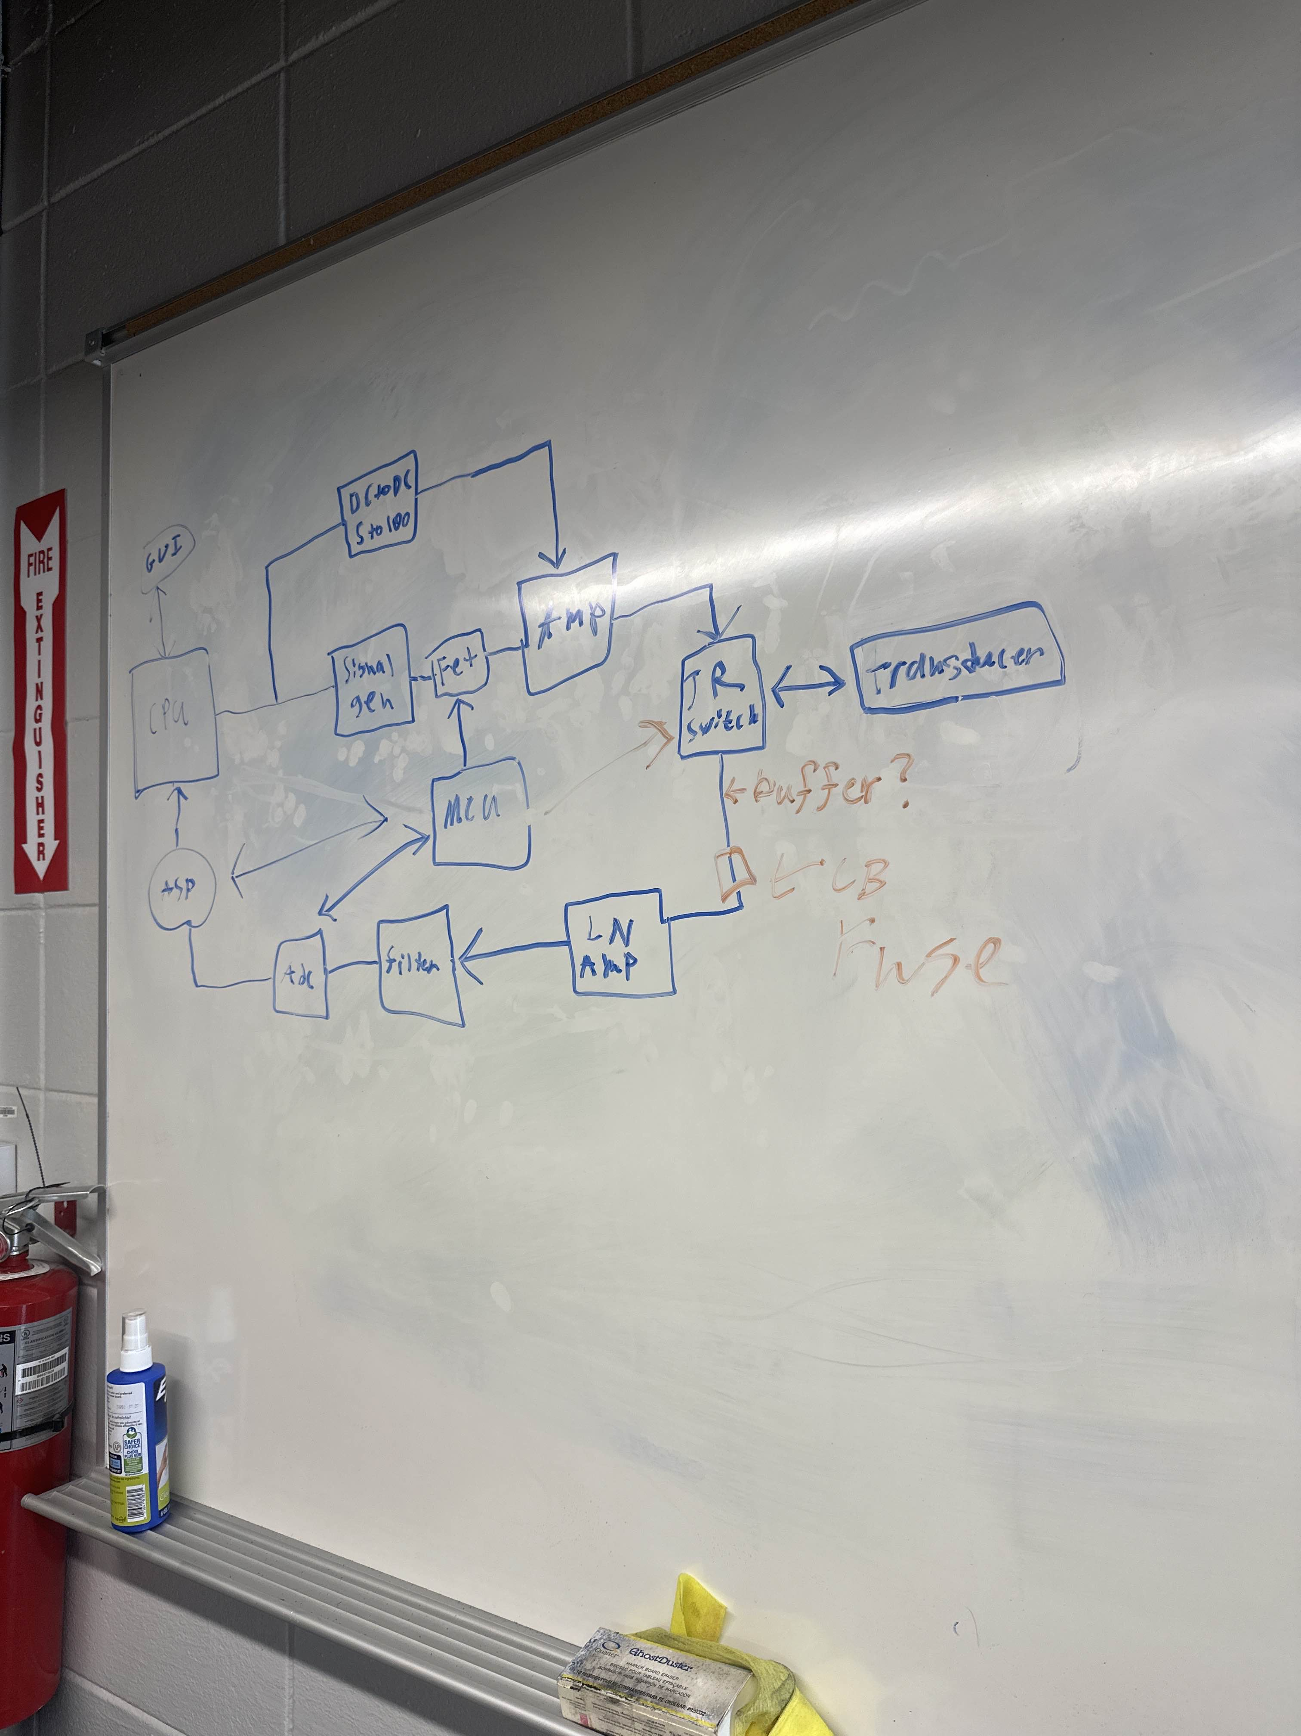
Basic block diagram of a pulse-echo system using tone burst (Layton).

Visted Marietta NDT. Advised to use an existing instrument and work at the system level. Potentially receiving an immersion probe.

Design consideration modified – 2 (Final)
Affordable Autonomous immersion defect detection system capable of producing C-scans.

Instrument Investigation
Discovered Echomods project: Family of open-source ultrasound pulser/reciever boards - (Layton Abbott)

Instruments considered (technically, these are pulser/reciever boards):

Board | Capabilities
lit3-32 | Capable of 100V 3 line pwm pulses. Controlled by FPGA (iCE40). 92dB gain VGA
un0rick | Capable of 25V, 50V, or 75V pwm pulses. Controlled by FPGA (iCE40). 48dB VGA
pic0rick | Capable of +-25V 3 line pwm pulses. Controlled by RP2040/RP2350. 48dB VGA

lit3-32 and un0rick are legacy and no longer produced. Pic0rick is the only modern option in it’s class and price range.

Due to the entire echomods project being open-source, printing the lit3-32 was strongly considered but advised against by senior project professor.

Pic0rick and lit3-32 were around the same price. After considering common probe specs, Pic0rick can achieve desired results, but overhead of lit3-32 and FPGA flexabilty would provide better results.

Pic0rick was selected with raspberry pi pico as MCU - (Layton).

Budget Update
Board and acessories (headers, sma connectors, sma cables, pico) totaled to ~$400. Board and accessories were purchased with financial assistance from senior project professor.

New team buget: $400 + $400 - $400 = $400

Design Constraint - 2
Raspberry pi pico uses USB 1.1, theoretically 12Mbps, practically much lower.

Design Constraint - 3
Pic0rick board leaves 8 remaining gpio pins. Need to eventually drive motors (limit switches, E-stop, temp sensors).

Initial Testing
Main board (reciever) and daughter board (pulser) arrived. Headers and Raspberry pi pico 1 were installed (Harrison). Board was hooked up to 10Mhz delay-line contact probe provided by senior project professor. Extremely minimal firmware gave a completely raw, one-pulse signal with no DSP. Pulse was called with simple python function through live python environment with computer connected to board via serial (usb).

Signal filtering was then applied (through interface) via bandpass filter, averaging, and hilbert envelop and displayed with pyqt. Target was a blank slab of steel with no known defects. Patroleum jelly was used as couplant.
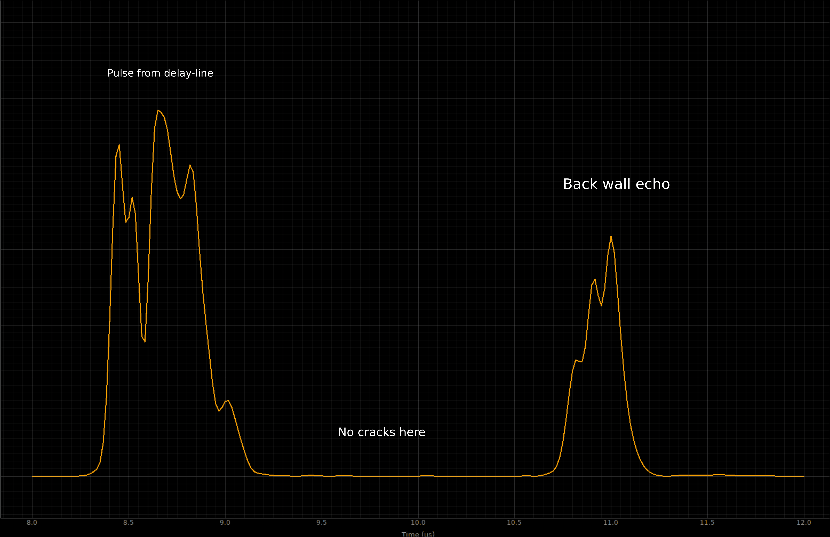

Python script was implemented to loop python function that triggers pulse and acquisition, along with windowing feature, input for gain, etc. (Mathew). Acquisition rate was approximately 1 pulse per 2 seconds.

Firmware was overhauled to use fast_pico_serial (Layton). Acquisition rate jumped to approximately 30 pulses per second with above signal processing and 2 signal averages.

Motion System Considerations
Used 3D printers and frugal CNC machines were considered for xyz motion system. Most 3D printers at a reasonable price move bed for y movement. This is not acceptable as water in scan area is sloshed. Both consumer/commercial CNC machines and 3D printers use dedicated microcontrollers with propriatary, unmodifiable firmware.

The MPCNC (Mostly Printable CNC) was discovered – (Layton)

The MPCNC is a guide to build a CNC machine with 3D printed parts and items found at local hardware stores and movement is driven by user choice of 5 Nema-17 motors. The user is required to choose microcontroller and motor drivers.

MPCNC was selected – (Layton)

Original MPCNC qoute for user sourcing parts was ~$450 (including cnc router, which isn’t used here)

MPCNC parts were reviewed for practicality and printed (Layton, Harrison, Matthew)

MPCNC was successfully assembled (Mathew) for ~$280

MCU Considerations

To get a usable scan resolution, micro controller needs to either support much higher serial transfer rate, or allow for onboard dsp to shrink size of data sent over serial.

Motors can be driven by the 8 remaining gpio pins due to 2 x axis motors rotating in opposing direction and 2 y axis motors rotating in opposing direction. This leaves no room for limit switches, E-stop, etc.

Solution | Pros | cons
PCB with motor controllers built around teensy 4.0. M/s setup between teensy and pico 1 | 3.0 USB speeds. Heavier onboard DSP. more gpio | Cost of teensy 4.0. M/s complexity. 2 sets of firmware
Move pic0rick to pico 2. Build gpio extension/motor driver drop in PCB | Onboard DSP with arm_math (none on pico 1). $2 increase in MCU cost. | Still limited to usb 1.1. added complexity of gpio expansion PCB

Replace pico 1 with pico 2 on pic0rick. Build gpio expansion pcb - (Layton)

