Test Report
T-001 – Pulse-echo acquisition:

Objective: Ensure the pic0rick can send drive a 10MHz probe and clearly display acquisitions.

Test Setup:
Pic0rick pulser/receiver board
10MHz Delay-line contact probe
petroleum jelly
0.6mm slab of steel
Computer running IPython

Test Description:
A 10MHz delay line probe was hooked up to the Pic0rick pulser/receiver board. The probe was coupled to the surface of a 0.6mm slab of steel using petroleum jelly. A computer was used to trigger the pulser and plot the aqcuisition.

Acceptance Criteria:
Reflections should repeatably be visually separate from noise. A main bang, delay-line front wall peak and reverberation with peaks slowly decreasing in intensity is expected.
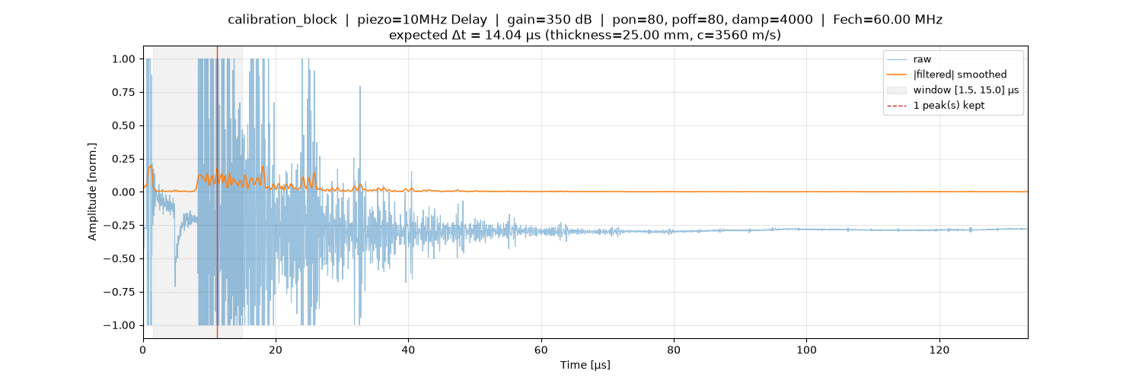

Figure T-001-A: Signal aqcuisition

