Deploy Nodejs app to Amazon EC2

1. Create AWS Account
   1. Sign Up Amazons free micro instance of EC2

<http://aws.amazon.com/ec2/>

* 1. Create Instance

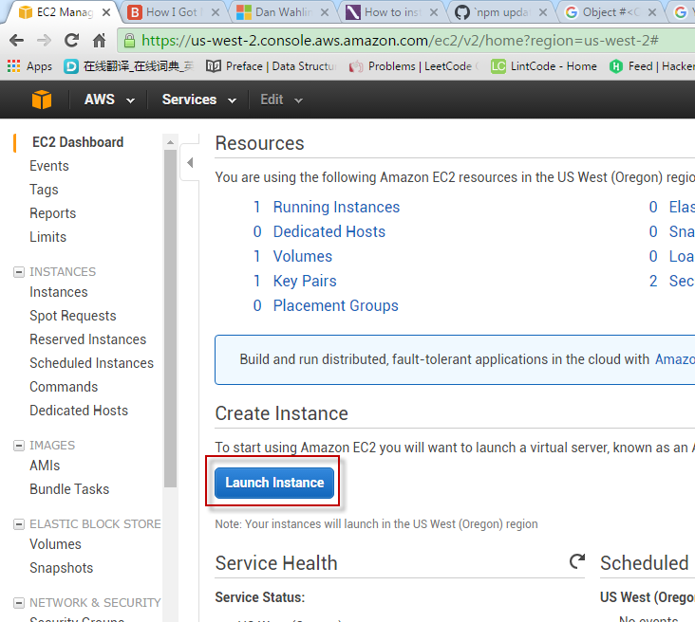

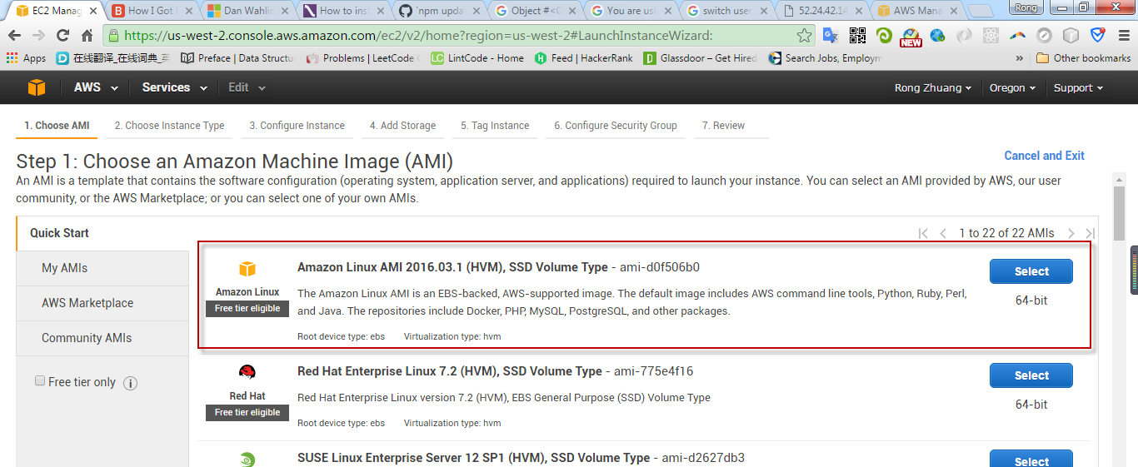

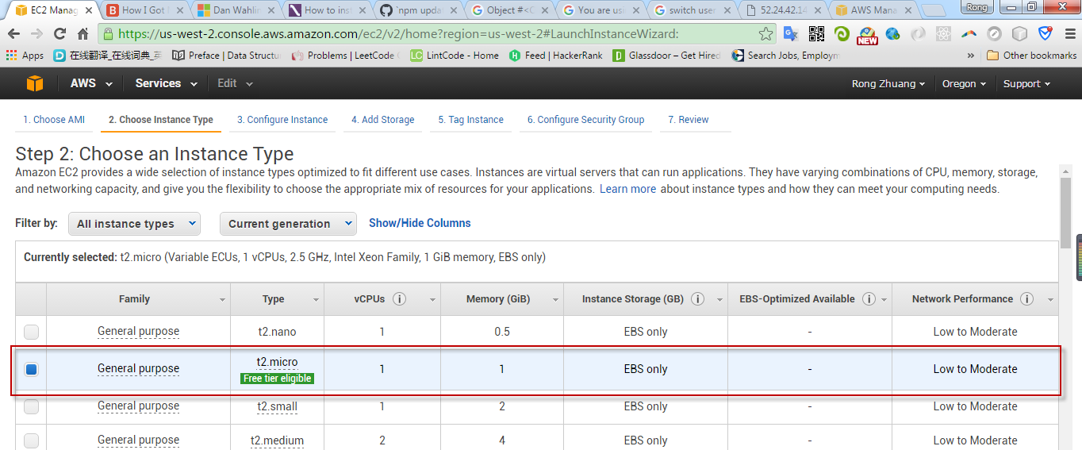

Review and launch.

Create security group.

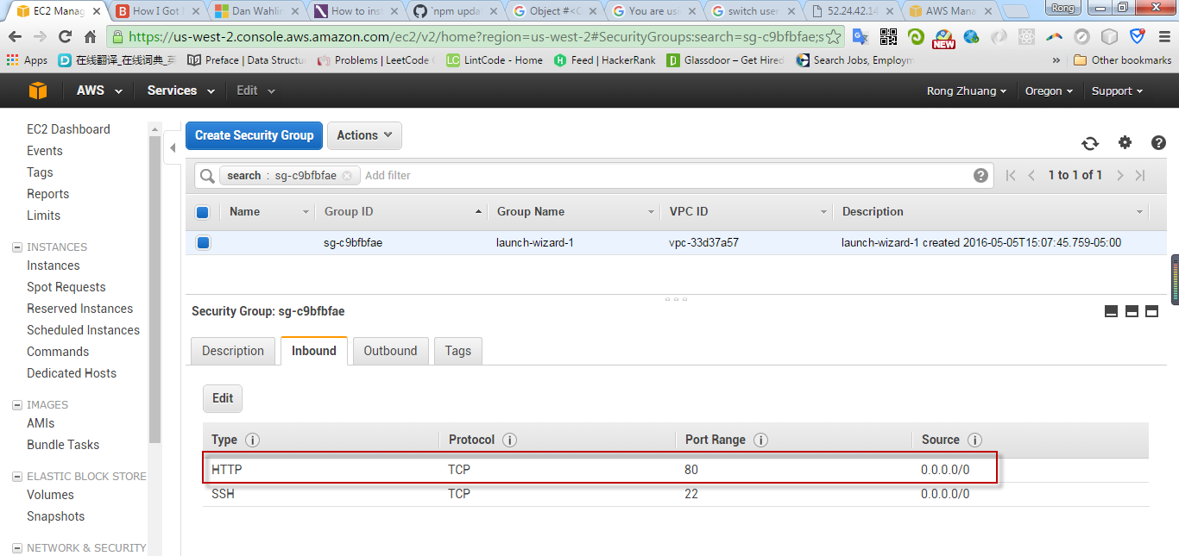

* 1. Create Key Pair

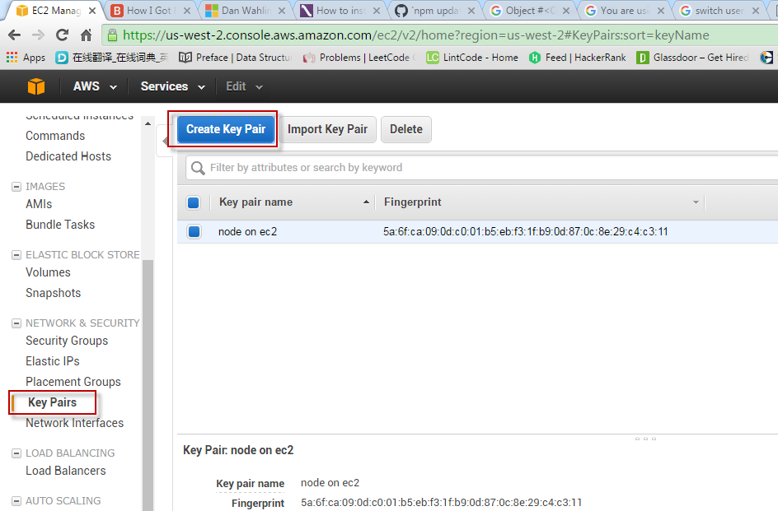

Down load the private key to local machine, eg. nodeonec2.pem.

1. Use Putty
   1. User PUTTYGEN.EXE to convert key

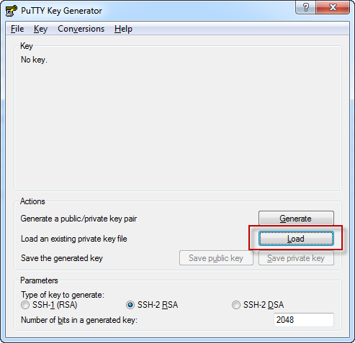

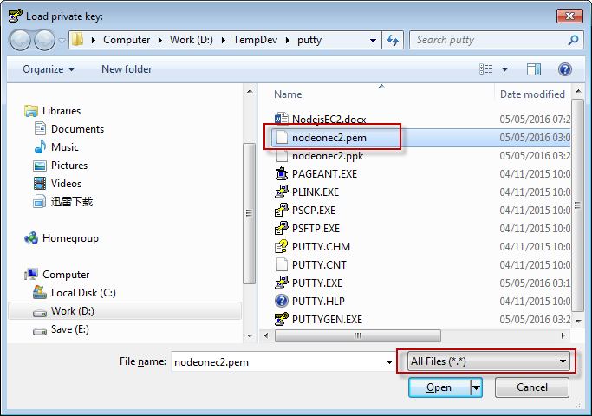

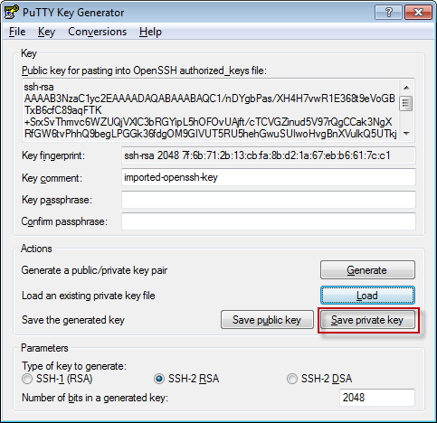

nodeonec2.ppk is generated.

* 1. Configure PUTTY.EXE

In session, provide ip and session name.

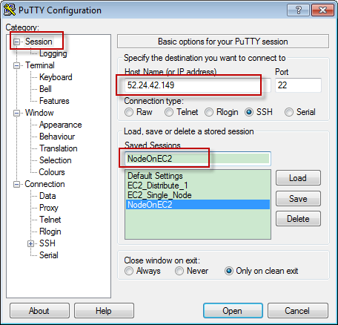

The IP is the Public IP of your EC2 instance. It is only available when the instance is running.

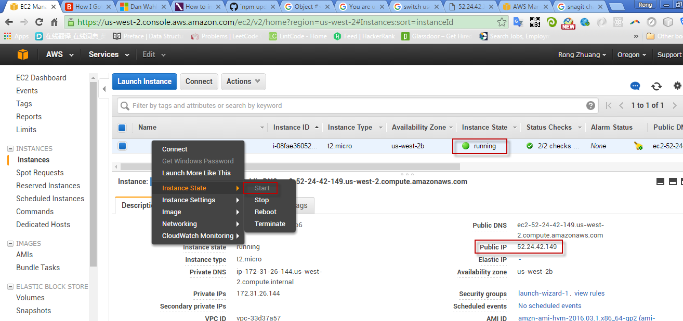

Connection->Data, add user, always ‘ec2-user’.

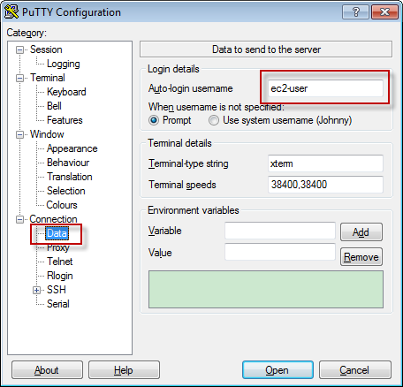

Connection ->SSH ->Auth, load the private key ppk file.

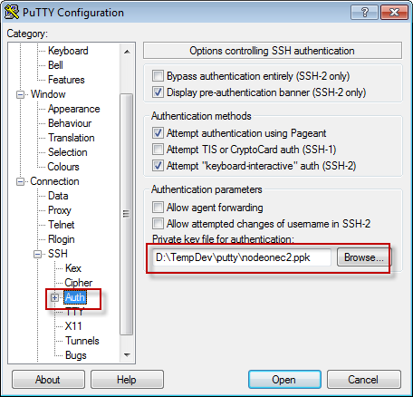

Back to session, save the configuration. Click open or double click the newly created session.

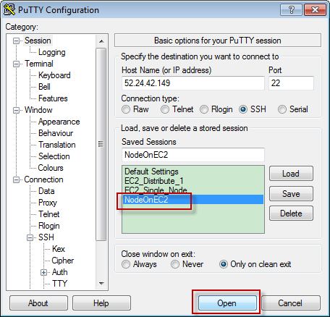

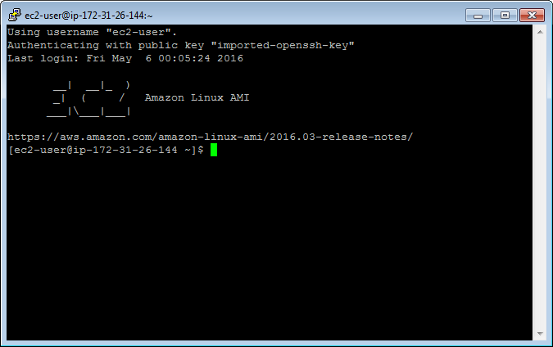

Note, the ip address here is internal ip.

1. Setup Instance

Use putty to connect EC2, make sure launch the instance first. You have to change the IP in putty every time if you reboot the instance. The Public IP address changes to different value once re-launched.

* 1. Update your EC2 Amazon Linux

sudo yum update

* 1. Install GCC

sudo yum install gcc-c++ make

sudo yum install openssl-devel

* 1. Install Node.js

sudo yum install git

git clone git://github.com/nodejs/node

cd node

./configure

make //it may take long time to compile

sudo make install

* 1. Add node folder to secure_path

sudo su

nano /etc/sudoers

append :/usr/local/bin to the end of secure_path

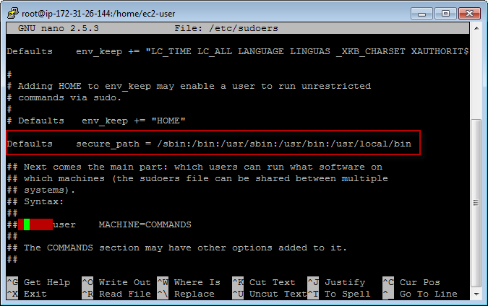

* 1. Install npm

git clone <https://github.com/npm/npm>

cd npm

sudo make install

1. Create NodeJs file
   1. Create folder ‘site’

mkdir site

* 1. Create file ‘server.js’

nano server.js

append the following content to the file, save and exit.

|  |
| --- |
| var http = require('http');  function onRequest(request, response) {  console.log("A user made a request" + request.url);  response.writeHead(200, {"Context-Type": "text/plain"});  response.write("Here is your response");  response.end();  }  http.createServer(onRequest).listen(8080);  console.log("The server is running at 80..."); |

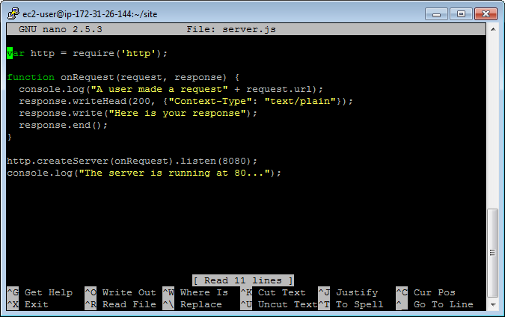

* 1. Redirect port

You cannot make node server listen to port 80. Run the following command to redirect port 80 to port 8080.

iptables -t nat -A PREROUTING -p tcp --dport 80 -j REDIRECT --to 8080

* 1. Start our Node server

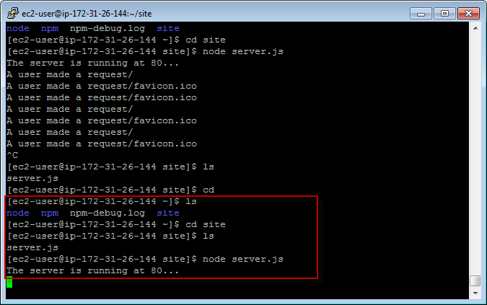

* 1. Open browser, access the site with public ip.

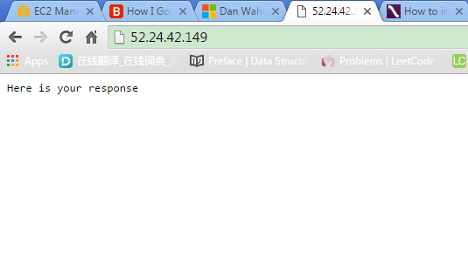

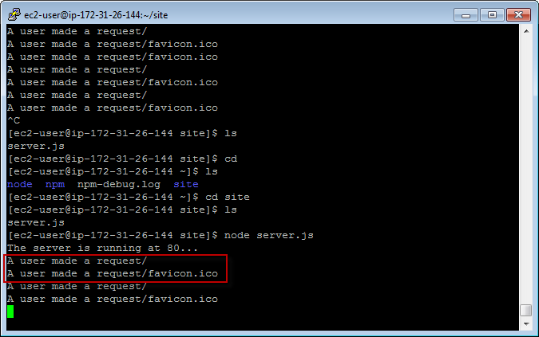

1. Deploy Local Node Project to EC2
   1. Install CyberDuck

<https://cyberduck.io/?l=en>

* 1. Launch CyberDuck and Upload

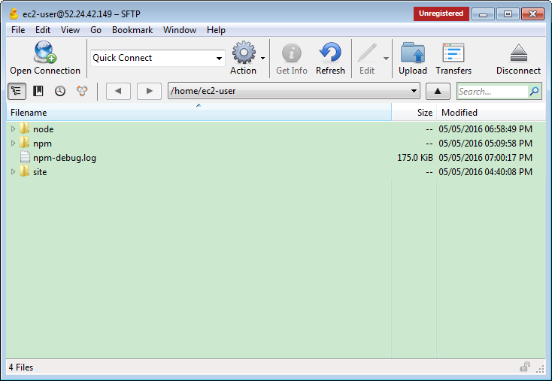

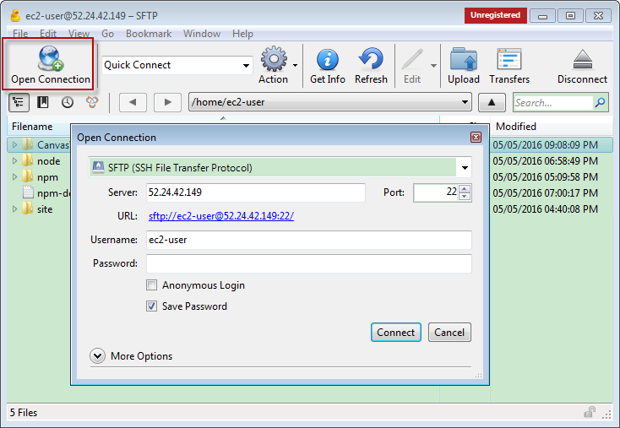

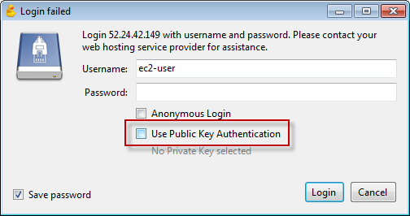

Select the folder, make sure delete all files in ‘node_modules’ folder.

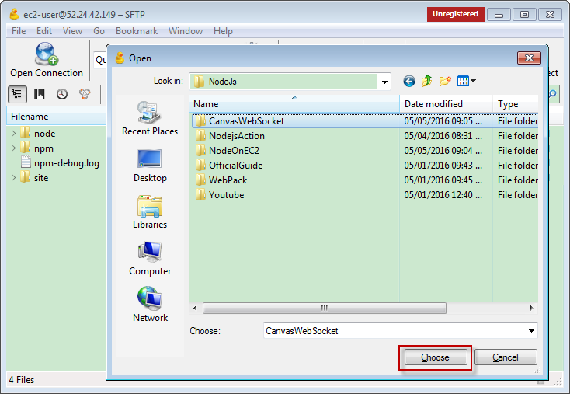

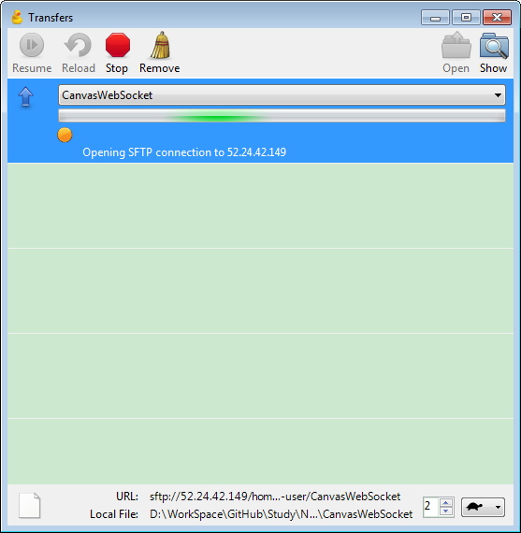

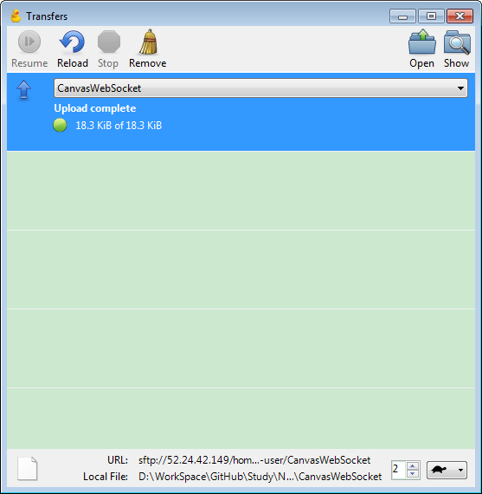

Refresh the folder in putty, the new folder exits.

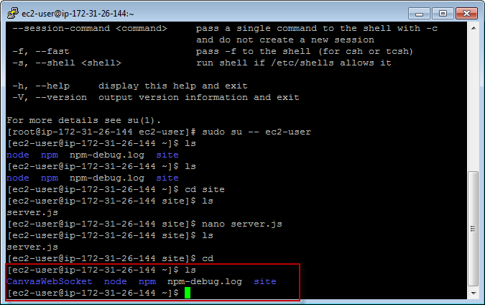

* 1. Go into the folder

npm install

npm start

* 1. Open Chrome, Firefox, on different device.

Draw on chrome.

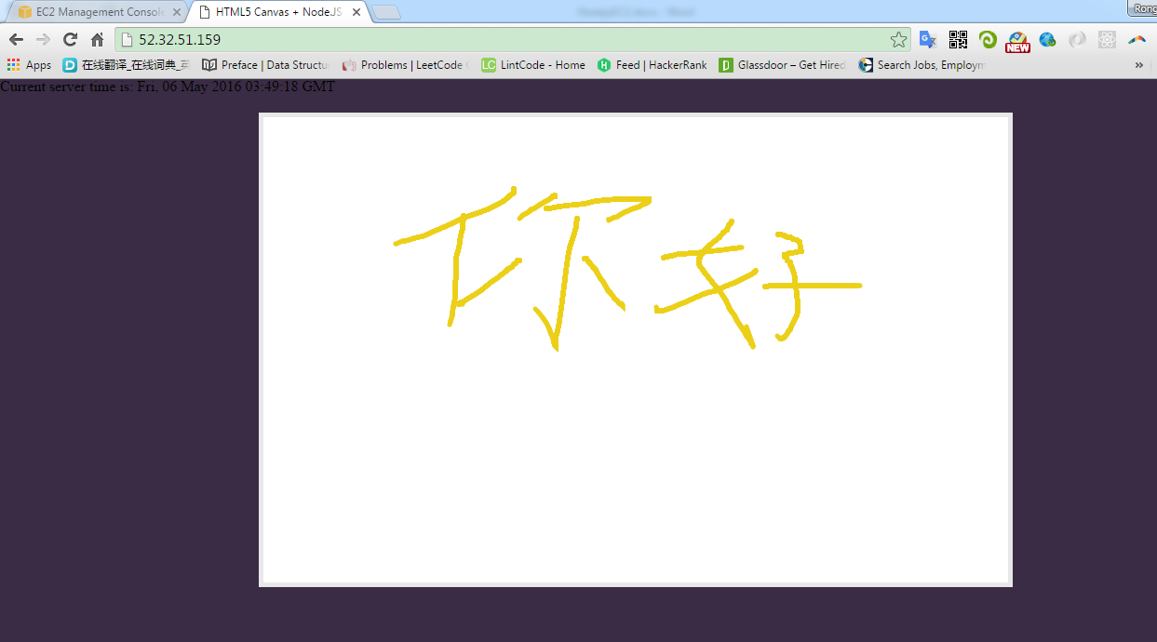

Same in firefox

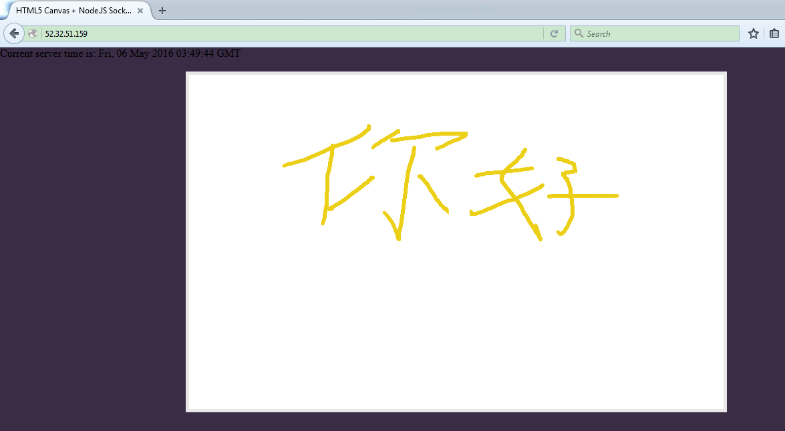

Same on iPad

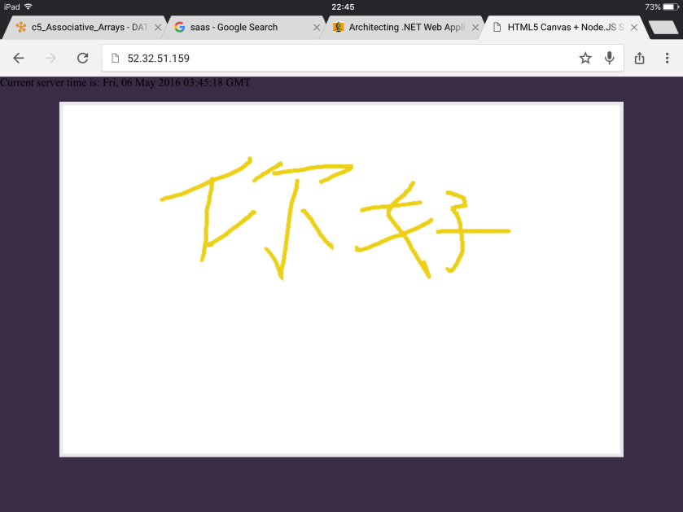

Same on iPhone

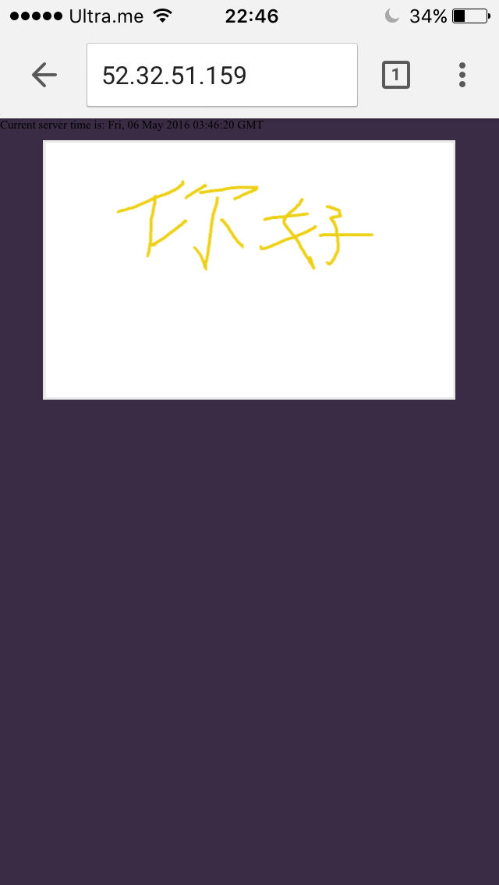

1. Useful command in linux

|  |  |
| --- | --- |
| **Command** | **Description** |
| ls | Show files/directories under the current folder |
| sudo su | Switch to root user |
| sudo su -- ec2-user | Switch to ec2-user |
| nano filename | Open/Create file with nano |
| mkdir foldername | Create folder |
| sudo make uninstall | Uninstall, go to the folder and run it. |

1. Reference

How I Got Node.js Running On A Linux Micro Instance Using Amazon EC2

<http://www.bennadel.com/blog/2321-how-i-got-node-js-running-on-a-linux-micro-instance-using-amazon-ec2.htm>

How to install & setup Node.js on Amazon EC2 – complete guide

<http://iconof.com/blog/how-to-install-setup-node-js-on-amazon-aws-ec2-complete-guide/>

Setup Node.Js Enviroment on Amazon EC2 linux

<http://adndevblog.typepad.com/cloud_and_mobile/2014/12/setup-nodejs-enviroment-on-amazon-ec2-linux-1.html>

<https://docs.npmjs.com/misc/removing-npm>

1. Issues
   1. Remove npm

Sometime, there is something wrong with npm, it doesn’t work.

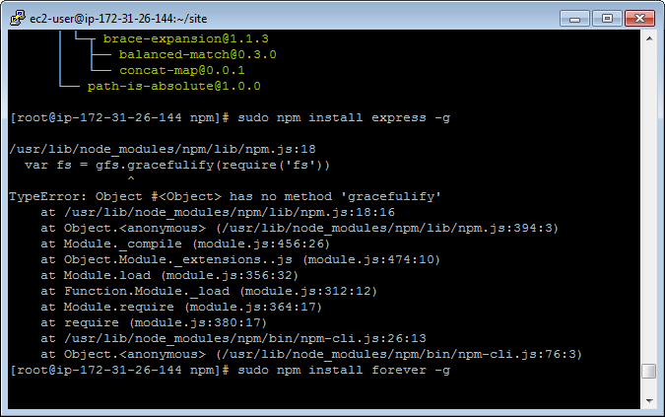

You need to uninstall and install again.

sudo npm uninstall npm -g

If it doesn’t work, go the ‘npm’ folder, run:

sudo make uninstall