**National Textile University, Faisalabad**



**Department of Computer Science**

**Course Name:**

*Internet of Things Fundamentals*

**Course Code:**

*AIE-3079*

**Submitted To:**

*Dr. Nasir Mahmood*

**Submission Date:**

*May 04, 2025*

**Group Members:**

* *Hasham Ul Haq — 22-NTU-CS-1361*
* *Abdul Wahab __22-NTU-CS-1337*
* *Abdul Qayyum __22-NTU-CS-1335*

# Project Title:

**IOT-Based Smart Home Energy Monitoring System**

# Group Name:

Iotrix

# Problem Statement and Objectives:

## Problem Statement

In most households, there is no clear way to monitor the real-time energy usage of units consumed, leading to inefficient energy consumption and increased electricity bills. A smart Iot-based system that tracks energy usage in real-time and identifies high-consumption devices can help reduce energy waste and enable informed decision-making.

## Objectives:

• Build a real-time energy consumption monitoring system for home appliances.

• Use IoT sensors (current sensors SCT-013) to calculate energy usage per device.

• Display energy consumed in kilowatt-hours (kWh) and calculate cost.

• Build a mobile/web dashboard to visualise real-time energy and cost data.

• Optionally integrate AI in the future to detect patterns and give energy-saving suggestions.

## Scope of the Project:

**In-Scope:**

• Monitoring voltage and current using IoT sensors like SCT-013.

• Real-time unit calculation using the formula:

•     ΔEnergy = (P × Δt) / 1000

• ESP32 microcontroller for data collection and WiFi transmission.

• Blynk/FireBase for dashboard and monitoring.

**Out-of-Scope (for now):**

• Monitoring energy per appliance or for a group of devices.

• Automatic control of appliances.

• AI-based prediction or anomaly detection (planned for FYP).

**Required Hardware:**

• ESP32 — WiFi-enabled microcontroller.

• SCT-013 Current Sensor — Measures current consumption.

• Voltage Sensor Module — Optional for more precise power monitoring.

• Breadboard + Jumper Wires — For circuit prototyping.

• Resistors, CT Burden Resistor — For safe signal handling.

• Relay — For future appliance control.

• Power Supply — For ESP32.

• Mobile/PC — For viewing dashboard.

**Software, Cloud, Database:**

• Arduino IDE — To program ESP32.

• Blynk / ThingSpeak / Firebase — For data monitoring and logging.

• HTML + CSS + JS — If building a custom dashboard.

• Google Sheets — For tracking usage history (optional).

**Subjects Used Other than IoT:**

• Electrical Engineering — Power measurement principles.

• Web Development — Dashboard design (HTML/JS or Blynk).

• Artificial Intelligence (Future Plan) — Pattern recognition and anomaly detection.

• Cloud Computing — IoT data storage and real-time access. Approach:

**Sensor Setup & Testing:**

Use SCT-013 sensor to detect current from appliances.

Convert analog signal to readable voltage via burden resistor.

• Energy Calculation:

Measure current (I) and voltage (V) to compute power:

    P = V × I

Calculate Energy in kWh using:

    Energy = (P × time)/1000

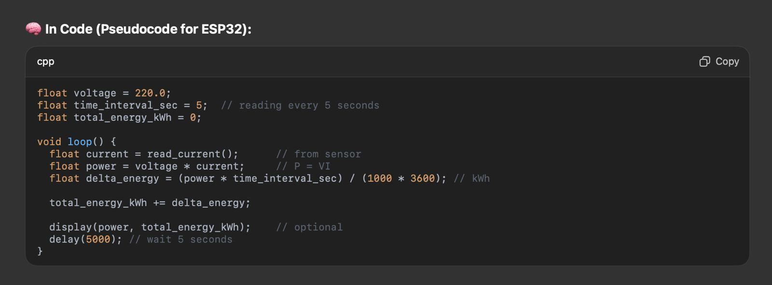

Iot Integration:

Program ESP32 to send real-time data via WiFi.

Upload data to Blynk or FireBase.

**Visualization:**

Create a live dashboard to show:

    • Current Power

    • Energy Consumed

    • Cost in PKR

Send alerts if energy crosses a certain limit.

**Testing:**

Use different appliances (bulb, fan, iron) to compare consumption.

Log usage patterns and match with actual bills.

**Deliverables:**

• A real-time IoT-based energy monitoring system.

• Live dashboard for viewing power, units, and cost.

• Data logs stored on cloud.

• Final report with system architecture and performance.

• Video demo and working hardware.

• System Architecture (Flow Chart):

## System Architecture (Flow Chart):

