**Internet of Things Fundamentals**

*Subject Project*

BS AI 6th Smester SP-25 (AIE-3079)

Date:

**Project Title:** Smart Energy Monitoring System

**Group Name/no.: IOTRIX**

**Team Members:**

|  |  |  |  |
| --- | --- | --- | --- |
| Members | Registration no | Name | Signature |
| **Member-1 (Leader)** | **22-NTU-CS-1361** | **M Hasham Ul Haq** |  |
| **Member-2** | **22-NTU-CS-1337** | **Abdul Wahab** |  |
| **Member-3** | **22-NTU-CS-1335** | **Abdul Qayoum** |  |
| **Member-4** |  |  |  |

|  |  |  |  |  |  |
| --- | --- | --- | --- | --- | --- |
| Contributions in % of each Team Members for each component | | | | | |
|  | | Member-1 | Member-2 | Member-3 | Member-4 |
| Distribution Components | | Name | Name | Name | Name |
| Coding | ESP32-coding | 40% | 35% | 25% |  |
| Python Coding |  |  |  |  |
| UI Design | | 15% | 15% | 70% |  |
| Database | | 35% | 40% | 25% |  |
| Cloud Integration | | 33.33% | 33.33% | 33.33% |  |
| IoT Gateway | |  |  |  |  |
| Edge Processing | | 33.33% | 33.33% | 33.33% |  |
| Documentation | | 50% | 25% | 25% |  |
| Presentation  Design | | 5% | 80% | 15% |  |
| Replace for other contribution | |  |  |  |  |
| Replace for other contribution | |  |  |  |  |
| Replace for other contribution | |  |  |  |  |
| Replace for other contribution | |  |  |  |  |

*To be filled by the evaluator*

# Team-Based Evaluation (60 Marks)

|  |  |  |
| --- | --- | --- |
| Criteria | Obtained Marks | Out of |
| System Design & Architecture |  | 10 |
| Hardware Integration & Circuit Setup |  | 10 |
| IoT Gateway and Cloud Communication |  | 10 |
| Working Prototype Demonstration |  | 10 |
| Performance & Reliability Testing |  | 10 |
| Presentation |  | 10 |
| Total (Team-Based) |  | 60 |

# Individual-Based Evaluation (40 Marks per Member)

|  |  |  |  |  |
| --- | --- | --- | --- | --- |
|  | Member 1 | Member 2 | Member 3 | Member 4 |
| Criteria |  |  |  |  |
| Understanding of the Project & Role | /10 | /10 | /10 | /10 |
| Code Contribution and Explanation | /10 | /10 | /10 | /10 |
| Q/A VIVA | /10 | /10 | /10 | /10 |
| Documentation/Reporting & Communication | /10 | /10 | /10 | /10 |
| Total (Individual-Based) | /40 | /40 | /40 | /40 |
| Total Overall (60+40) | /100 | /100 | /100 | /100 |
| Weightage Lab Grade (50) |  |  |  |  |

**1. Abstract / Executive Summary**

This IoT-based Smart Energy Monitoring System project is designed to monitor household electricity usage in real time using ESP32, voltage and current sensors, and an OLED display. It calculates power consumption (kWh), estimates the cost of energy usage based on Pakistani tariffs, logs data to an SD card, and visualises metrics using Blynk. Time synchronisation is handled via NTP servers. This system aims to promote energy efficiency and real-time monitoring without reliance on traditional utility meters.

**2. Table of Contents**

1. Abstract / Executive Summary
2. Table of Contents
3. Introduction
4. Literature Review
5. Methodology / System Design
6. Implementation
7. Results & Discussion
8. Testing & Validation
9. Conclusion & Future Work
10. References
11. Links

**3. Introduction**

*Background & Motivation:*

Electricity usage in homes often lacks visibility until monthly bills arrive. Real-time insights can help reduce consumption and optimise usage patterns.

*Problem Statement:*

There is a lack of accessible, real-time energy monitoring tools for domestic users in Pakistan.

*Project Goals:*

* Measure real-time voltage, current, power, and energy.
* Display results on OLED and mobile (via Blynk).
* Log data to SD card for offline analysis.
* Estimate bill in PKR.
* Ensure time accuracy using NTP(Network Time Protocol).

**4. Literature Review**

*Relevant IoT/ESP32 Concepts:*

ESP32 is a low-cost, Wi-Fi-enabled microcontroller ideal for IoT applications. EmonLib helps accurately measure power parameters. Blynk is a mobile dashboard for IoT.

*Similar Projects/Research:*

Numerous Arduino- and ESP32-based energy meters exist, but few offer a complete stack, including SD logging, mobile visualisation, and NTP syncing.

**5. Methodology / System Design**

**5.1 Hardware Components**

* ESP32-S3
* ZMPT101B (Voltage Sensor)
* SCT-013 (Current Sensor)
* OLED 128x64 (SSD1306)
* Micro SD Card Module
* Resistors, breadboard, jumper wires, USB cable

*Circuit Diagram:* (Include labeled diagram in submission)

**5.2 Software Design**

* Arduino IDE
* Libraries:
  + EmonLib
  + Adafruit_GFX
  + Adafruit_SSD1306
  + Blynk
  + WiFi, SD, SPI, Time, SNTP
* Blynk App
* NTP Time Sync

*Pseudocode:*

* Initialize hardware
* Connect WiFi and Blynk
* Sync time using NTP
* Loop:
  + Read sensors
  + Calculate kWh & cost
  + Update OLED
  + Send to Blynk
  + Log to SD

**6. Implementation**

*Step-by-step Setup:*

* Connect sensors to ESP32 GPIOs
* Connect OLED to I2C pins (GPIO8 SDA, GPIO9 SCL)
* Connect SD card module (CS = GPIO10)
* Power up via USB
* Upload Arduino sketch

*Code Snippets:* (included in main sketch with comments)

* display.print() used for OLED
* Blynk.virtualWrite() for app
* calculateCost() implements real tariff slabs
* SD.open() logs readings to microSD

*Challenges & Solutions:*

* **OLED not displaying**: Fixed by correct I2C address and display.display()
* **Low Vrms readings**: Handled with voltage threshold logic
* **NTP failure**: Added timeout and fallback logic

**7. Results & Discussion**

*Screenshots/Output:*

* OLED shows V, I, P, kWh, PKR
* Blynk app reflects same in real-time
* SD card logs in CSV format

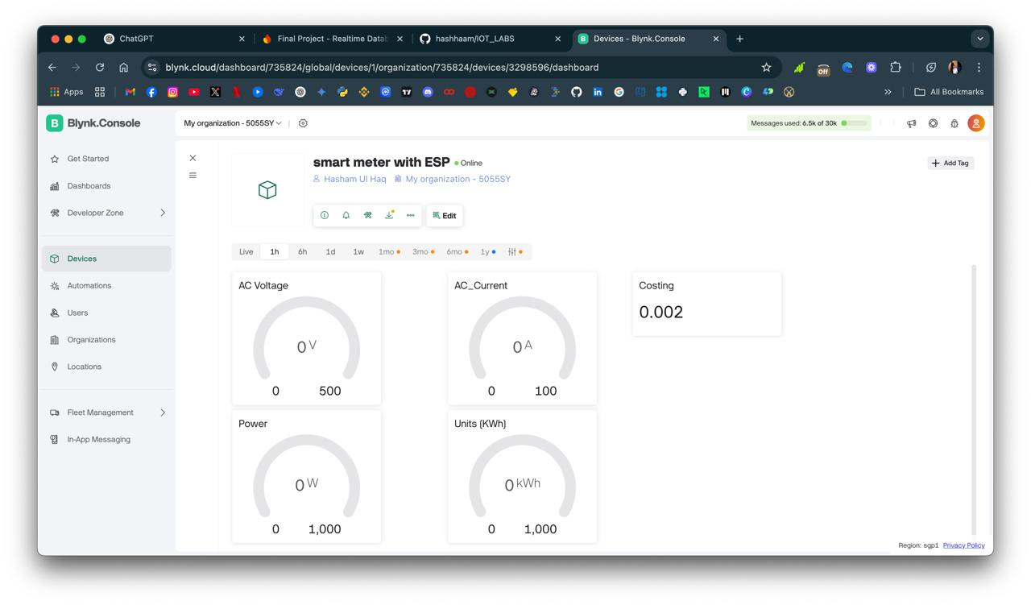

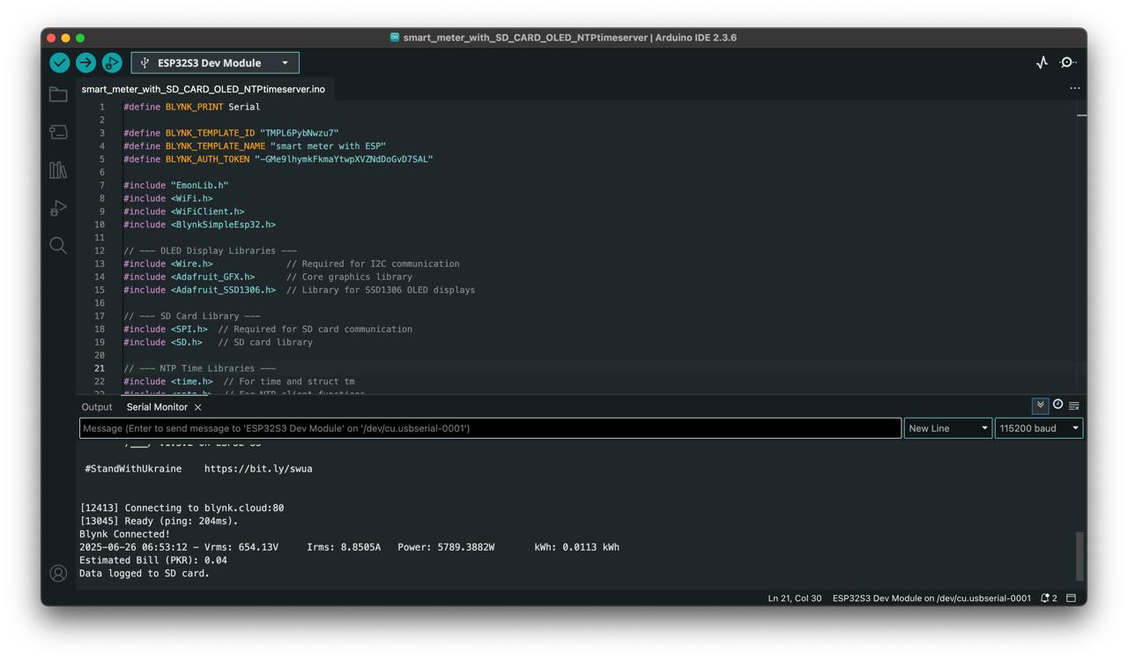

*Performance Analysis:*

* **Accuracy:** Acceptable within sensor limits
* **Latency:** Minimal (updates every 5 sec)
* **Reliability:** Stable with good power supply

*Comparison:*

Matches expectations. Accurate kWh accumulation, clean OLED and Blynk UI.

**8. Testing & Validation / Limitations**

*Test Cases:*

* Disconnected sensors → fallback to 0
* Voltage spike → correctly handled
* SD not present → shows warning on OLED

*Limitations:*

* Not calibrated for industrial use
* Wi-Fi dropout disrupts Blynk
* SD card may fail if not initialized properly

**9. Conclusion & Future Work**

*Key Takeaways:*

* Real-time energy monitoring is feasible using ESP32
* Multi-channel output (OLED + Blynk + SD) enhances value

*Future Work:*

* Add AI to predict usage
* Cloud dashboard (e.g., Firebase, AWS IoT)
* Solar input monitoring
* Overload alert notifications

**10. References**

* EmonLib: https://openenergymonitor.org
* SSD1306 Docs: https://learn.adafruit.com/monochrome-oled-breakouts
* NTP: https://www.pool.ntp.org
* Blynk Docs: https://docs.blynk.io

**11. Links**

* GitHub Repo: *https://github.com/hashhaam/IOT_LABS.git*
* Video Demo: *https://drive.google.com/file/d/1t6nS9EwEwuOBz5t3qDYOVO-mZlSvZ-KV/view?usp=sharing*