UNIVERSITY OF ENGINEERING AND TECHNOLOGY, PESHAWAR PAKISTAN
Main Campus

CS-224 Web Technologies Assignment No. 01
Submitted By
Name: | Hisham khan
Registration No. | 24pwbcs1402
Semester: | BS CS 4th
Section: | E
Submission Date:
Submitted To
Sir Mohammad

DEPARTMENT OF COMPUTER SCIENCE & IT
UNIVERSITY OF ENGINEERING AND TECHNOLOGY, PESHAWAR, PAKISTAN

Index.html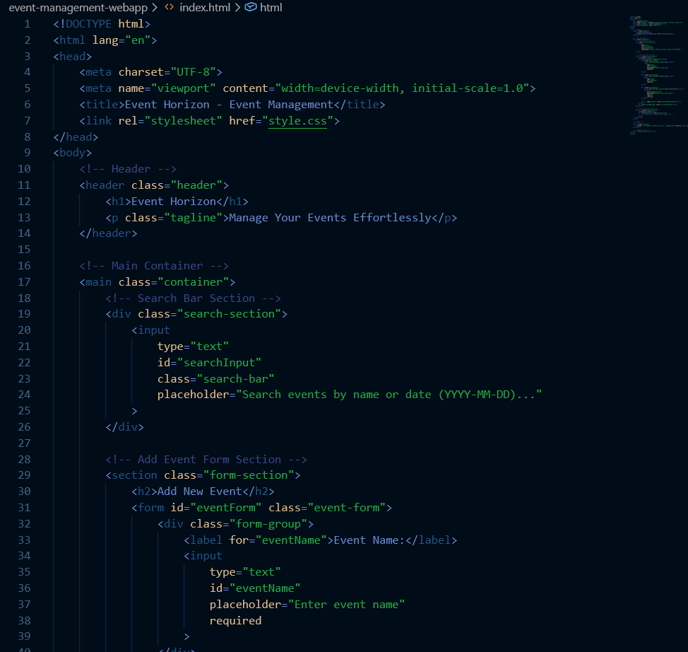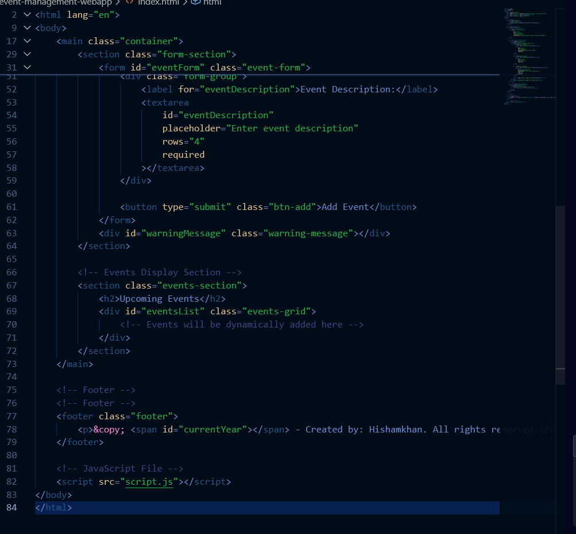

Script
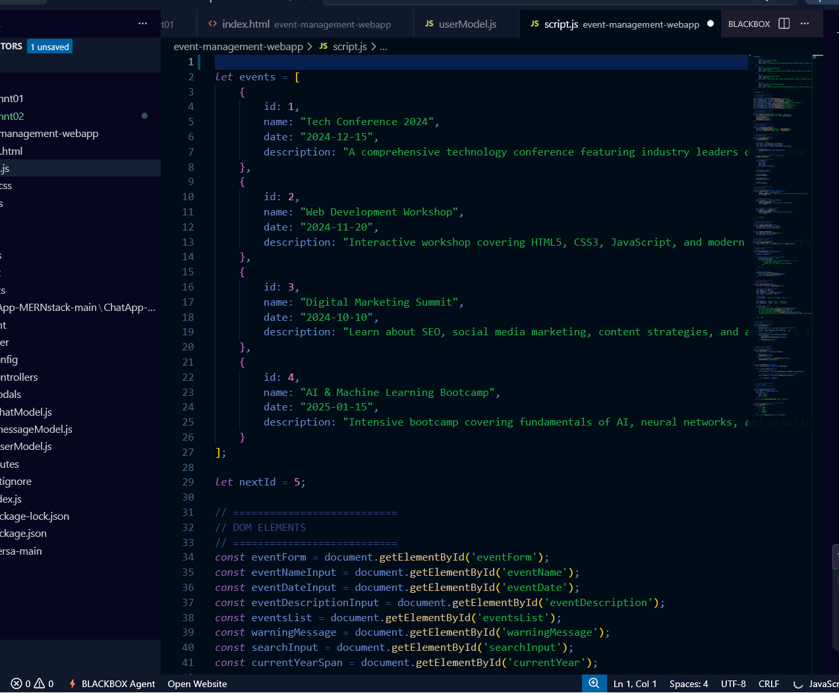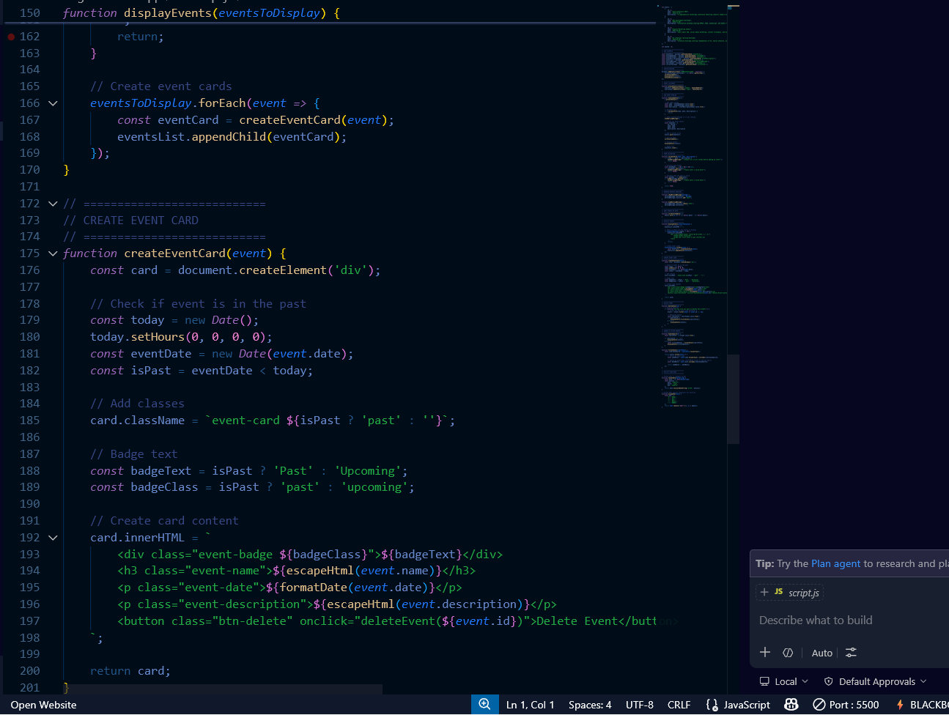
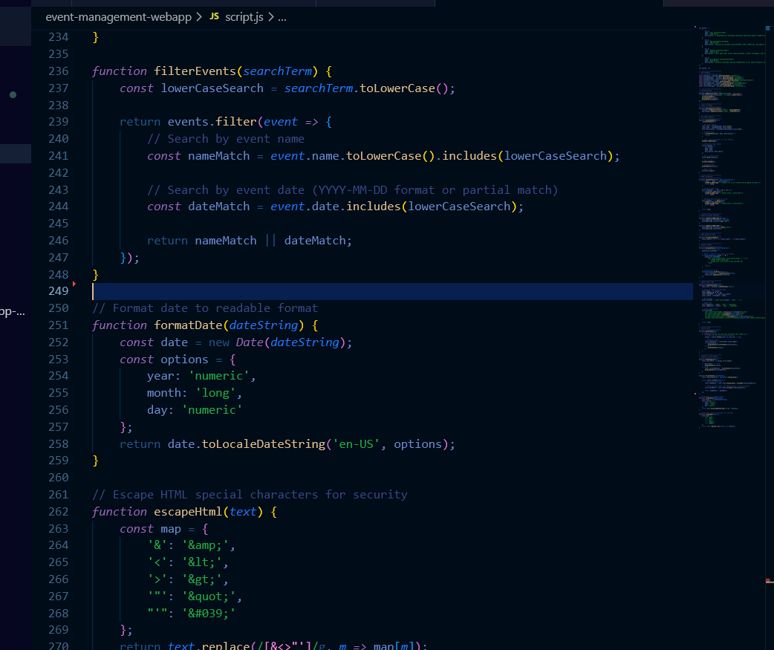

Style.css
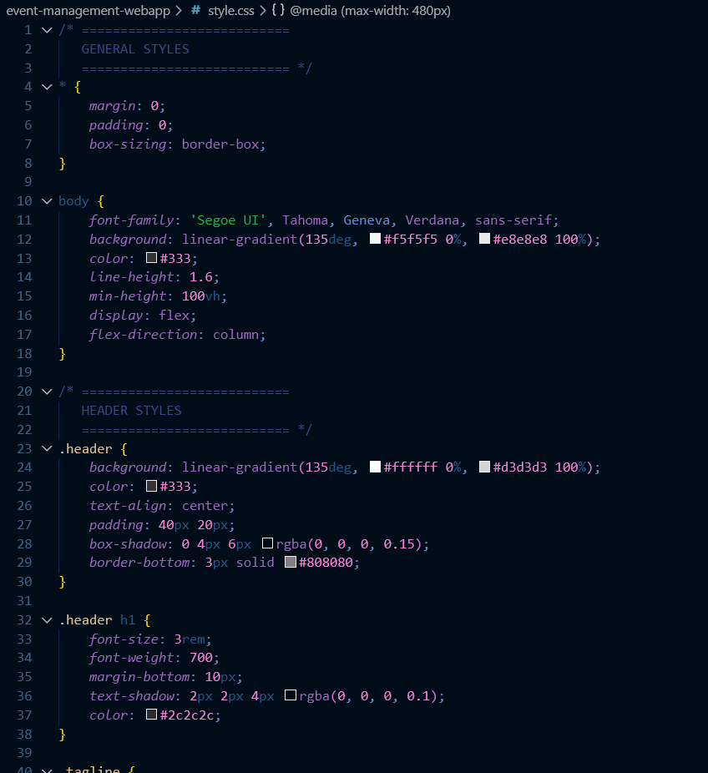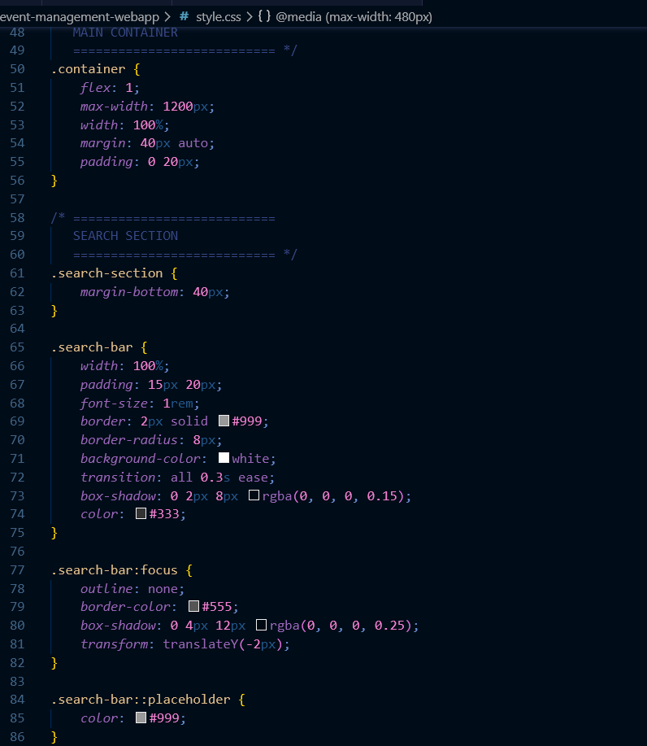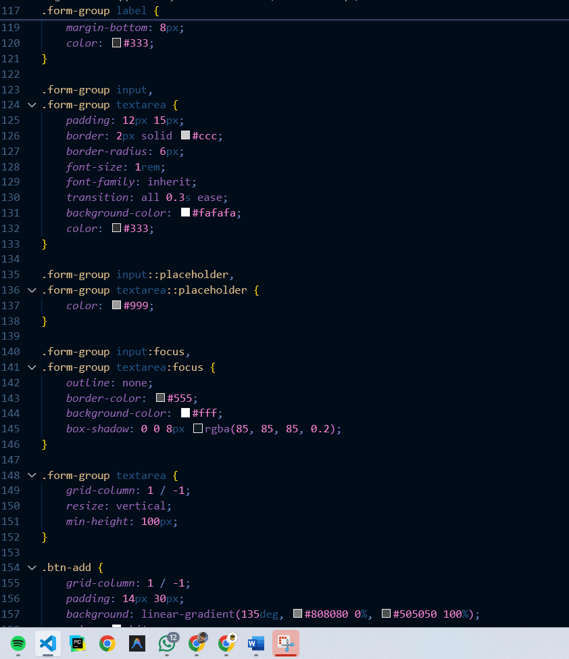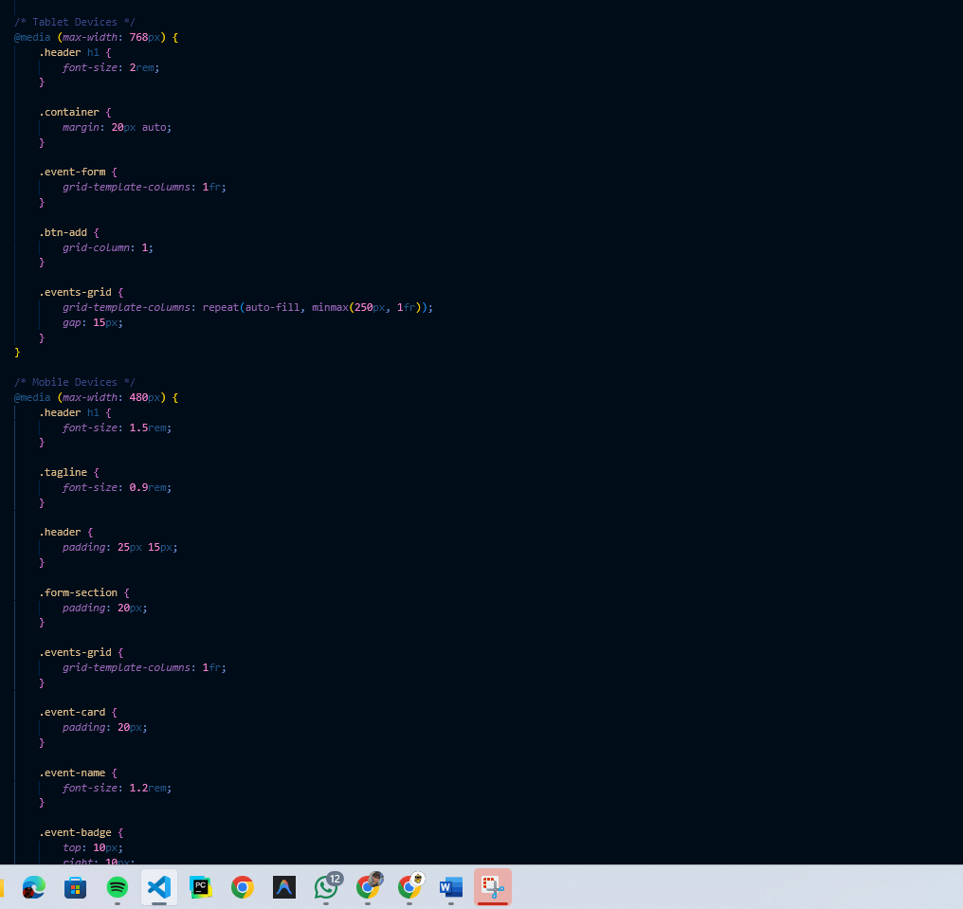

Github

