UNIVERSITY OF ENGINEERING AND TECHNOLOGY, PESHAWAR PAKISTAN
Main Campus

CS-224 Web Technologies Assignment No. 02
Submitted By
Name: | Hisham khan
Registration No. | 24pwbcs1402
Semester: | BS CS 4th
Section: | E
Submission Date:
Submitted To
Sir Mohammad

DEPARTMENT OF COMPUTER SCIENCE & IT
UNIVERSITY OF ENGINEERING AND TECHNOLOGY, PESHAWAR, PAKISTAN

CODE
Structure
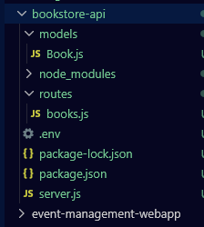
Models/books.js
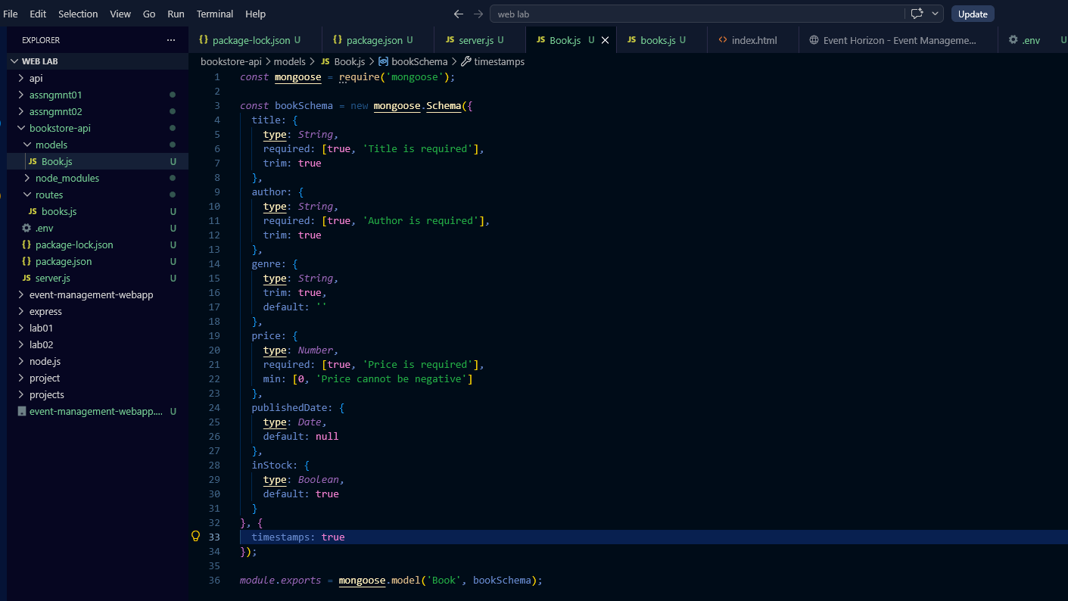

Route/book.js
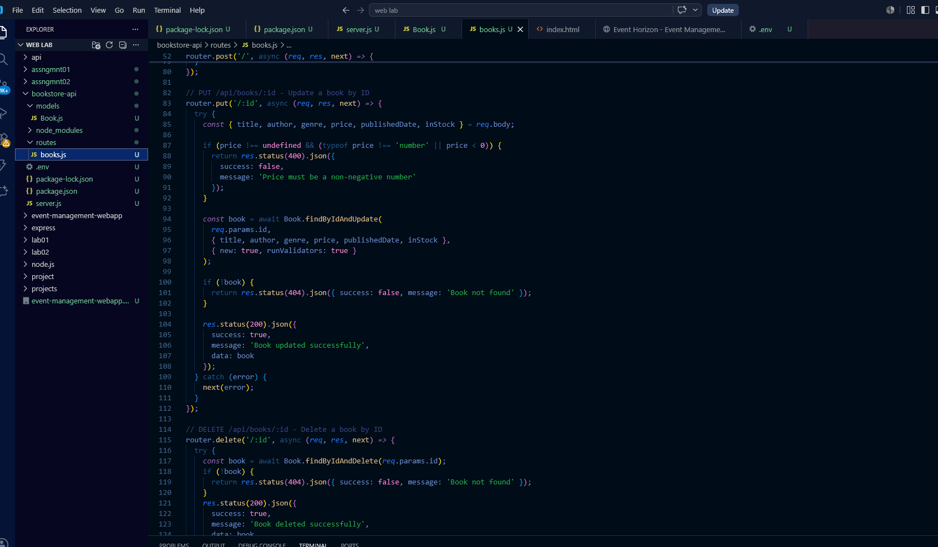
Env
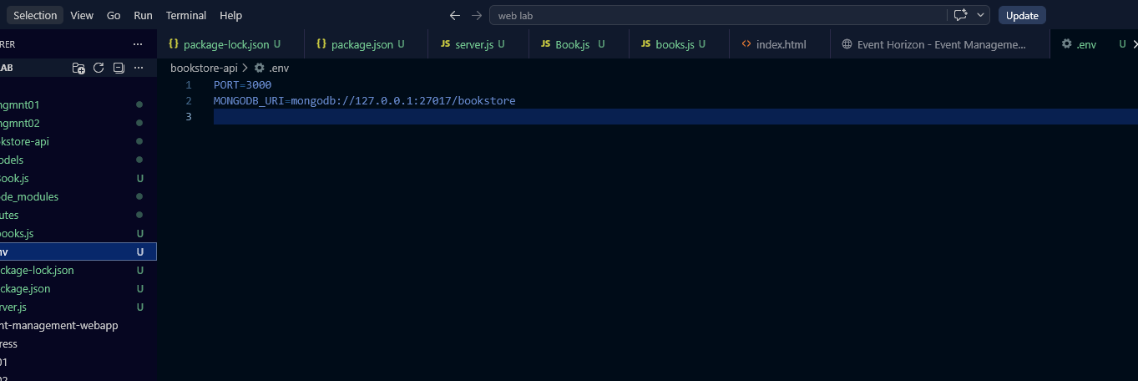

Package_lock.js
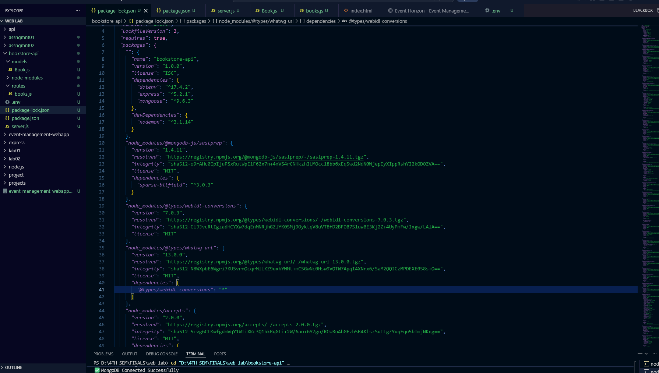
Server.js
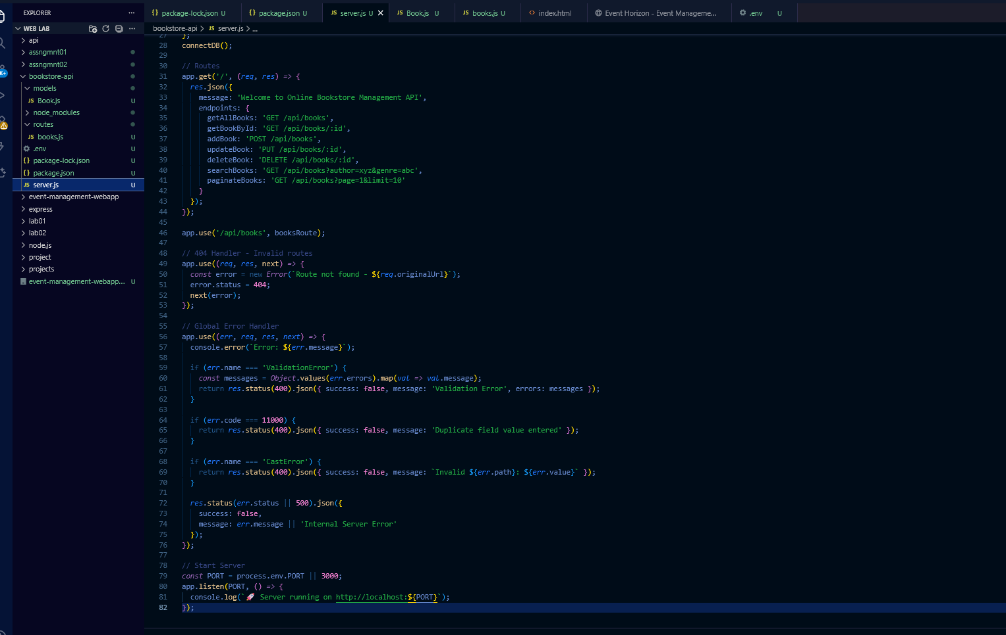

1. GET Single Book by ID

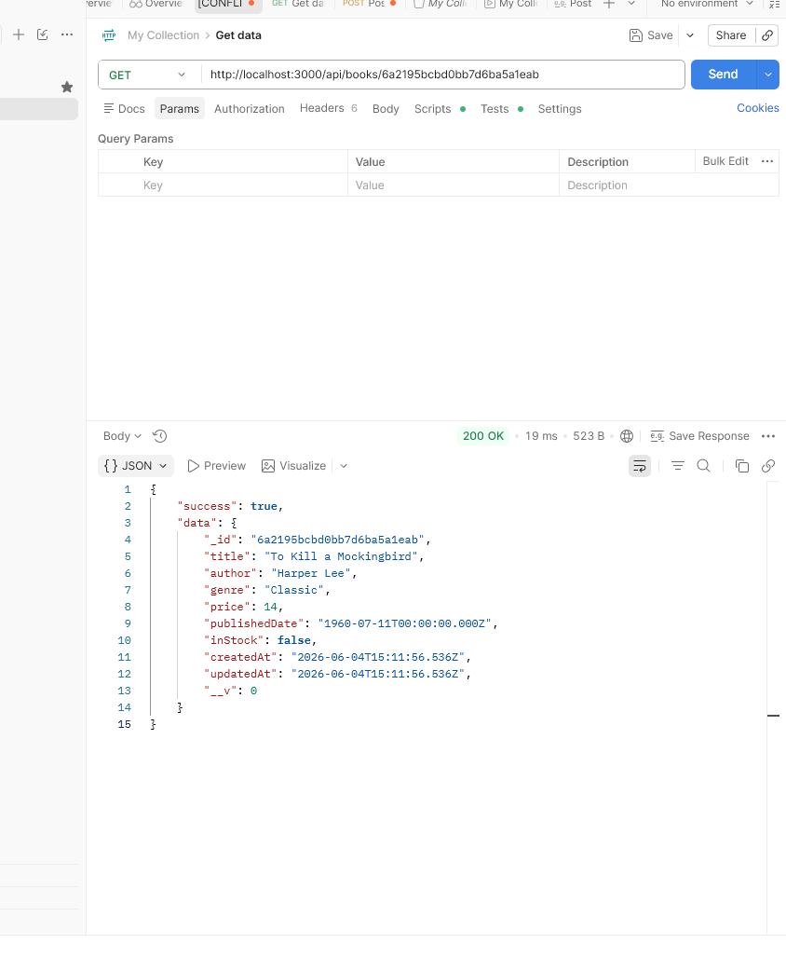

2. UPDATE a Book (PUT)

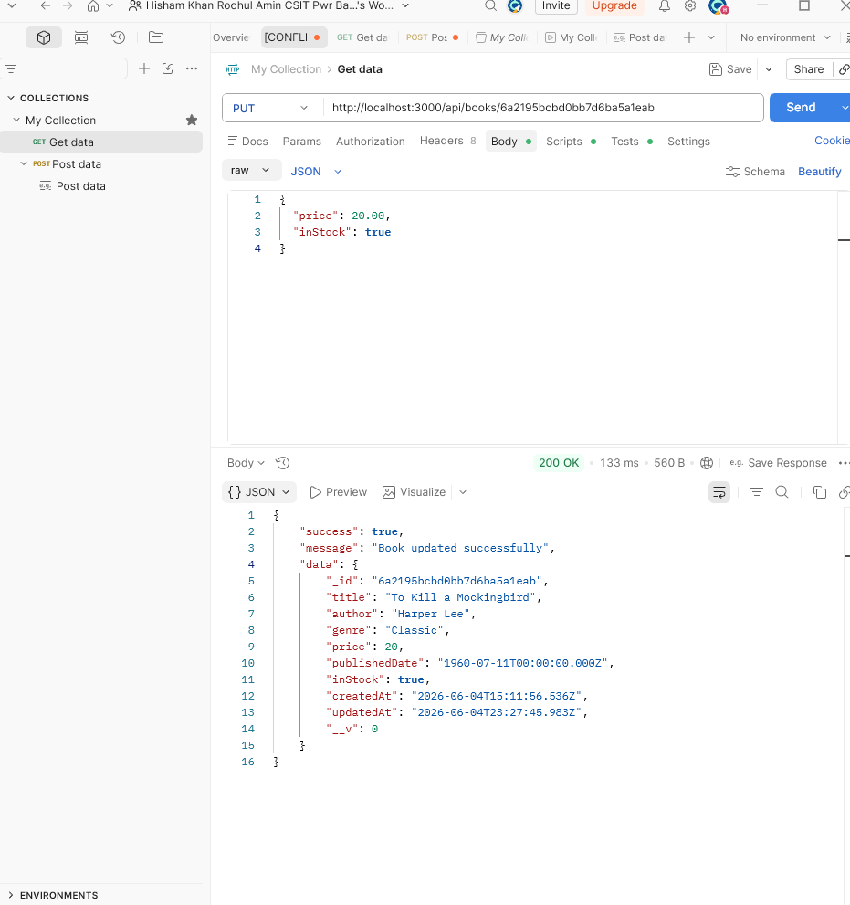

3. DELETE a Book (DELETE)

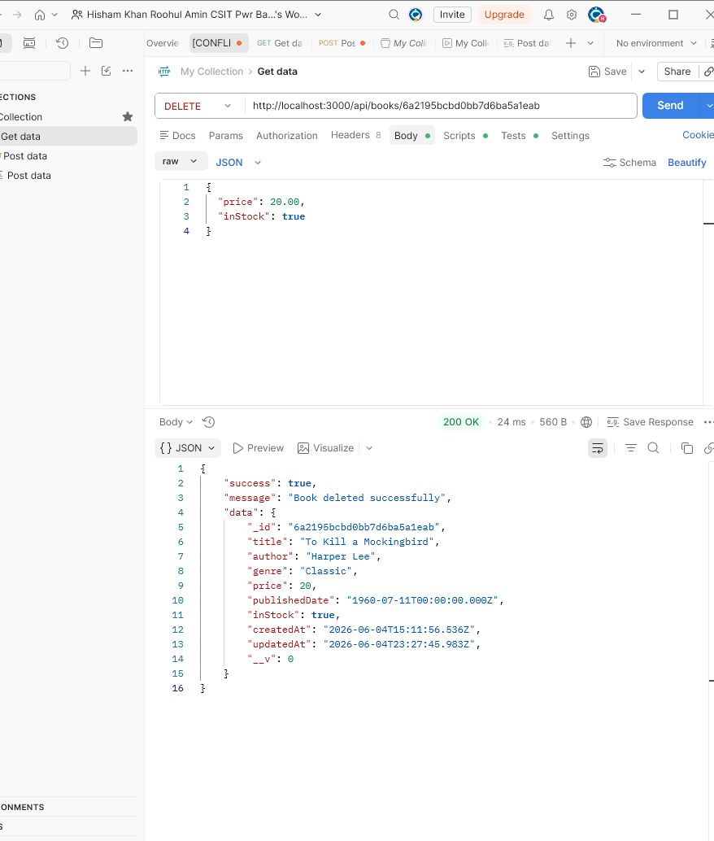

4. SEARCH by Author

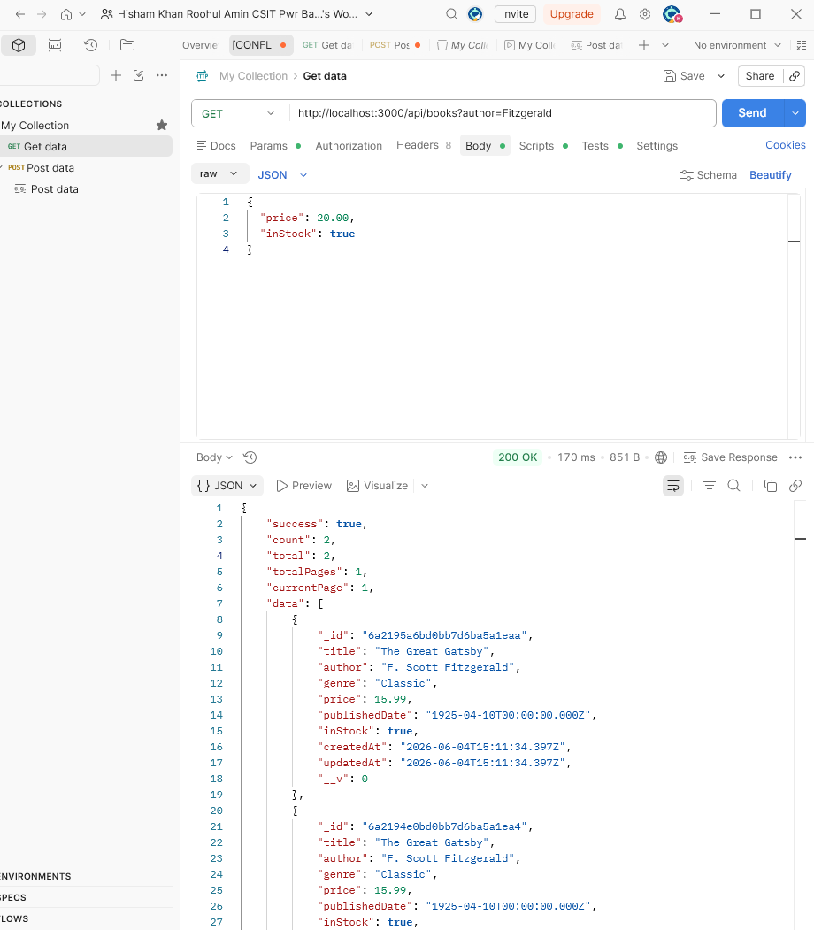

5. SEARCH by Genre

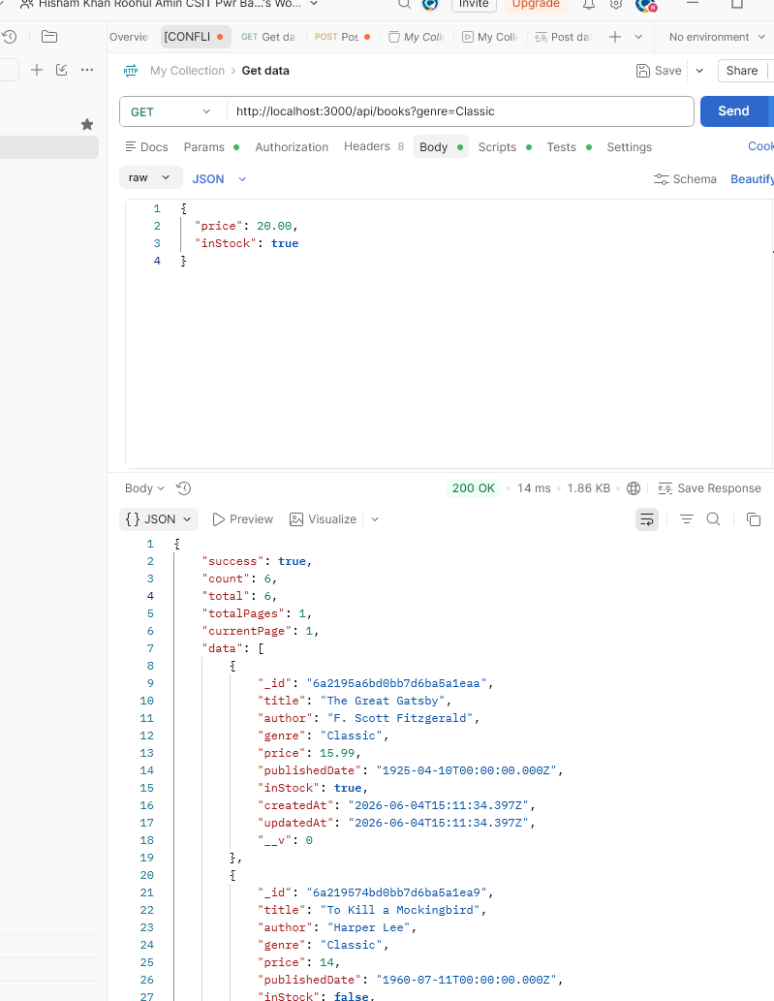

6. PAGINATION

