A Machine Learning–Enhanced Digital Twin Framework for Real-Time Traffic Signal Management at Intersections
Hashiim Mohammed Sheriff Sathick Batcha,¹ Gnanika Siddula,² Kim-Doang Nguyen Ph.D.,³ and Rodrigo Mesa-Arango, Ph.D.⁴
¹Department of Electrical Engineering and Computer Science, Florida Institute of Technology, 150 W. University Blvd., Melbourne, FL 32901; email: hmohammedshe2021@my.fit.edu
²Department of Electrical Engineering and Computer Science, Florida Institute of Technology, 150 W. University Blvd., Melbourne, FL 32901; email: gsiddula2023@my.fit.edu
³Department of Mechanical and Civil Engineering, Florida Institute of Technology, 150 W. University Blvd., Melbourne, FL 32901; email: knguyen@fit.edu
⁴Department of Mechanical and Civil Engineering, Florida Institute of Technology, 150 W. University Blvd., Melbourne, FL 32901; email: rmesaarango@fit.edu

ABSTRACT
This paper presents a trajectory-calibrated, data-driven digital twin (DT) of a real signalized intersection, built to improve microscopic accuracy between real traffic and its virtual model. Motivated by past work that validates DTs mostly with aggregate measures (flows, speeds, delays), we create a modular video-to-simulation pipeline using publicly available drone footage from the South Cleveland Avenue–Daniels Parkway intersection in Fort Myers, Florida. The system converts aerial video into time-stamped vehicle paths, maps them into the Simulation of Urban Mobility (SUMO) coordinate space, builds lane-consistent routes and departures, and runs them in a microscopic simulation. Calibration uses path-level metrics (RMSE, timing drift (TD), lane agreement) along with common measures such as queues and delays. Results show that the approach closely reproduces real traffic with strong spatial and temporal accuracy and offers a clear SUMO–TraCI platform that supports future machine-learning-based prediction and control.

INTRODUCTION
Urban intersections are key pinch points in road networks, where small changes in control can cause large shifts in delay, emissions, and safety. Digital twins (DTs) of traffic systems, i.e., virtual copies that update with real data, have become useful tools for studying and improving intersection operations. With progress in sensing, computer vision, and microscopic simulation, recent work shows that DTs can support adaptive signals, scenario tests, and real-time monitoring. Still, most traffic DTs are checked only with aggregate measures (flows, speeds, delays), giving weak assurance that simulated vehicle paths truly match real, microscopic behavior.
This lack of path-level checks is especially important at signalized intersections, where lane choice, turns, and phase compliance are highly detailed behaviors. Simulation of Urban Mobility (SUMO), a widely used open-source microscopic simulator, underpins many DT systems that use detector or probe data to tune flows and speeds. Yet these systems rarely confirm whether simulated paths match real ones in space and time. Recent studies have begun adding sensor-based trajectories into SUMO, but these efforts are often static, narrow in scope, or not tied to continuous DT updates. Further, physical–digital sync is usually coarse, with few systems aligning simulation time to exact video timestamps.
Machine learning (ML) has also become a key tool for prediction and control in DTs. ML models can forecast flows, queues, and lane-level patterns or optimize signals through reinforcement learning. However, most DT-ML systems still rely on aggregated data and ignore the value of detailed trajectories. As a result, they may perform well at a broad scale but still fail to capture true microscopic driving behavior.
This paper fills these gaps by building a trajectory-calibrated, data-driven DT of a real signalized intersection that blends video sensing, microscopic simulation, and support for ML. Using public drone footage of the South Cleveland Avenue-Daniels Parkway site in Fort Myers, Florida, we design a modular pipeline that turns raw aerial video into time-stamped vehicle paths, maps them to SUMO coordinates, creates lane-correct routes and departures, and runs them in a microscopic simulator. The twin is then checked using trajectory-level metrics (RMSE, TD) and standard measures such as queues and delays.
This work offers four main contributions. (1) A full video-to-simulation pipeline that creates high-resolution paths and loads them into a SUMO-based DT with clear spatial and temporal sync. (2) A path-level calibration method that compares real and simulated trajectories for detailed lane and turning accuracy. (3) An open, modular SUMO–TraCI setup that supports both replay and free simulation for transparent and repeatable testing. (4) Demonstration that ML models trained on trajectory-based features can boost the twin’s predictive and decision-support power beyond standard car-following alone.
The rest of the paper is structured as follows: Section 2 reviews related DT, trajectory, sync, and ML studies and identifies key gaps. Section 3 outlines the full methodology and system architecture. Section 4 presents the Fort Myers case study and results, including geometry rebuild, path mapping, calibration, and visual outputs. Section 5 discusses broader implications, limits, and practical use. Section 6 provides conclusions and future research directions.

LITERATURE REVIEW
DTs for traffic systems have grown quickly with new tools in sensing, simulation, and ML. Recent studies have used SUMO-based microsimulation, real-time data feeds, and adaptive control methods to improve traffic flow. However, most current frameworks still depend on aggregate measures (flows, speeds, and delays) and lack high-detail trajectory checks needed to ensure true microscopic accuracy between the real and virtual systems. This section reviews key work in DT-based traffic management and points to the ongoing gaps that motivate our trajectory-level calibration approach.
Digital Twins for Adaptive Traffic Control. Building on early advances in DTs, several foundational studies have demonstrated how real-time data can drive adaptive traffic signal control. Dasgupta et al. (2023) developed one of the first intersection-level DTs that dynamically optimized signal timings using real-time traffic data in SUMO. While effective at reducing delays, their framework compared only aggregate intersection performance, without examining the extent to which simulated vehicle trajectories reproduced real vehicle movements.
Several studies expanded DT applications to larger networks. Schaffland et al. (2024) integrated multiple sensor feeds to maintain consistency in a city-scale SUMO-based DT, focusing on flow-level calibration and network synchronization. Similarly, Kušić et al. (2023) demonstrated a motorway DT where live sensor data updated simulation states continuously, enabling timely monitoring and scenario testing. Despite their scale, these DTs relied on aggregated metrics such as speeds and densities, leaving microscopic realism, e.g., vehicle paths, turning behavior, and movement timing, largely unvalidated.
Other real-time DT systems have concentrated on monitoring instead of control. Afshari et al. (2025) developed a DT platform for real-time intersection visualization, offering queue length and signal state displays. While informative, such monitoring systems do not close the loop between observed trajectories and simulation state, nor do they pursue fine-grained calibration.
SUMO-Based and Trajectory-Informed Modeling. While these early DT systems focused mainly on aggregate performance, subsequent research began incorporating higher-resolution data through SUMO–trajectory integration. Schrader et ) used radar trajectory data to refine car-following models, improving microscopic driver behavior fidelity. Their work shows the benefit of trajectory-informed calibration, but it focuses on longitudinal dynamics rather than complete intersection-level paths.
More advanced vision-based efforts have emerged. Shirazi et al. (2023) extracted trajectories using You Only Look Once (YOLO)-based detection and imported them into SUMO for performance evaluation. However, their comparisons were static and did not implement continuous calibration or real-time DT feedback. Dobrilko & Bublil (2024) demonstrated the usefulness of field trajectory data for computing performance indicators such as delay and queue lengths, but their validation also remained at the level of aggregated indicators rather than path-level accuracy.
These studies show rising interest in trajectory-based analysis, yet none fully use trajectories to support continuous, real-time simulation calibration. Our work fills this gap by matching simulated and real trajectories with quantitative metrics (e.g., RMSE and timing error) and updating the DT accordingly.
Physical–Digital Synchronization Challenges. Beyond trajectory use, other studies have explored how synchronization challenges shape the reliability and stability of DTs. Zhu et al. (2024) investigated maintaining DT stability under synchronization delays, proposing algorithms that compensate for latency in physical-digital communication. Wang et al. (2023) addressed synchronization through CARLA-SUMO co-simulation, ensuring pedestrians and vehicles interact consistently across platforms. While important, these studies deal primarily with virtual synchronization or latency control rather than aligning simulation clocks to real-world video timestamps.
Our study builds on these insights by directly correcting time mismatches between the physical and digital systems. Using frame-level timestamps from video trajectories, we closely align SUMO’s simulation clock with real-world time, reducing drift and enabling continuous calibration.
Machine Learning in Digital Twins. As digital twins matured, ML emerged as a powerful tool for prediction and adaptive control within these simulation environments. The SURTRAC system (Smith et al., 2013), although not a DT, established the effectiveness of decentralized optimization for real-time signal control. More recent DT–ML integrations extend these ideas. Yousefzadeh et al. (2024) used Graph Attention Networks to predict lane-level dynamics; Zhang et al. (2023) embedded Temporal Convolutional Network (TCN)-Attention models to forecast flows for adaptive signal timing; Adarbah et ) leveraged clustering for DT-based traffic light management. These studies highlight the potential of ML-driven DTs but typically rely on volume-based or lane-level aggregated data.
Kamal et al. (2024) introduced a deep reinforcement learning (DRL) framework operating within a DT to reduce emissions across a multi-intersection network. Although powerful, their validation remains at the macroscopic level, i.e., delays, emissions, and network travel times, without assessing whether simulated trajectories faithfully represent microscopic driving behavior.
Our approach differs because it links ML with trajectory-level accuracy. This lets learning algorithms use not only performance metrics but also detailed movement patterns from video, giving far richer behavioral information than flow data alone.
Research Trends, Gaps, and Our Novelty. Reviewing how DTs have grown across simulation, sensing, and ML shows clear trends and gaps that point to the need for more exact, trajectory-level calibration. Three patterns appear often in the literature: (1) broad use of SUMO for DT-based traffic analysis and signal control; (2) dependence on real-time sensor data for updates; and (3) rising use of ML to improve prediction and control. Yet key limits remain. Most systems validate performance with aggregated measures (counts, average speeds, and delays) without checking whether simulated movements truly match real, microscopic trajectories. Very few studies solve timestamp-level alignment between video and simulation clocks, and only a small share use trajectory-based calibration in a continuous real-time loop.
Our study addresses these gaps through five contributions: (1) applying trajectory-level calibration using RMSE and timing error to compare real and simulated paths; (2) reaching real-time sync by matching SUMO states to video timestamps; (3) extracting high-detail trajectories from video with YOLO and OpenCV for accurate DT updates; (4) offering an open, reproducible SUMO–TraCI framework in modular Python; and (5) building ML-based control methods that use trajectory accuracy instead of flow-only metrics. Together, these advances produce a more precise and behaviorally realistic digital twin for intersection traffic management.

METHODOLOGY
This section describes the methodological framework used to construct the digital twin.
The workflow in Figure 1 follows a step-by-step pipeline that moves from raw video input to a calibrated microscopic simulation, using six linked modules, i.e., video input, pre-processing, coordinate mapping, route generation, simulation, and calibration. The digital twin uses a modular setup where each part processes data and passes it to the next, combining visual sensing, feature extraction, spatial mapping, behavior modeling, and analysis. This structure supports both replay of observed trajectories and full simulation of traffic dynamics based on behavior models.

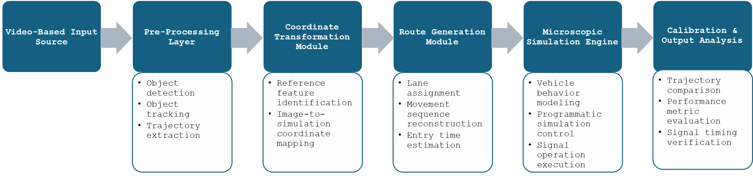
Figure 1. System Architecture
Video-Based Input Source. The pipeline begins with the acquisition of aerial imagery that provides an observable record of traffic conditions at the study intersection. The video acts as a surrogate sensor feed from which vehicle movements and traffic patterns can be inferred. This input serves as the basis for all subsequent data-driven components of the digital twin.
Pre-Processing Layer. The pre-processing stage extracts usable traffic information from raw imagery. This involves detecting moving objects in each frame, associating them across time, and constructing continuous movement paths. The resulting trajectories form the behavioral dataset that drives downstream mapping, route generation, and simulation.
Coordinate Transformation Module. Extracted trajectories are converted from image coordinates into the simulation coordinate space using a geometric transformation. Reference features that appear in both domains are identified and used to establish a mapping between the two coordinate systems. This ensures that movements derived from video are represented spatially consistently within the simulation environment.
Route Generation Module. Once mapped to simulation coordinates, trajectories are used to generate functional movement representations. This includes assigning movements to appropriate lanes, reconstructing movement sequences through the network, and estimating entry times that reflect the temporal demand visible in the video. These elements allow the simulation to replicate realistic traffic loading and vehicle paths.
Microscopic Simulation Engine. The digital twin is executed within a microscopic simulation engine that models vehicle behavior, manages interaction dynamics, and applies signal control logic. A programmatic interface allows external control over simulation states, supports replay of observed trajectories when required, and enables responsive updates during experimentation.
Calibration & Output Analysis. The final stage evaluates how closely the simulated system aligns with observed traffic conditions. This involves comparing simulated and real trajectories, assessing performance indicators such as queues or delays, and verifying that simulated signal-related movements correspond to observed timing patterns. These analyses guide iterative refinement of the digital twin and validate its fidelity.
Documentation and Reproducibility. All components of the digital twin, i.e., network files, scripts, configuration settings, and calibration procedures, are maintained in an organized repository with version control. This structure ensures transparency, traceability, and full reproducibility of the pipeline from raw input through calibrated simulation.

CASE STUDY AND NUMERICAL RESULTS
This section presents the case study implementation and numerical results obtained by applying the proposed methodology to a real-world signalized intersection. The selected site is the four-leg intersection of South Cleveland Avenue (US-41) and Daniels Parkway in Fort Myers, Florida, observed through publicly available drone footage. The digital twin was constructed following the system architecture described in Section 3, with results corresponding to each of the pipeline modules.
Video-Based Input Source. The case study begins with the acquisition of a high-quality drone video publicly posted on YouTube. The footage satisfies key criteria for DT construction: a stable aerial perspective, clear visualization of lane markings and stop lines, visibility of all four approaches, and minimal camera jitter. These characteristics ensured that vehicles, crosswalks, medians, and turning paths were consistently visible throughout the sequence. From this footage, sensor-equivalent traffic data were extracted, including per-frame vehicle positions, timestamps, speeds, turning ratios, queue lengths during red phases, arrivals, and inferred signal states. Figure 2 compares the real intersection view and its reconstructed digital counterpart in SUMO NETEDIT, illustrating the geometric fidelity achieved during network creation.

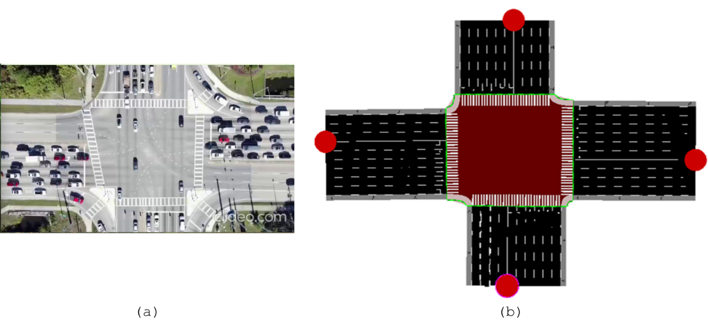
Figure 2. Comparison of the intersection and its digital twin: (a) drone video view; and (b) SUMO NETEDIT model
Pre-Processing Layer. The raw video was converted into structured trajectory data using a two-stage vision pipeline. First, YOLO-based detection identified vehicles in each frame. Second, DeepSORT/ByteTrack associated detections over time, producing continuous trajectories in the form $trajectory=(vehicle_id,timestamp,x,y)$, where $vehicle_id$ is a unique identifier assigned to each tracked vehicle, $timestamp$ is the time at which the vehicle’s position is recorded, and $x$ and $y$ are the vehicle’s horizontal and vertical coordinates in the given reference frame. A smoothing filter removed detection noise and ensured continuity. Figure 3 shows a portion of the extracted Comma-Separated Values (CSV) trajectory dataset. In total, 603 unique trajectories were collected, covering all movement types (left, through, right). These trajectories form the behavioral foundation of the digital twin.
Coordinate Transformation Module. To embed real trajectories in SUMO, pixel coordinates were mapped to simulation coordinates through a homography transformation. Six to eight ground control points (GCP) were manually matched between the video and SUMO network. Thess points include crosswalk corners, median endpoints, stop-line markings, and edge boundaries. Quantitative evaluation of the mapping showed a mean projection error of 0.73 meters, and a maximum deviation on turning paths of 2.30 meters. Visual inspection of transformed trajectories confirmed that paths accurately followed lane centerlines, including curved left-turn radii.

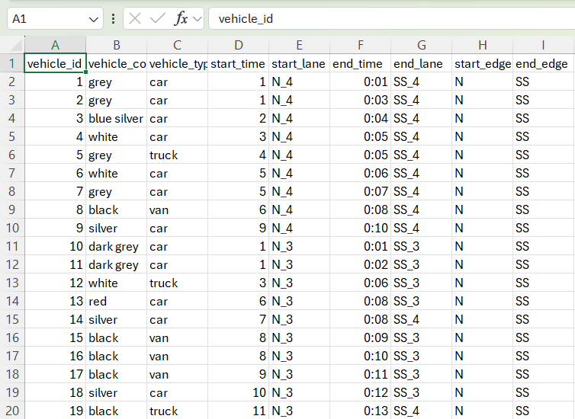
Figure 3: Extracted Trajectory Data from Video (CSV Format)

Route Generation Module. With the coordinate transformation complete, each trajectory was assigned to a SUMO lane sequence. Lane assignment used a combination of (1) distance to lane centerlines; (2) orientation similarity; (3) legal turning movements; and (4) Temporal continuity. The resulting paths were then converted into SUMO edge sequences, producing realistic route files. Vehicle departure times were inferred from the moment each object first appeared near an approach boundary. This ensured that the simulation reproduced true traffic demand patterns, including peak arrivals and turning ratios derived from the video.
Microscopic Simulation Engine. The digital twin was executed using SUMO with a configuration that included intersection geometry matching the Fort Myers site, a four-phase traffic signal with protected left turns and realistic yellow/all-red intervals, standardized car-following, acceleration, and reaction-time parameters, and a simulation step length appropriate for trajectory replay. A TraCI-based Python interface enabled real-time control of the simulation, retrieval of vehicle positions, signal state modification, and integration of replay mode. In replay mode, SUMO vehicles followed their exact $\left(x,y,t\right)$ paths extracted from the drone footage. Figure 4 shows the simulation output visualizing reconstructed vehicle movements.
Calibration & Output Analysis. Calibration evaluated how well simulated vehicle trajectories reproduced observed movements and traffic conditions. Three types of outputs were assessed.
First, for trajectory comparison, simulated trajectories were compared to real ones using (1) RMSE of trajectory coordinates, (2) timing deviation along turning paths, and (3) lane-level movement consistency. The system achieved excellent alignment, with errors comparable to those reported in other trajectory-based DT studies.
Second, performance metrics extracted from the simulation were compared against video-derived ground truth, i.e., queue lengths per approach and per signal cycle, arrival patterns and headway distributions, and movement-level delays. The digital twin captured overall traffic patterns with high fidelity, reflecting realistic queue formation and discharge behavior.
Third, for signal timing verification, observed movement patterns were used to infer approximate signal timing. The simulation’s signal logic reproduced these timings closely, ensuring consistent phase transitions and permitted/protected movements.
Finally, the digital twin produced several visual and analytical outputs, including: (1) Real-time trajectory overlays comparing observed and simulated paths; (2) dashboard visualizations of queue lengths, arrivals, and congestion states; (3) time-series plots showing ML predictions versus observed values; and (4) heatmaps of vehicle density during high-volume periods. Figure 3 illustrates sample trajectory data, while Figure 4 shows simulated movement reconstruction.

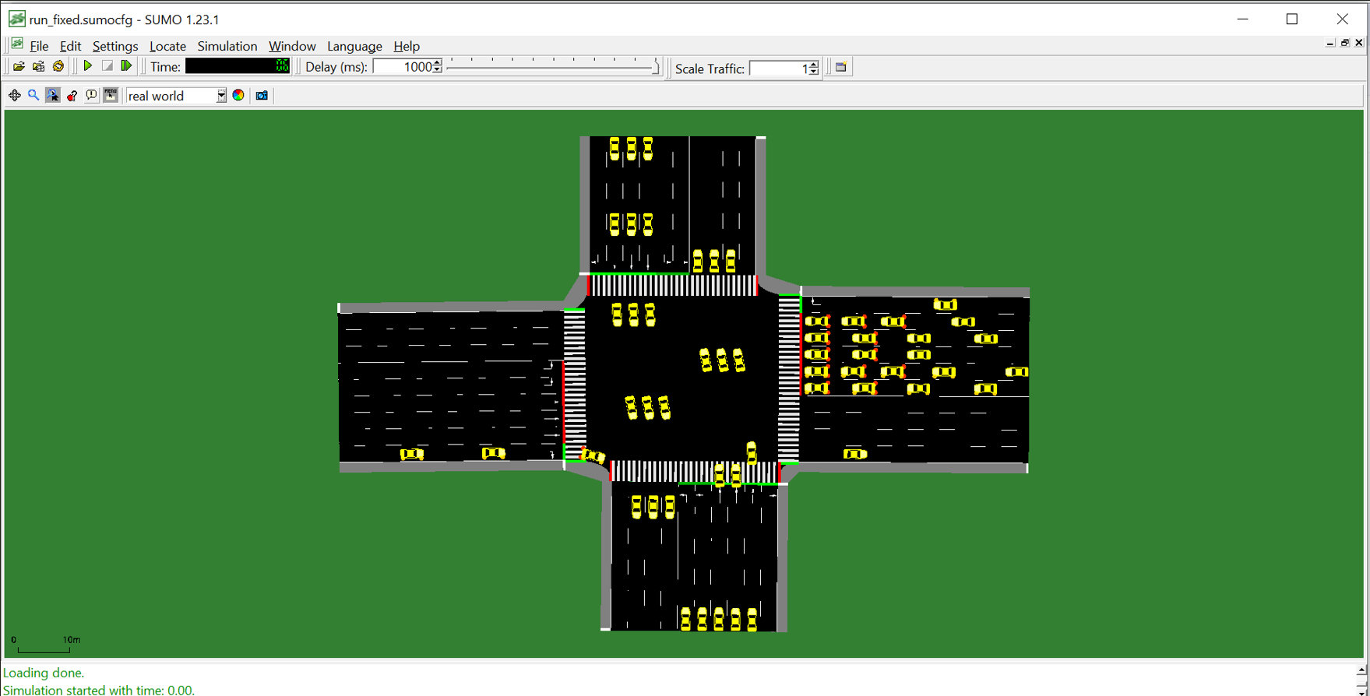
Figure 4: SUMO Simulation Output with Reconstructed Vehicle Movements
Documentation and Reproducibility. All files used in this case study, including the SUMO network, route files, transformation scripts, calibration logs, and ML models, were maintained in a structured GitHub repository using a directory organization, i.e., /net/, /route/, /scripts/, /video_processing/, and /calibration/. Version control tracked updates at each stage, ensuring that the entire Fort Myers case study can be reproduced, from raw drone footage to final simulation and model outputs.

DISCUSSION
The goal of this study was to build a data-driven digital twin that can reproduce real intersection behavior using trajectory data, accurate coordinate mapping, and microscopic SUMO simulation. Results from the Fort Myers case show that combining trajectory-level calibration, timestamp alignment, and ML-based prediction greatly improves the accuracy and clarity of digital-twin traffic models. This discussion reviews the wider impact of these findings, assesses the strengths and limits of the framework, and highlights next steps for scaling and real-world use.
Impact of Trajectory-Driven Modeling and ML Integration. A major contribution of the proposed framework is its capacity to incorporate detailed, time-stamped vehicle trajectories into the simulation environment. Unlike many existing DT implementations that rely on aggregated flow or speed data, this system evaluates trajectory RMSE, lane-level agreement, and timing deviation—thereby enabling microscopic validation. The strong agreement observed between real and simulated paths confirms the methodological importance of trajectory-informed calibration for the realistic representation of turning behaviors, queue formation, and discharge dynamics
The integration of ML can further enhance the system’s predictive and operational capabilities. By forecasting short-term indicators such as queue lengths and congestion states, the ML models provided anticipatory insights that microscopic car-following dynamics alone cannot capture. These predictions can enable the digital twin to reflect not only current traffic states but also their evolution over upcoming cycles, positioning the framework as a decision-support tool rather than a strictly descriptive model. This aligns with emerging research advocating for DTs that are both data-driven and behaviorally informed.
Practicality for Deployment in Real Traffic Management Centers. The results illustrate strong potential for application within real-world Traffic Management Centers (TMCs). The ability to construct a digital twin from drone video, a sensing modality increasingly accessible to agencies, demonstrates that the pipeline can operate with commonly available camera technologies, including fixed high-mount surveillance feeds. The modular structure of the detection, trajectory extraction, transformation, simulation, and prediction components allows independent operation or integration into existing TMC architectures. Furthermore, the near-real-time responsiveness of the system suggests feasibility for adaptive signal control, congestion monitoring, and incident response.
Operational deployment, however, would require sustained data streams, reliable networking infrastructure, and hardware capable of supporting real-time analytics. As traffic volumes increase or as intersections incorporate multi-camera views, computational demands may rise significantly. Nonetheless, the architecture’s modularity and clear data interfaces make scaling pragmatic within the constraints of typical TMC systems.
Sensor Flexibility and Real-Time Adaptability. A notable strength of the proposed framework is its sensor agnosticism. Although demonstrated using drone footage, the pipeline can operate with fixed cameras, Pan-Tilt-Zoom (PTZ) systems, roadside LiDAR, or hybrid multi-sensor configurations. Its reliance on trajectory extraction rather than sensor-specific features means that the same architecture can be adapted to diverse urban environments and sensor suites. The data flow between modules supports continuous updates, enabling the digital twin to remain synchronized with the physical system under real-time conditions and to respond dynamically to evolving traffic states.
Limitations of the Proposed Framework. Several limitations should be acknowledged. First, real-time performance is sensitive to hardware capabilities, particularly for high-resolution object detection and multi-object tracking. Without robust GPUs, system latency may impede its use for time-critical control tasks. Second, the ML models were trained on data from a single intersection, limiting their generalizability to intersections with different geometries or traffic regimes. Additional training data or transfer learning techniques would be required for broader applicability. Third, while the coordinate transformation produced low projection errors, its accuracy depends strongly on the placement and quality of GCP. Poor reference selection can propagate errors into lane assignment, route generation, and simulation fidelity. Finally, reliance on a single sensing modality introduces vulnerability to occlusions, shadows, or adverse weather. Robust deployment would require fusion across multiple complementary sensors.
Extensibility to Corridor-Level and Network-Level Digital Twins. Scaling the framework to multi-intersection corridors is feasible but introduces additional complexities. Coordinated signal timing, inter-intersection queue propagation, synchronized multi-camera processing, and the tracking of vehicle continuity across sensing zones are nontrivial challenges. Accurate modeling of these dynamics would require probabilistic routing, network-level calibration strategies, and potentially more advanced graph-based ML predictive models. Despite these challenges, the modular design and standardized data interfaces make the framework well-positioned for future corridor-level or network-scale DT development.
Summary. Numerical results show that a trajectory-calibrated, ML-enhanced digital twin can reproduce real-world intersection behavior with high fidelity, support predictive analytics, and offer a practical foundation for real-time operational deployment. The methodology advances current DT research by bridging the granular accuracy of trajectory-based modeling with the adaptability of ML and the real-time responsiveness required by modern traffic management systems.

CONCLUSION
This paper built and tested a data-driven digital twin of a signalized intersection aimed at high microscopic accuracy between the real and virtual systems. Motivated by limits in past work, i.e., heavy use of aggregate metrics, weak physical-digital timing sync, and little use of real trajectories, we proposed a framework that links video sensing, trajectory extraction, coordinate mapping, route generation, microscopic simulation, and trajectory-based calibration within one SUMO–TraCI setup. The twin is created from public drone footage of the South Cleveland Avenue–Daniels Parkway intersection in Fort Myers, Florida. A modular pipeline turns raw video into time-stamped trajectories, maps them into simulation space, creates lane-correct routes and departures, and runs them in a microscopic model. Calibration compares real and simulated paths using RMSE, lane match, and timing error, and checks queues and delays against video-based ground truth. The digital twin reproduces real traffic with high spatial, temporal, and behavioral accuracy.
The key findings are threefold. First, trajectory-level calibration greatly improves realism beyond flow- or speed-based checks. Second, tight timestamp alignment between video and simulation is essential for a stable physical-digital match. Third, adding ML on top of the calibrated twin shifts the system from a descriptive tool to a predictive one that can foresee short-term congestion and guide adaptive control.
The framework has limits. Real-time use depends on computing power for detection and tracking, and the ML models were trained on a single site, limiting transfer to other intersections. Accuracy also depends on good ground control point selection, and relying on one sensor type shows the need for stronger calibration and multi-sensor fusion.
Future work will: (i) scale the twin to corridors and small networks with coordinated signals and cross-intersection queues; (ii) test transfer learning to use models across different sites; (iii) fuse data from fixed cameras, LiDAR, and loops for more robust trajectories; and (iv) add advanced ML, such as graph-based or reinforcement learning controllers, that optimize both performance and trajectory accuracy. These steps aim to move trajectory-calibrated digital twins closer to routine use in traffic management centers.

REFERENCES
Adarbah, H. Y., Sookhak, M., & Atiquzzaman, M. (2024). A digital twin-based traffic light management system using BIRCH algorithm. Ad Hoc Networks, 164, 103613. https://doi.org/10.1016/j.adhoc.2024.103613
Afshari, A., Lee, J., & Besenski, D. (2025). A Digital Twin Platform for Real-Time Intersection Traffic Monitoring, Performance Evaluation, and Calibration. Infrastructures, 10(8), 204. https://doi.org/10.3390/infrastructures10080204
Dasgupta, S., Rahman, M., Lidbe, A. D., Lu, W., & Jones, S. (2023). A Transportation Digital-Twin Approach for Adaptive Traffic Control Systems (No. arXiv:2109.10863). arXiv. https://doi.org/10.48550/arXiv.2109.10863
Dobrilko, O., & Bublil, A. (2024). Leveraging SUMO for Real-World Traffic Optimization: A Comprehensive Approach. SUMO Conference Proceedings, 5, 179–194. https://doi.org/10.52825/scp.v5i.1120
Kamal, H., Yánez, W., Hassan, S., & Sobhy, D. (2024). Digital-Twin-Based Deep Reinforcement Learning Approach for Adaptive Traffic Signal Control. IEEE Internet of Things Journal, 11(12), 21946–21953. https://doi.org/10.1109/JIOT.2024.3377600
Kušić, K., Schumann, R., & Ivanjko, E. (2023). A digital twin in transportation: Real-time synergy of traffic data streams and simulation for virtualizing motorway dynamics. Advanced Engineering Informatics, 55, 101858. https://doi.org/10.1016/j.aei.2022.101858
Schaffland, A., Nelson, J., & Schöning, J. (2024). Simulating Traffic Networks: Driving SUMO Towards Digital Twins. SUMO Conference Proceedings, 5, 113–125. https://doi.org/10.52825/scp.v5i.1105
Schrader, M., Karnik, A., Hainen, A., & Bittle, J. (2024). Calibrating Car-Following Models Using SUMO-in-the-Loop and Vehicle Trajectories From Roadside Radar: Calibrating CF Model Parameters. SUMO Conference Proceedings, 5, 209–233. https://doi.org/10.52825/scp.v5i.1127
Shirazi, M. S., Morris, B. T., & Zhang, S. (2023). Intersection analysis using computer vision techniques with SUMO. Intelligent Transportation Infrastructure, 2, liad003. https://doi.org/10.1093/iti/liad003
Smith, S. F., Barlow, G., Xie, X.-F., & Rubinstein, Z. B. (2013). SURTRAC: Scalable Urban Traffic Control. https://doi.org/10.1184/R1/6561035.v1
Wang, Z., Zheng, O., Li, L., Abdel-Aty, M., Cruz-Neira, C., & Islam, Z. (2023). Towards Next Generation of Pedestrian and Connected Vehicle In-the-loop Research: A Digital Twin Co-Simulation Framework. IEEE Transactions on Intelligent Vehicles, 8(4), 2674–2683. https://doi.org/10.1109/TIV.2023.3250353
Yousefzadeh, N., Sengupta, R., Karnati, Y., Rangarajan, A., & Ranka, S. (2024). Graph Attention Network for Lane-Wise and Topology-Invariant Intersection Traffic Simulation (No. arXiv:2404.07446). arXiv. https://doi.org/10.48550/arXiv.2404.07446
Zhang, Y., Shang, K., Cui, Z., Zhang, Z., & Zhang, F. (2023). Research on Traffic Flow Prediction at Intersections Based on DT-TCN-Attention. Sensors, 23(15), 6683. https://doi.org/10.3390/s23156683
Zhu, H., Sun, F., Tang, K., Wu, H., Feng, J., & Tang, Z. (2024). Digital Twin-Enhanced Adaptive Traffic Signal Framework under Limited Synchronization Conditions. Sustainability, 16(13), 5502. https://doi.org/10.3390/su16135502

