**Windows Troubleshoot**

Issue:

Upon Accessing the url <http://localhost> we observer 503 issue.

We identified the issue with Application pool service and its not in started state and its identity were not enabled state.

We made following changes

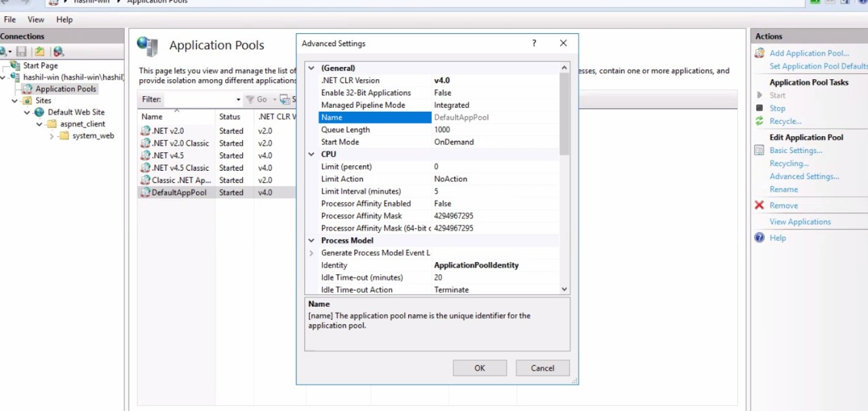

Made the identity as Application pool identity