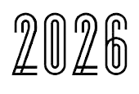

User Guide

Cyber Security API
Intelligence Dashboard

Certificate Of Completion the Project

Under the Super Vision of : Sir Muhammad Ikram Saeed

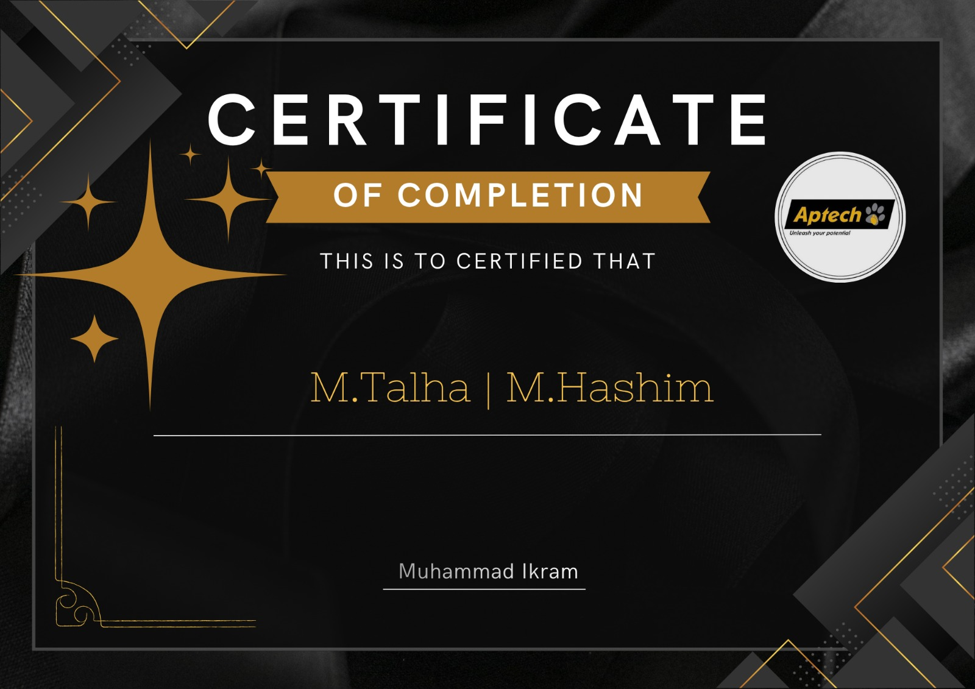

Team Members
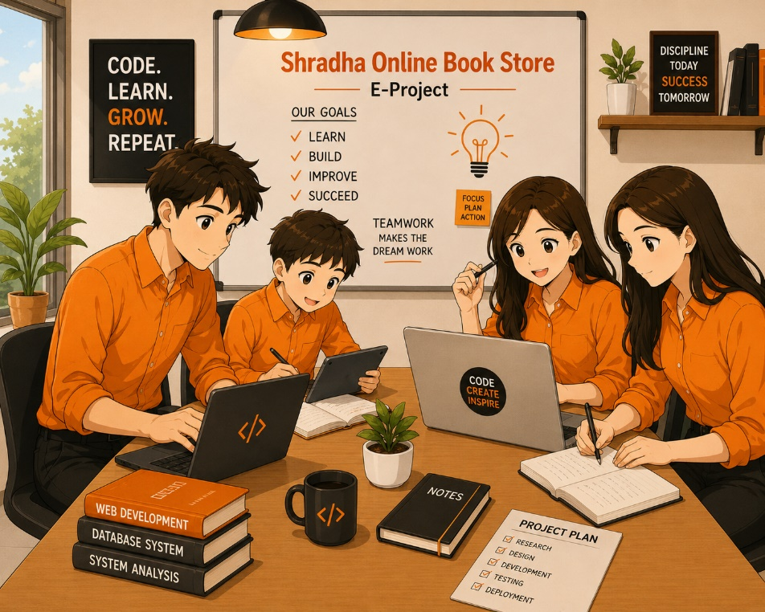

STUDENT IDs | STUDENT NAMES
Student1717275 | Muhammad Hashim
Student1717277 | Muhammad Talha

Landing Page
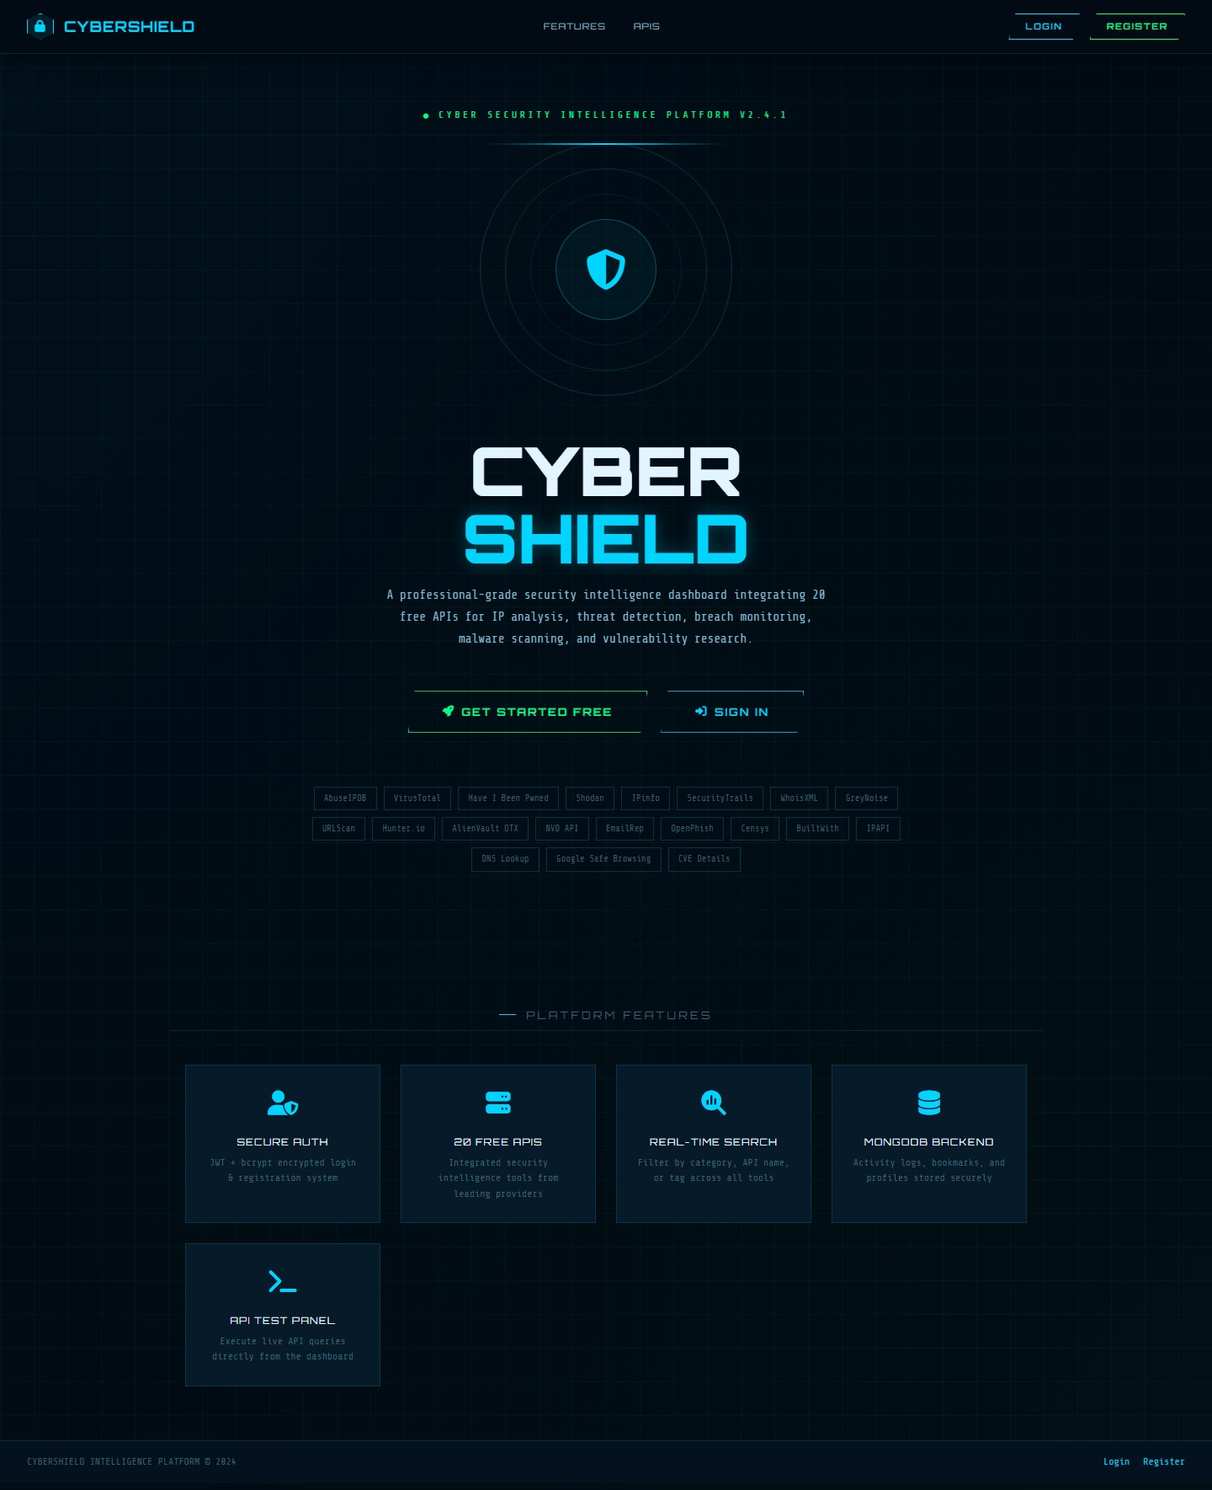

User Register Page
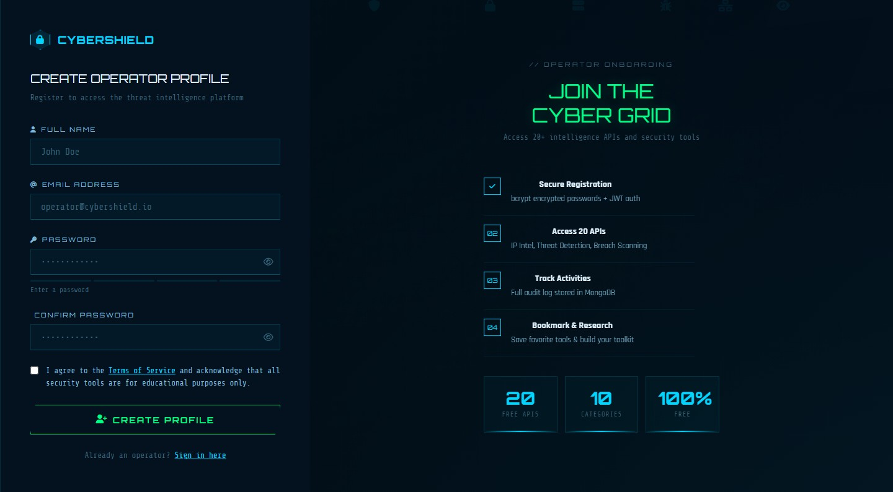
User Login Page 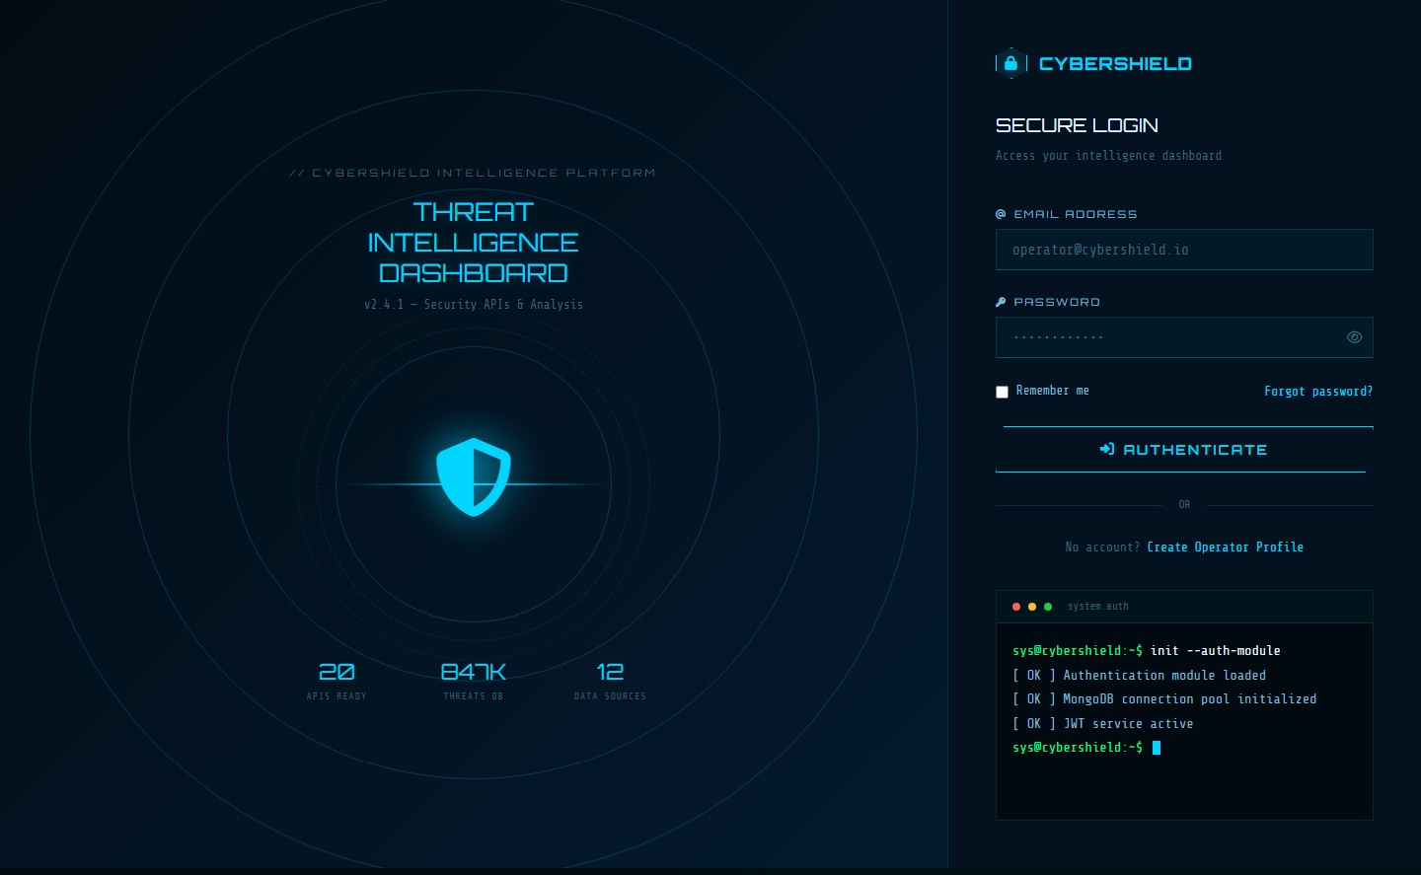

Dashboard
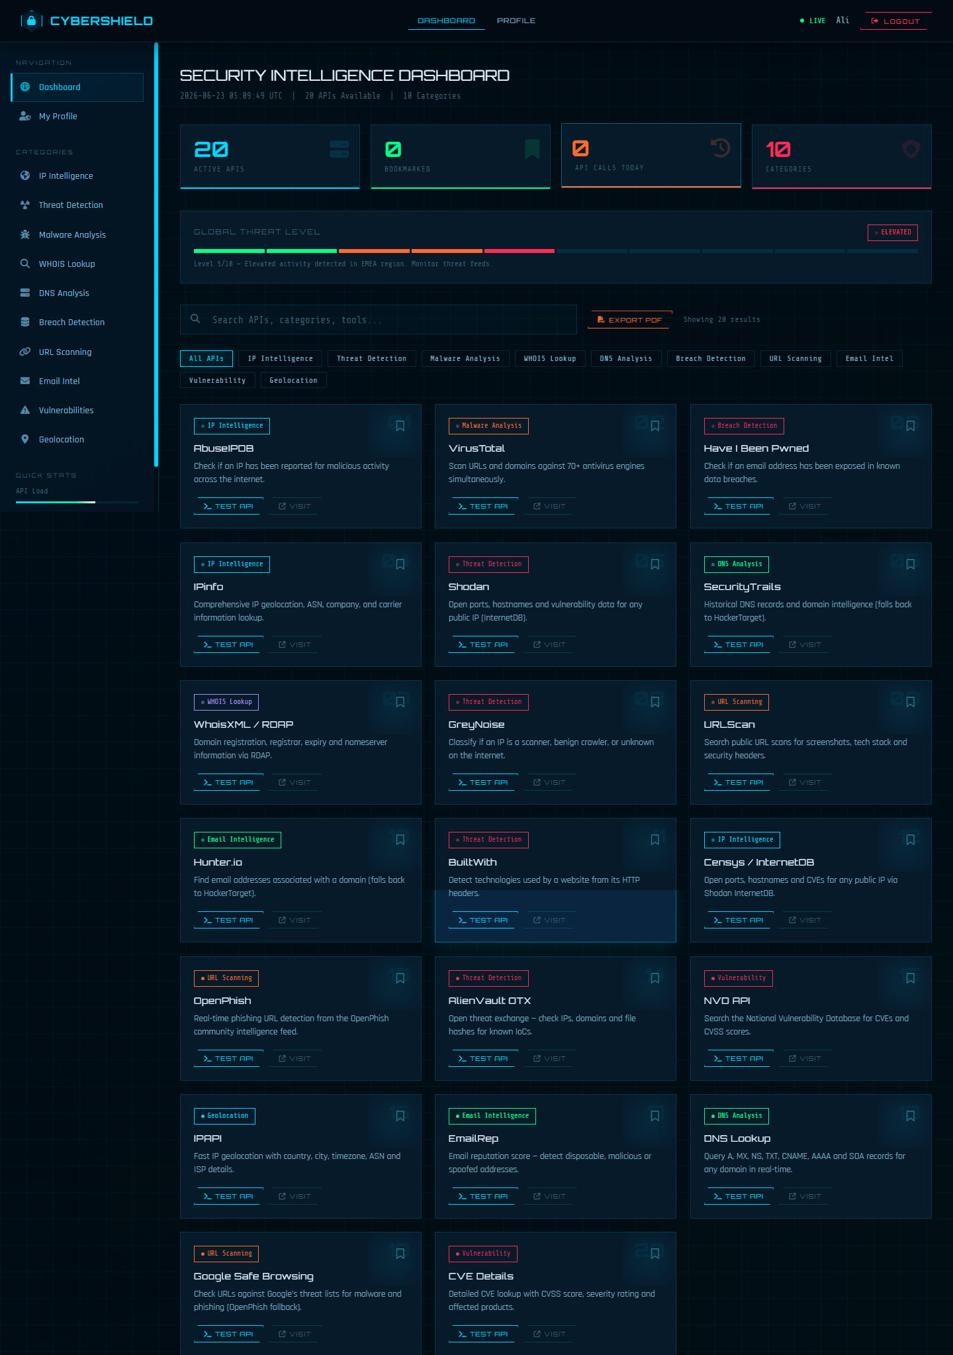
Profile Page
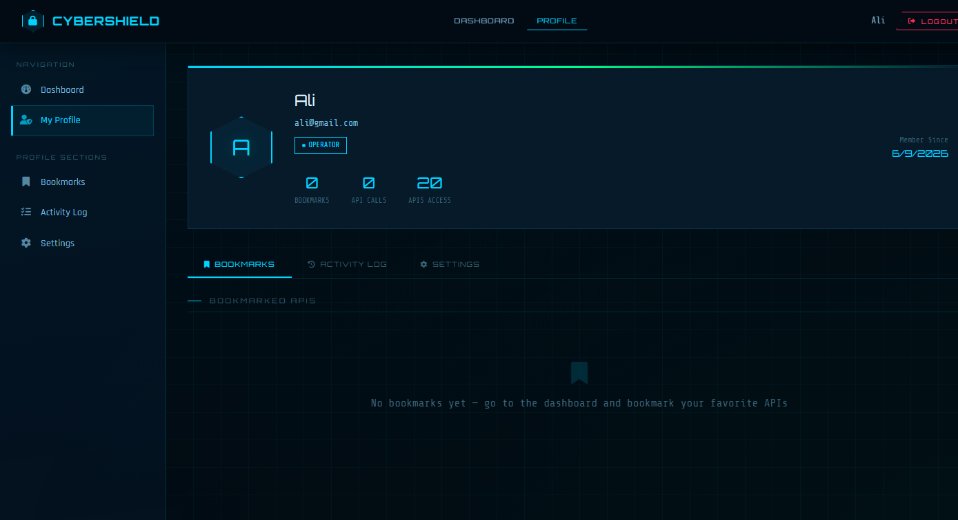
Users Chatbot
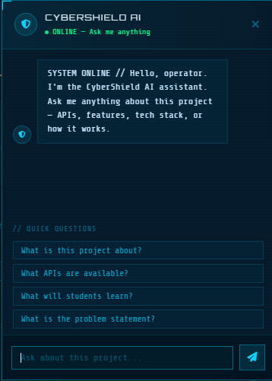

Thank You!

