**DEVOPS FINAL PROJECT**

**Muhammad Hashim Awan 22i-0976**

**Muhammad Taha 22i-0870**

**Tauha Imran 22i-1239**

**Github Repo Link : https://github.com/hashimaawan/DevOps_SentimentalModel_Deploy**

**Project Overview**

We created Sentiment Analysis that enables users to analyze the sentiment (positive, negative, neutral) of input text. It uses a FastAPI backend for text processing and a React frontend for user interaction. The system is fully containerized using Docker and orchestrated via Docker Compose, and then Kubernetes and so on, allowing for seamless deployment and scalability.

**Application**

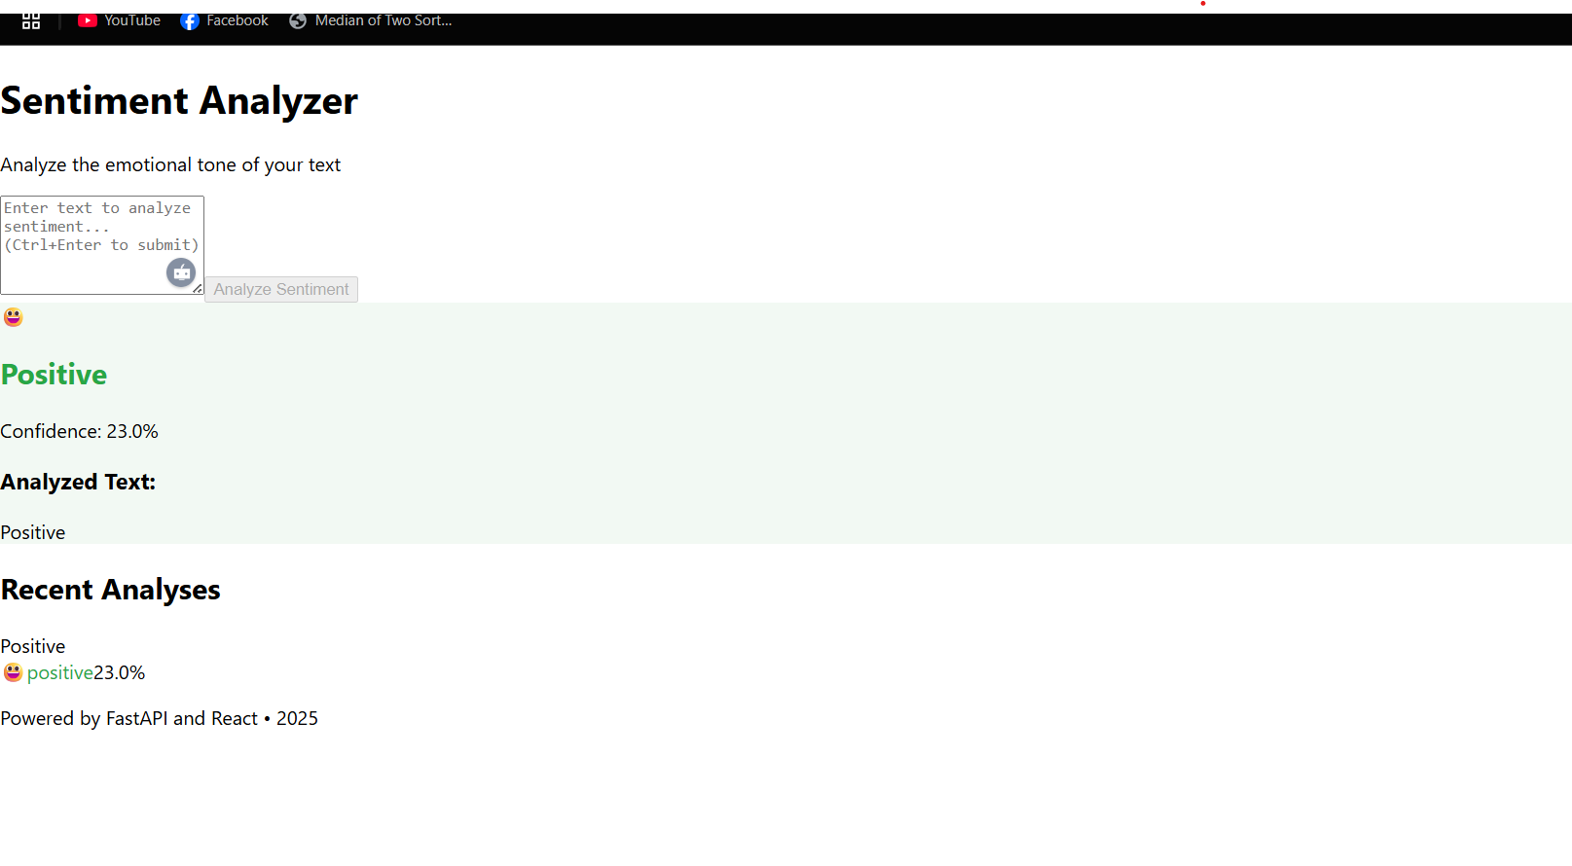

**Docker**

**Github Actions**

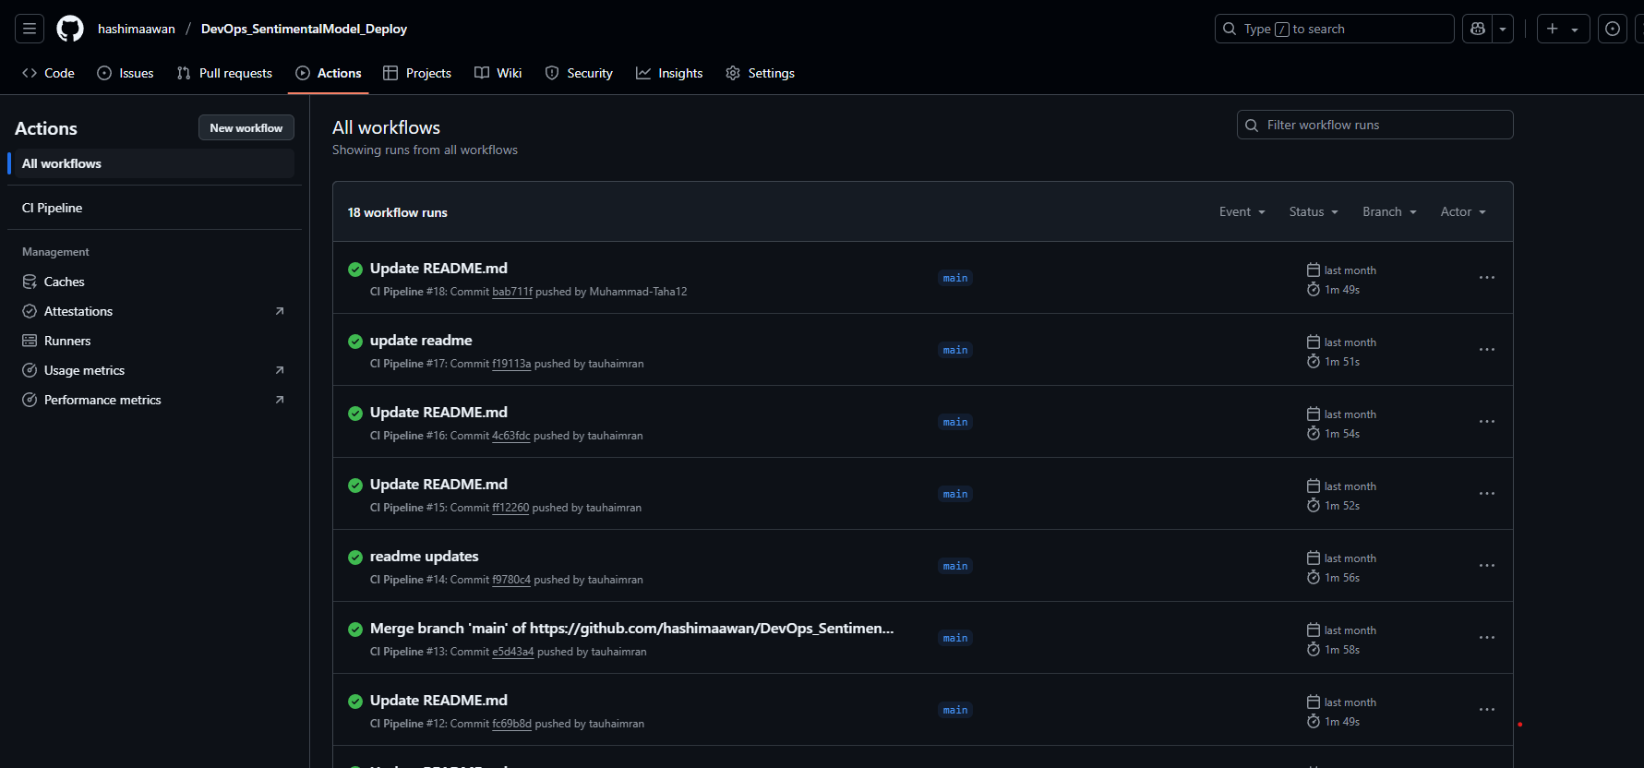

**Kubernetes**

**Cluster setup MiniKube**

**Build docker image in minikube**

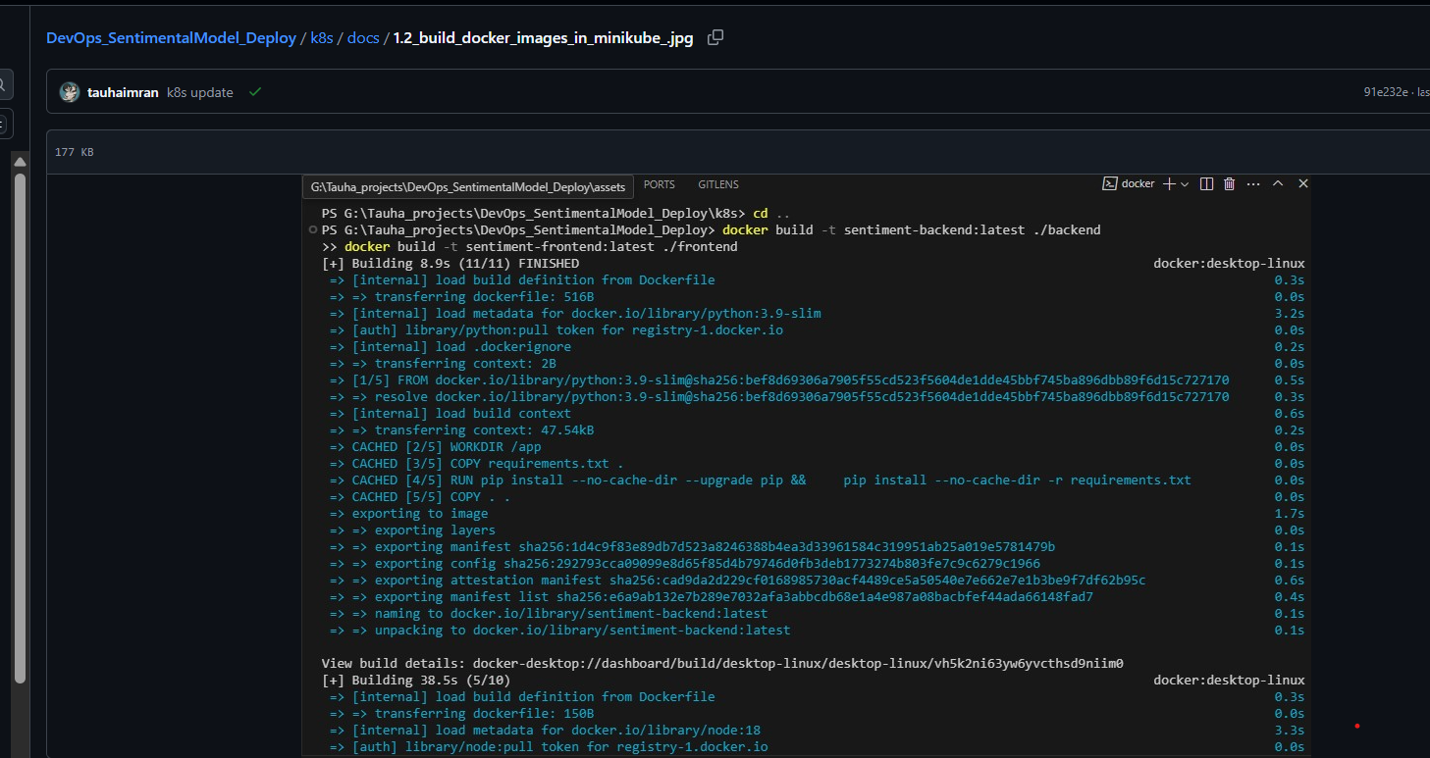

**ARGOCD**

**ArgocdCLI**

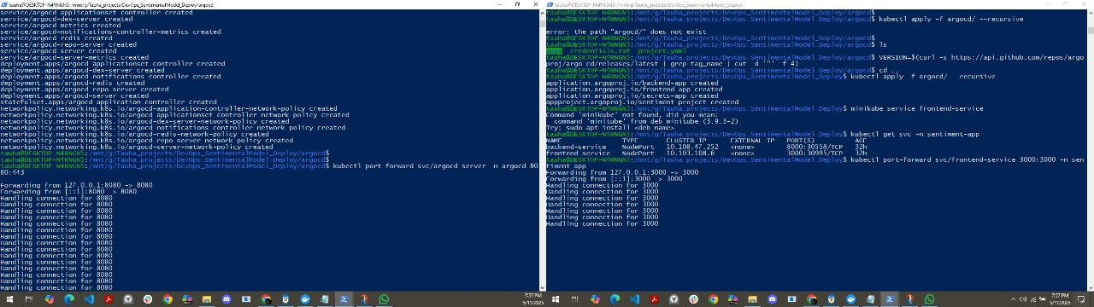

**ArgoCD UI**

