Contents
Task 1: Ontology and Architecture
Task 2: Semantic Model Design
Task 3: DAX Business Logic
Task 4: OLAP Operations (Modern MOLAP)
Task 5: Reflection
References

Task 1: Ontology and Architecture

1.1 The Software Components and Their Roles
Building an SSAS Tabular solution is a process involving several software components, each of which performs a specific function at a particular stage in the entire system. It is just as important to know when and how to use each component as it is to know how to operate them. This section provides general information on each component and its role within the overall BI architecture.

Visual Studio with SSDT (SQL Server Data Tools)
Microsoft's Visual Studio serves as the development and design-time environment for building the tabular data model. This is where the designer adds tables to the model, connects related tables together, builds hierarchies in the data and enters formulas using DAX. Everything the developer does within Visual Studio remains completely separate from what business users see until the designer publishes the model to the server. Therefore, developers make all their design decisions about how they want to present their data to the end-users in Visual Studio. The term "workshop" is an appropriate way to think of this tool because everything is developed and tested prior to deployment to end-users.

The SSAS Tabular Instance
SQL Server Analysis Services, which runs in tabular mode, is what actually runs your model once you have deployed it. When the model is up and running, SSAS uses a compressed columnar data format known as VertiPaq in memory to store your data. This allows it to respond very quickly to questions being asked by tools such as Excel and Power BI, even when there are many records involved. As Sheldon (2013) describes, Tabular models combine the features of relational databases and SSAS multidimensional cubes. Just like a database they support tables and relationships, but just like a cube, they also support KPIs and measures.

The Workspace Database
When you are developing using Visual Studio, it will generate an interim temporary version of your model on the SSAS server, known as the workspace database. This interim version is created so that developers can see how their changes affect the performance of their models before making them permanent by deploying the updated model. Essentially, this provides developers with a scratch area to perform their work, the workspace database reflects all changes made in the design environment as soon as possible.

The Deployed Tabular Database
The deployed database is the production model used by all business users who use either Excel or Power BI for their reporting. To deploy the model means to transfer the entire model's structure from Visual Studio into the SSAS server. The data is then processed and loaded into the structure that was just transferred. As noted by Microsoft (2025a), deployment and processing are two distinct processes, and both need to complete successfully before users will be able to access the information contained within the model.

SQL Server Management Studio (SSMS)
The main purpose of SSMS is as a query and administrative tool. The administrator will use this tool to connect to their deployed SSAS, trigger data processing, execute DAX queries, and monitor the overall health of the database. It should be noted that structural changes to the model, adding tables, changing how related tables are connected, or creating new measures, cannot be made within SSMS. All structural changes must first be made via Visual Studio before they can be redeployed. As Sheldon (2013) observes, SSMS offers only a limited view of the Tabular model compared to the design environment, but it remains essential for day-to-day administration.

Excel and Power BI (Client Tools)
Excel and Power BI are the direct interaction points for business end-users. They connect to the deployed Tabular database by consuming the measures, hierarchies and dimensions created by the developer. The semantic layer converts the technical data structure of the database into business-friendly field names and pre-defined calculations, so that users can create reports and PivotTables without needing to know anything about the underlying system (Kimball and Ross, 2013).

1.2 Key Distinctions

Deployment vs Processing
Deployment moves the model's schema (tables, columns, foreign key constraints, measure definitions, hierarchies) from a Visual Studio environment to an SSAS server environment. Processing then populates that schema with data from the source system. A model may be successfully deployed without containing any data, and likewise it can be successfully reprocessed to update data without changing its structure. Both steps must be completed before users can meaningfully query the model.

System of Record vs Analytical Storage
An operational system of record (represented by the Northwind transactional database) has been developed for operational processes. It is able to process individual transactions quickly while maintaining high levels of data integrity and providing good write performance. An analytical store, as illustrated by the NorthwindDM Data Mart and the SSAS Tabular model built on top of it, serves an entirely separate purpose: fast aggregations and queries across large amounts of historical data. The Data Mart serves as the link between the two, converting the operational data into an appropriate format for analysis (Kimball and Ross, 2013).

Design-Time vs Run-Time
Design-time is the process of working within Visual Studio prior to deploying the model, defining relationships, developing DAX formulas for measures, and establishing hierarchies. Run-time covers everything that happens once the model has been deployed to the SSAS server and is responding to end-user queries. Any changes implemented during design-time will be invisible to users until those changes have been formally published. Users can apply dynamic filter conditions in a PivotTable, which will then conditionally alter the evaluation of DAX measures at run-time with no further action required from the developer (Microsoft, 2025b).

Task 2: Semantic Model Design

2.1 Creating the NorthwindDM Data Mart
The NorthwindDM Data Mart was built in SQL Server through execution of two SQL scripts. The first script generated the DateDimension table and populated it with over 24,700 rows spanning 70 years, from January 1960 to December 2030, and included numerous fields such as Day, Month, Quarter, Year, Week Number, Day of Week, and public holiday indicators for both US and Scottish holidays. The second script used the Northwind OLTP database as its source to generate four dimension tables and one fact table. After creating the tables, each date value was incremented by twenty years to bring them into a more current time frame, and the DateDimension primary key was also modified from DATE to DATETIME so that it could serve as a valid foreign key reference in the relationship with the fact table.
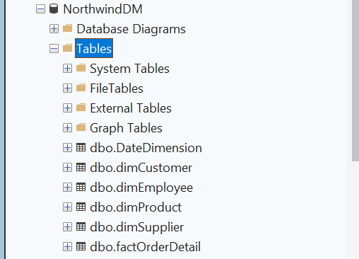
Figure 1: NorthwindDM database in SSMS showing all 6 tables: DateDimension, dimCustomer, dimEmployee, dimProduct, dimSupplier, and factOrderDetail

2.2 Creating the SSAS Tabular Project
The SSAS Tabular project was created using the Analysis Services Tabular Project template within Visual Studio 2022. Integrated Workspace Mode was selected as it allows the model to be designed and tested without having to set up a separate workspace server, this is particularly useful during local development as everything can be accomplished from one machine. Prior to creating the project, the Analysis Services Projects extension was downloaded through the Visual Studio Extensions menu.

2.3 Importing Tables from NorthwindDM
All six tables were imported from the NorthwindDM data source using the Table Import Wizard. The server name used was HASHIMDELL and the database was NorthwindDM. All six tables, DateDimension, dimCustomer, dimEmployee, dimProduct, dimSupplier, and factOrderDetail, were selected and imported successfully.
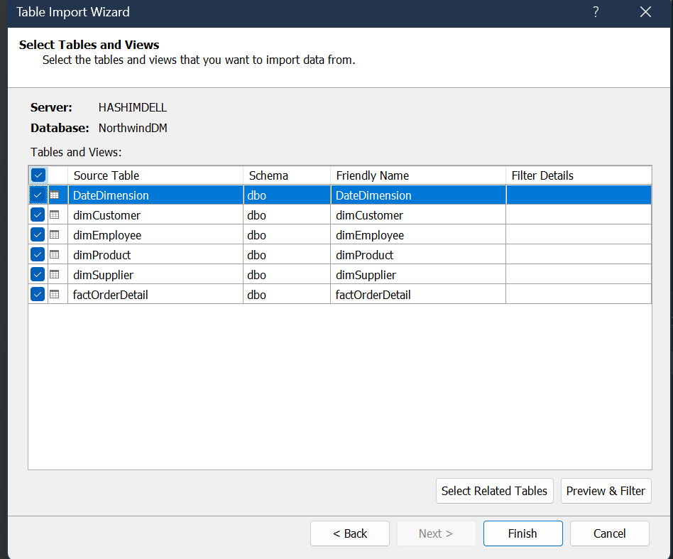
Figure 2: Table Import Wizard showing all 6 tables selected from NorthwindDM
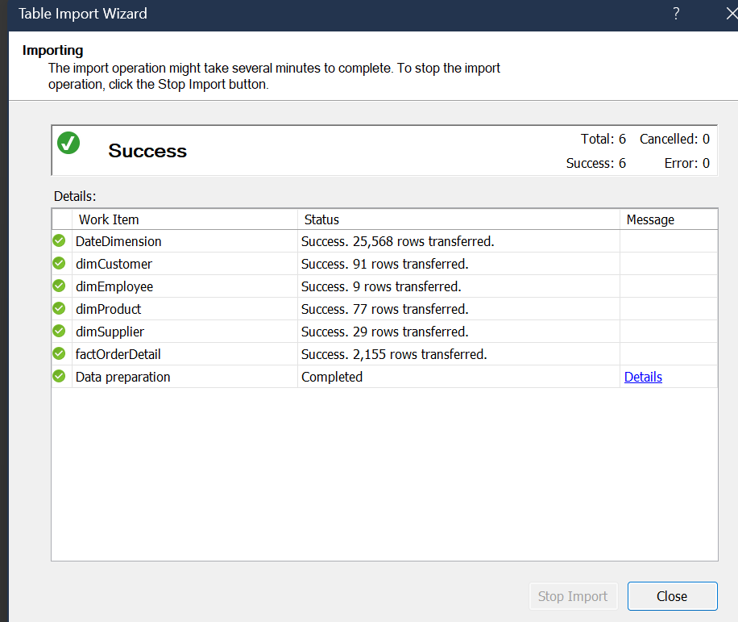
Figure 3: Successful import confirmation, showing all 6 tables loaded with over 28,000 rows combined

2.4 Star Schema and Relationships
The data model is an example of a typical star schema with the fact table factOrderDetail at the centre. The fact table was related to all four dimension tables through their respective foreign keys. The DateDimension table is related to the fact table three different ways (to OrderDate, RequiredDate, and ShippedDate) with both active and inactive relationships used together. Only the OrderDate relationship is set as active because SSAS Tabular only allows one active relationship between any two tables at a time. The RequiredDate and ShippedDate relationships would need to be activated via the USERELATIONSHIP DAX function if a measure needs to filter on those date columns specifically.
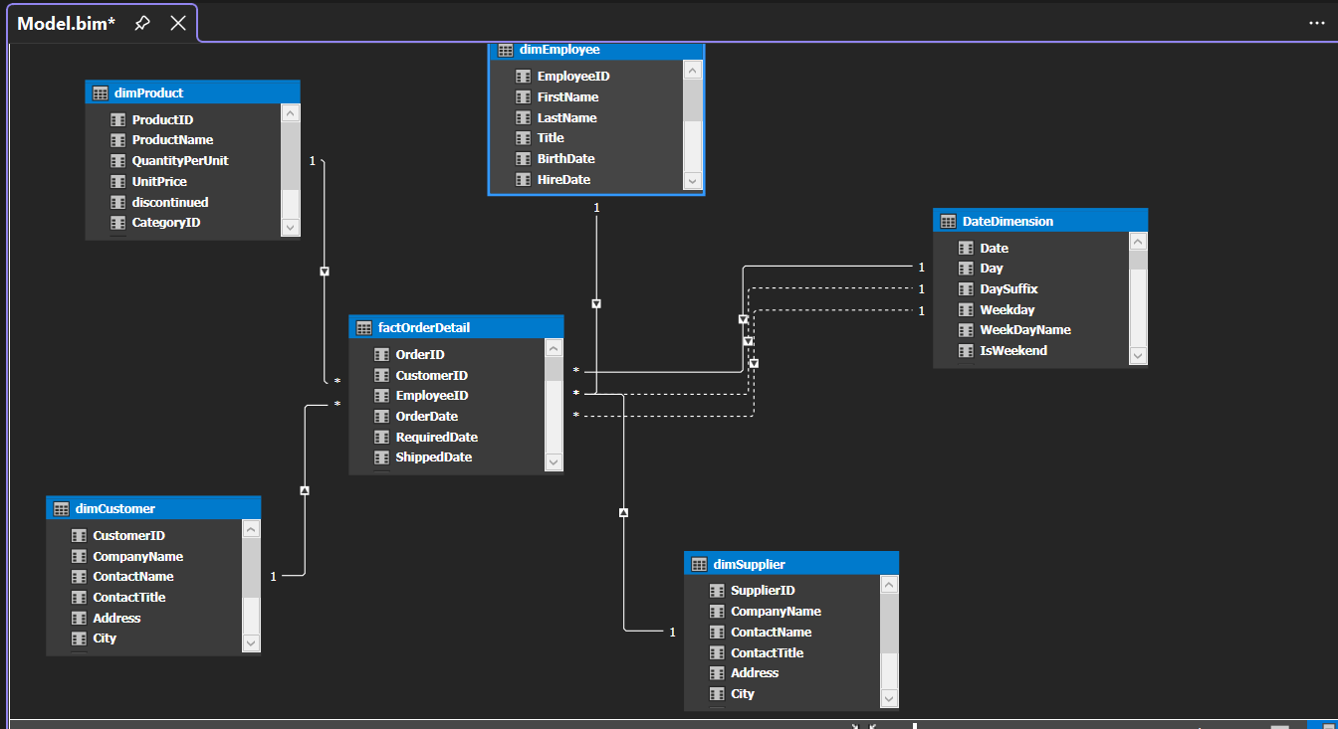
Figure 4: Diagram view showing the star schema, factOrderDetail at the centre connected to all five dimension tables

2.5 Date Table and Hierarchies
The DateDimension table was marked as the Date table within the model, with the Date column defined as the primary date key. This designation is required for DAX time intelligence functions such as TOTALYTD and SAMEPERIODLASTYEAR to work correctly. Following that, two hierarchies were created to allow for logical drill-down capabilities in both Excel and Power BI.
The Date Hierarchy was built into the DateDimension table with three levels (Year, Quarter, and Month) allowing users to view time-based information at different levels of granularity without needing to know what is inside the various columns. The Product Hierarchy was built into the dimProduct table as a two-level structure (CategoryName and ProductName) allowing users to move from broad product categories down to specific individual products.
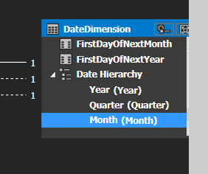
Figure 5: Date Hierarchy in DateDimension showing Year, Quarter and Month levels
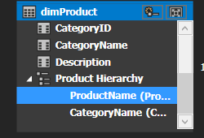
Figure 6: Product Hierarchy in dimProduct showing CategoryName and ProductName levels

Task 3: DAX Business Logic
Four DAX measures were created for the factOrderDetail table. The key characteristic of DAX measures is that they are dynamic, their results change automatically depending upon the filters applied by the user at run-time through either Excel or Power BI (Microsoft, 2025b). This is what makes them so powerful: a single measure definition can handle every possible filter combination without the developer needing to anticipate or hard-code any of those combinations in advance.

Measure 1: Units Sold
Units Sold := SUM(factOrderDetail[Quantity])
The Units Sold measure sums the total number of items purchased across every line item on every customer order. It is the most basic volume measurement and is used by managers to understand how many products were sold, as opposed to how much money was made. Simple to create, this measure is very useful as a baseline against which other performance measures can be compared. If a manager filters the report to a specific product category or time period, Units Sold adjusts automatically to reflect only what was sold within that selection.

Measure 2: Net Sales
Net Sales := SUMX(factOrderDetail, factOrderDetail[Quantity] * factOrderDetail[UnitPrice] * (1 - factOrderDetail[Discount]))
Net Sales determines the actual revenue generated once all discounts have been subtracted. The reason SUMX is used here rather than a simple SUM is important, SUMX performs the calculation row by row across the fact table before summing the results. This is essential because the discount varies per transaction, and a simple SUM would give the wrong result. In essence, this formula gives managers the amount of money the company actually made after all price reductions, which provides a much more accurate representation of real revenue than gross sales figures.

Measure 3: Order Count
Order Count := DISTINCTCOUNT(factOrderDetail[OrderID])
This measure provides a count of the number of distinct orders placed within the current filter context. Since there may be five or six different products on a single order, and each product line appears as a separate row in the factOrderDetail table, using a simple COUNT would significantly inflate the number. DISTINCTCOUNT ensures that each OrderID is counted only once, giving management a meaningful count of customer transactions rather than individual line items.

Measure 4: Average Order Value
Average Order Value := DIVIDE([Net Sales], [Order Count], 0)
Average Order Value gives managers an idea of how much revenue they can expect from each order. It is calculated by dividing the Net Sales measure by the Order Count measure, which means whatever filter the user has applied is automatically inherited by both. DIVIDE is used rather than the division operator because it handles division by zero gracefully, returning 0 rather than an error when no orders exist in the selected context. If Average Order Value is rising, customers are spending more per order. If it is falling, this could indicate heavy discounting or a shift towards lower-value products.
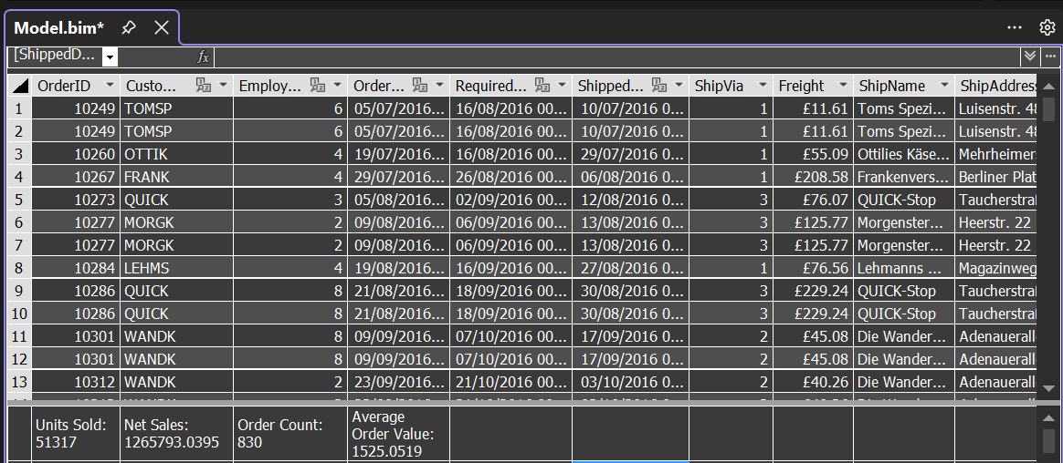
Figure 7: All four DAX measures in the factOrderDetail measure grid, Units Sold: 51,317 | Net Sales: £1,265,793.04 | Order Count: 830 | Average Order Value: £1,525.05

Task 4: OLAP Operations (Modern MOLAP)
The SSAS Tabular model was connected to Excel via the Analyse in Excel feature within Visual Studio. This opened a PivotTable with all model dimensions, hierarchies and measures available in the field list on the right-hand side. The five classical OLAP operations were then demonstrated using this PivotTable, each of which is discussed and illustrated below.
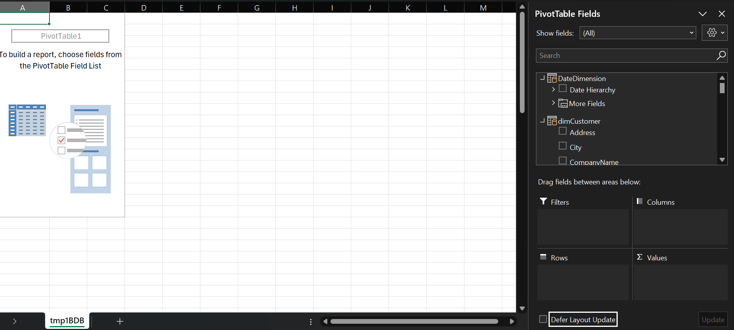
Figure 8: Excel connected to the NorthwindTabular SSAS model via Analyse in Excel, all dimensions and measures visible in the field list

4.1 Roll-Up (Month to Year)
Roll-up moves from a more detailed level of analysis to a less detailed level, it combines data as you move up through the layers of a hierarchy. The Date Hierarchy was placed in the Rows area and Net Sales was placed in the Values area. The result shows Net Sales aggregated by Year, with all quarterly and monthly transactions summarised into annual totals. This is the most common OLAP operation used in practice, as most business reporting starts at a summary level before drilling down to the detail.
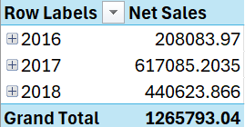
Figure 9: Roll-Up, Net Sales summarised by Year. 2016: £208,083.97 | 2017: £617,085.20 | 2018: £440,623.87 | Grand Total: £1,265,793.04

4.2 Drill-Down (Year to Quarter)
Drill-down is the opposite of roll-up, it expands a summarised level to reveal more granular detail. When you click the expand button on 2016, it reveals the Q3 and Q4 figures beneath it. This confirms that the Date Hierarchy is working correctly across all three levels and that the model is aggregating data properly at each level of the hierarchy.
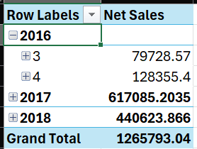
Figure 10: Drill-Down, 2016 expanded to reveal Q3: £79,728.57 and Q4: £128,355.40

4.3 Slice (Single Dimension Filter)
A slice filters the entire dataset using a single dimension, reducing it to a specific subset. The Country field from dimCustomer was added to the Filters area and set to Germany. The entire PivotTable then shows only German sales, with all other countries excluded. This is by far the most commonly used operation in day-to-day business reporting and the simplest way to reduce your data to only what you want to see.
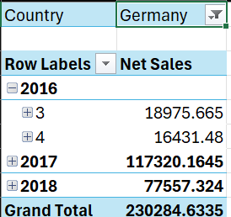
Figure 11: Slice, Country filter set to Germany. Total Net Sales for Germany: £230,284.63

4.4 Dice (Multi-Dimensional Filter)
A dice creates an intersection across multiple dimensions at once (what can be described as a sub-cube) by combining more than one dimension-specific filter. CategoryName from dimProduct was applied as a second filter alongside Country, and both were set to Germany and Beverages respectively. The final results show only German Beverage sales, representing the precise intersection of those two specific dimensions.
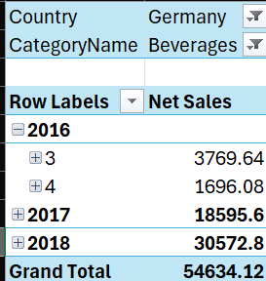
Figure 12: Dice, Two filters applied: Country = Germany AND CategoryName = Beverages. Net Sales = £54,634.12

4.5 Pivot (Rotate the View)
A pivot allows you to view the same data from a completely different angle simply by moving one of your dimensions from one axis to the other, without changing any of the filters. The Date Hierarchy was moved from the Rows area to the Columns area. Instead of being listed vertically down the left side, Years now appear horizontally across the top of the table, allowing for much easier comparisons across years for the same country and product category. All of these changes occurred whilst the Country filter (Germany) and Category filter (Beverages) remained in place.
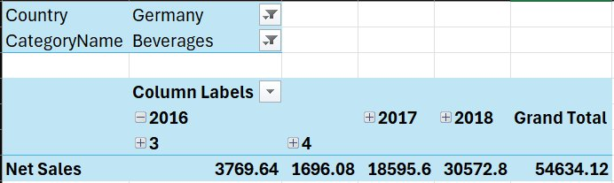
Figure 13: Pivot, Date Hierarchy moved to Columns. Years 2016, 2017, 2018 now appear as column headers with Germany and Beverages filters still applied

Task 5: Reflection

SSAS Tabular as Modern MOLAP
One of the most fascinating aspects of using SSAS Tabular is its ability to provide all of the characteristics of traditional MOLAP (Multidimensional Online Analytical Processing) without ever requiring you to build an actual cube. Traditional OLAP systems always involved explicitly defining dimensions, measures, and the relationships between fact tables within a multidimensional data structure. In contrast, SSAS Tabular achieves equivalent analytical results through a tabular-style table model, a semantic layer, and DAX measures. This is precisely why it is now increasingly referred to as modern MOLAP.
The way in which SSAS Tabular delivers this is through how it stores and processes data. Whilst older OLAP-based cubes use sparse multidimensional arrays, the Tabular engine uses an aggressively compressed column-store called VertiPaq. This allows users to process data extremely quickly whilst still being able to perform the same analytical operations as if they were using a traditional cube. Users can expand and collapse their views from month level to year level, drill from a category down to an individual product, and apply filters on any dimension they choose. As far as the end-user experience goes, there is no visible difference. They interact with their data in the same way they would with a traditional OLAP cube, and the cube itself remains completely invisible to them (Sheldon, 2013).
The practical value of the semantic layer became very clear when building this model. A business user connecting Excel directly to the NorthwindDM database would encounter tables called factOrderDetail or dimEmployee, technical naming conventions that mean very little outside of an IT context. The semantic layer replaces these with business-friendly names, pre-built measures like Net Sales and Average Order Value, and an intuitive hierarchy of Year to Quarter to Month. Once the business logic is defined by the developer, it lives inside the model itself. Every user who connects gets the exact same numbers every time, there can never be a situation where two different analysts calculate Net Sales differently, because the definition is contained within the model. As Kimball and Ross (2013) describe this, it is a single version of the truth, which is one of the primary objectives of any Business Intelligence solution.
The greatest insight from building this model was realising just how much complexity is hidden from the end-user by design. The developer works with connection strings, DAX syntax, relationship cardinalities, inactive relationships, and processing pipelines. The business user simply sees a clean list of fields and drags them onto a canvas. That gap (between the technical depth underneath and the simplicity on top) is exactly what the semantic layer achieves. SSAS Tabular is not simply a database technology. It is an engineering solution that enables raw data to be turned into accessible, trustworthy insight for the people who need it most (Microsoft, 2025a).

References
Feng, J. (2026) Introduction to SSAS and SSAS Tabular. COMP10002 Lecture Slides. University of the West of Scotland.
Kimball, R. and Ross, M. (2013) The Data Warehouse Toolkit. 3rd edn. Indianapolis: Wiley.
Microsoft (2025a) Tabular models (SSAS). Available at: https://learn.microsoft.com/en-us/analysis-services/tabular-models/tabular-models-ssas (Accessed: 3 April 2026).
Microsoft (2025b) DAX overview. Available at: https://learn.microsoft.com/en-us/dax/dax-overview (Accessed: 3 April 2026).
Sheldon, R. (2013) Getting started with the SSAS Tabular model. Simple Talk, 22 May. Available at: https://www.red-gate.com/simple-talk/databases/sql-server/bi-sql-server/getting-started-with-the-ssas-tabular-model/ (Accessed: 3 April 2026).

