ALGORITHM

Electricity Bill Calculator
START
Step 1: Input
- Read the customer name and remove extra spaces.
- Read the customer type (R or C), remove extra spaces and convert to uppercase.
- Read the previous month’s meter reading (integer).
- Read the current month’s meter reading (integer).
- Read whether the bill was paid after the due date (Y or N), remove extra spaces and convert to uppercase.
Step 2: Validation
- Set valid = 1.
- If the customer type is neither R nor C, print “You Can Only Type R or C” and set valid = 0.
- If the previous reading is less than 0, print “Previous Reading Cant Be Negative” and set valid = 0.
- If the current reading is less than 0, print “Current Reading Cant Be Negative” and set valid = 0.
- If the current reading is less than the previous reading, print “Current Reading Should be greater than previous reading” and set valid = 0.
- If valid = 0, go to END. (All the checks above are performed even if an earlier one fails, so every error message gets printed.)
- Otherwise (valid = 1), go to Step 3.
Step 3: Calculate units consumed
- units consumed = current reading − previous reading
Step 4: Calculate energy charges
- If customer type is R (Residential):
  - If units ≤ 100: energy charges = units × 10
  - Else if units ≤ 200: energy charges = (100 × 10) + (units − 100) × 15
  - Else if units ≤ 300: energy charges = (100 × 10) + (100 × 15) + (units − 200) × 20
  - Else: energy charges = (100 × 10) + (100 × 15) + (100 × 20) + (units − 300) × 25
- If customer type is C (Commercial):
  - energy charges = units × 30
Step 5: Calculate fixed charges
- If customer type is R and units ≤ 200: fixed charges = 100
- Else: fixed charges = 200
- If customer type is C: fixed charges = 500 (this overrides the value above)
Step 6: Calculate GST
- gst = (energy charges + fixed charges) × 18 / 100
Step 7: Calculate late payment surcharge
- If bill paid after due date is Y: surcharge = (energy charges + fixed charges + gst) × 10 / 100
- Otherwise (any other input, including N): surcharge = 0
Step 8: Calculate total bill
- total = energy charges + fixed charges + gst + late payment surcharge
Step 9: Determine consumption level
- If units ≤ 100: level = “Low”
- Else if units ≤ 300: level = “Moderate”
- Else: level = “High”
Step 10: Print the bill
- Print the customer name.
- If customer type is R, set type = “Residential”; otherwise type = “Commercial”. Print the customer type.
- Print units consumed.
- Print energy charges.
- Print fixed charges.
- Print GST.
- Print late payment surcharge.
- Print total payable (2 decimal places, in Rs).
- Print consumption level.
END

TEST CASES
TEST CASE # 1:

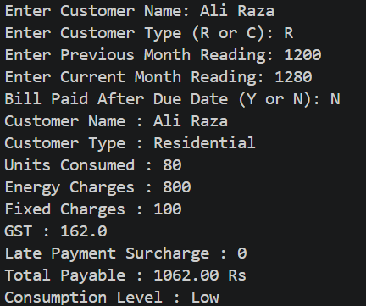

TEST CASE # 2:

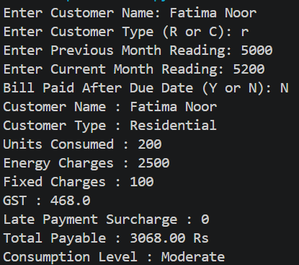

TEST CASE # 3:

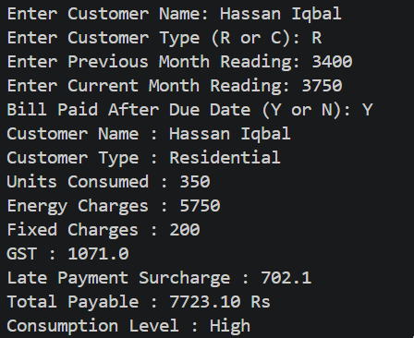

TEST CASE # 4:

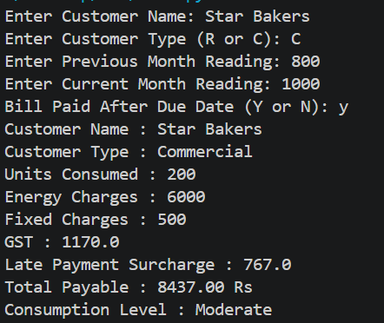

TEST CASE # 5:

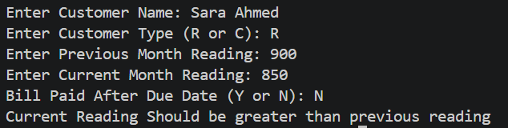

TEST CASE # 6:

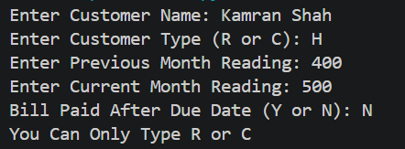

HAND CALCULATIONS
TEST CASE 3:
INPUTS
Enter Customer Name: Hassan Iqbal
Enter Customer Type (R or C): R
Enter Previous Month Reading: 3400
Enter Current Month Reading: 3750
Bill Paid After Due Date (Y or N): Y

CALCULATIONS:
- All Inputs correct
- Units consumed = Current Month Reading - Previous Month Reading = 3750 – 3400 = 350
- As Customer type is ‘R’ means residential and units consumed >= 300, so,
As we know,
Energy charges = (100*10) + (100*15) + (100*20) + (units consumed - 300) * 25
= 1000 + 1500 + 2000 + (350-300)*25 = 4500 + 1250 = 5750
- As Customer type is ‘R’ means residential and units consumed >= 300, so,
Fixed charges = 200
- As we know,
Gst = (energy charges + fixed charges) * 18 / 100
= (5750 + 200) * 18 / 100 = 1071.0
- As Bill Is paid after due date so,
Late payment surcharge = (energy charges + fixed charges + gst)*10/100
= (5750 + 200 + 1071.0)*10/100 = 702.1
- Total = energy charges + fixed charges + gst + Late payment surcharge
= 5750 + 200 + 1071.0 + 702.1 = 7723.10
- As units consumed > 300:so,
Consumption level is High
OUTPUT:
Customer Name : Hassan Iqbal
Customer Type : Residential
Units Consumed : 350
Energy Charges : 5750
Fixed Charges : 200
GST : 1071.0
Late Payment Surcharge : 702.1
Total Payable : 7723.10 Rs
Consumption Level : High

TEST CASE 4:
INPUTS
Enter Customer Name: Star Bakers
Enter Customer Type (R or C): C
Enter Previous Month Reading: 800
Enter Current Month Reading: 1000
Bill Paid After Due Date (Y or N): y

CALCULATIONS:
- All Inputs correct
- Units consumed = Current Month Reading - Previous Month Reading = 1000 – 800 = 200
- As Customer type is ‘C’ means Commercial so,
Energy charges = units consumed * 30
= 200 * 30 = 6000
- As Customer type is ‘C’ means Commercial so,
Fixed charges = 500
- As we know,
Gst = (energy charges + fixed charges) * 18 / 100
= (6000 + 500) * 18 / 100 = 1170.0
- As Bill Is paid after due date so,
Late payment surcharge = (energy charges + fixed charges + gst)*10/100
= (6000 + 500 + 1170.0)*10/100 = 767.0
- Total = energy charges + fixed charges + gst + Late payment surcharge
= 6000 + 500 + 1170.0 + 767.0 = 8437.00 Rs
- As units consumed = 200 :so,
Consumption level is Moderate
OUTPUT:
Customer Name : Star Bakers
Customer Type : Commercial
Units Consumed : 200
Energy Charges : 6000
Fixed Charges : 500
GST : 1170.0
Late Payment Surcharge : 767.0
Total Payable : 8437.00 Rs
Consumption Level : Moderate

EXPECTED VS ACTUAL RESULTS

Expected Results (hand-calculated)
Run | Customer | Type | Units | Energy | Fixed | GST (18%) | Late Surcharge | Total Payable | Level
1 | Ali Raza | R | 80 | 800 | 100 | 162.0 | 0 | 1062.00 Rs | Low
2 | Fatima Noor | R | 200 | 2500 | 100 | 468.0 | 0 | 3068.00 Rs | Moderate
3 | Hassan Iqbal | R | 350 | 5750 | 200 | 1071.0 | 702.1 | 7723.10 Rs | High
4 | Star Bakers | C | 200 | 6000 | 500 | 1170.0 | 767.0 | 8437.00 Rs | Moderate
5 | Sara Ahmed | R | - | - | - | - | - | Error: “Current Reading Should be greater than previous reading” | -
6 | Kamran Shah | H | - | - | - | - | - | Error: “You Can Only Type R or C” | -

Actual Results (hand-calculated)

Actual Results Hyperlinked

EXPLANATION
First, I have taken five inputs from the user: Customer Name, Customer Type (R or C), Previous Month Meter Reading, Current Month Meter Reading, and whether the bill was paid after the due date (Y or N).
After taking the inputs, I have performed validation using a flag variable called valid, which is initially set to 1. I then use separate if statements to check whether the customer type is R or C, whether either meter reading is negative, and whether the current reading is less than the previous reading. If any condition is invalid, the program displays the corresponding error message and sets valid to 0. Since every check runs independently, all applicable error messages are displayed together instead of stopping at the first one. Equal meter readings are allowed.
After the validation checks, the program uses if valid == 1 to decide whether to continue. If valid is still 1, it means all inputs are correct, and the program enters this block, where I calculate the units consumed by subtracting the previous reading from the current reading. If valid is 0, the block is skipped and no bill is generated.
Next, I calculate the energy charges using conditional statements. For Residential customers, I apply different rates according to unit slabs: Rs. 10 for the first 100 units, Rs. 15 for the next 100, Rs. 20 for the next 100, and Rs. 25 for additional units. For Commercial customers, the rate is Rs. 30 per unit.
After that, I calculate fixed charges: Rs. 100 for Residential customers consuming up to 200 units, Rs. 200 for those consuming more than 200 units, and Rs. 500 for Commercial customers.
Then, I calculate GST at 18% on energy charges and fixed charges. I also calculate the late payment surcharge, which is 10% of the amount including energy charges, fixed charges, and GST, if the user enters Y. Otherwise, it remains zero.
After calculating all charges, I calculate the total payable amount by adding energy charges, fixed charges, GST, and the late payment surcharge.
I then use an if-elif-else ladder to determine the consumption level: up to 100 units is Low, more than 100 and up to 300 units is Moderate, and above 300 units is High.
Finally, I print the complete electricity bill using print statements and f-strings. It displays the customer name, customer type, units consumed, all individual charges, total payable amount, and consumption level.
All calculations and bill printing are performed inside the if valid == 1 block so that they execute only when all the input validation conditions are satisfied.

