ALGORITHM

Electricity Bill Calculator
START
Step 1: Input
- Read the customer name.
- Read the customer type (R or C) and convert it to uppercase.
- Read the previous month’s meter reading.
- Read the current month’s meter reading.
- Read whether the bill was paid after the due date (Y or N) and convert it to uppercase.
Step 2: Validation
- If the customer type is neither R nor C, print “You Can Only Type R or C” and STOP.
- If the previous reading is less than 0, print “Previous Reading Cant Be Negative” and STOP.
- If the current reading is less than 0, print “Current Reading Cant Be Negative” and STOP.
- If the current reading is less than the previous reading, print “Current Reading Should be greater than previous reading” and STOP.
- Otherwise, go to Step 3.
Step 3: Calculate units consumed
- Units consumed = current meter reading – previous meter reading
Step 4: Calculate energy charges
If customer type is C (Commercial):
- Energy charges = units consumed × 30
If customer type is R (Residential):
- If units ≤ 100: energy charges = units × 10
- Else if units ≤ 200: energy charges = (100 × 10) + (units − 100) × 15
- Else if units ≤ 300: energy charges = (100 × 10) + (100 × 15) + (units − 200) × 20
- Else: energy charges = (100 × 10) + (100 × 15) + (100 × 20) + (units − 300) × 25
Step 5: Calculate fixed charges
- If customer type is C: fixed charges = 500
- Else if customer type is R and units ≤ 200: fixed charges = 100
- Else (R and units > 200): fixed charges = 200
Step 6: Calculate GST
- gst = (energy charges + fixed charges) × 18 / 100
Step 7: Calculate late payment surcharge
- If bill_paid is Y: late payment surcharge = (energy charges + fixed charges + gst) × 10 / 100
- Otherwise: late payment surcharge = 0
Step 8: Calculate total bill
- total = energy charges + fixed charges + gst + late payment surcharge
Step 9: Determine consumption level
- If units ≤ 100: consumption level = “Low”
- Else if units ≤ 300: consumption level = “Moderate”
- Else: consumption level = “High”
Step 10: Determine customer type name
- If customer type is R: type = “Residential”
- Otherwise: type = “Commercial”
Step 11: Print the bill
Print the following:
- Customer Name
- Customer Type
- Units Consumed
- Energy Charges
- Fixed Charges
- GST
- Late Payment Surcharge
- Total Payable (to 2 decimal places, in Rs)
- Consumption Level
END

TEST CASES
TEST CASE # 1:

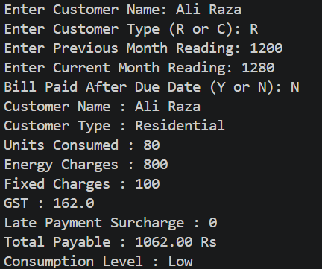

TEST CASE # 2:

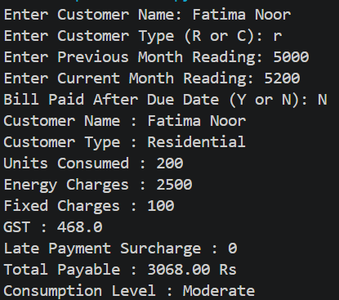

TEST CASE # 3:

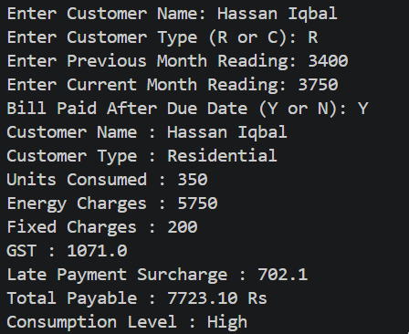

TEST CASE # 4:

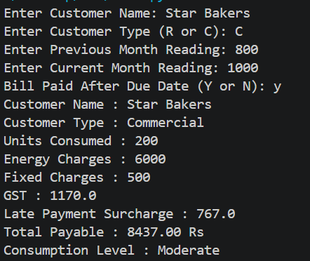

TEST CASE # 5:

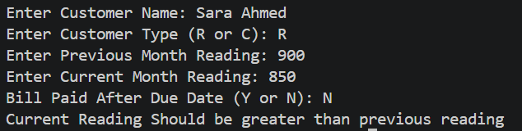

TEST CASE # 6:

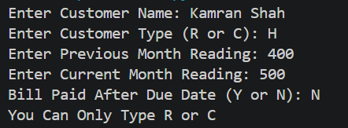

HAND CALCULATIONS
TEST CASE 3:
INPUTS
Enter Customer Name: Hassan Iqbal
Enter Customer Type (R or C): R
Enter Previous Month Reading: 3400
Enter Current Month Reading: 3750
Bill Paid After Due Date (Y or N): Y

CALCULATIONS:
- All Inputs correct
- Units consumed = Current Month Reading - Previous Month Reading = 3750 – 3400 = 350
- As Customer type is ‘R’ means residential and units consumed >= 300, so,
As we know,
Energy charges = (100*10) + (100*15) + (100*20) + (units consumed - 300) * 25
= 1000 + 1500 + 2000 + (350-300)*25 = 4500 + 1250 = 5750
- As Customer type is ‘R’ means residential and units consumed >= 300, so,
Fixed charges = 200
- As we know,
Gst = (energy charges + fixed charges) * 18 / 100
= (5750 + 200) * 18 / 100 = 1071.0
- As Bill Is paid after due date so,
Late payment surcharge = (energy charges + fixed charges + gst)*10/100
= (5750 + 200 + 1071.0)*10/100 = 702.1
- Total = energy charges + fixed charges + gst + Late payment surcharge
= 5750 + 200 + 1071.0 + 702.1 = 7723.10
- As units consumed > 300:so,
Consumption level is High
OUTPUT:
Customer Name : Hassan Iqbal
Customer Type : Residential
Units Consumed : 350
Energy Charges : 5750
Fixed Charges : 200
GST : 1071.0
Late Payment Surcharge : 702.1
Total Payable : 7723.10 Rs
Consumption Level : High

TEST CASE 4:
INPUTS
Enter Customer Name: Star Bakers
Enter Customer Type (R or C): C
Enter Previous Month Reading: 800
Enter Current Month Reading: 1000
Bill Paid After Due Date (Y or N): y

CALCULATIONS:
- All Inputs correct
- Units consumed = Current Month Reading - Previous Month Reading = 1000 – 800 = 200
- As Customer type is ‘C’ means Commercial so,
Energy charges = units consumed * 30
= 200 * 30 = 6000
- As Customer type is ‘C’ means Commercial so,
Fixed charges = 500
- As we know,
Gst = (energy charges + fixed charges) * 18 / 100
= (6000 + 500) * 18 / 100 = 1170.0
- As Bill Is paid after due date so,
Late payment surcharge = (energy charges + fixed charges + gst)*10/100
= (6000 + 500 + 1170.0)*10/100 = 767.0
- Total = energy charges + fixed charges + gst + Late payment surcharge
= 6000 + 500 + 1170.0 + 767.0 = 8437.00 Rs
- As units consumed = 200 :so,
Consumption level is Moderate
OUTPUT:
Customer Name : Star Bakers
Customer Type : Commercial
Units Consumed : 200
Energy Charges : 6000
Fixed Charges : 500
GST : 1170.0
Late Payment Surcharge : 767.0
Total Payable : 8437.00 Rs
Consumption Level : Moderate

EXPECTED VS ACTUAL RESULTS

Expected Results (hand-calculated)
Run | Customer | Type | Units | Energy | Fixed | GST (18%) | Late Surcharge | Total Payable | Level
1 | Ali Raza | R | 80 | 800 | 100 | 162.0 | 0 | 1062.00 Rs | Low
2 | Fatima Noor | R | 200 | 2500 | 100 | 468.0 | 0 | 3068.00 Rs | Moderate
3 | Hassan Iqbal | R | 350 | 5750 | 200 | 1071.0 | 702.1 | 7723.10 Rs | High
4 | Star Bakers | C | 200 | 6000 | 500 | 1170.0 | 767.0 | 8437.00 Rs | Moderate
5 | Sara Ahmed | R | - | - | - | - | - | Error: “Current Reading Should be greater than previous reading” | -
6 | Kamran Shah | H | - | - | - | - | - | Error: “You Can Only Type R or C” | -

Actual Results (hand-calculated)

Actual Results Hyperlinked

EXPLANATION

First, I have taken five inputs from the user: Customer Name, Customer Type (R or C), Previous Month Meter Reading, Current Month Meter Reading, and whether the bill was paid after the due date (Y or N).

After taking the inputs, I have used if, elif, and else statements for validation. I check whether the customer type is R or C, whether either meter reading is negative, and whether the current reading is less than the previous reading. If any condition is invalid, the program displays the corresponding error message and does not proceed further. Equal meter readings are allowed.

If all validation conditions are satisfied, the program enters the else block, where I calculate the units consumed by subtracting the previous reading from the current reading.

Next, I calculate the energy charges using conditional statements. For Residential customers, I apply different rates according to unit slabs: Rs. 10 for the first 100 units, Rs. 15 for the next 100, Rs. 20 for the next 100, and Rs. 25 for additional units. For Commercial customers, the rate is Rs. 30 per unit.

After that, I calculate fixed charges: Rs. 100 for Residential customers consuming up to 200 units, Rs. 200 for those consuming more than 200 units, and Rs. 500 for Commercial customers.

Then, I calculate GST at 18% on energy charges and fixed charges. I also calculate the late payment surcharge, which is 10% of the amount including energy charges, fixed charges, and GST, if the user enters Y. Otherwise, it remains zero.

After calculating all charges, I calculate the total payable amount by adding energy charges, fixed charges, GST, and the late payment surcharge.

I then use an if-elif-else ladder to determine the consumption level: up to 100 units is Low, more than 100 and up to 300 units is Moderate, and above 300 units is High.

Finally, I print the complete electricity bill using print statements and f-strings. It displays the customer name, customer type, units consumed, all individual charges, total payable amount, and consumption level.

All calculations and bill printing are performed inside the else block so that they execute only when the input validation conditions are satisfied

