WEEK 1 INTERNSHIP PROJECT
Virtual Computer Fundamentals Support
Troubleshooting and Strategic Support Plan

Submitted by: HASHINI A
Department: Computer Science and Engineering
Internship Role: Virtual Computer Fundamentals Support Intern
Task: Week 1 – Computer Fundamentals Support
Submission Date: 3 October 2026

Project Focus
A structured support framework for identifying, troubleshooting, documenting, and escalating common computer-related issues in academic and general support environments.

Contents
1. Executive Summary
2. Introduction
3. Objectives
4. Scope and Support Context
5. Common Computer Support Issues
6. Problem Identification
7. Step-by-Step Troubleshooting Method
8. Troubleshooting Flowchart
9. Solution Strategy
10. Escalation Procedure
11. Strategic Roadmap
12. Recommended Best Practices
13. Follow-Up and Documentation
14. Example Support Case
15. Conclusion
16. References

1. Executive Summary
This report presents a structured plan for virtual computer fundamentals support. The purpose is to provide a consistent method for handling common technical queries in academic and general computer-support environments. The report focuses on problem identification, information gathering, safe first-level troubleshooting, verification, documentation, and escalation.
Common issues considered include startup failures, slow performance, internet connectivity, audio and display problems, keyboard and mouse failures, printer issues, application errors, and low storage. Each issue is connected to possible causes and suitable first-level actions. The support process emphasizes starting with simple, low-risk checks before moving to more advanced actions.
The strategy also defines when an issue should be escalated, particularly when basic troubleshooting does not resolve the problem, specialist knowledge or administrative access is required, or the issue may affect multiple users. The plan concludes with best practices and a documentation model that can be reused during future support sessions.

2. Introduction
Computer support is the organized process of helping users identify, understand, and resolve problems involving computer hardware, operating systems, software, networks, and peripheral devices. In academic environments, effective support can reduce interruptions to learning, laboratory work, communication, and administrative activities.
Troubleshooting is important because a reported symptom does not always identify the actual cause. A systematic process helps the support person gather evidence, test reasonable causes, apply appropriate solutions, and confirm the result. Microsoft's current Windows support resources also provide built-in troubleshooters for areas such as audio, network and internet, printers, Bluetooth, compatibility, and Windows Update. [1]

3. Objectives
- Identify common computer-related support problems.
- Understand likely causes of common hardware, software, network, and configuration issues.
- Develop a repeatable step-by-step troubleshooting procedure.
- Provide safe first-level solutions for common issues.
- Define clear conditions for escalation to a specialist or higher support level.
- Improve documentation and follow-up practices.
- Create a structured support plan that can be reused in future sessions.

4. Scope and Support Context
This plan is designed for basic and intermediate computer-support situations that can occur in classrooms, computer laboratories, offices, and virtual support sessions. It is intended to guide first-level support rather than replace qualified hardware repair, network administration, cybersecurity investigation, or other specialist services.
Support principle
Start with the least disruptive, reversible, and understandable check. Avoid unnecessary system changes, protect user data, and escalate when the problem is outside the support scope.

5. Common Computer Support Issues
Issue | Possible causes | First-level checks | Escalate when
Computer does not start | Power, charger, battery, hardware fault | Check power source, charger/cable, indicators; try a normal restart if possible | No power response, suspected hardware fault, or repeated failure
Slow performance | Too many processes, low storage, startup load, pending updates | Close unused apps, check storage, restart, check updates | Persistent slowness or suspected hardware/system fault
No internet/Wi-Fi | Wi-Fi disabled, router/network issue, configuration | Check Wi-Fi, reconnect, test another device, run network diagnostics | Multiple users affected or network service requires administrator action
No sound | Muted volume, wrong output, driver/device issue | Check volume/output device, reconnect audio device, use audio troubleshooter | Hardware failure or repeated driver/device failure
Keyboard/mouse not working | Loose connection, battery, driver, hardware | Reconnect, try another port/device, check settings | Device remains unusable after basic checks
Printer not printing | Connection, offline status, queue, paper/consumables | Check connection/status, queue, paper and printer state | Shared printer/server issue or hardware fault
Application not opening | Application error, compatibility, damaged installation | Restart app/PC, update, use repair option if available | Repeated failure or administrator/installation issue
Low storage | Large files, downloads, unused apps, temporary data | Review storage, remove unnecessary files safely, archive important data | Storage failure or organization policy prevents cleanup
Display problem | Cable, display setting, driver, monitor issue | Check cable/input, display settings, restart | No display after basic checks or suspected hardware fault
Microsoft's support documentation groups Windows assistance around installation and updates, drivers and devices, network and internet, files and storage, security and privacy, troubleshooting and repair, and hardware. [2]

6. Problem Identification
Before changing settings or installing software, the support person should first establish what is actually happening.
- Clarify the symptom: ask the user to describe the problem in simple terms.
- Identify timing: determine when the issue started and whether it is recurring.
- Check recent changes: note recent updates, new software, new hardware, or configuration changes.
- Capture evidence: record error messages, codes, affected applications, and relevant observations.
- Determine scope: establish whether one device, one user, or multiple users are affected.
- Classify the issue as hardware, software, network, configuration, or user-process related.

7. Step-by-Step Troubleshooting Method
Step 1: Identify the problem — Define the symptom and expected behavior.
Step 2: Collect information — Ask focused questions and record relevant error messages or recent changes.
Step 3: Check basic causes — Verify power, cables, connectivity, settings, and device status.
Step 4: Reproduce or confirm — Where safe, confirm the problem and determine whether it is consistent.
Step 5: Form a likely cause — Use the evidence to narrow the possible causes.
Step 6: Apply a safe solution — Start with simple and reversible actions.
Step 7: Test the result — Confirm that the original problem has been resolved.
Step 8: Document and close or escalate — Record the outcome; if unresolved or outside scope, escalate with the evidence collected.
Data-protection rule
Before recovery or repair actions that could affect files or settings, important data should be backed up when possible. Microsoft specifically advises backing up important files before using recovery options that may result in data loss. [3]

8. Troubleshooting Flowchart
The following flowchart summarizes the support process from problem reporting through resolution or escalation.
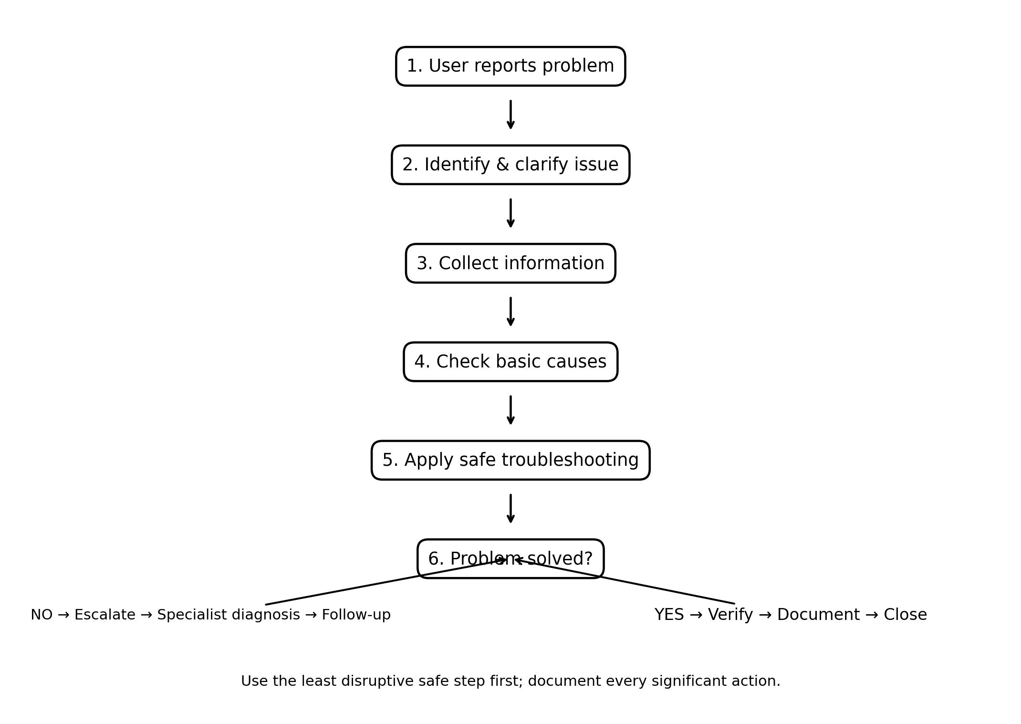
Figure 1. General computer-support troubleshooting workflow.

9. Solution Strategy

Hardware support
Check power, physical connections, peripheral status, cables, and basic device indicators. Avoid opening or repairing hardware unless authorized and qualified.

Software support
Restart the affected application, check updates, use supported repair options, and document any changes. Microsoft provides an application repair feature for supported Windows apps. [4]

Network support
Check local connectivity, Wi-Fi status, network symptoms, and whether other devices are affected. Use built-in network diagnostics where available. [1]

User and configuration support
Confirm settings, explain the correct procedure, and provide simple guidance without making unnecessary configuration changes.

10. Escalation Procedure
Escalation means transferring an unresolved or higher-risk issue to the appropriate technical support level with enough information to continue diagnosis efficiently.
- Confirm that reasonable first-level checks have been completed.
- Record the exact symptom, time, affected device/user, error messages, and actions already attempted.
- Assess whether the issue requires specialist knowledge, administrator access, hardware repair, security handling, or wider infrastructure support.
- Send the case to the appropriate technical team or supervisor.
- Provide the collected evidence and clearly state what has already been tested.
- Track the case until the user receives a resolution or an appropriate next step.
- Document the final outcome for future reference.
Typical escalation triggers include repeated failure after basic troubleshooting, suspected hardware faults, issues affecting multiple users, required administrative privileges, or potential security incidents.

11. Strategic Roadmap
Phase 1 – Identify | Phase 2 – Troubleshoot | Phase 3 – Resolve/Escalate | Phase 4 – Follow Up
Understand the symptom, scope, and evidence. | Perform safe checks and test likely causes. | Confirm resolution or transfer with complete notes. | Verify the outcome and document the case.

12. Recommended Best Practices
- Keep operating systems, browsers, and security software updated. CISA recommends installing software updates promptly because updates can address security risks. [5]
- Maintain regular backups of important files. Windows Backup can back up selected folders and settings. [6]
- Use strong authentication and protect account credentials.
- Avoid installing unknown or untrusted software.
- Check simple causes before advanced troubleshooting.
- Make one significant change at a time where practical so the effect can be identified.
- Protect user data and avoid destructive actions without authorization.
- Communicate technical steps in clear, non-technical language.
- Record the problem, actions taken, result, and escalation status.
- Follow up after resolution when the issue could recur or affect important work.

13. Follow-Up and Documentation
A consistent support record helps future troubleshooting and provides evidence of what was already attempted.
Field | Example
Problem | No internet connection
Date | 03-10-2026
Reported by | User
Possible cause | Local network/Wi-Fi connection
Action taken | Checked Wi-Fi status and network connection
Result | Internet connection restored
Status | Resolved
Follow-up | Monitor for recurrence

14. Example Support Case
Scenario: A student reports that a laptop cannot connect to the internet.
- Confirm whether Wi-Fi is enabled and whether the correct network is selected.
- Check whether other devices can connect to the same network.
- Reconnect to the network and run the available Windows network diagnostic.
- Restart the device or network equipment when appropriate.
- Test the connection again.
- If only the device remains affected and basic checks fail, record the evidence and escalate to the relevant support team.
- Document the final status and any follow-up required.
This example demonstrates the principle of moving from simple checks to more specialized support only when necessary.

15. Conclusion
This project provides a practical and repeatable framework for virtual computer fundamentals support. Effective support begins with accurate problem identification and continues through evidence gathering, safe troubleshooting, verification, documentation, and escalation when required.
The proposed approach can help future support sessions remain organized and consistent. It also emphasizes preventive practices such as timely software updates, backups, careful configuration, and clear communication. Using a structured support record ensures that resolved issues and unsuccessful troubleshooting attempts can be reused as useful knowledge in future cases.

16. References
- Microsoft Support. Windows troubleshooters. https://support.microsoft.com/en-us/support/get-help/windows-troubleshooters
- Microsoft Support. Windows help and learning. https://support.microsoft.com/en-us/windows/
- Microsoft Support. Recovery options in Windows. https://support.microsoft.com/en-us/windows/experience/backup-recovery/recovery-options-in-windows
- Microsoft Support. Repair apps and programs in Windows. https://support.microsoft.com/en-us/windows/apps/repair-apps-and-programs-in-windows
- CISA. Secure Our World – Software Updates Tip Sheet. https://www.cisa.gov/sites/default/files/2024-09/Secure-Our-World-Software-Updates-Tip-Sheet.pdf
- Microsoft Support. Back up and restore with Windows Backup. https://support.microsoft.com/en-us/windows/experience/backup-recovery/back-up-and-restore-with-windows-backup

