WEEK 2 INTERNSHIP PROJECT
Data Visualization and Insight Communication using R
A visual analysis of the AirPassengers dataset
HASHINI A
Second-Year Computer Science and Engineering
Virtual Internship
Week 2
3 October 2026

Table of Contents
1. Executive Summary
2. Introduction
3. Objectives
4. Dataset Overview
5. Data Preparation in R
6. Visualization 1 – Line Chart
7. Visualization 2 – Bar Chart
8. Visualization 3 – Histogram
9. Visualization 4 – Scatter Plot
10. Visualization 5 – Box Plot
11. Key Insights
12. Communication for a Non-Technical Audience
13. Conclusion
14. R Code Appendix
15. References

1. Executive Summary
This Week 2 project demonstrates how R can be used to transform a structured dataset into clear visual information. The AirPassengers dataset was selected because it contains 144 monthly observations covering 1949 to 1960 and provides a useful time-based example for communicating trends, seasonality, variation, and growth. Five complementary visualizations were developed: a line chart, annual bar chart, histogram, scatter plot, and box plot. Each chart answers a different analytical question. The line chart shows the overall time trend and repeated seasonal pattern. The bar chart compares total passenger volume across years. The histogram describes the distribution of monthly passenger counts. The scatter plot shows the relationship between year and annual passenger totals, while the box plot compares passenger distributions across calendar months. Together, the visuals communicate that passenger counts increased substantially over the study period and that demand followed a recurring seasonal pattern. The report includes the R code, chart outputs, interpretation, and practical guidance for explaining the findings to a non-technical audience.

2. Introduction
Data visualization is the process of presenting data through charts and graphs so that patterns can be understood more quickly than from a table alone. In this project, R and the ggplot2 visualization library are used to explore a time-series dataset. The goal is not only to create attractive graphs, but also to select an appropriate chart for each question and explain what the audience can learn from it.

3. Objectives
- Understand the structure and important variables of a public dataset.
- Create multiple visualization types using R and ggplot2.
- Identify trends, seasonal patterns, variation, and relationships.
- Embed reproducible R code with each visualization.
- Communicate findings clearly to a non-technical audience.

4. Dataset Overview
The AirPassengers dataset is a classic monthly time-series dataset distributed with base R. It contains the monthly number of international airline passengers from 1949 through 1960, expressed in thousands. It has 144 observations and one main measurement variable, Passengers, with Month providing the time index.
Variable | Type | Meaning
Month | Date/Time | Month of the observation
Passengers | Numeric | Number of airline passengers in thousands
Year | Integer | Calendar year derived from Month
Month_Name | Categorical | Three-letter calendar month label
Month_Number | Integer | Calendar month from 1 to 12

5. Data Preparation in R
The original AirPassengers time-series object was converted into a data frame so that ggplot2 could use explicit columns for the date, passenger count, year, and month. The transformation also makes it easier to create annual summaries and compare calendar months.
Core R preparation code:
data("AirPassengers")
air_df <- data.frame(
Month = as.Date(time(AirPassengers)),
Passengers = as.numeric(AirPassengers)
)
air_df$Year <- as.integer(format(air_df$Month, "%Y"))
air_df$Month_Name <- format(air_df$Month, "%b")
air_df$Month_Number <- as.integer(format(air_df$Month, "%m"))

6. Visualization 1 – Line Chart
Purpose: Show how monthly passenger numbers changed over time and reveal recurring seasonal movement.
ggplot(air_df, aes(x = Month, y = Passengers)) +
geom_line() +
labs(title = "Monthly Airline Passengers (1949-1960)",
x = "Year", y = "Passengers (thousands)") +
theme_minimal()
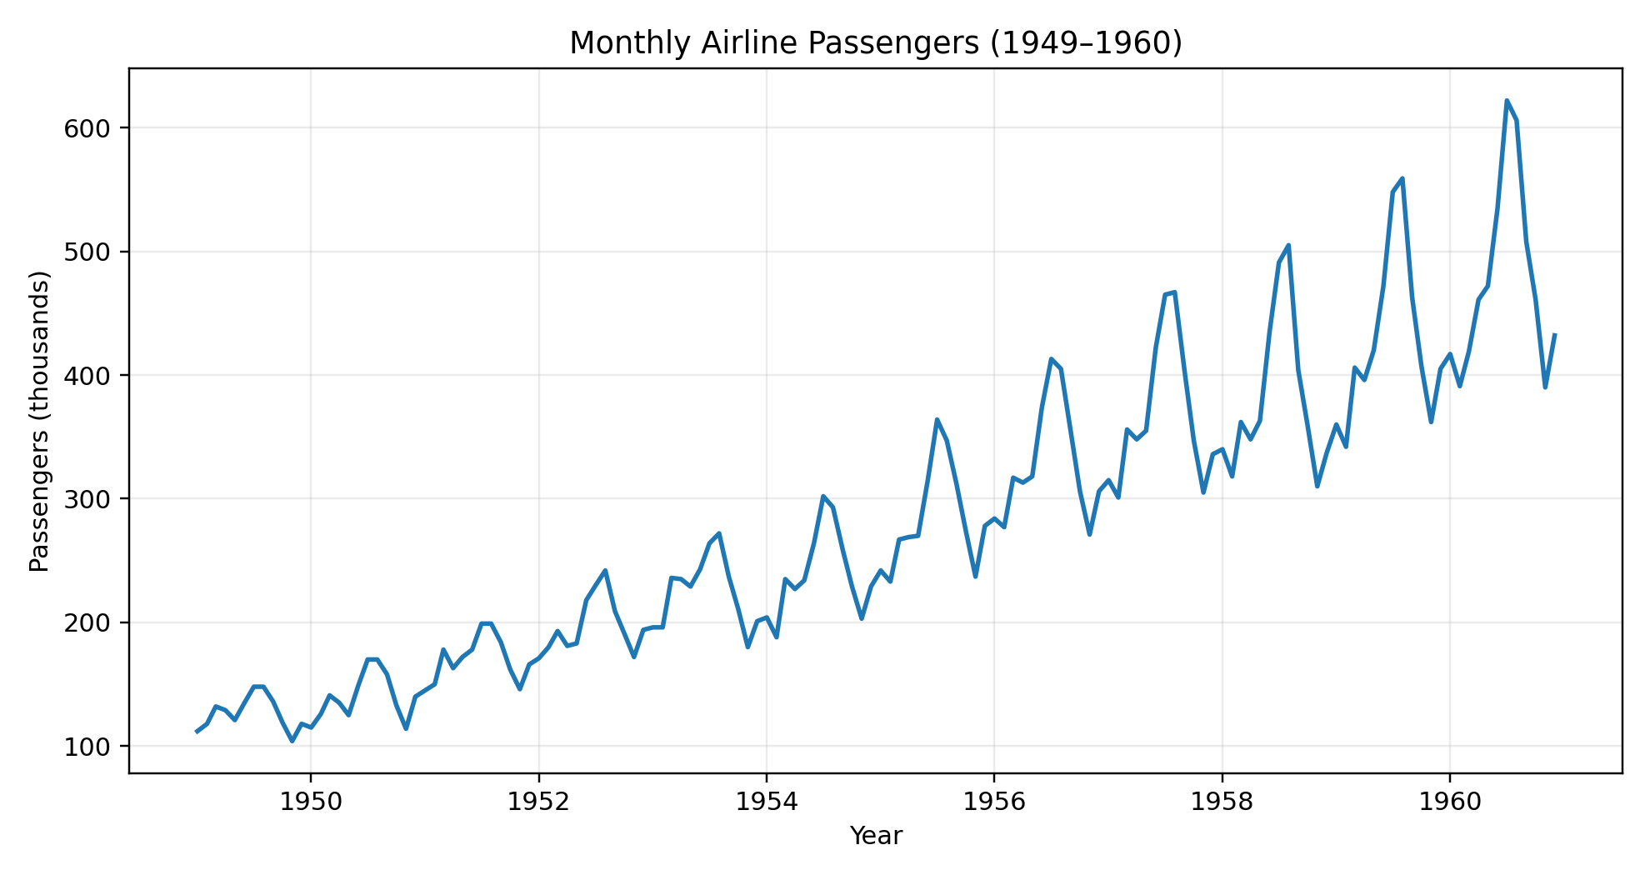

Interpretation
The line chart shows a clear long-term upward movement in monthly passenger counts from the beginning to the end of the period. It also shows repeated peaks and lower points at similar times of the year. This indicates a strong seasonal pattern alongside the overall growth.

Why this chart was selected
A line chart is appropriate because the observations are ordered by time. Connecting consecutive observations makes changes and recurring patterns easy to see.

7. Visualization 2 – Bar Chart
Purpose: Compare total passenger volume across individual years.
annual <- aggregate(Passengers ~ Year, data = air_df, sum)
ggplot(annual, aes(x = factor(Year), y = Passengers)) +
geom_col() +
labs(title = "Total Airline Passengers by Year",
x = "Year", y = "Annual passengers (thousands)") +
theme_minimal()
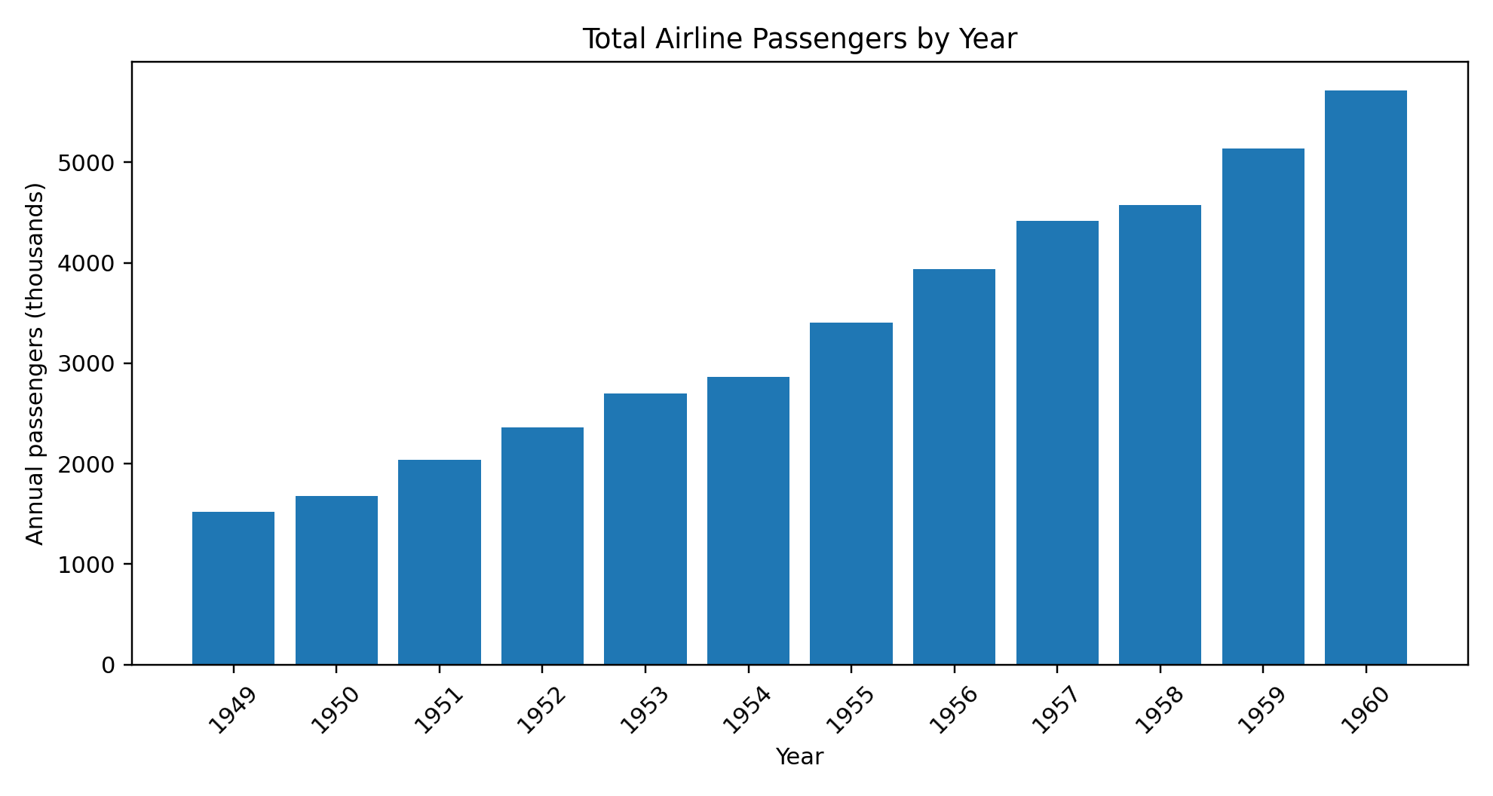

Interpretation
The annual bars generally become taller as the years progress. This confirms that the total number of passengers increased over the 12-year period. The year-to-year comparison is straightforward because each bar represents one complete year.

Why this chart was selected
A bar chart is useful when the audience needs to compare separate categories—in this case, calendar years.

8. Visualization 3 – Histogram
Purpose: Understand the distribution and typical range of monthly passenger counts.
ggplot(air_df, aes(x = Passengers)) +
geom_histogram(bins = 12, color = "black") +
labs(title = "Distribution of Monthly Passenger Counts",
x = "Passengers (thousands)", y = "Number of months") +
theme_minimal()
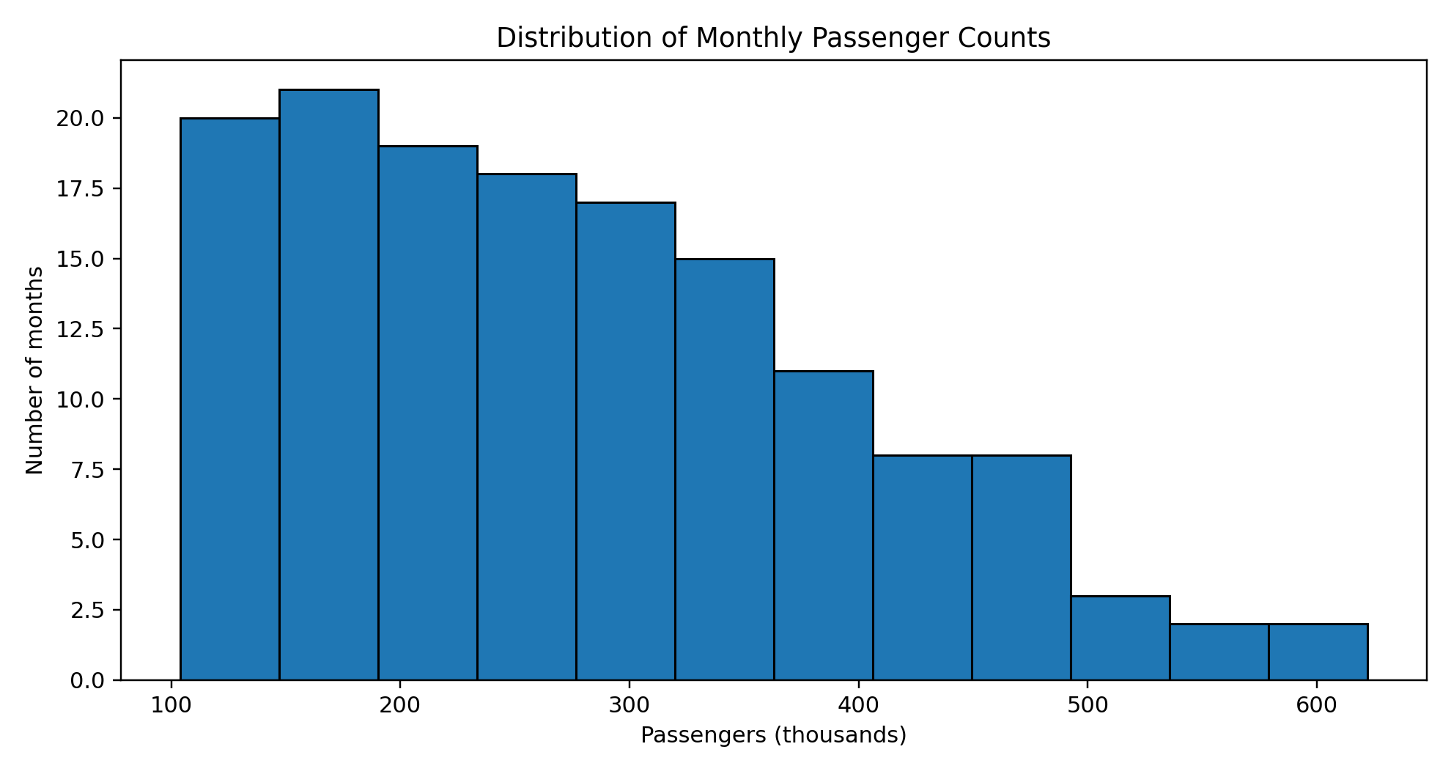

Interpretation
The histogram is concentrated toward the lower and middle passenger values, with fewer months at the highest levels. The distribution is not symmetric because the dataset contains a strong upward trend across the years, causing later observations to occupy larger values.

Why this chart was selected
A histogram is suitable for showing how frequently numerical values occur and whether the distribution is concentrated, spread out, or skewed.

9. Visualization 4 – Scatter Plot
Purpose: Show the relationship between calendar year and annual passenger totals.
ggplot(annual, aes(x = Year, y = Passengers)) +
geom_point(size = 3) +
geom_smooth(method = "lm", se = FALSE) +
labs(title = "Year vs Annual Passenger Total",
x = "Year", y = "Annual passengers (thousands)") +
theme_minimal()
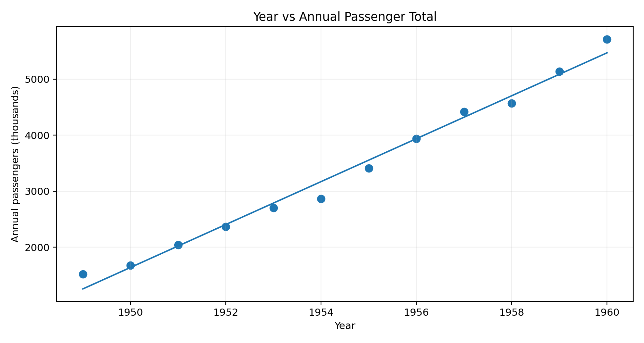

Interpretation
The points form a strong upward pattern from 1949 to 1960. The fitted trend line summarizes the positive direction: later years are associated with higher annual passenger totals. This is a descriptive relationship in the dataset; it does not by itself establish causation.

Why this chart was selected
A scatter plot is effective for showing the direction and strength of association between two numerical variables.

10. Visualization 5 – Box Plot
Purpose: Compare the distribution of passenger counts for each calendar month.
ggplot(air_df, aes(x = factor(Month_Number), y = Passengers)) +
geom_boxplot() +
labs(title = "Monthly Passenger Distribution by Calendar Month",
x = "Month number", y = "Passengers (thousands)") +
theme_minimal()
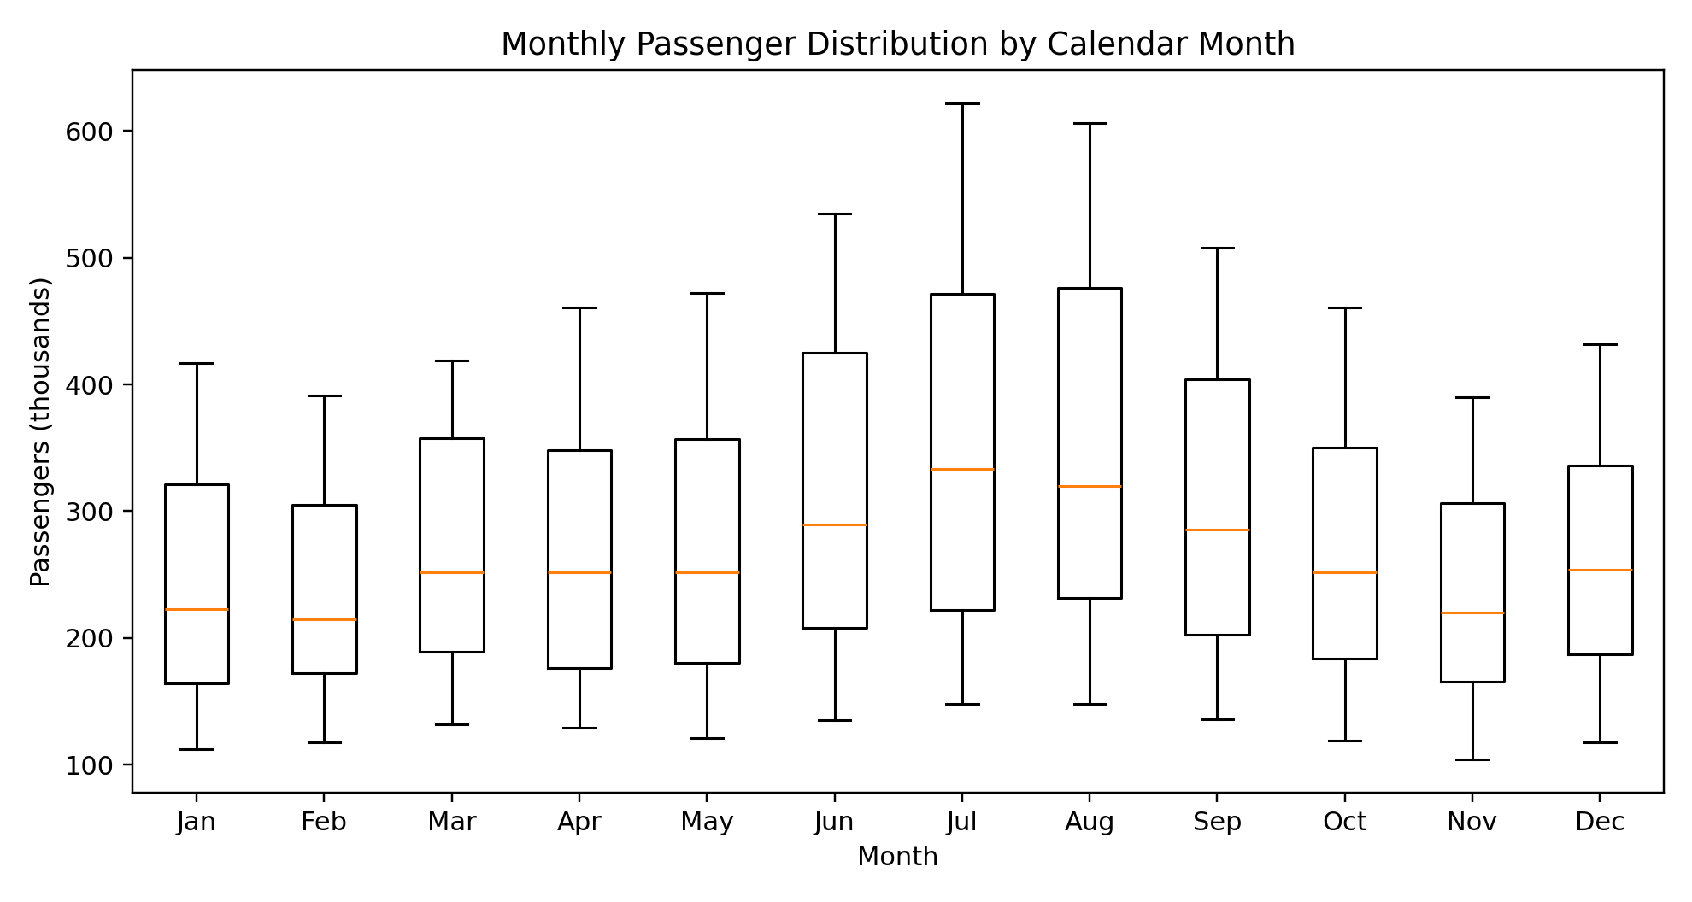

Interpretation
The box plots show that some calendar months consistently have higher passenger counts than others. The spread within a month also reflects the overall growth of the dataset because the same month is observed repeatedly across different years. This visualization therefore helps identify recurring seasonal differences while also showing variation.

Why this chart was selected
A box plot summarizes the median, spread, and unusual observations, making it useful for comparing several groups at once.

11. Key Insights
- Passenger volume increased substantially over the 1949–1960 period.
- A recurring seasonal pattern is visible, with certain months repeatedly showing higher demand.
- Annual totals provide a clear year-by-year picture of growth.
- The monthly distribution becomes wider and shifts upward because the later years contain larger passenger counts.
- Different chart types reveal different aspects of the same dataset; no single visualization communicates every insight equally well.

12. Communication for a Non-Technical Audience
For a non-technical audience, the main message can be communicated in simple terms: airline passenger demand increased over time, and the demand followed a repeating seasonal pattern. The line chart should be used first because it provides the overall story. The annual bar chart then confirms the year-to-year growth. The histogram explains the range of monthly values, while the scatter plot gives a simple view of the relationship between year and annual total. Finally, the box plot helps explain that passenger levels differ by calendar month. Keeping the explanation focused on these practical observations prevents the audience from being overwhelmed by technical terminology.

13. Conclusion
This project demonstrates how R visualization can convert a time-series dataset into a set of understandable analytical messages. Using five complementary chart types made it possible to examine trend, annual comparison, distribution, relationship, and seasonal variation. The AirPassengers dataset showed a strong upward movement over time together with recurring seasonal behavior. The project also demonstrates the importance of matching a visualization to the question being asked. All visualizations are supported by reproducible R code so that the analysis can be recreated or extended with additional techniques.

14. R Code Appendix
library(ggplot2)
data("AirPassengers")
air_df <- data.frame(
Month = as.Date(time(AirPassengers)),
Passengers = as.numeric(AirPassengers)
)
air_df$Year <- as.integer(format(air_df$Month, "%Y"))
air_df$Month_Number <- as.integer(format(air_df$Month, "%m"))
ggplot(air_df, aes(Month, Passengers)) +
geom_line() +
labs(title="Monthly Airline Passengers",
x="Year", y="Passengers (thousands)")
annual <- aggregate(Passengers ~ Year, air_df, sum)
ggplot(annual, aes(factor(Year), Passengers)) +
geom_col() +
labs(title="Total Airline Passengers by Year",
x="Year", y="Annual passengers (thousands)")
ggplot(air_df, aes(Passengers)) +
geom_histogram(bins=12, color="black") +
labs(title="Distribution of Monthly Passenger Counts",
x="Passengers (thousands)", y="Number of months")
ggplot(annual, aes(Year, Passengers)) +
geom_point(size=3) +
geom_smooth(method="lm", se=FALSE) +
labs(title="Year vs Annual Passenger Total",
x="Year", y="Annual passengers (thousands)")
ggplot(air_df, aes(factor(Month_Number), Passengers)) +
geom_boxplot() +
labs(title="Monthly Passenger Distribution by Calendar Month",
x="Month number", y="Passengers (thousands)")

15. References
- R Core Team. R: A Language and Environment for Statistical Computing. R Foundation for Statistical Computing.
- R Documentation. AirPassengers — Monthly Airline Passenger Numbers 1949–1960.
- Wickham, H. ggplot2: Elegant Graphics for Data Analysis. Springer.
- Box, G. E. P., Jenkins, G. M., and Reinsel, G. C. Time Series Analysis: Forecasting and Control.

