IT Monitor Asset Accountability Form

|  |  |
| --- | --- |
| **Name: Jerome Abelida** | **Assign Date: 06-30-2025** |
| **E-mail Address:** [**jerome.abelida@riaadvisory.com**](mailto:jerome.abelida@riaadvisory.com) | |

**IT Equipment Assigned**

 **Monitor:**

|  |  |
| --- | --- |
| Brand | AOC |
| Model | AOC 24B1XH2 |
| Serial Number | ATMQ29A003820 |
| Asset Type | Desktop Monitor |
| Remarks | No physical damage or any issue on the machine. |

 **Accessories (if any):**

|  |  |
| --- | --- |
| Accessories Included | AC Adapter, Monitor Stand, HDMI Cable |
| Model (if applicable) | AOC |

**Acknowledgement**

By signing this form, I agree to the following: I am responsible for the equipment or property issued to me; I will use it/them in the manner intended; I will be responsible for any damage done (excluding normal wear and tear); violations of this policy may result in disciplinary action or salary

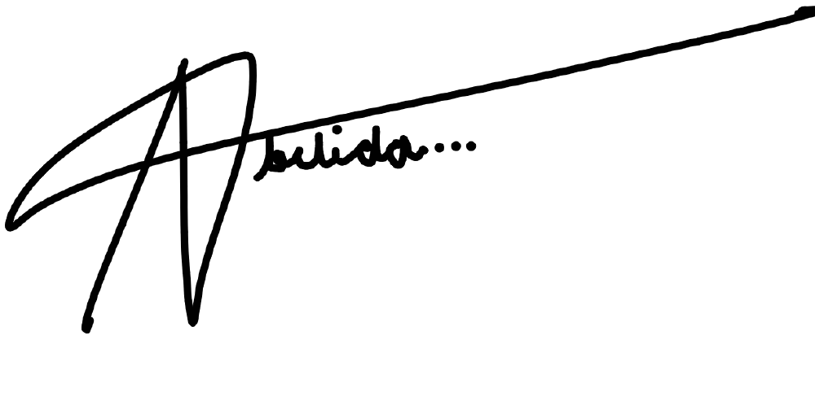deduction; upon separation from the Company, I will return the item(s) issued to me in proper working order; I will replace any items issued to me that are damaged or lost at my expense.

**Employee Signature:**

**Date:** Click or tap to enter a date.

**Released by: Lawrence Jamero Date: 30/06/2025**