Project Report
Smart University Campus Network Design and Traffic Analysis Using Cisco Packet Tracer


Spring 2026
CSE-203L Computer Communication & Networks Lab

Submitted by: Group I
Class Section: B

Group Members
Hashir Ali (24PWCSE2350)
Samiullah (24PWCSE2343)

Submitted to:
Engr. Mahad Shah
July 08, 2026

Department of Computer Systems Engineering
University of Engineering and Technology, Peshawar

Objectives:
The objectives of this project are:
- Design and Implement a Robust Network: Create a secure, scalable and efficient Smart University Campus Network topology utilizing Cisco Packet Tracer.
- Establish Network Segmentation: Implement Virtual Local Area Networks (VLANs) to improve network organization and enhance communication efficiency between different university departments.
- Deploy Inter-VLAN Routing: Configure Router-on-a-Stick architecture to enable controlled and efficient traffic flow between isolated VLANs.
- Automate Network Services: Integrate centralized Dynamic Host Configuration Protocol (DHCP) for automated IP address assignment and Domain Name System (DNS) for reliable hostname resolution.
- Enforce Security Policies: Implement Access Control Lists (ACLs) on the core infrastructure to protect sensitive zones (such as Administration) and enforce strict network access control policies.
Introduction:
Modern universities require reliable and well-organized computer networks to support academic departments, administrative offices, libraries, computer laboratories, student hostels and centralized services. As the number of users and devices increases, a flat network becomes difficult to manage and vulnerable to security threats.
This project presents the design and implementation of a Smart University Campus Network using Cisco Packet Tracer. The network is divided into multiple VLANs to reduce broadcast traffic and improve security. A Router-on-a-Stick architecture is implemented to enable communication between VLANs using a single router interface. DHCP is configured to automatically assign IP addresses to client devices, while DNS is used for hostname resolution. ACLs are implemented to restrict unauthorized communication between departments while allowing access to common services.
Problem Statement:
A university campus contains multiple departments that require secure and efficient communication. Without proper network segmentation, all users share the same broadcast domain, resulting in excessive network traffic, poor performance and limited security. Manual IP address assignment is time-consuming and difficult to manage, while unrestricted communication between departments can lead to unauthorized access to sensitive resources.
The objective of this project is to solve these problems by designing a structured campus network using VLAN segmentation, centralized DHCP and DNS services, inter-VLAN routing and Access Control Lists. The implemented solution provides improved scalability, easier management, automated configuration and enhanced network security.

Methodology:
The Smart University Campus Network was designed and implemented using a systematic approach in Cisco Packet Tracer. The implementation was completed in multiple phases to ensure proper configuration, testing and verification of all networking services.
The methodology followed in this project is summarized below:
- Network Topology Design:
- Designed the overall campus network using a hierarchical architecture consisting of an Edge Router, Core Router, Distribution Switch, Access Switches, Servers and End Devices.

- VLAN Configuration:
- Created separate VLANs for each university department.
- Assigned switch ports to their respective VLANs.
- Configured trunk links between the Distribution Switch and Access Switches.

- Inter-VLAN Routing:
- Configured Router-on-a-Stick using subinterfaces on the Core Router.
- Assigned gateway addresses for all VLANs.

- DHCP Configuration:
- Configured a centralized DHCP Server.
- Created separate DHCP pools for each VLAN.
- Configured DHCP Relay using the ip helper-address command.

- DNS Configuration:
- Configured a DNS Server.
- Added hostname records for different departments and network services.

- Access Control Lists (ACLs):
- Implemented Extended ACLs to restrict Computer Lab and Hostel users from accessing the Administration VLAN while allowing access to shared services.

- Testing and Verification:
- Verified IP address assignment.
- Tested Inter-VLAN communication.
- Tested DNS resolution.
- Verified ACL functionality.
- Analyzed packet flow using Packet Tracer Simulation Mode.

Tools, Software and Components Used:
- Software Used:
Cisco Packet Tracer: Used for network design and simulation

- Networking Devices Used:
- Cisco 2911 Router (Core)
- Cisco 2911 Router (Edge/ISP
- Cisco 2960 Distribution Switch
- Cisco 2960 Access Switches
- DHCP Server
- DNS Server
- PCs
- Cloud

- Network Technologies Used:
- Virtual Local Area Network (VLAN)
- Router-on-a-Stick
- IEEE 802.1Q Trunking
- DHCP
- DNS
- Access Control Lists (ACLs)
- Static Routing
- Packet Tracer Simulation Mode
Project Overview:
The Smart University Campus Network is designed to provide secure, organized and efficient communication among different departments of a university. The network follows a hierarchical design in which a Distribution Switch connects all departmental Access Switches to a Core Router. The Core Router performs Inter-VLAN Routing using Router-on-a-Stick, while an Edge Router provides connectivity toward the external network.
Each department is assigned a separate VLAN and subnet to reduce broadcast traffic and improve network security. Centralized DHCP and DNS servers are deployed within the Server VLAN to automate IP address assignment and hostname resolution. Access Control Lists are configured to enforce security policies by preventing unauthorized access to the Administration department while allowing communication with shared services.
This design improves scalability, simplifies network management and provides a secure environment suitable for a modern university campus.

Network Architecture:
The implemented network consists of the following components:
- Edge Router (Internet Gateway)
- Core Router
- Distribution Switch
- Six Access Switches
- Administration VLAN
- Library VLAN
- Faculty VLAN
- Computer Lab VLAN
- Hostel VLAN
- Server VLAN
- DHCP Server
- DNS Server
- End User PCs

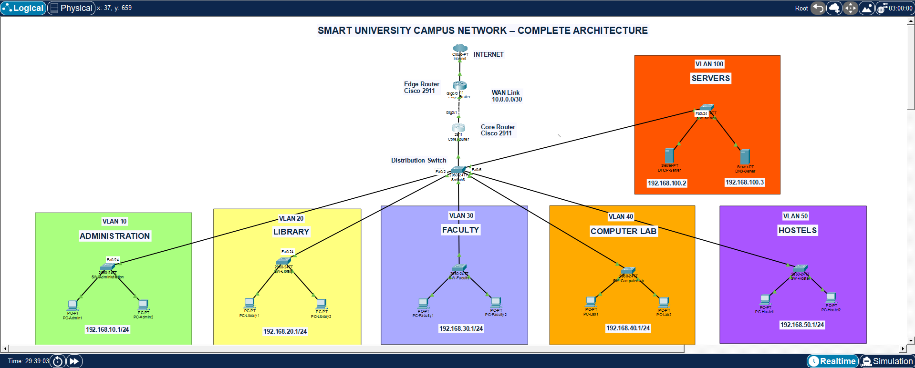
Figure 1: Complete Smart University Campus Network Topology

VLAN Structure:
VLAN ID | Department | Network Address | Default Gateway
10 | Administration | 192.168.10.0/24 | 192.168.10.1
20 | Library | 192.168.20.0/24 | 192.168.20.1
30 | Faculty | 192.168.30.0/24 | 192.168.30.1
40 | Computer Lab | 192.168.40.0/24 | 192.168.40.1
50 | Hostel | 192.168.50.0/24 | 192.168.50.1
100 | Servers | 192.168.100.0/24 | 192.168.100.1

IP Addressing Plan:
Device | IP Address
Core Router G0/0.10 | 192.168.10.1
Core Router G0/0.20 | 192.168.20.1
Core Router G0/0.30 | 192.168.30.1
Core Router G0/0.40 | 192.168.40.1
Core Router G0/0.50 | 192.168.50.1
Core Router G0/0.100 | 192.168.100.1
Core Router WAN | 10.0.0.1/30
Edge Router WAN | 10.0.0.2/30
DHCP Server | 192.168.100.2
DNS Server | 192.168.100.3

Physical Topology Setup:
The first phase of the project involved creating the physical network topology in Cisco Packet Tracer. A hierarchical network architecture was selected to improve scalability, simplify management and support future expansion. The network consists of an Edge Router connected to a Core Router, which is further connected to a Distribution Switch. Six Access Switches were connected to the Distribution Switch, with each switch serving a specific department.
The following departmental networks were created:
- Administration
- Library
- Faculty
- Computer Lab
- Hostel
- Server Network
Each department contains two end-user computers connected to its respective Access Switch. A dedicated Server Switch connects the DHCP Server and DNS Server to the network. The Edge Router represents the Internet Service Provider (ISP) connection, while the Core Router performs inter-VLAN routing.



Figure 2: Physical Topology Implemented in Cisco Packet Tracer

VLAN Configuration:
To improve security and reduce unnecessary broadcast traffic, the network was divided into multiple Virtual Local Area Networks (VLANs). Each department was assigned a unique VLAN ID and subnet. This segmentation ensures that devices in one department remain isolated from other departments unless communication is explicitly allowed through the router.
The following VLANs were configured:

VLAN | Department
10 | Administration
20 | Library
30 | Faculty
40 | Computer Lab
50 | Hostel
100 | Servers

Each Access Switch port connected to a PC was configured as an Access Port and assigned to the corresponding VLAN. The uplink ports connecting the Access Switches to the Distribution Switch were configured as Trunk Ports to allow multiple VLANs to pass through a single physical connection.
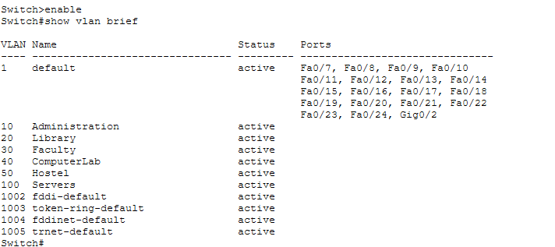
Figure 3: Output of show vlan brief from the Distribution Switch

Router-on-a-Stick Configuration:
Since all VLANs need to communicate with each other, Inter-VLAN Routing was implemented using the Router-on-a-Stick technique. Instead of using multiple physical router interfaces, a single Gigabit Ethernet interface was divided into multiple logical subinterfaces.
Each subinterface was configured with:
- VLAN encapsulation using IEEE 802.1Q
- Gateway IP address
- VLAN identification number
The configured gateway addresses are shown below.

VLAN | Gateway
VLAN 10 | 192.168.10.1
VLAN 20 | 192.168.20.1
VLAN 30 | 192.168.30.1
VLAN 40 | 192.168.40.1
VLAN 50 | 192.168.50.1
VLAN 100 | 192.168.100.1

These gateway addresses allow communication between different VLANs while maintaining logical separation.

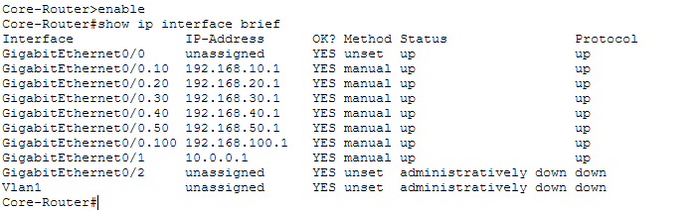

Figure 4: Output of show ip interface brief from the Core Router
DHCP Server Configuration:
To eliminate the need for manual IP configuration, a centralized DHCP Server was deployed in VLAN 100. Separate DHCP pools were created for each department so that devices automatically receive valid network settings upon joining the network.
Each DHCP pool contains:
- Network address
- Default gateway
- DNS server address
- Starting IP address
- Maximum number of users
The Core Router was configured with the ip helper-address command on each VLAN subinterface to forward DHCP broadcast requests to the centralized DHCP Server.
The configured DHCP pools are summarized below.

Department | DHCP Range
Administration | 192.168.10.10 – 192.168.10.200
Library | 192.168.20.10 – 192.168.20.200
Faculty | 192.168.30.10 – 192.168.30.200
Computer Lab | 192.168.40.10 – 192.168.40.200
Hostel | 192.168.50.10 – 192.168.50.200

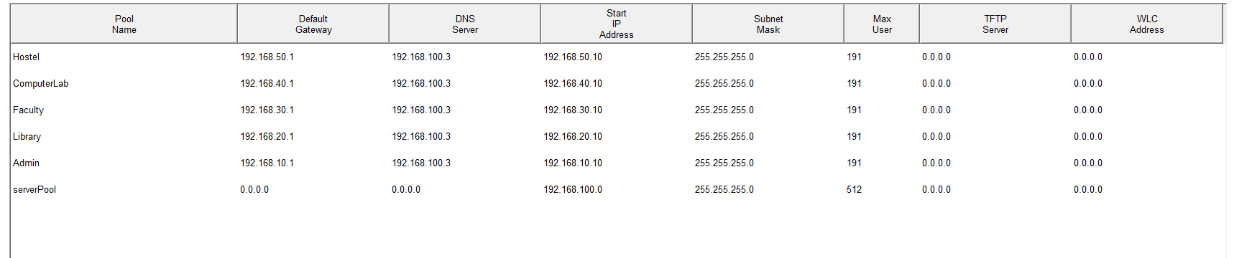
Figure 5: DHCP Service window showing all configured pools

DNS Server Configuration:
A centralized DNS Server was configured within the Server VLAN to provide hostname resolution across the campus network. Instead of using numerical IP addresses, users can communicate using meaningful domain names.
The following DNS records were created.

Hostname | IP Address
admin.campus.edu | 192.168.10.1
library.campus.edu | 192.168.20.1
faculty.campus.edu | 192.168.30.1
lab.campus.edu | 192.168.40.1
hostel.campus.edu | 192.168.50.1
dhcp.campus.edu | 192.168.100.2
dns.campus.edu | 192.168.100.3

When a user enters a hostname, the DNS Server translates it into the corresponding IP address before communication begins. This makes the network easier to use and reduces the need to remember numerical addresses.

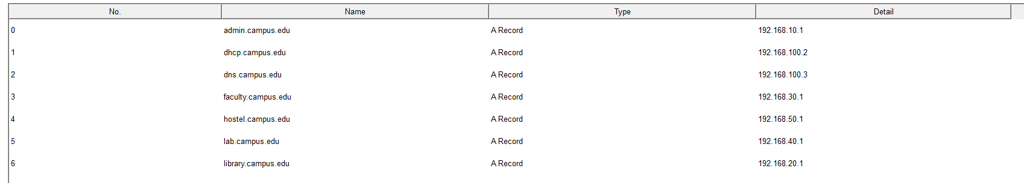

Figure 6: DNS Service window displaying all configured DNS records

Access Control List (ACL) Configuration:
To enhance network security, Extended Access Control Lists (ACLs) were implemented on the Core Router. The purpose of the ACLs was to restrict unauthorized communication between specific departments while allowing access to shared network services.
According to the project requirements, users in the Computer Lab and Hostel VLANs were restricted from accessing the Administration VLAN. However, these users were still allowed to communicate with the DHCP Server, DNS Server and other permitted departments.
Separate ACLs were created for the Computer Lab and Hostel VLANs and applied inbound on their respective router subinterfaces.
ACL Security Policy:

Source VLAN | Administration | Other VLANs | DHCP/DNS Servers
Administration | ✓ | ✓ | ✓
Library | ✓ | ✓ | ✓
Faculty | ✓ | ✓ | ✓
Computer Lab | ✗ | ✓ | ✓
Hostel | ✗ | ✓ | ✓

The implemented ACLs successfully prevented unauthorized access to the Administration department while maintaining normal communication with essential network services.

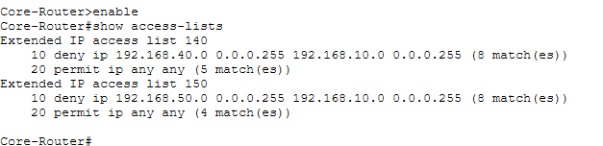
Figure 7: Output of show access-lists from the Core Router

Network Testing and Verification:
After completing the network configuration, several tests were performed to verify that all services were operating correctly.
- DHCP Testing:
Each client computer was configured to obtain an IP address automatically. The DHCP Server successfully assigned the appropriate IP address, subnet mask, default gateway, and DNS server to every client.

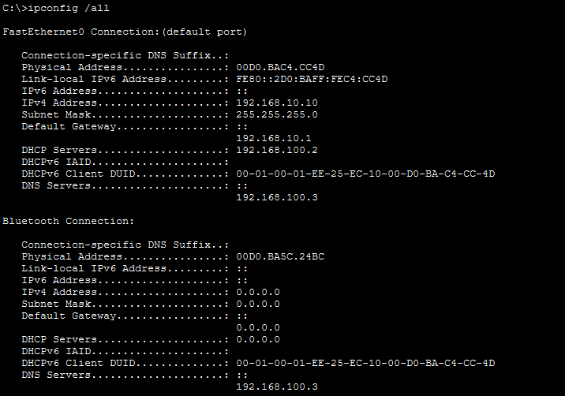

Figure 8: ipconfig /all from PC-Admin1

- Inter-VLAN Routing Testing:
Communication between departments was tested using the ping command. Devices located in different VLANs successfully communicated through the Core Router, confirming that Router-on-a-Stick was functioning correctly.

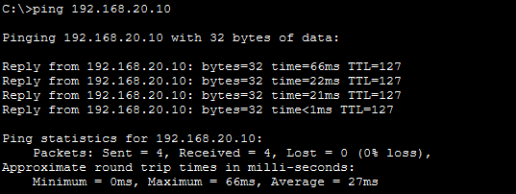

Figure 9: Successful ping from PC-Admin1 to PC-Library1

- DNS Testing:
Hostname resolution was verified by pinging domain names instead of IP addresses. The DNS Server correctly translated the configured hostnames into their corresponding IP addresses.

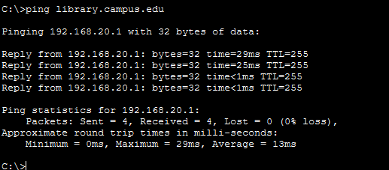

Figure 10: Command Prompt showing ping library.campus.edu resolving successfully

- ACL Testing:
Security policies were verified by attempting communication between restricted VLANs and the Administration VLAN.
The Computer Lab and Hostel VLANs were unable to access Administration resources, while Faculty and Library users communicated successfully. Access to the DHCP and DNS servers remained available for all departments.

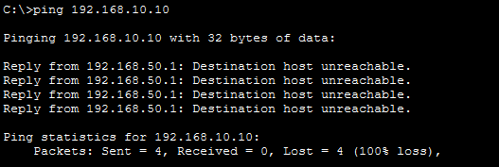
Figure 11: Failed ping from PC-Hostel1 to PC-Admin1

Packet Tracer Simulation Analysis:
Cisco Packet Tracer Simulation Mode was used to analyze packet movement throughout the network. This feature provided a visual representation of how packets travel between devices and helped verify the correct operation of network protocols.
The following scenarios were analyzed:
- DHCP Process:
The DHCP process followed the standard DORA sequence:
- Discover
- Offer
- Request
- Acknowledge
This confirmed that the DHCP Server was correctly assigning network parameters to client devices.

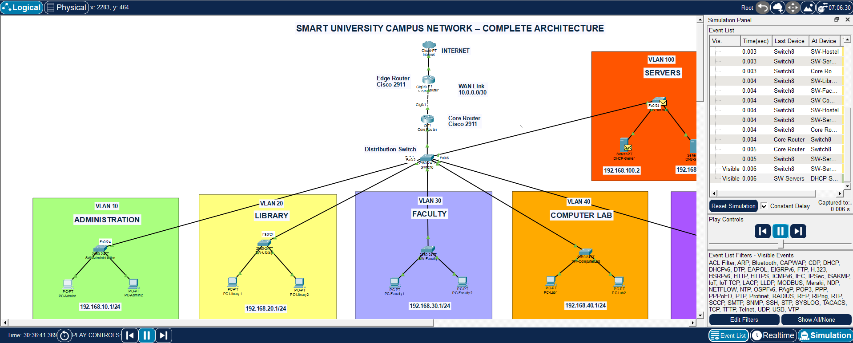

Figure 12: DHCP Discover Message Arrived Successfully at DHCP Server

Similarly, it will follow the rest of DORA process.

- DNS Process:
When a hostname was entered, the client first sent a DNS query to the DNS Server. After receiving the corresponding IP address, communication continued using ICMP packets.

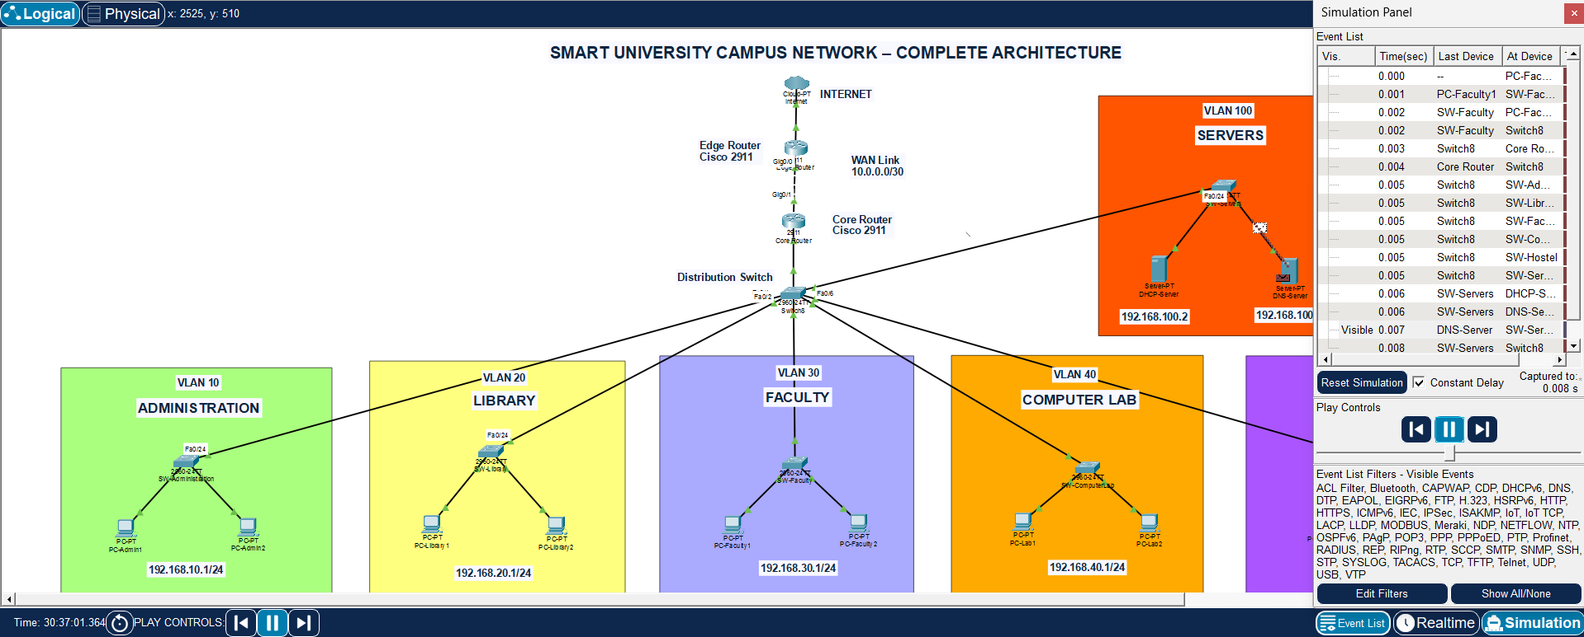

Figure 13: DNS Response on its Way Towards Client Query

- ACL Verification:
When a Computer Lab client attempted to access the Administration VLAN, the packet reached the Core Router and was discarded by the configured ACL. This verified that the implemented security policy was functioning correctly.

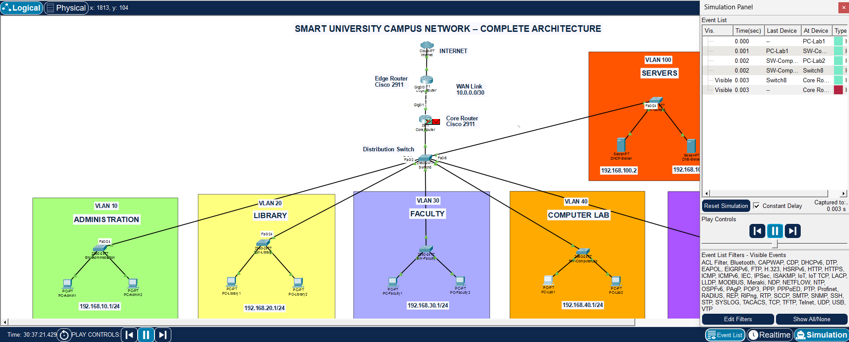

Figure 14: Packet Being Declined by the Core Router

Results:

Test Performed | Result
Physical Topology | ✓ Pass
VLAN Configuration | ✓ Pass
Trunk Configuration | ✓ Pass
Inter-VLAN Routing | ✓ Pass
DHCP Configuration | ✓ Pass
DNS Configuration | ✓ Pass
ACL Configuration | ✓ Pass
Packet Simulation | ✓ Pass

Observations:
- VLAN segmentation reduced unnecessary broadcast traffic.
- Router-on-a-Stick enabled efficient communication between VLANs.
- DHCP simplified client configuration by assigning IP addresses automatically.
- DNS allowed users to access network resources using hostnames instead of IP addresses.
- ACLs successfully prevented unauthorized communication while maintaining access to shared services.
- Packet Tracer Simulation Mode clearly illustrated packet flow and protocol operations.
Conclusion:
The Smart University Campus Network was successfully designed and implemented using Cisco Packet Tracer. The project fulfilled all the planned objectives by providing a structured, secure and scalable network infrastructure for different university departments.
The network was logically divided using Virtual Local Area Networks (VLANs), allowing each department to operate within its own broadcast domain. Inter-VLAN communication was successfully achieved using the Router-on-a-Stick technique, enabling efficient communication between departments while maintaining network segmentation.
A centralized DHCP Server automated IP address assignment, reducing manual configuration and minimizing the possibility of addressing errors. Similarly, a DNS Server was configured to translate hostnames into IP addresses, making network resources easier to access and manage.
Network security was improved through the implementation of Extended Access Control Lists (ACLs), which restricted unauthorized communication between specific departments while still allowing access to shared services such as DHCP and DNS. Extensive testing and packet analysis using Packet Tracer Simulation Mode confirmed that all configured services operated correctly.
References:
The following resources were used during the development of this project:
- Cisco Networking Academy, Introduction to Networks (ITN), Cisco Systems.
- Cisco Networking Academy, Switching, Routing and Wireless Essentials (SRWE), Cisco Systems.
- Andrew S. Tanenbaum and David J. Wetherall, Computer Networks, 5th Edition, Pearson Education.
- Behrouz A. Forouzan, Data Communications and Networking, 5th Edition, McGraw-Hill Education.

