HCI & GRAPHICS • PROJECT REPORT
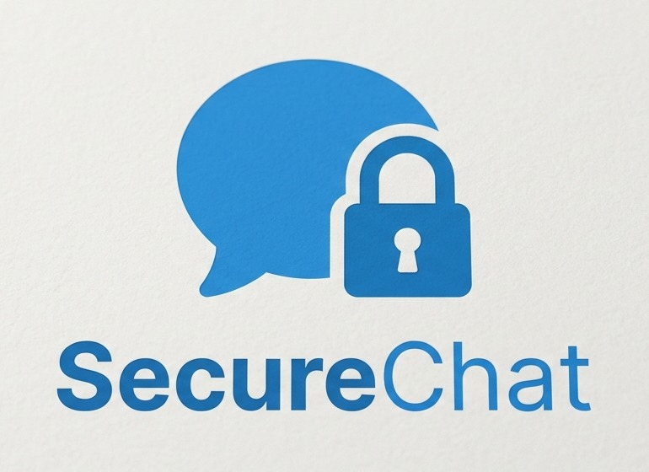
Privacy and Data Ethics
in UX Design
Human-centred design case study implemented through SecureChat
PROJECT POSITION Privacy is a visible interaction between the user and system—not a hidden policy or purely technical claim.

Academic detail | Information
Institution | Iqra University
Programme | BS Computer Science
Semester | 5th Semester
Course | Human–Computer Interaction & Graphics
Student | ____________________________
Instructor | ____________________________
Submission date | ____________________________

1. Introduction

Problem Statement
Digital messaging interfaces often request personal information and expose behavioural signals without helping users understand the consequences. Privacy controls may be hidden, technical or disconnected from the moment of choice. This creates uncertainty, weak consent and reduced trust.

Objectives
- Design an understandable consent-first communication flow.
- Make privacy consequences visible beside each relevant control.
- Give users meaningful control over identity, presence, receipts, typing, retention and stored data.
- Apply Shneiderman’s Eight Golden Rules to a realistic interactive system.
- Support accessibility and honest security communication without overwhelming users.

Scope
Included | Boundary
HCI focus | Usability, learnability, feedback, consistency, accessibility, control and error recovery.
Data ethics | Minimisation, informed consent, transparency, user agency and responsible defaults.
Interactive context | A responsive secure-chat web application used as a design case study.
Excluded | Production-scale deployment, commercial operations and claims of audited messenger-level security.
RESEARCH QUESTION How can a chat interface make privacy understandable and actionable while remaining familiar and efficient?

2. System Overview

SecureChat — Short Overview
SecureChat is an academic messaging prototype that embeds privacy decisions into normal chat tasks. Users can discover accounts through limited username suggestions, request consent before interaction, exchange protected content, manage visibility, and review or remove their data.

Main Features
Feature | User value
Consent-first requests | The receiver sees an introduction and chooses Accept or Decline before relationship signals are shared.
Browser E2EE | Message, attachment and voice-note content is encrypted in registered browsers.
Privacy controls | Discoverability, profile visibility, online status, receipts, typing and notifications are configurable.
Safe recovery | Users can cancel requests, edit/delete messages, clear their own chat view and confirm destructive actions.
Accessibility | Text size, contrast, reduced motion, keyboard focus and understandable status feedback are supported.
Data control | Users can request an encrypted archive and access protected account deletion.

Primary User Flow
01  Discover  Type 2+ username characters | 02  Request  Send one introduction | 03  Consent  Accept or decline | 04  Communicate  Message with feedback | 05  Control  Manage privacy and data
INFORMATION ARCHITECTURE Chats, Privacy and Settings remain primary. The profile photo at the rail bottom continuously identifies the logged-in account.

3. HCI & Data Ethics Design

HCI Principles and Shneiderman’s Golden Rules
Golden Rule | SecureChat evidence
Consistency | Shared navigation, controls, language, spacing and dialog patterns.
Shortcuts | Ctrl/Cmd + K focuses search; familiar icons support repeat use.
Feedback | Skeletons, connection state, receipts, success notices and clear errors.
Closure | Requests, saves, uploads, logout and deletion end with visible outcomes.
Error prevention | Validation, disabled invalid actions and confirmations before destructive tasks.
Easy reversal | Cancel requests, edit/delete messages, remove photos and change preferences.
User control | Users initiate permissions and choose privacy, retention and account actions.
Reduce memory load | Visible labels, contextual help, identity cues and progressive disclosure.

Privacy by Design
Privacy defaults and explanations are built into the task flow. Email is not searchable; username results are limited; profile visibility is controlled; new contacts cannot observe presence, typing or read activity before consent.

Consent & Transparency
The request introduction supports an informed decision. Security screens distinguish protected content from service-visible metadata and clearly state the academic prototype’s limitations.

User Control
Users can manage discovery, profile photo visibility, online status, receipts, typing, notification detail, disappearing messages, local chat clearing, data export and account deletion.

Accessibility
The interface supports keyboard focus, readable labels, contrast adjustment, scalable text, reduced motion, stable scrolling and status announcements. Short transitions aid orientation but never become essential to task completion.

4. System Implementation & Outputs
The following outputs are included as interaction evidence. Blue frames identify the evaluated interface state; captions explain the HCI and ethical purpose rather than implementation code.

4.1 Main Chat and End-to-End Encryption
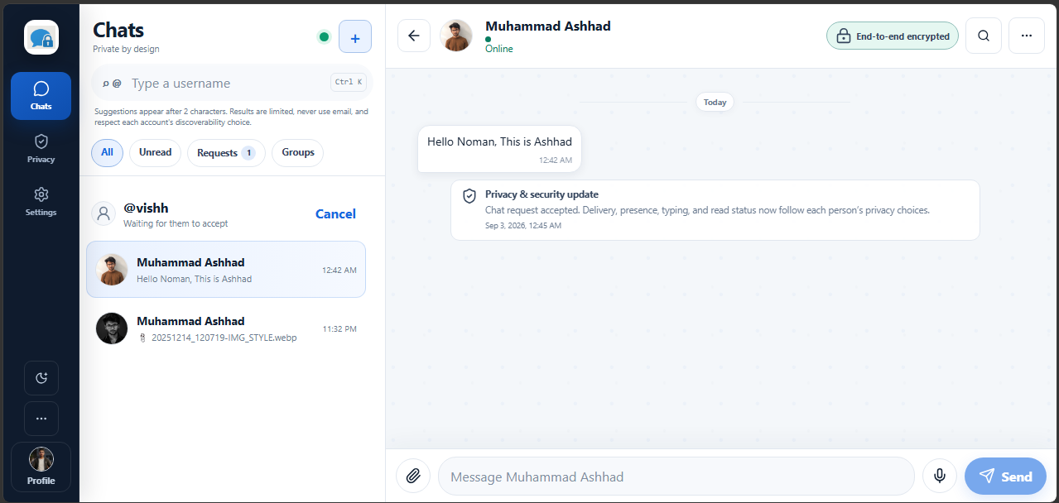
Figure 1 — Main chat and E2EE state. The fixed header communicates participant identity and encryption status, while the fixed composer preserves action continuity. Only message history scrolls, reducing disorientation and supporting consistency.
HCI FOCUS Visibility of system status • consistent layout • low memory demand • user confidence

4.2 Search and Consent-First Chat Request
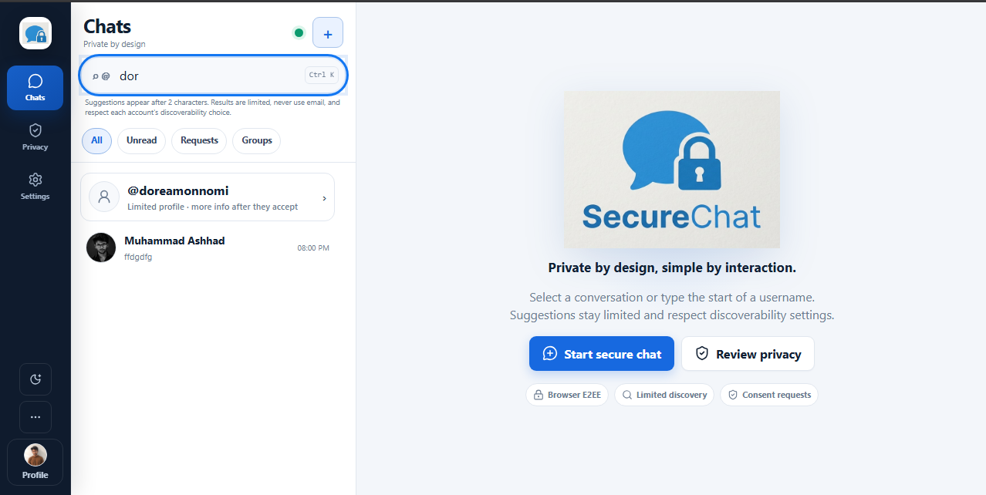 | 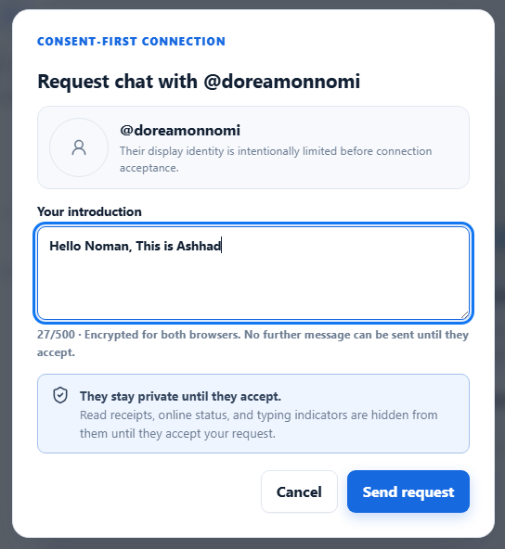
Figure 2 — Progressive discovery and request composition. Limited suggestions appear after two characters. The request dialog explains privacy consequences before sending, keeps the introduction editable, and clearly separates Cancel from the primary action.

Ethical rationale
The design balances discoverability with minimisation: it does not search email, returns a limited set, and respects incognito settings. The recipient controls whether communication begins.
HCI FOCUS Progressive disclosure • error prevention • meaningful consent • informative feedback

4.3 Privacy Settings
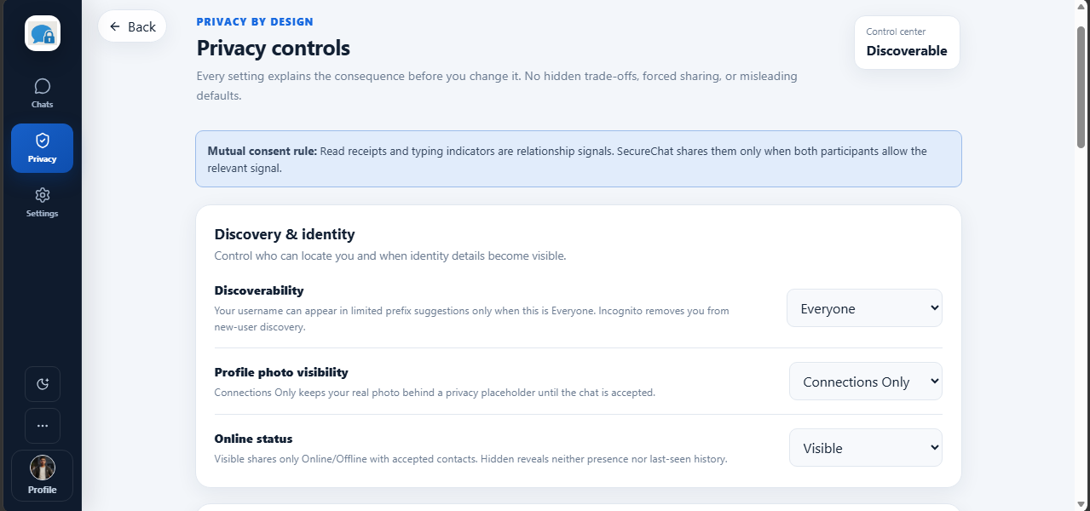
Figure 3 — Privacy control centre. Each setting describes its consequence before change. Related identity controls are grouped together, and the mutual-consent rule explains that relationship signals depend on both participants’ choices.

Why this screen matters
The screen turns abstract privacy into understandable decisions. Labels use user language, defaults remain visible, and the current discovery state provides immediate closure.
HCI FOCUS Recognition over recall • clear mapping • transparency • internal locus of control

4.4 Group Consent and Encrypted Attachments
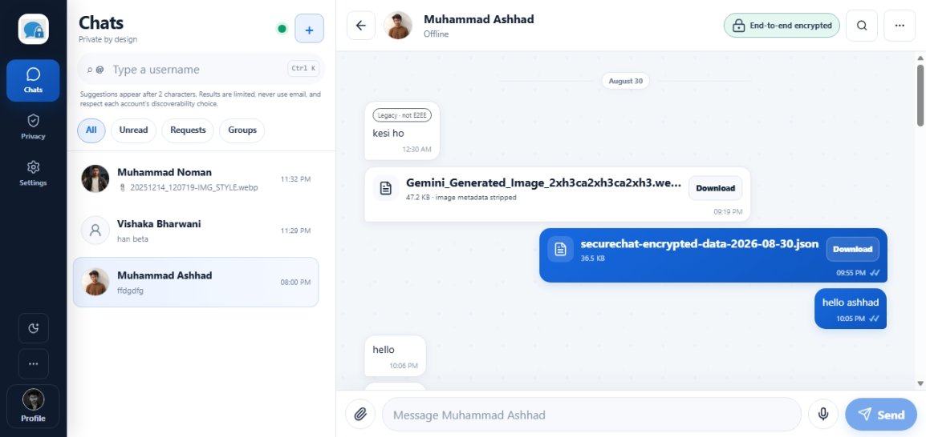 | 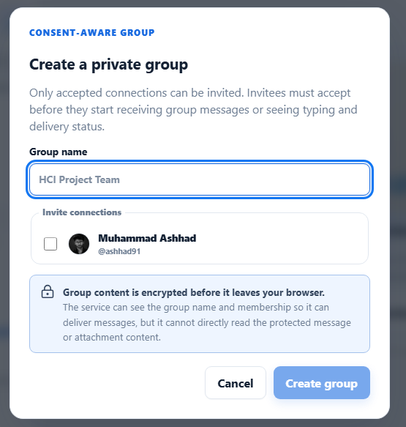
Figure 4 — Protected media and consent-aware groups. The chat shows encrypted file exchanges with clear download actions. Group creation restricts invitations to accepted connections and explains that invitees receive no content or activity until acceptance.

Interaction outcome
Security information appears near the action it affects. This supports comprehension without forcing users to remember rules from another screen.
HCI FOCUS Contextual guidance • controlled disclosure • familiar actions • privacy by default

4.5 Data Control and Account Wipe
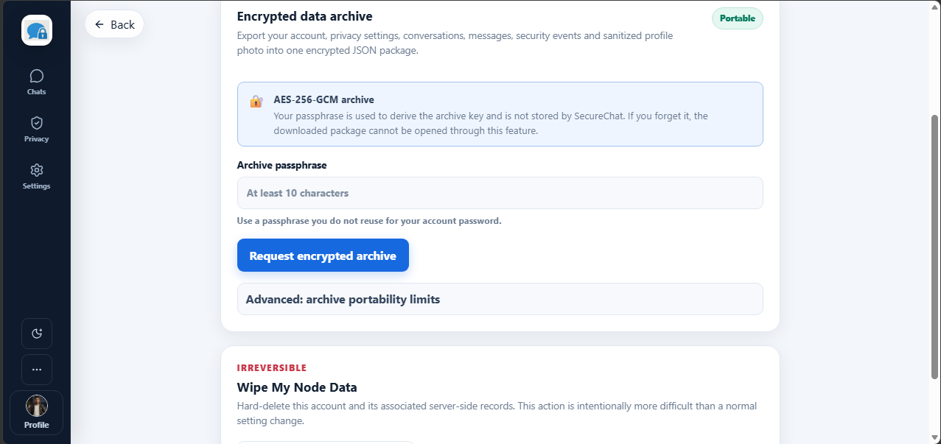
Figure 5 — Data portability and irreversible deletion. Archive export explains the separate passphrase and its recovery boundary. Account wiping is visually separated and labelled irreversible, adding deliberate friction where mistakes would be costly.

Ethical rationale
Portability supports ownership; deletion supports autonomy. The interface avoids false reassurance by explaining what the archive contains and why an irreversible action requires stronger confirmation.
HCI FOCUS Error prevention • clear consequence • closure • responsible friction

5. Evaluation
A task-based heuristic review was conducted across desktop and compact layouts. The review assessed completion, consistency, feedback, privacy comprehension, accessibility and recovery.
Task | Observed outcome | Result
Create account on short screen | All fields reachable without zooming. | Pass
Search a username | Related results appear after two characters. | Pass
Send/accept request | Introduction and consent boundary remain visible. | Pass
Open/close chat | Header/composer stay fixed; messages alone scroll. | Pass
Change privacy setting | Immediate confirmation without layout shift. | Pass
Export or wipe data | Consequences and destructive scope are explicit. | Pass

Key Findings
- Consequences are easier to understand when explained beside the control.
- Consent-first requests reduce unwanted behavioural disclosure.
- Visible feedback and recovery actions improve confidence in sensitive tasks.
- Honest limits make security communication more credible than absolute claims.

Limitations
This is an academic prototype evaluated through heuristic and task review, not a production messenger or large-sample study. Future evaluation should include representative participants, task time, error rate, completion rate and a brief post-task usability questionnaire.

6. Conclusion
SecureChat demonstrates how Privacy and Data Ethics can become visible parts of UX design. The interface combines meaningful consent, minimisation, transparency, accessibility and user control with familiar chat patterns. Its core HCI contribution is not the number of controls; it is helping users predict outcomes, understand boundaries and recover from mistakes.
FINAL DESIGN CLAIM A secure experience is usable only when people understand what is happening and remain in control.

Short Viva Showcase
- Identify the logged-in account using the bottom profile photo.
- Type two username characters and explain limited, privacy-aware discovery.
- Send a request and explain the pre-acceptance consent boundary.
- Open an accepted chat and point out E2EE status, fixed controls and message feedback.
- Change a privacy setting and show its consequence and confirmation.
- Open Data Control and explain portability versus irreversible deletion.

References
- Shneiderman, B. et al. Designing the User Interface, 6th ed. https://www.cs.umd.edu/users/ben/goldenrules.html
- European Union. GDPR Article 5 — transparency and data minimisation. https://eur-lex.europa.eu/legal-content/EN/TXT/?uri=CELEX:32016R0679
- NIST Privacy Framework. https://www.nist.gov/privacy-framework
- W3C. Web Content Accessibility Guidelines (WCAG) 2.2. https://www.w3.org/TR/WCAG22/

