Cloud Computing Final Project Submission
  - Cloud-Native Microservices DevOps Project
Course: Lab-DevOps for Cloud Computing
Repository: https://github.com/hashirjutt13/cloud-native-microservices-devops-project

Team Members
Name | Roll Number | Role | Assigned Area
Hashir Sarwar | fa23-bcs-065 | Team Lead | Dashboard, repo setup, CI/CD, final submission
Soban Rabbani | fa23-bcs-082 | Member | User/Product contribution and PR proof
Abdul Hadi | fa23-bcs-012 | Member | Order/Notification contribution and PR proof

Project Summary
This project implements a DevOps-focused cloud-native e-commerce platform with a frontend dashboard, four REST microservices, Docker containerization, GitHub Actions, Jenkins pipeline artifacts, Kubernetes manifests, Render deployment hooks, and documentation for final submission.
Item | Status
GitHub repository | Created and public
Git Flow branches | main, develop, release
GitHub Environments | development, staging, production
Docker Hub | Images published under hashirsarwar
GitHub Actions | CI, Docker Publish, and Render Deploy successful
Team member PRs | Pending: Soban and Abdul Hadi

Submission URLs
Field | URL / Value
GitHub Repository | https://github.com/hashirjutt13/cloud-native-microservices-devops-project
Docker Hub | https://hub.docker.com/u/hashirsarwar
Development Environment | Paste final Render development URL here
QA/Staging Environment | Paste final Render staging URL here
Production Environment | Paste final Render production URL here

Team Lead Screenshots
The following screenshots were captured from the team-lead side and are ready for submission evidence.

GitHub Repository Home
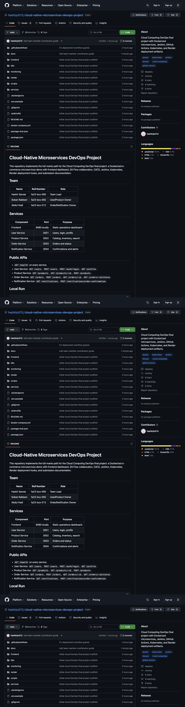
teamlead-01-repo-home.png

GitHub Branches
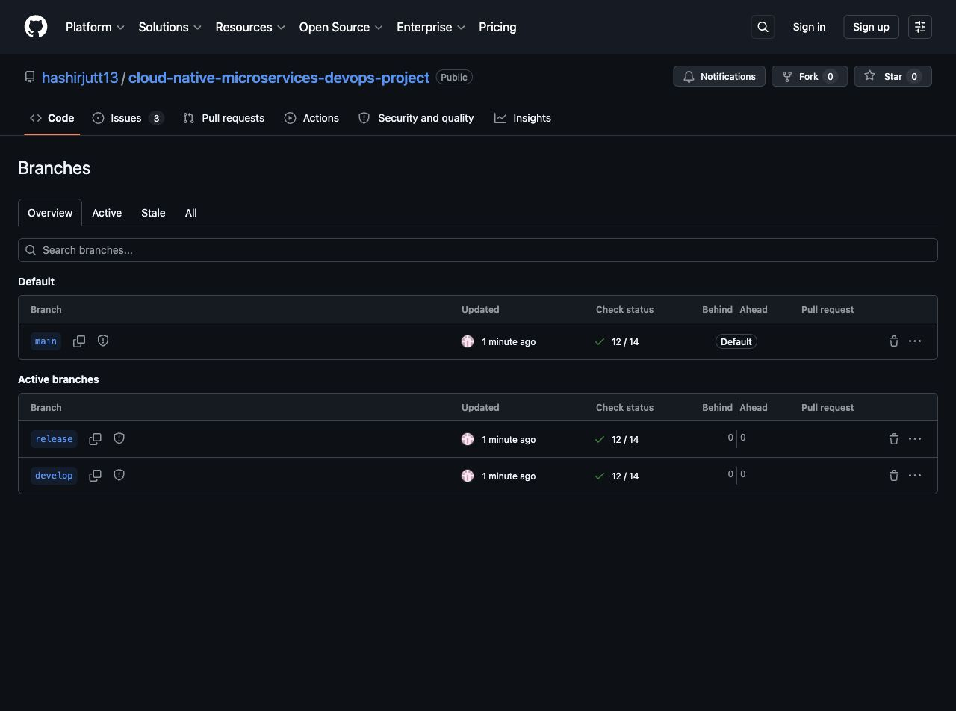
teamlead-02-branches.png

GitHub Actions Runs
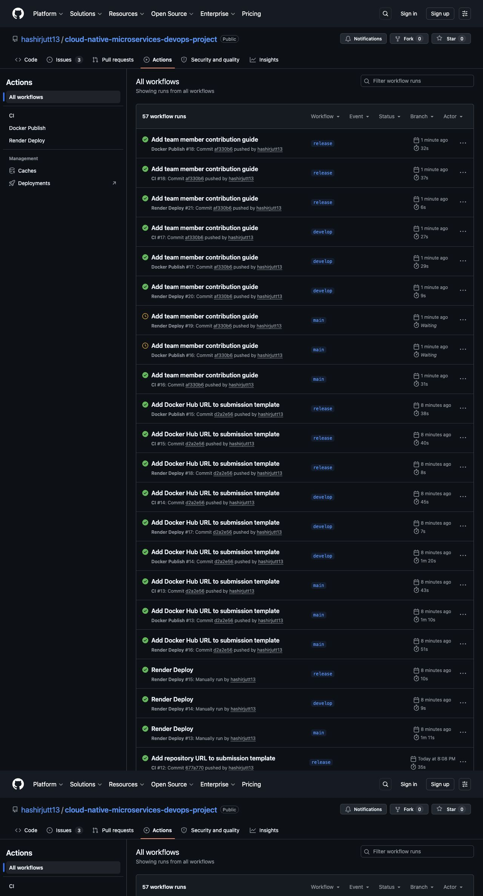
teamlead-03-actions.png

GitHub Issues And Member Tasks
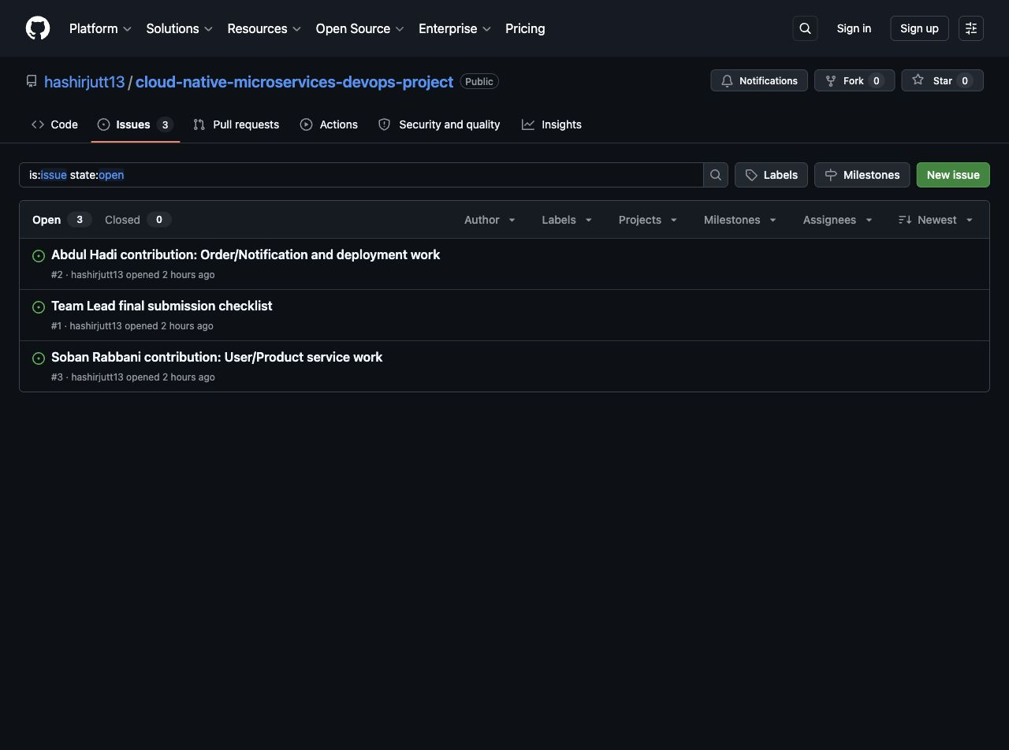
teamlead-04-issues.png

Docker Hub Images
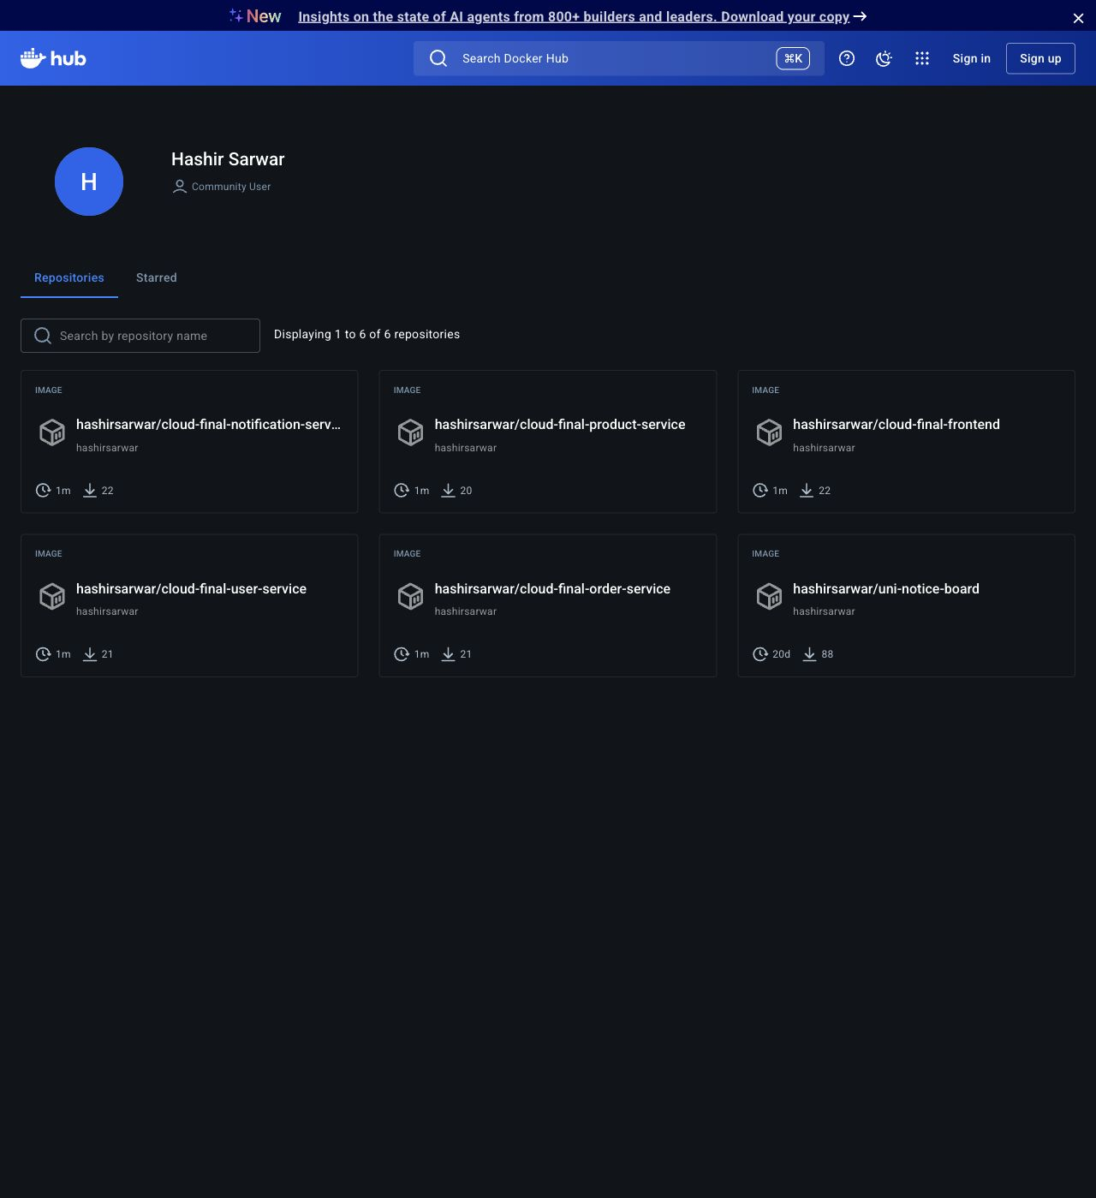
teamlead-05-dockerhub-images.png

Repository Setup Proof
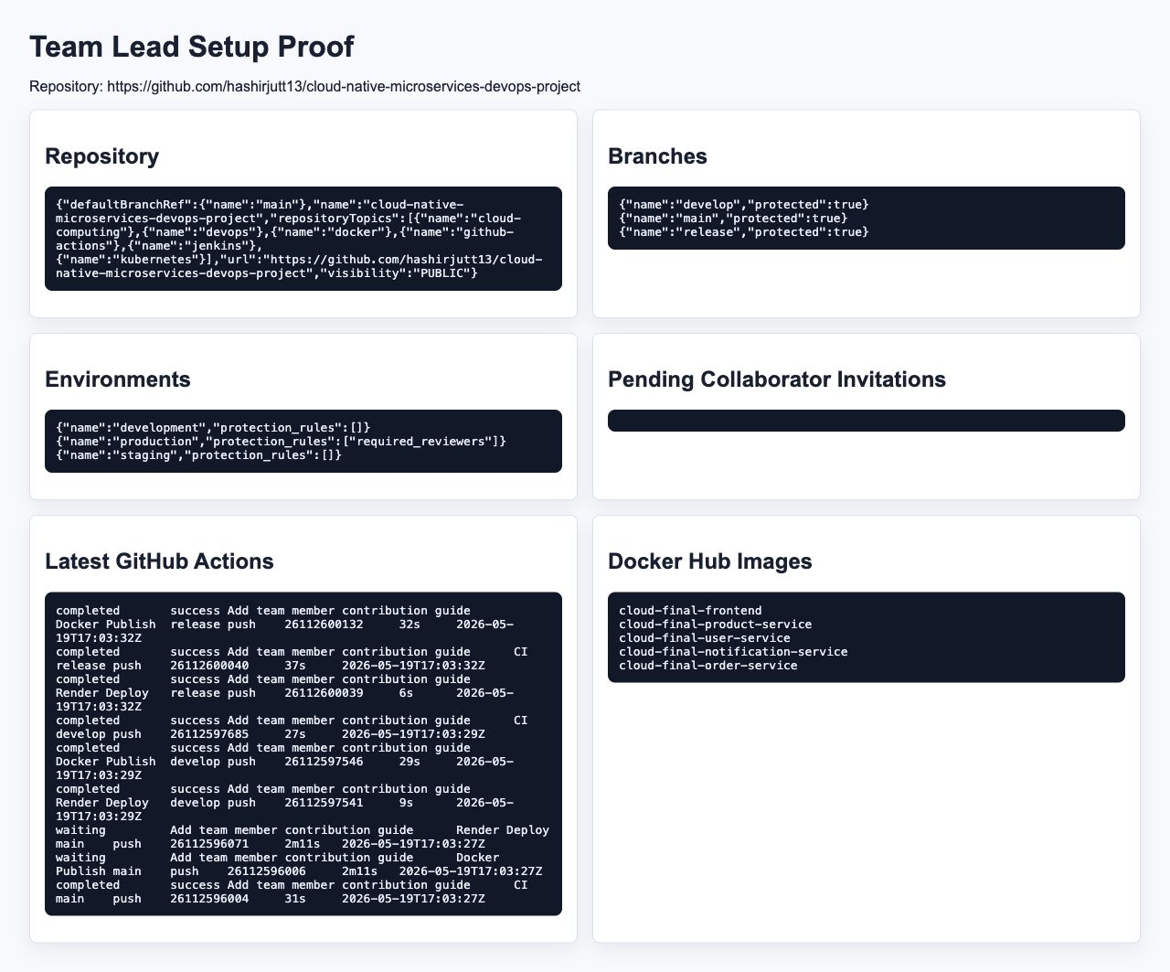
teamlead-13-setup-proof.png

Local Dashboard
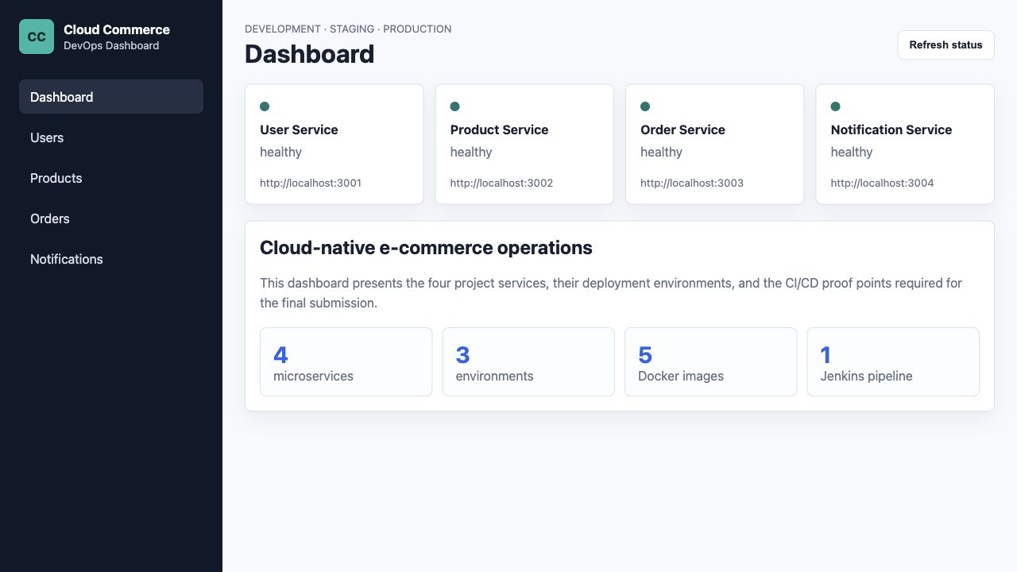
teamlead-08-local-dashboard.png

Local Users Page
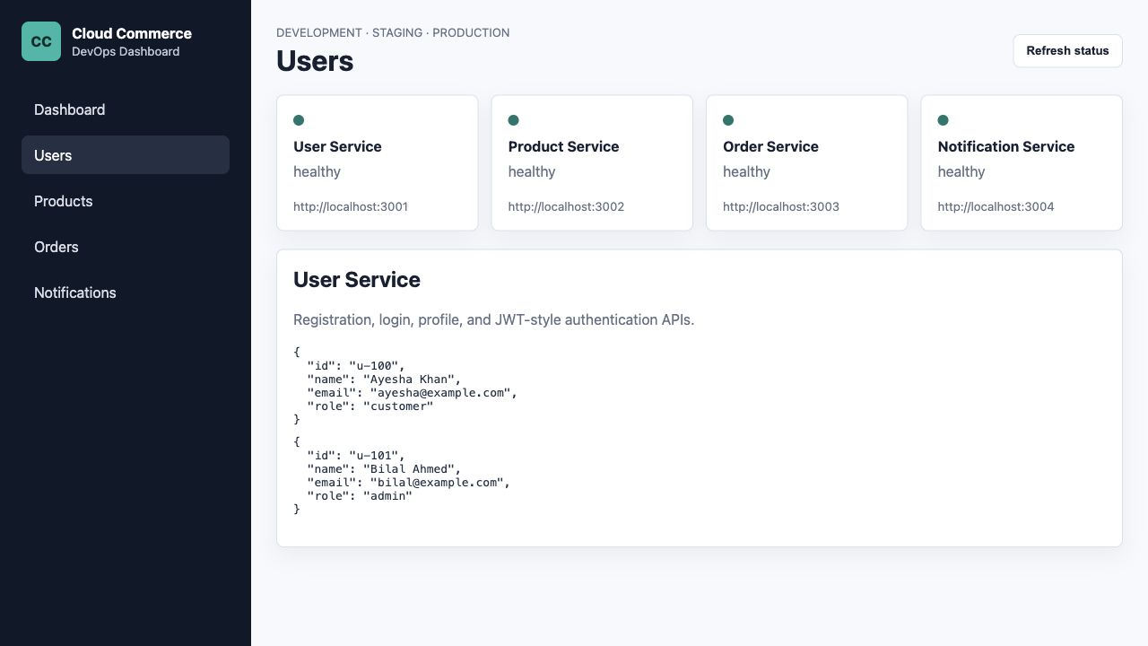
teamlead-09-local-users.png

Local Products Page
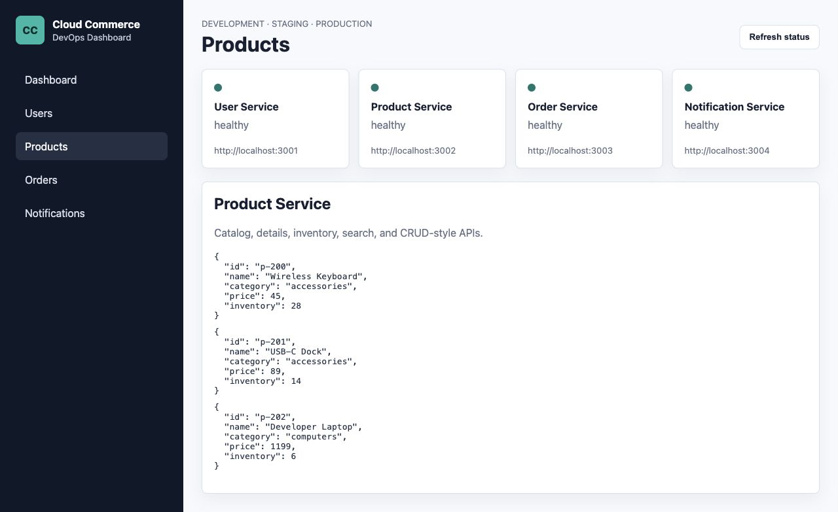
teamlead-10-local-products.png

Local Orders Page
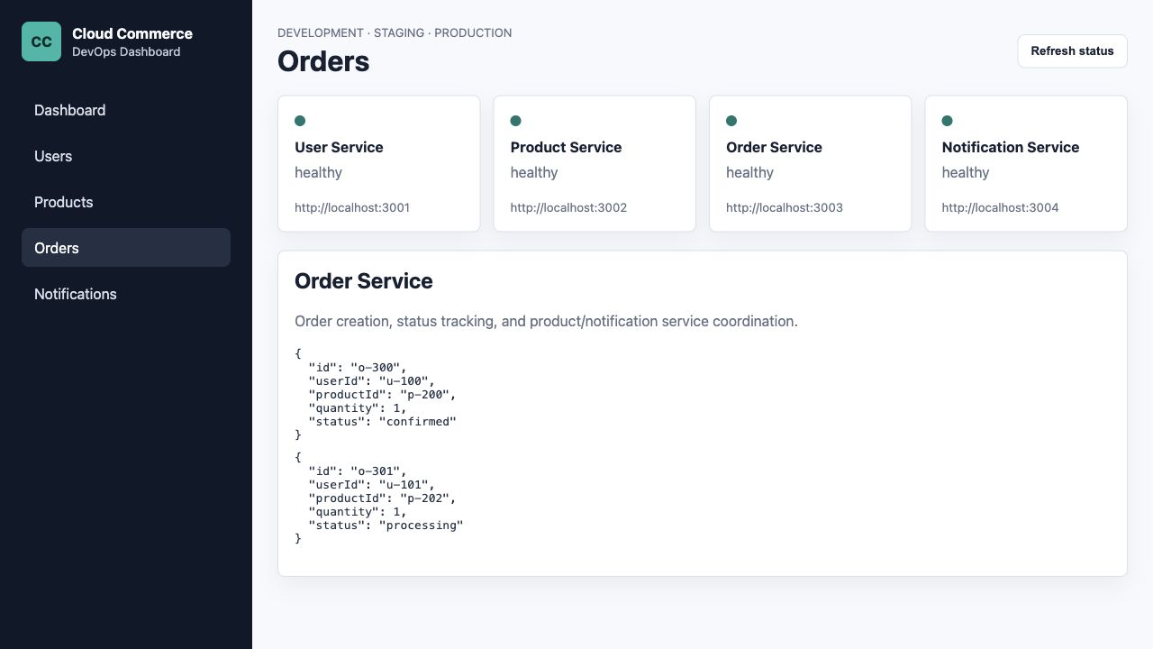
teamlead-11-local-orders.png

Local Notifications Page
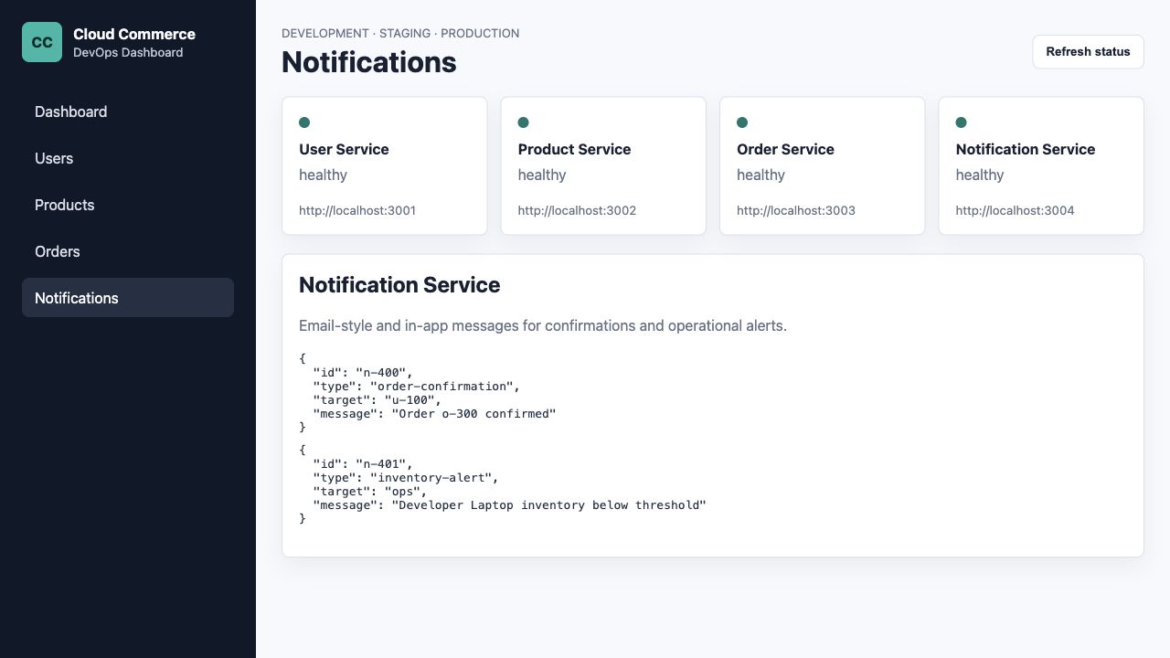
teamlead-12-local-notifications.png

Pending Team Member Screenshots
Paste the following screenshots after Soban Rabbani and Abdul Hadi complete their feature branches and pull requests. These placeholders are intentionally blank.

Soban Screenshot 1: Repo Access
PASTE SCREENSHOT HERE\nShow the repository page after accepting the invitation.

Soban Screenshot 2: Local Checks
PASTE SCREENSHOT HERE\nShow terminal output after npm run check passes.

Soban Screenshot 3: Feature Branch
PASTE SCREENSHOT HERE\nShow branch feature/soban-user-product on GitHub.

Soban Screenshot 4: Commit Proof
PASTE SCREENSHOT HERE\nShow Soban's commit author and message.

Soban Screenshot 5: Pull Request
PASTE SCREENSHOT HERE\nShow PR title and base branch develop.

Soban Screenshot 6: PR CI Passed
PASTE SCREENSHOT HERE\nShow green checks on the PR.

Abdul Hadi Screenshot 1: Repo Access
PASTE SCREENSHOT HERE\nShow the repository page after accepting the invitation.

Abdul Hadi Screenshot 2: Local Checks
PASTE SCREENSHOT HERE\nShow terminal output after npm run check passes.

Abdul Hadi Screenshot 3: Feature Branch
PASTE SCREENSHOT HERE\nShow branch feature/abdul-order-notification on GitHub.

Abdul Hadi Screenshot 4: Commit Proof
PASTE SCREENSHOT HERE\nShow Abdul Hadi's commit author and message.

Abdul Hadi Screenshot 5: Pull Request
PASTE SCREENSHOT HERE\nShow PR title and base branch develop.

Abdul Hadi Screenshot 6: PR CI Passed
PASTE SCREENSHOT HERE\nShow green checks on the PR.

Reflection Drafts
Hashir Sarwar: I learned how a DevOps project is structured end to end, from Git Flow and branch protection to Docker images, CI/CD pipelines, and Kubernetes deployment.
Soban Rabbani: I worked with service/page ownership and saw how individual contributions fit into a shared repository through feature branches and pull requests.
Abdul Hadi: I focused on deployment and pipeline artifacts, including Jenkins, Kubernetes manifests, and environment promotion.

Final Checklist
- Soban accepts GitHub invitation and opens PR into develop.
- Abdul Hadi accepts GitHub invitation and opens PR into develop.
- Team lead merges PRs and promotes develop to release, then release to main.
- Paste remaining member screenshots into this document.
- Paste final Render environment URLs.
- Export or submit this Word document according to instructor instructions.

