Database Management
Project Milestone 2

Member Details:

Member 1 ID: 22i-0754
Member 1 Name: Hashir Khan
Section: CS-F

Member 2 ID: 22i-1284
Member 2 Name: Mahtab Ahmed
Section: CS-F

Member 3 ID: 22i-0884
Member 3 Name: Dilawar Rasool
Section: CS-F

Main Menu:
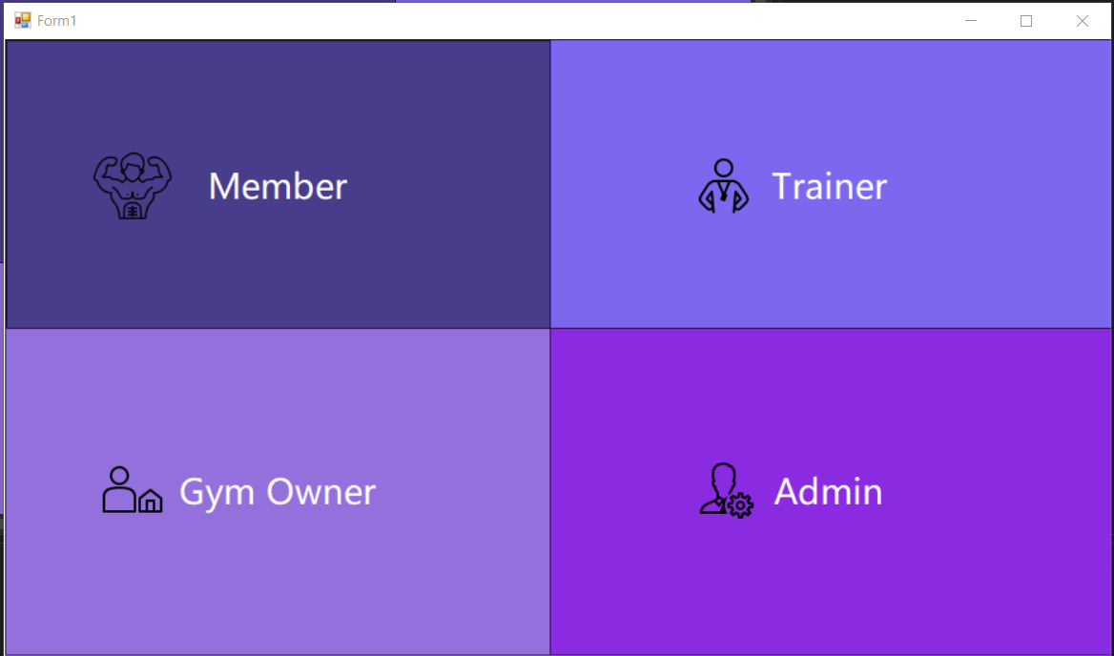
The main menu screens shows the user 4 different interfaces so that they can login into or register into whichever category they want to.

Trainer Interfaces:
- Log in:
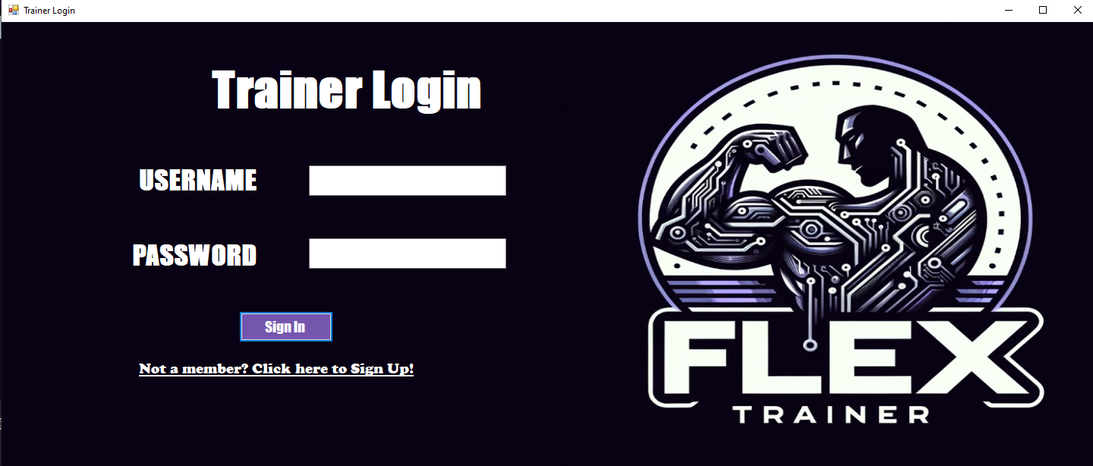
Allows trainers to log in to their flex trainer accounts and also has a redirect link to the sign up page.

- Sign Up:
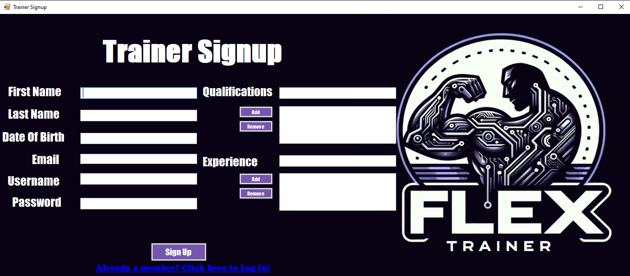
Here the trainer who wants to sign up can enter their information in text boxes and sign up, or if they already have an account they can get redirected to the login page.
- Trainer Menu:
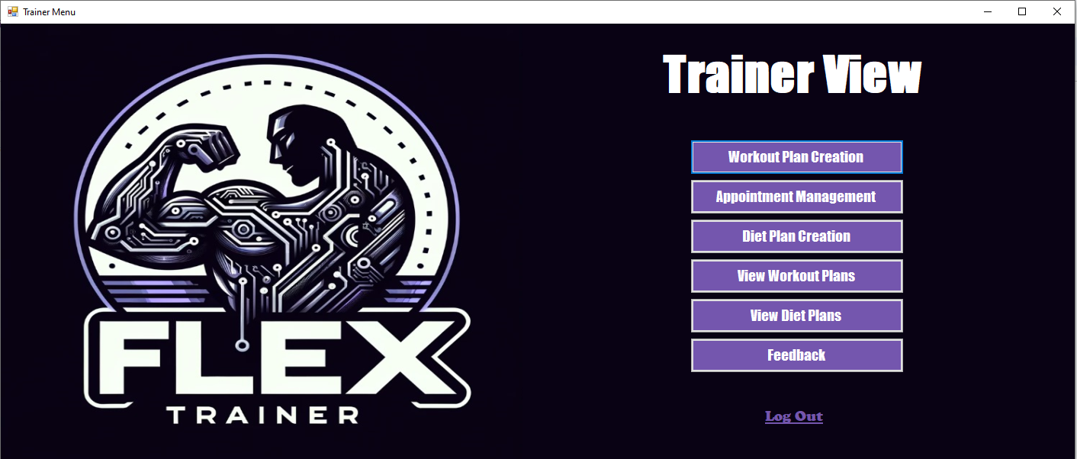
Here the trainer can view and visit all the facilities provided on the Flex Trainer app and if they want to they can log out using the link at the bottom.

- Workout Plan Creation:
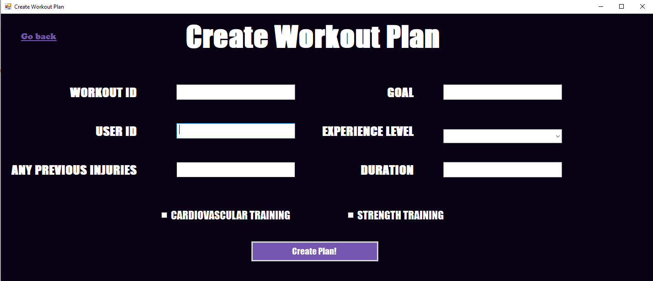
Here the trainer can create a workout for a specific user by filling the following fields and once the trainer clicks on create plan, they will get a message to tell them that the plan is created successfully and be redirected to appointment management.

- Appointment Management:
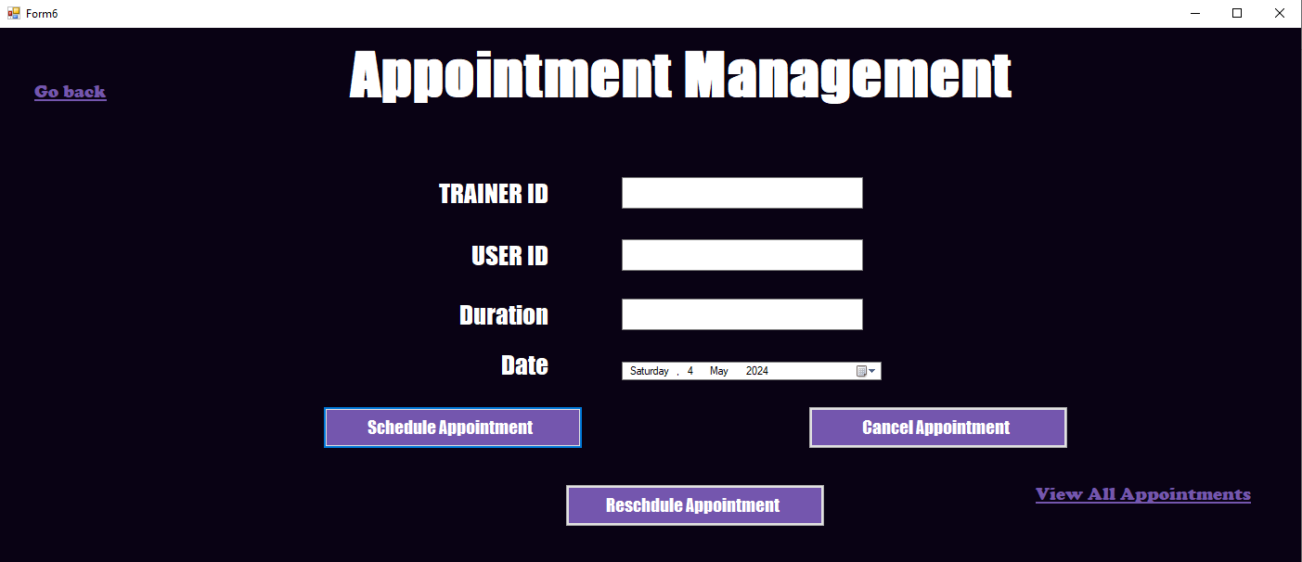
Here the trainer can set up, reschedule or cancel appointments with specific users by filling the information and the trainer can also go and view all appointments that are currently scheduled.

- All Appointments:
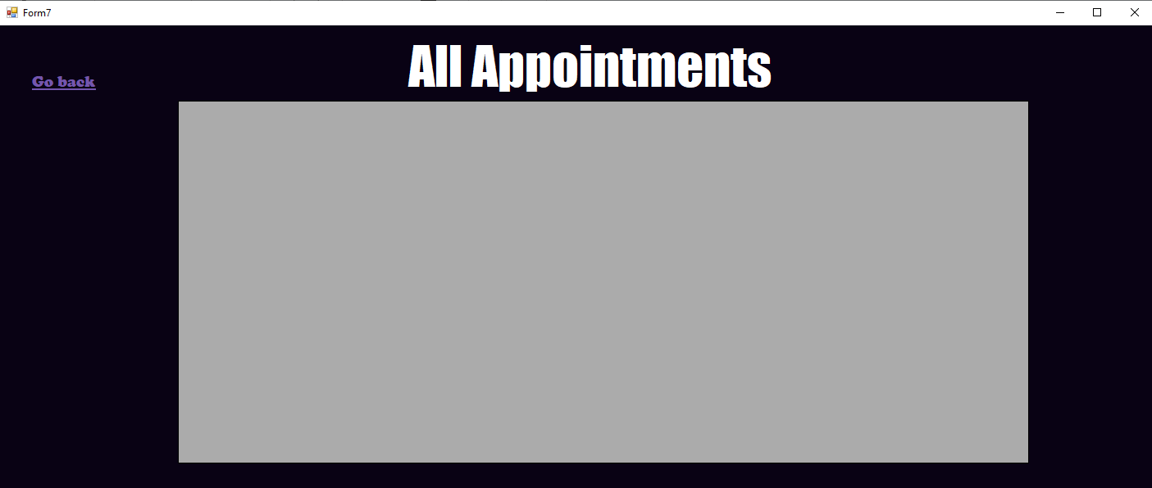
Here the trainer will be able to view all appointments booked right now in a grid view or go back to the menu.

- Diet Plan Creation:
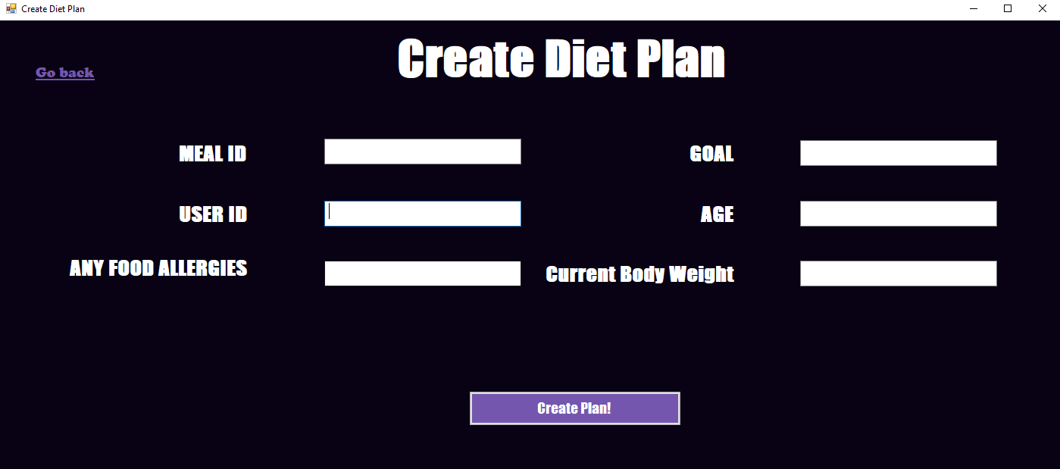
Here the trainer can create diet plans for specific users by filling the information or go back to the menu.

- View Diet Plans:
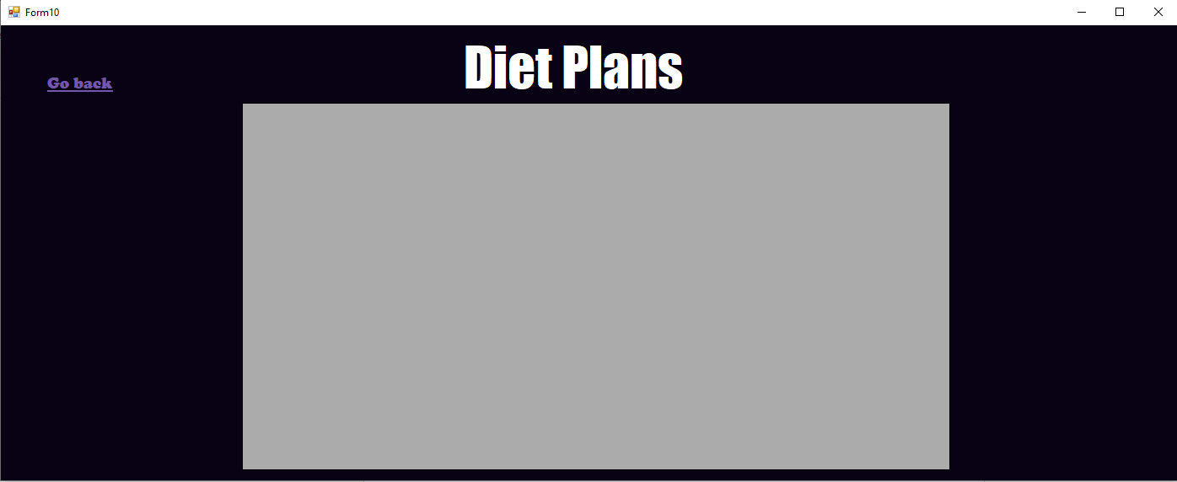
Here the trainer will be able to view all the diet plans currently tracked in the system right now.

- Feedback:

Here the trainer can view all the feedback given to trainers by the users in a grid format.

- View All Workout Plans:

Here the trainer will be able to view workout plans that have been created in the system yet.
These are all the interfaces for the trainer.

Member Interfaces:
- Registration:
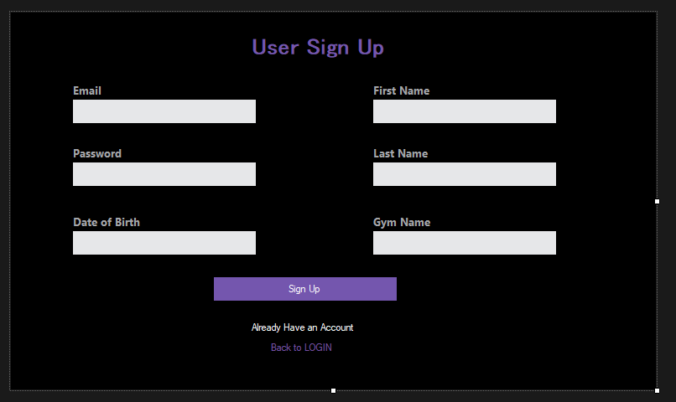
The registration screen of the member interface ask for the member’s personal details along with the gym name where the member goes to train.

- Login:
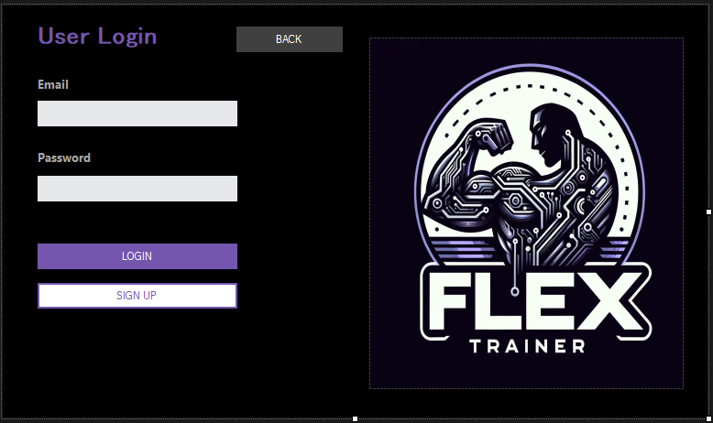
The Login page requires user/member to input their email and password and then click login to enter into the system. There is also option to sign up/register if the user is a new gym member.

- Member Main Menu:
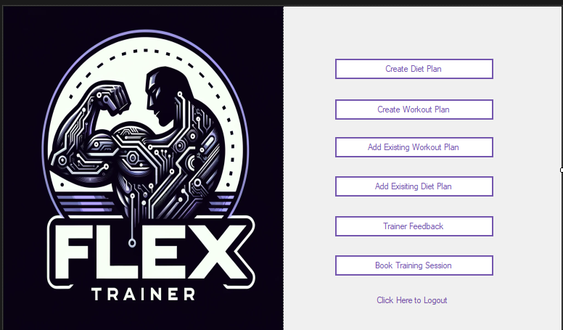
The member main menu contains buttons for separate screens through which the user can perform different functions, like changing workout and diet plans or creating new ones. There is also option for booking training sessions with trainers and giving feedback afterwards.

- Create Diet Plan:

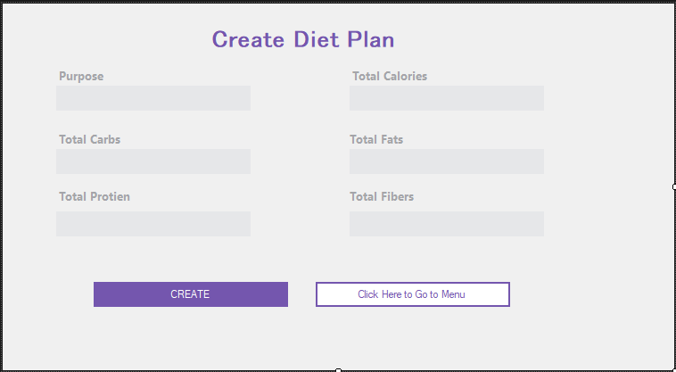
The Create Diet Plan screen asks user for the details of their new diet plan.

- Add Meal:
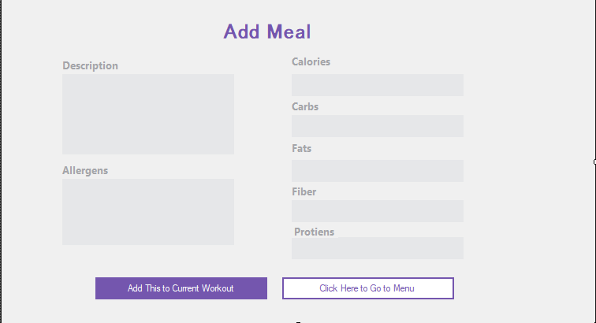

The Add Meal screen provides the user with the ability to details about their meals and also add details about any potential allergens.

- Create Workout Plan:
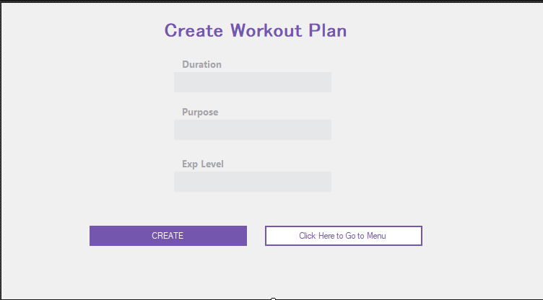

This form let the user to make their own personalized workout plan, with details catered to their own needs.

- Making a workout schedule:
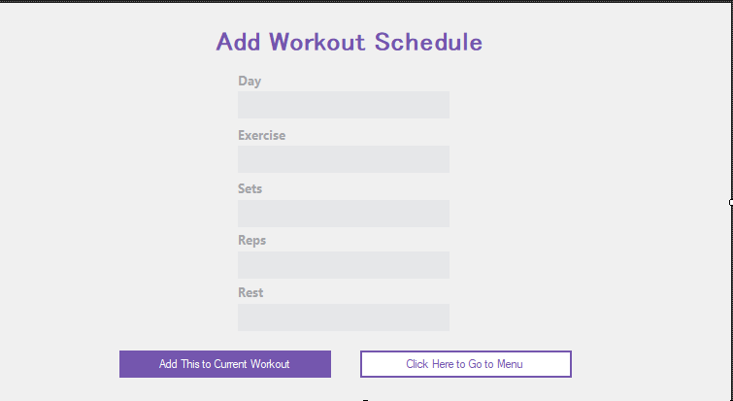
This forms is a continuation of the previous screen and it allows the user to input the exercises within the workout plan and what to do on which day and for how long etc.
- Exploring workout plans within the database
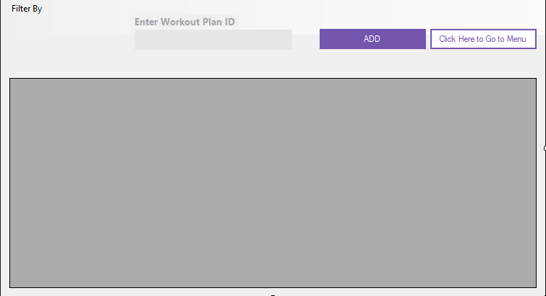
This form lets the user to go through all the present workout plans in the system and choose the one they find the best suited.
- Exploring diet plans
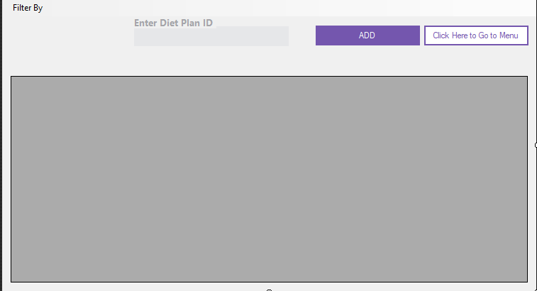
This form lets the user to go through all the present workout plans in the system and choose the one they find the best suited
- Trainer Feedback:
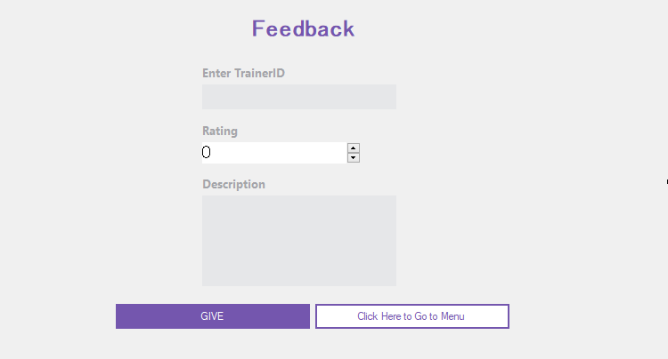
This forms lets the member to give a review of the trainer after their training session together.

- Training Session Booking
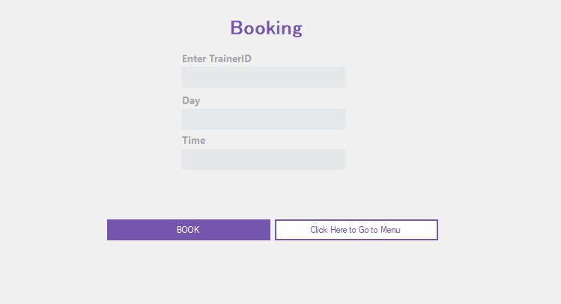
This form allows users/members to find the best trainer available to train them.

Gym Owner Interfaces:
- Login:
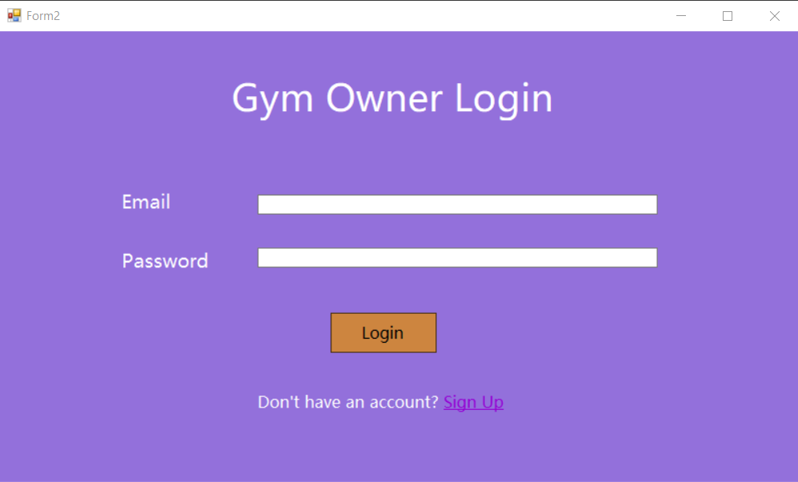
This form lets the gym owner to login into the system. If the gym owner is new to the system, it gives them the option to register themselves into the system.

- Registration:
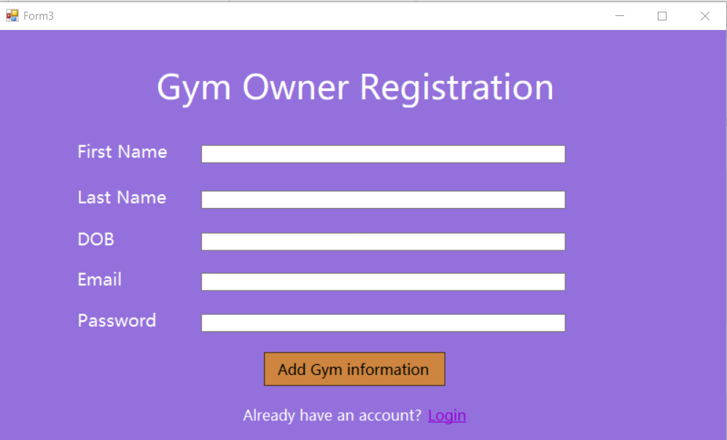
Asks for the gym owners personal account information and then lets the gym owner enter the detail of their gym by redirecting them to the following form.

- Gym Registration:
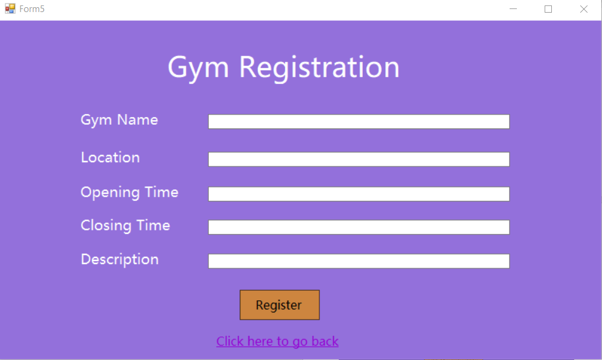
Gym Owner needs to input vital information about their gym into the fields above. After clicking register, the admin needs to first approve of the gym details before it can be added into the system.

- Gym Owner Menu:
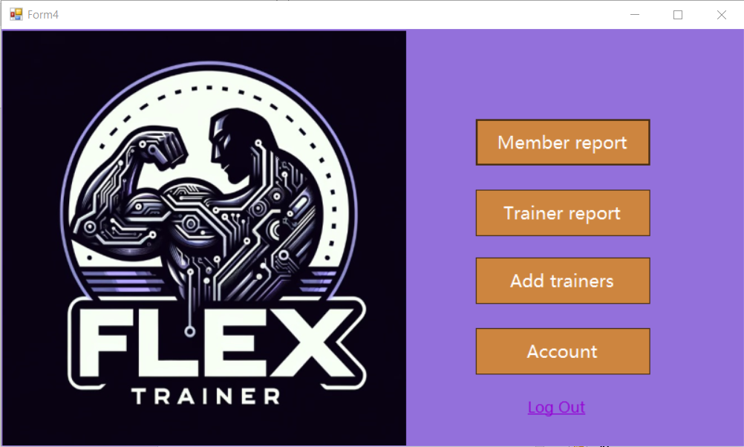
The menu page of the gym owner interfaces lets the gym owner carry out different tasks.

- Member Report:
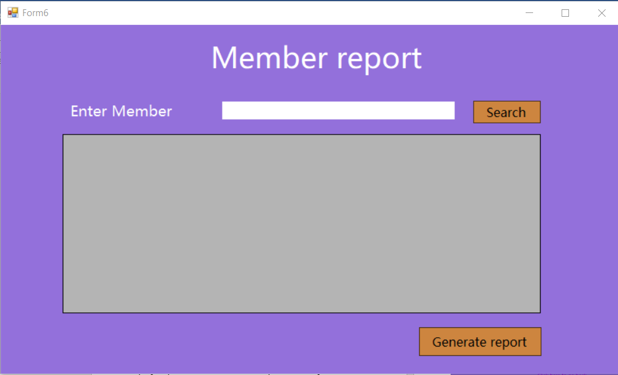
The blank grey space is actually a data grid that will let the gym owner view all the members that are currently going to their gym.

- Member Report Generation:
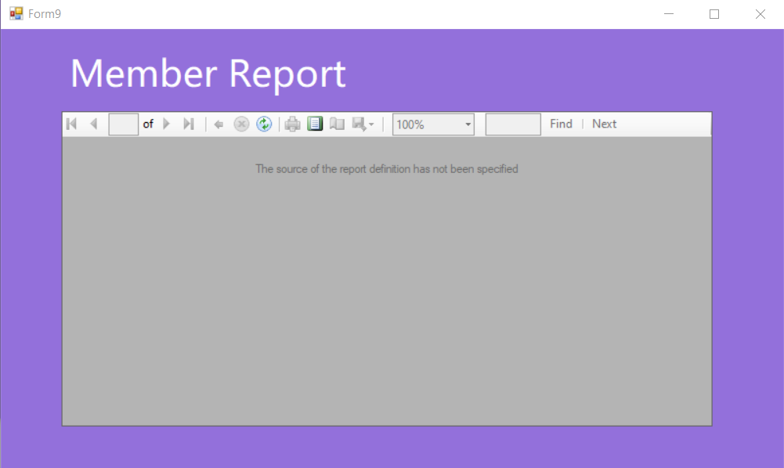
The member report here shows all the information necessary like membership duration, membership type etc.

- Trainer Report:
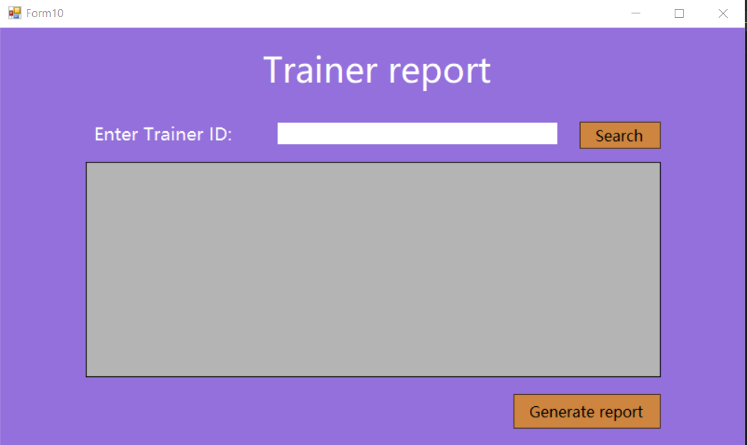
The blank grey space is actually a data grid that will let the gym owner view all the trainers that are currently going to their gym.

- Trainer Report Generation:
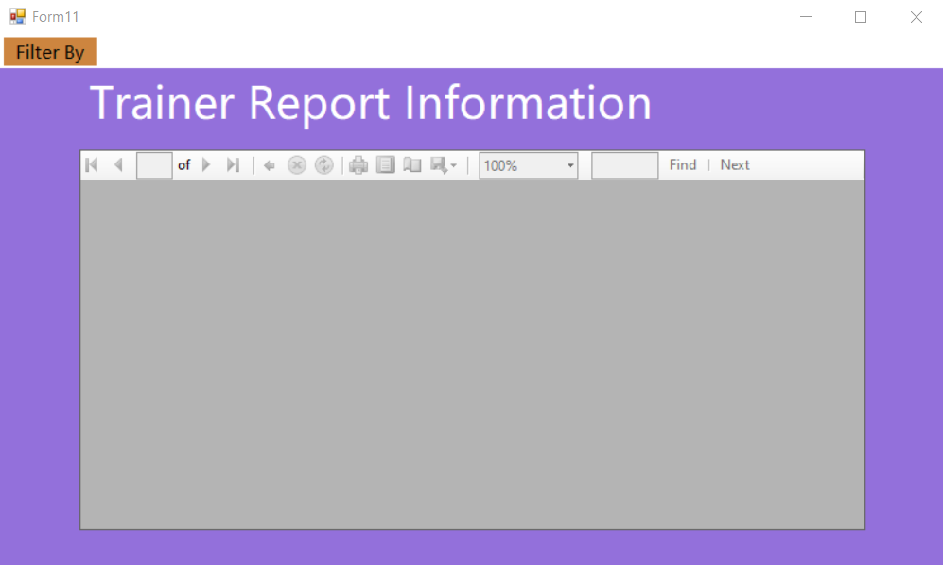
The trainer report here shows all the information necessary like experience, rating and you can also filter the trainers by these variables.

- Add Trainer:
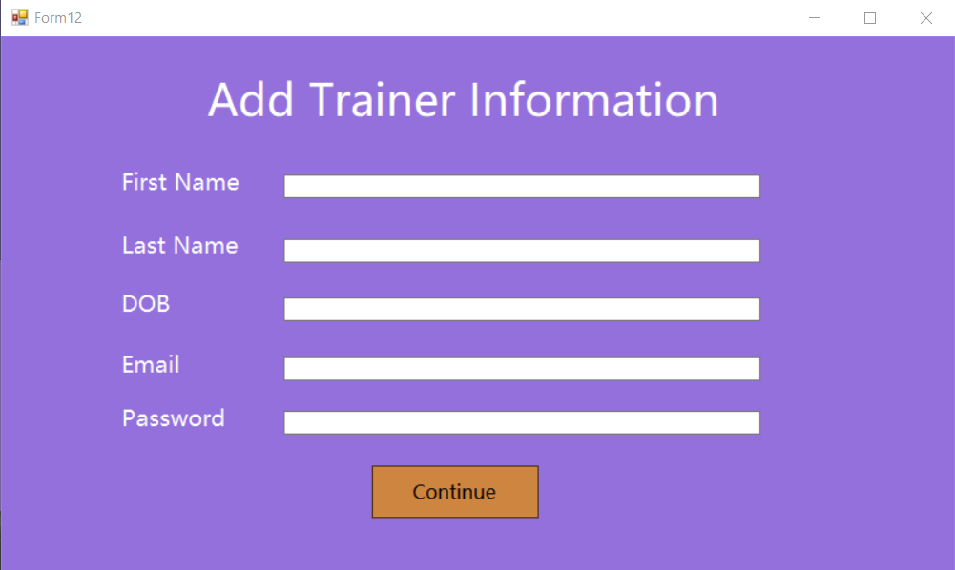
This form allows the gym owner to add all the details about new trainer. The continues button redirects to another form below
- Trainer Information:
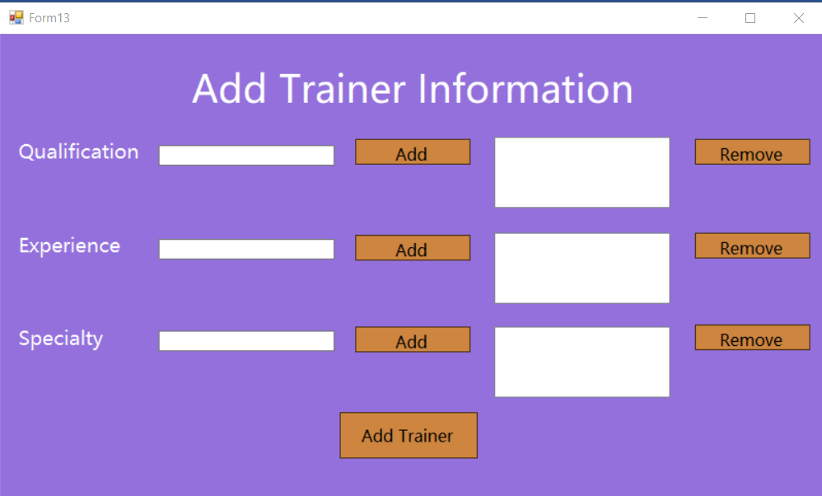
The gym owner can add qualification, experience and specialty areas for the trainers. The form contains listBoxes which lets the gym owner to add multiple values for the respective fields.
- Removing Accounts:
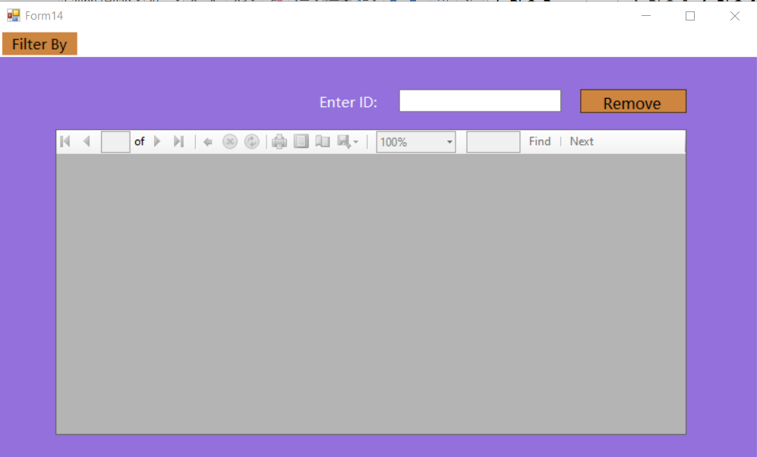
This form lets the gym owner to delete accounts of members or trainers that no longer attend the gym or people who have broken laws, or not paid any fees.

Admin Interfaces:
- Login:
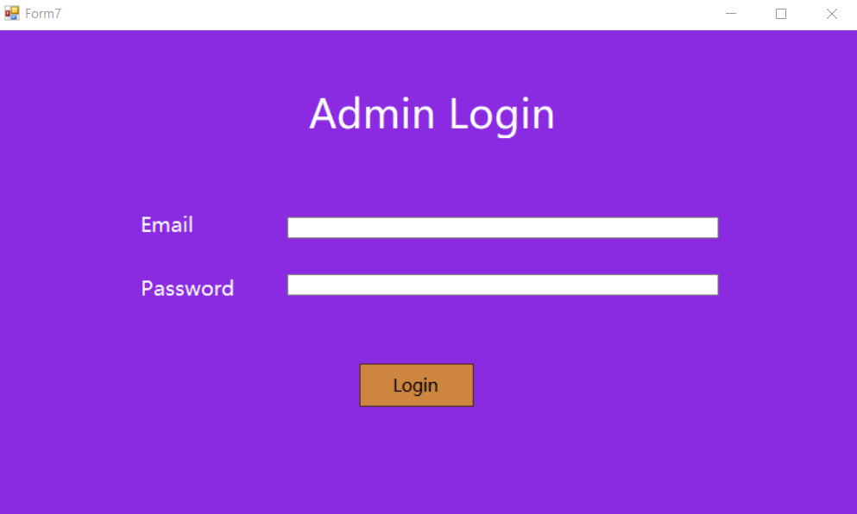
The admin interface only has a login page and no registration page, because the admin exists through database relation and not by registration into the system.

- Admin Menu:
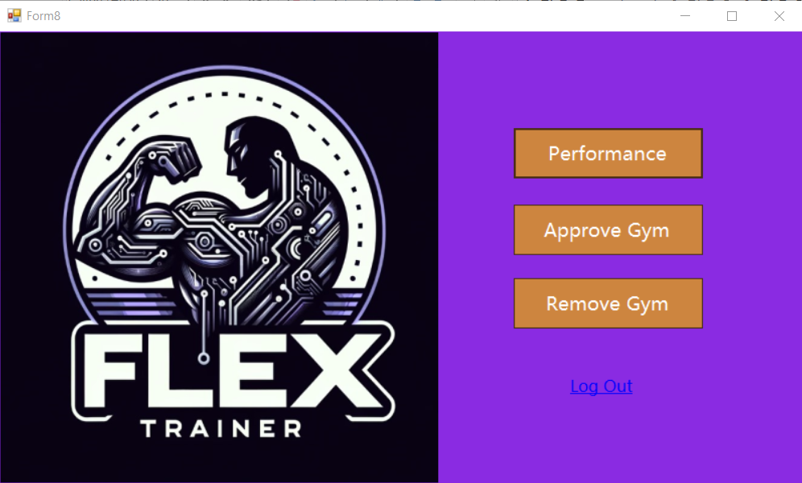
The Admin menu lets the admin have complete power over the gyms and gym owners within the sysytem.
- Performance:
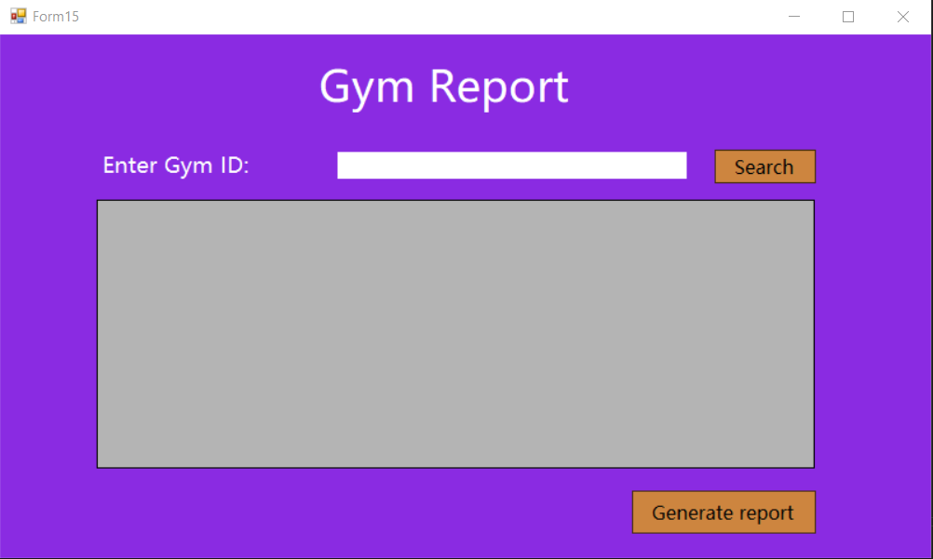
This form lets the admin look at the list of all gyms within the system and generate a report on it.
- Gym Report Information:
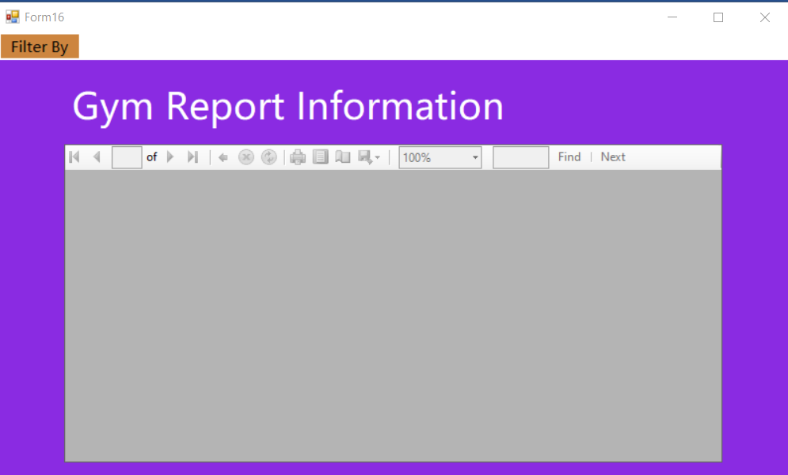
The report can be filter through certain criteria like attendance rate of member of the gym and the financial status or the business model of the gym.
- Add Gyms:
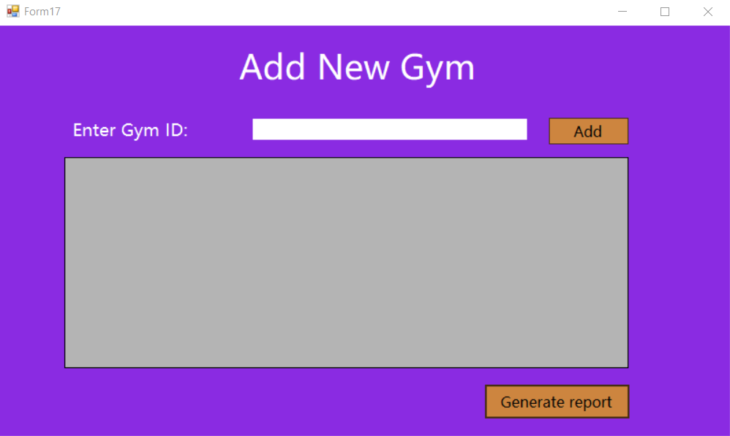
This form lets the admin add new gyms by looking at the data gird which will show the potential new gyms that have registered with the system.
- Add Gym Report Information:
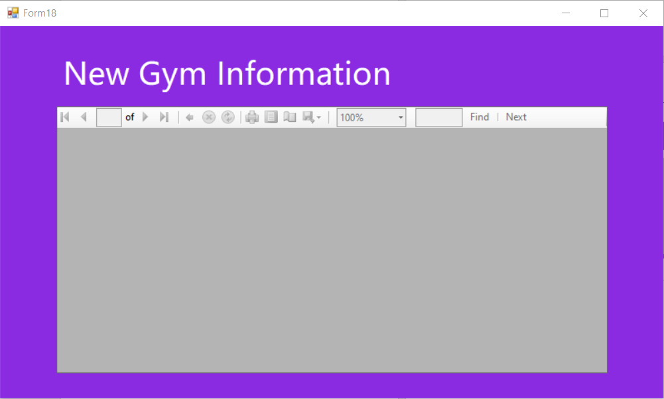
Shows information regarding the newly added gym.

- Removing Gyms:
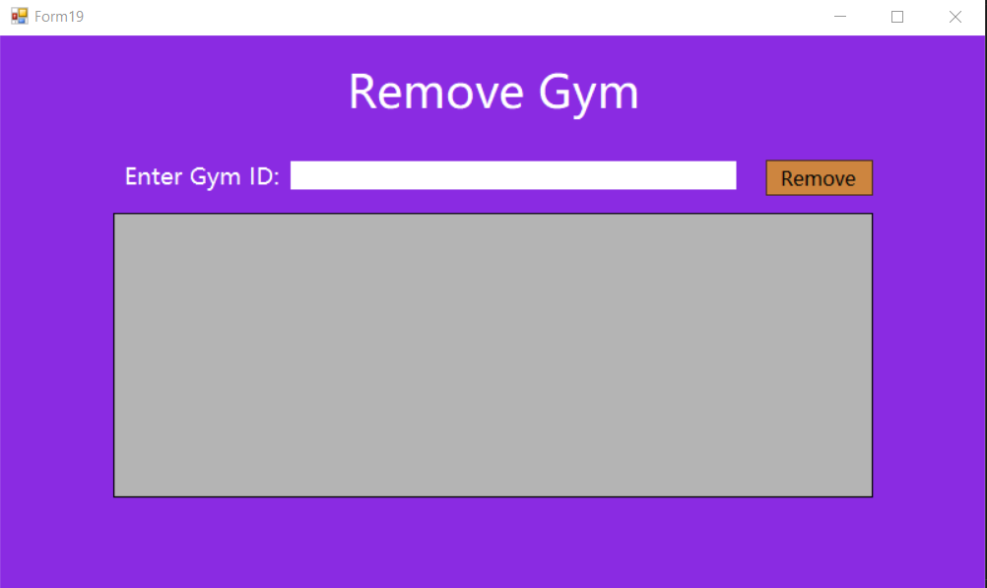
The admin can go through the list of gyms that might be violating laws and breaking rules, and thereby remove them from the system.

