 

**DEPARTMENT OF COMPUTER & SOFTWARE ENGINEERING**

**DIGITAL SYSTEM DESIGN**

**ASSIGNMENT 02**

**SUBMITTED BY:** AIMUN TARIQ

CE-38-A

**SUBMITTED TO:** DR. SAJID GUL KHAWAJA

QUESTION NO 01;

TEST BENCH OF FULL ADDER:

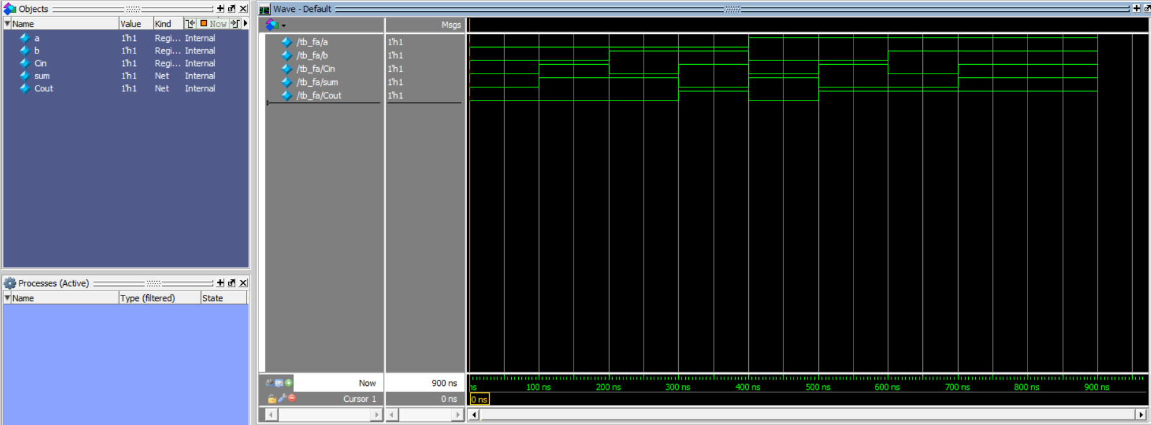

TEST BENCH OF CARRY RIPPLE ADDER:

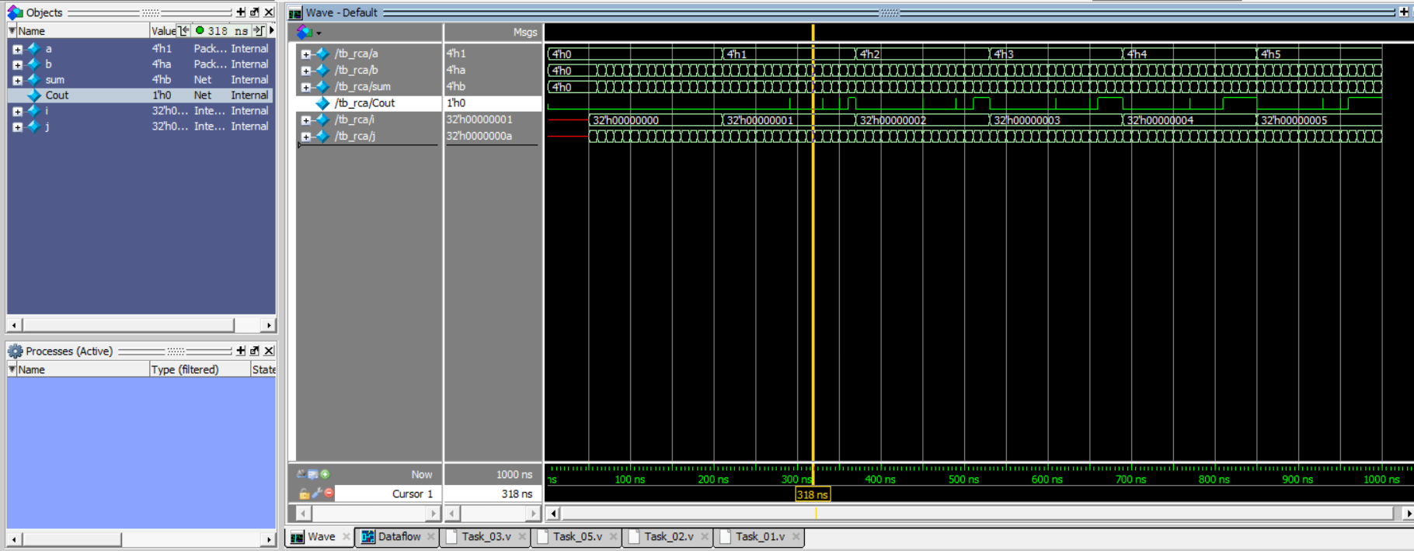

QUESTION NO 02;

TEST BENCH FOR MULTIPLY ACCUMULATOR CIRCUIT:

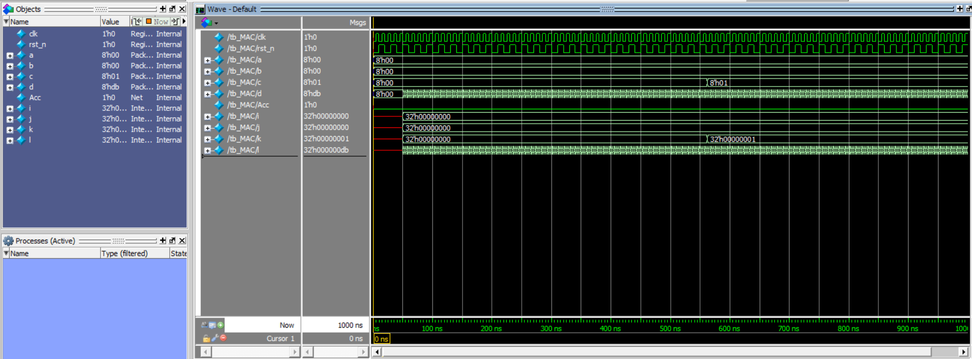

QUESTION NO 03;

TEST BENCH FOR THE DIAGRAM CIRCUIT OF TASK 03:

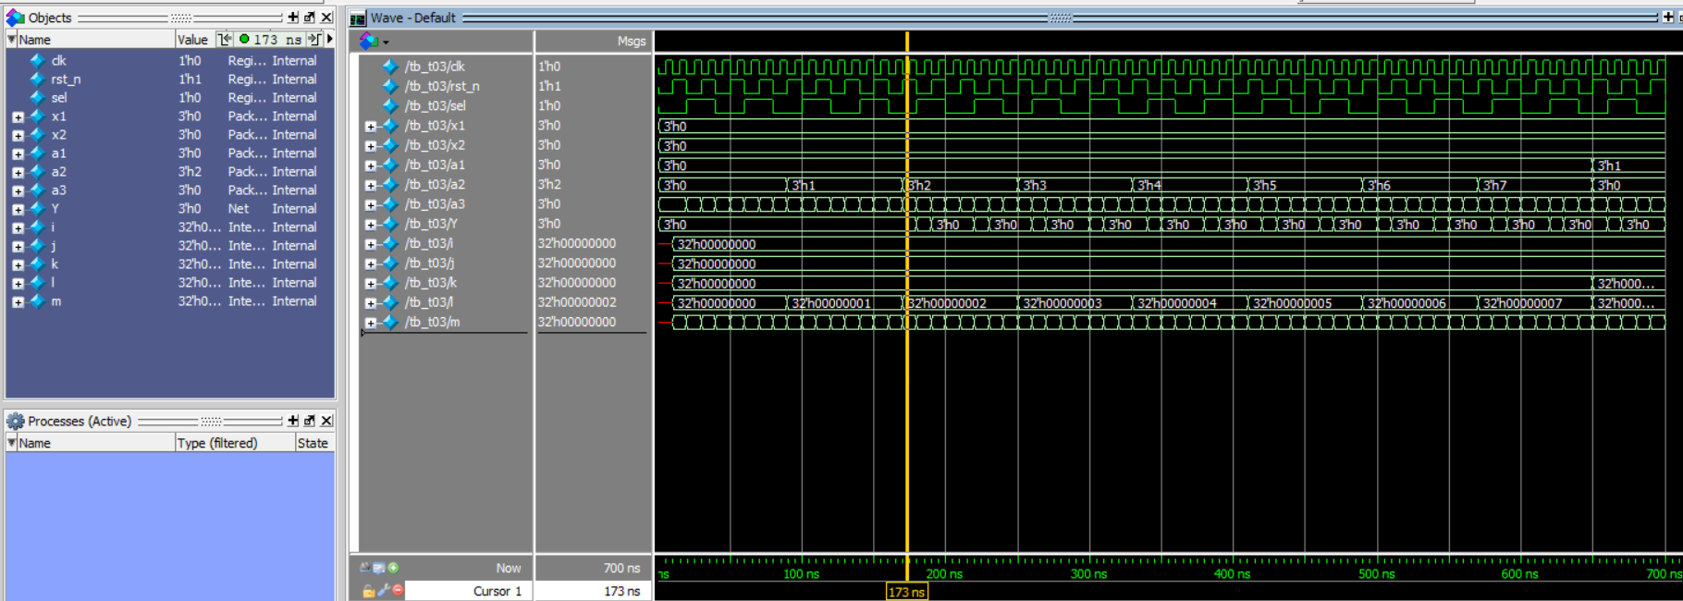

QUESTION NO 04;

No Outputs for this question.

QUESTION NO 05;

TEST BENCH FOR ALU CIRCUIT:

