­



**Project Report**  
WEB ENGINEERING (SE-206)

**Group Members:**  
Minahil Ovais ( SE - 003 )  
M. Hashir Tihami ( SE – 065 )

About Copedia:  
Our website holds the information and location of the coaching centers/educational institutes from all over Karachi. All the coaching centers are listed in our website along with their respective locations, which makes it easier for any student to locate any coaching center near him.

Our Mission:  
In a city like Karachi, its not easy to find a coaching center of your choice. Our mission is to facilitate every student/parent to find the best and suitable coaching center in Karachi without facing any problem.

Scope of the Project:  
The information of the coaching centers will be entered by the representatives of respective coaching centers. Any owner of any coaching center can contact us and fill our form, so that we could hold the information of their coaching centers. The owner has to select a deal, which would allow his coaching center’s information to be displayed on our website.

INDEX: (Welcome Page)

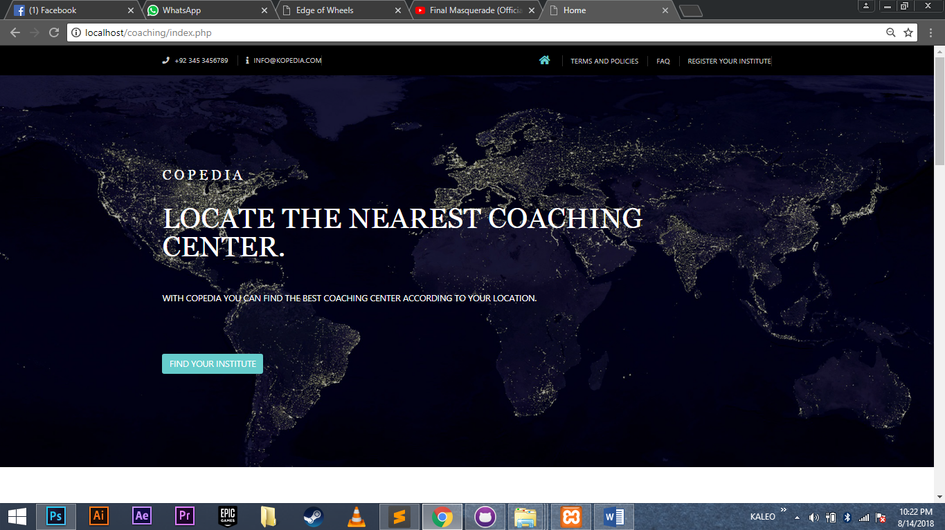

This is the main page of our website. It consists of a navigation bar which directs the users to different pages to know more about our website and its functionalities. It also has a “Find your institute” button which directs user to our database where he can find the nearest coaching center.

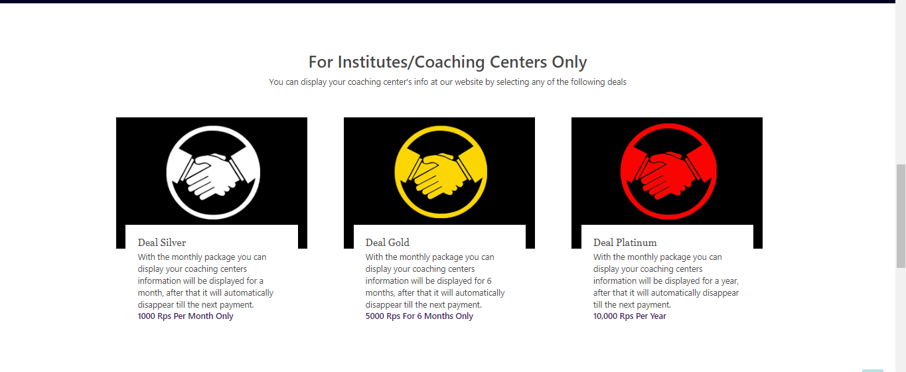

It also has a section designed only for the owners of different institutes or Coaching centers, where they can select the appropriate deal for their coaching centers, after selecting a deal they will be redirected to the form.php page where they have to fill the information of their coaching center.

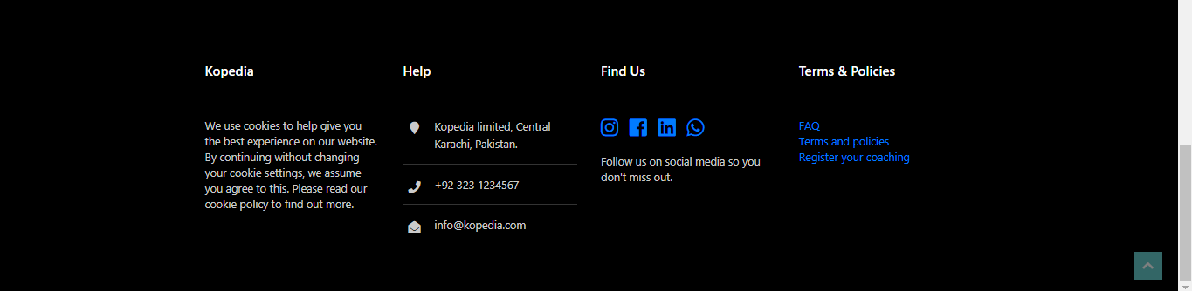

In the end, it has a footer, where the contact us information and links to our social networks, and more links which directs the users to different pages to know more about our website and its functionalities.

DATABASE: (For Students)

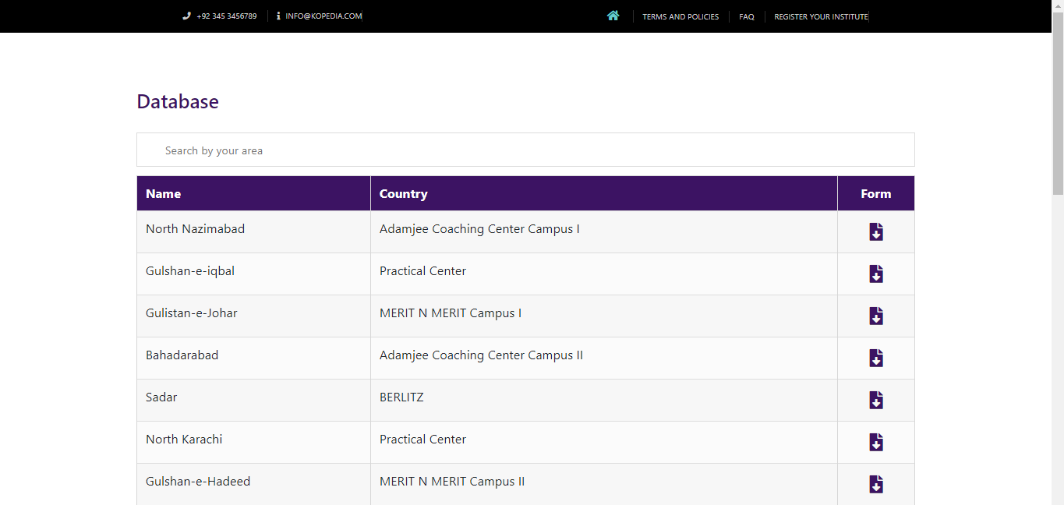

This page holds the information of all the coaching centers that are included in our website. Also the user can enter his area which will show the names of all the coaching centers present in his area. After that he can click the download icon so he could download the admission form of the respective coaching center, where all the information (fee structure, time table, etc) are written. He can print that form out and fill it. Now he can visit and get admission in the respective coaching center.

FORM: (Only for business partners)

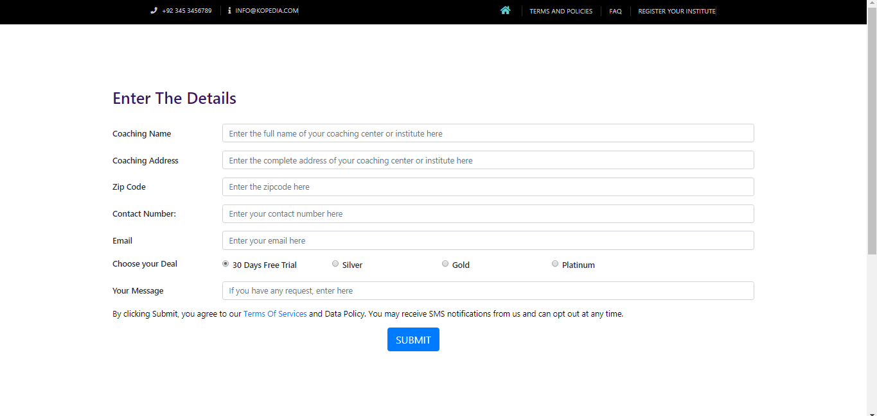

This page allows our business partners (owners of coaching centers/institutes) to give us the information of their coaching centers. So we can display it on our website for the students of the city.

PAYMENT FORM: (Only for business partners)

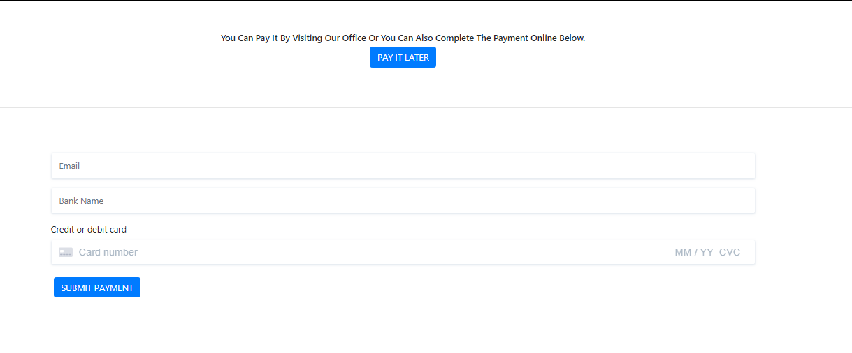

after submitting the form the respective owner will be redirected to a payment gateway (stripe payment gateway) where he could either choose to pay using his credit/debit card, or he could also choose to pay it later at our office.

CONFIRMATION: (Only for business partners)

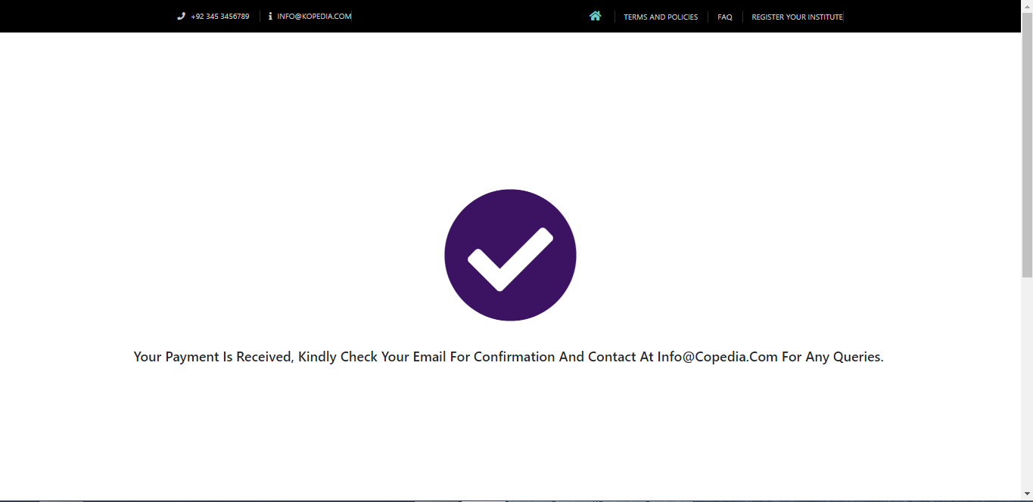

If he pays the amount using the payment gateway, the following confirmation message will be displayed.

TERMS AND POLICY:

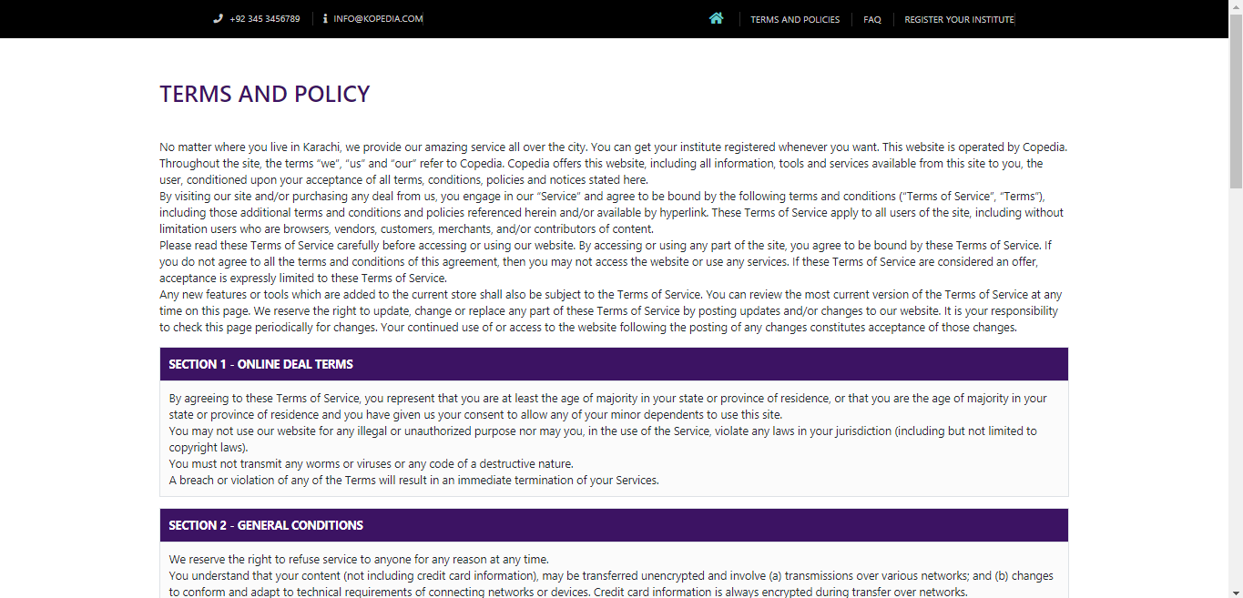

The following page holds all the information of our terms and policies about the data security and other relevent data.

FAQ:

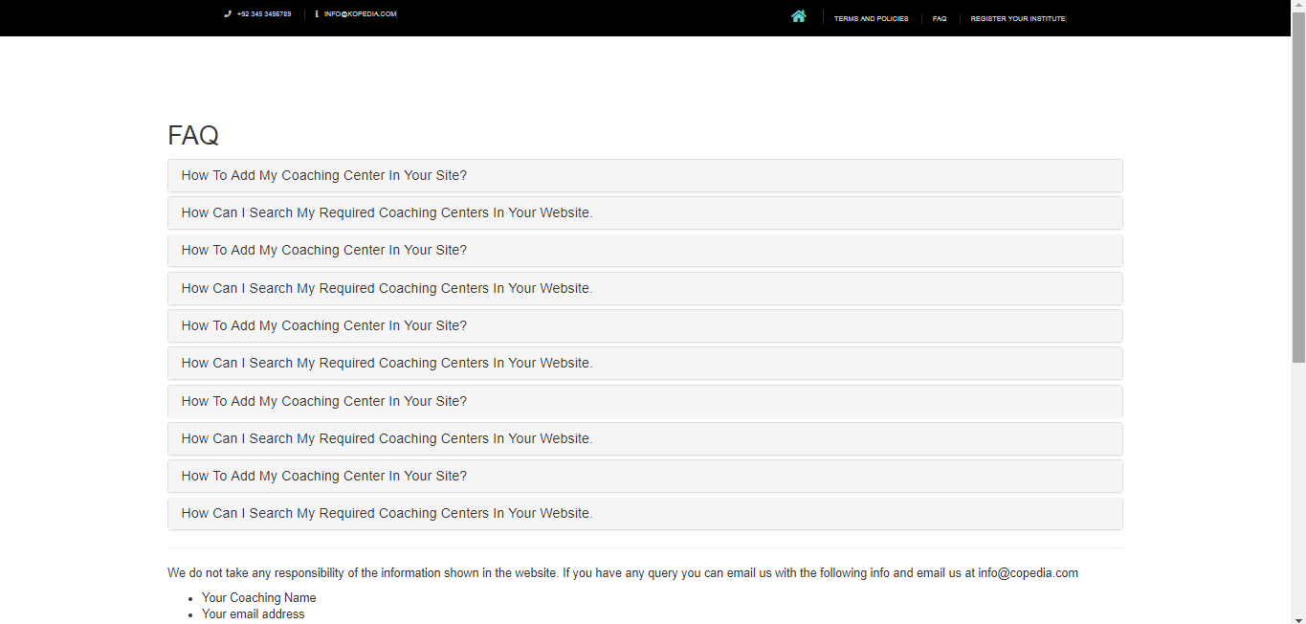

This page holds all the possible questions that may arise in our user’s mind. He can get the most common answers from here without contacting us.