*TravelAdvisor* **Project**

**Use-Case Model overview with Individual use case specifications**

**Abstract**

|  |
| --- |
| ***This document provides an overview of the solution context, scope and high-level functional capabilities for the TravelAdvisor project. It catalogs the actors that interact with the system and the use cases that together describe all the ways in which they interact with the system. It also documents the use-case diagrams that show the relationships that exist between the actors and the use cases.*** |

**Version History**

|  |  |  |  |
| --- | --- | --- | --- |
| **Date** | **Version** | **Author** | **Description** |
| 17/07/2015 | 1.0.0 | Nicholas Gamarra | Product Owner |
| 17/07/2015 | 1.0.0 | Hope Ashmeade | Developer |
| 17/07/2015 | 1.0.0 | David Mendieta | Scrum Master |
| 17/07/2015 | 1.0.0 | Adeola Adebiyi | Developer |

An Essential Unified Process Document

Table of Contents

1 Stories 2

1.1 New User: 2

1.2 Searching User: 3

1.3 Returning User: 3

5 Use case Specification 9

5.1 Brief Description 9

5.2 Basic Flow 9

5.3 Alternative Flows 10

5.3.1 Unavailable User Name 10

5.3.2 Verify Email 10

5.4 Post-Conditions 10

5.5 Extensibility 10

5.6 Scenarios 10

6 Use case Specification 12

*The Searching User Use-Case Specification specifies all requirements relating to this use case, including the flows through the use case and any non-functional requirements that relate specifically to this use case.* 12

6.1 Brief Description 12

6.2 Basic Flow 12

6.3 Scenarios 12

Name 12

Flows Exercised 12

Additional Notes 12

Searching User 13

Locations 13

Categories 13

arranged by ratings 13

7 Use case Specification 14

*The Returning User Use-Case Specification specifies all requirements relating to this use case, including the flows through the use case and any non-functional requirements that relate specifically to this use case.* 14

7.1 Brief Description 14

7.2 Preconditions 14

7.3 Basic Flow 14

7.4 Alternative Flows 15

7.4.1 Log in error 15

7.4.2 Flag inappropriate comment 15

7.5 Post-Conditions 15

1. User can see his posted comments on his profile page under comments history 15

7.6 Special Requirements 16

1. Rating is based from 1 to 5 16

7.7 Extensibility 16

1. Allows other users to view comments and ratings 16

8 Example of use case specification 16

# Stories

## New User:

Ted Ulrich searches “Travel information on South Africa” into Google and gets linked to our website [*www.USA2SA.com*](http://www.usa2sa.com). Mr. Ulrich clicks on the hyperlink, which takes him to our page. He browses through the website and finds it to be informative and easy to navigate, so he wants to make an account. Clicking on the ‘Sign Up’ button up a drop down menu that prompts him to enter his information such as preferred Login Name, Password, and an Email Address of choice. Ted continues by entering his valid email address along with his preferred user name. He then clicks the “Sign Up” button only to a disappointment because the user name he requested has unfortunately been taken already. This is shown by a ‘**X**’ by the user name with the saying “User name already in use. Please use a different user name.” next to the ‘**X**’. He then tries a different user name and clicks “Sign Up” again, but this time there was a ‘✔’ by his user name with the approval that his account has been created and that a verification email has been sent to him to his email address. He resumes by going to his email and clicking the “Verify Email Address” button and gets linked to the website login window. The user name and password are entered correctly and he has finally created an account with *USA2SA* with a functioning login.

## Searching User:

Brady Upton is a young traveler who loves outdoor activities and is looking for his next adventure. He visits the *USA2SA* website and first selects on the “Locations” button. It brings a drop down menu displaying the three major cities of South Africa, which are Cape Town, Johannesburg, and Durban. He selects “Cape Town” and the website shows him multiple photos of Cape Town’s beautiful mountains and ocean. As he continues scrolling down the page he sees other users feed back on South Africa’s city Cape Town. By Brady reading previous travelers input on the Cape Town he is convinced that this is his destination of choice. He is already sold, but does not know where to start. He notices a Categories tab on the menu and clicks it. Another drop down menu presents three options: Social, Adventure, and Landmarks. Going through each tab and reading the information provided other users through comments and ratings, Brady realizes that Cape Town has an excellent night life, amazing hiking trails and water sports, along with rich historical places like Robben Island. He proceeds by going to an airline website to purchase a ticket to Cape Town for his next vacation.

## Returning User:

Rachel Upton and her husband just got back from their trip in Cape Town. They enjoyed their time so much in South Africa that they took time out of their day to write a review about it on *USA2SA*. Rachel clicks “Locations” and then selects “Cape Town” from the drop down menu and scrolls down to click the “Leave a Review/Comment” button. She clicks it and a text box appears. She begins to describe the trip and all the adventures that Cape Town has to offer. Then clicks 5/5 stars on the ratings bar and submits her review. The prompt “Your review/comment has been submitted” appears on the screen. Lastly she goes to the “Categories” button and select “Social”. She leaves recommendations on where to go for the best Karoke bars in Cape Town, rates the “Adventures” tab 5/5 stars, and comments on “Landmarks” to go check out the prison where Nelson Mandela was kept in and submits all of them.

1. **Use-Case Diagrams**
   1. **New User:**

New User creates account. Enters user name which is checked for availability by the administrator, enters an email which needs to be verified with the administrator, creates a password and enters an optional BIO description. Once logged in the user has the options to change the password, view comment history, and edit their BIO.

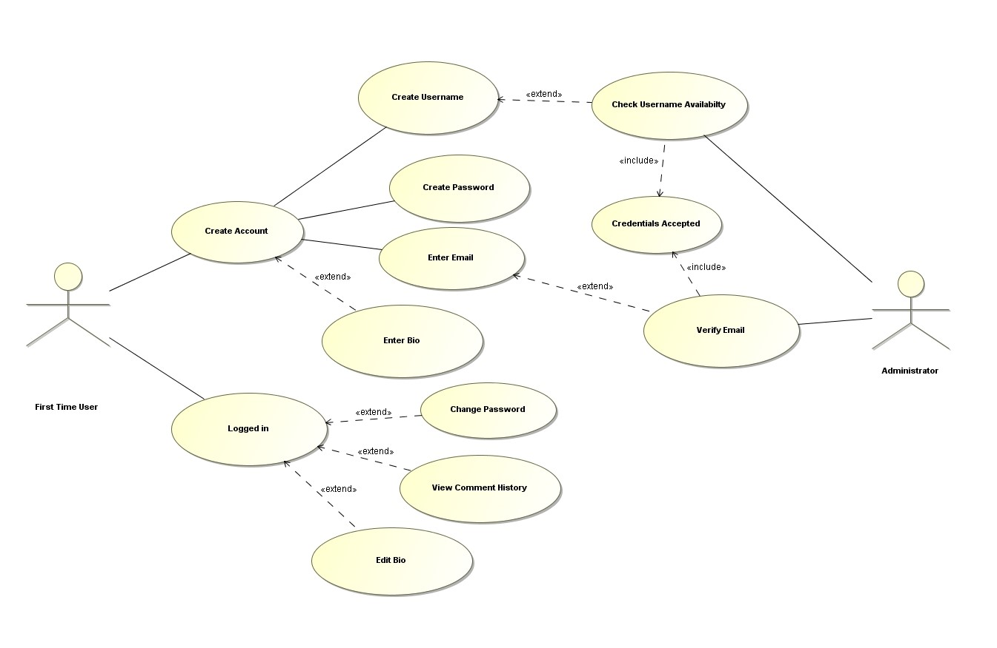

* 1. **Searching User**

User uses our website to search attractions and activities for their trip. User selects the locations or categories drop down menus and is presented with 3 choices each. Each category and location has attractions and activities that correspond to them and organized by ratings.

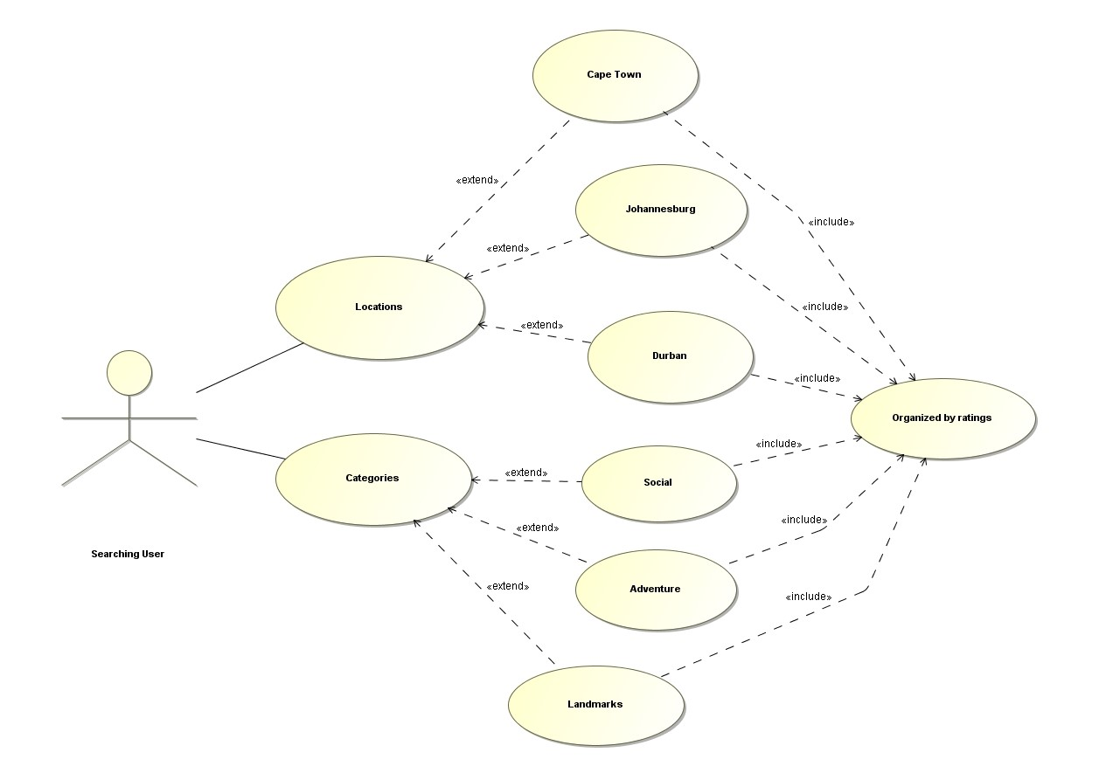

* 1. **Returning User:**

A returning user comes back to the website and logs in. After going to the corresponding location or attractions/activities the user leaves feedback in the form of a comment or/and rating.

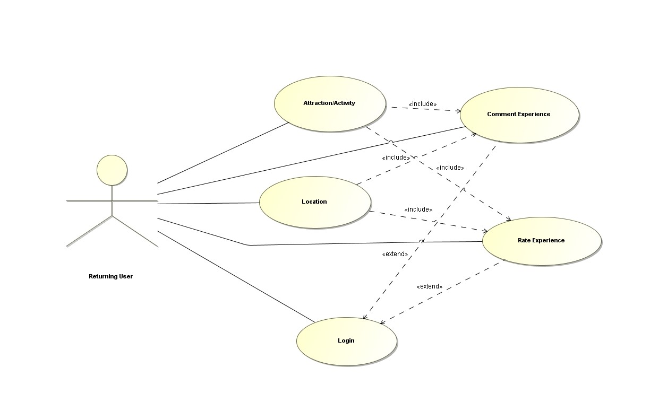

1. **Actor Catalog**

|  |  |
| --- | --- |
| **Name** | **Brief Description** |
| New User  (Ted Ulrich) | Came upon our website and creates an account with USA2SA |
| Searching User  (Brady Upton) | Uses USA2SA comments and ratings on locations and attractions/activities to base their trip that they are embarking on. |
| Returning User (Rachel Upton) | After their trip they return to USA2SA and log in to leave feedback in the form of a comment or rating on the location or attraction/activity that they visited. |
| Administrator | Checks the availability of the selected user name and verifies the users email. |

1. **Use-Case Catalog**

|  |  |  |  |
| --- | --- | --- | --- |
| **ID** | **Name** | **Type** | **Brief Description** |
| 01 | New User | base | visits website and creates an account |
| 02 | Searching User | base | Uses comments and ratings to plan their next trip. |
| 03 | Returning User | base | Leaves comments and ratings about their previous trip. |

# Use case Specification

|  |
| --- |
| ***The New User Use-Case Specification specifies all requirements relating to this use case, including the flows through the use case and any non-functional requirements that relate specifically to this use case.*** |

## Brief Description

Shows the use-case in which the user visits the site USA2A and creates an account.

## Basic Flow

1. User comes across USA2SA and visits the site
2. User clicks the sign up button
3. The SITE presents the user with a pop-up to create a user name, password, and enter his email
4. User fills in the required fields
5. The SITE presents the user with their profile page.
6. The SITE shows the users comment history, BIO, profile picture, and settings where he/she can edit his picture, BIO, change his/her email and password.

## Alternative Flows

### Unavailable User Name

If Ted enters a user name already in the system in step 6 then the system rejects the user name and

1. The SITE asks the user for another user name and repeats the check

### Verify Email

#### Once Ted enters email in step 6 the

1. SITE asks to verify the email address for future possible password resets

## Post-Conditions

1. User can now comment and rate on attractions/ activities or locations on SITE

## Extensibility

1. Allows the use-case for the Returning User to be able to comment and rate on locations and/or attractions/activities.

## Scenarios

A scenario is an instance or specific occurrence of a use case. This section lists key representative scenarios for this use-case, listing for each scenario:

* Name – a unique and meaningful name for the scenario
* Flows Exercised – List of the use case flows exercised by the scenario
* Additional Notes – any supporting notes about the scenario or its purpose.

|  |  |  |
| --- | --- | --- |
| **Name** | **Flows Exercised** | **Additional Notes** |
| New User | Create Account  Log In | User initiates accounts preparation |
| Administrator | Checks UserName  Verifies Email | Administrator verify prepared account |

# Use case Specification

|  |
| --- |
| *The Searching User Use-Case Specification specifies all requirements relating to this use case, including the flows through the use case and any non-functional requirements that relate specifically to this use case.* |

## Brief Description

User uses USA2SA as reference to see what locations and/or attractions/activities are best to visit while on vacation based on the comments and ratings from other users experience.

## Basic Flow

1. User visits USA2SA
2. User selects Locations or Categories on the homepage
3. SITE takes the selected location or category and filters out the database based on selection
4. SITE displays the attractions/activities based on ratings
5. User takes the comments and ratings into consideration.

## Scenarios

|  |  |  |
| --- | --- | --- |
| Name | Flows Exercised | Additional Notes |
| Searching User | LocationsCategories | arranged by ratings |

# Use case Specification

|  |
| --- |
| *The Returning User Use-Case Specification specifies all requirements relating to this use case, including the flows through the use case and any non-functional requirements that relate specifically to this use case.* |

## Brief Description

After the user participates or visits the locations and/or attractions/activities the user returns to USA2SA to leave feedback in the form of a comment and/or rating so other users can be informed.

## Preconditions

1. User must have account

## Basic Flow

1. User returns from trip
2. User logs into USA2SA
3. User searches for the locations and/or attractions/activities they visited
4. SITE displays the location and/or attraction/activity with other comments and ratings
5. User uses comment box to comment on his/her experience
6. User uses the 5 star rating area to rate his/her experience
7. SITE updates the database table for the comments with the respected user who commented
8. SITE updates the database table for the location or attraction/activity for the new rating and updates the new average.
9. SITE registers the users comment to its comment history
10. SITE displays the new comment/rating
11. User signs off.

## Alternative Flows

### Log in error

The user enters the wrong user name and/or password in step 2

1. SITE sends an error message to try again
2. SITE displays option to reset password via email

### Flag inappropriate comment

#### In step 4 the user realizes there is an inappropriate comment so he clicks the flag button.

#### SITE removes the comment from the page so it is no longer seen

#### SITE reports flagged comment to administrator for further investigation

## Post-Conditions

# User can see his posted comments on his profile page under comments history

1. Users new rating affects the overall average rating for the location or attraction/activity.

## Special Requirements

# Rating is based from 1 to 5

1. Comment must be less then 1000 characters

## Extensibility

# Allows other users to view comments and ratings

# Example of use case specification

This section provides any additional information required to make the use case more accessible to the stakeholders and the development team.

|  |  |  |  |
| --- | --- | --- | --- |
| **Use Case Template** | **Description** | **Description** | **Description** |
| Use Case Name | New User | Searching User | Returning User |
| Use Case ID | 01 | 02 | 03 |
| Revision and Reference | V1.0.0 | V1.0.0 | V1.0.0 |
| Use Case Diagram |  |  |  |
| Status | In progress | in progress | Planned |
| Goal | User successfully creates a unique log in. | User uses comments and ratings to plan trip | User post comments and ratings |
| Summary | User creates a log in where a bio, comment history, and settings are available. | User visits USA2SA to search locations and/or attractions to visit will going on trip based on ratings and comments left by other users | User logs in to comment and/or rate his experience at a location and/or attraction/activity |
| Category | Base-Case | *Base-Case* | *Base-Case* |
| Actor | New user - ted Ulrich | Searching user - Brady Upton | Returning user - Rachel Upton |
| Primary Actor (initiates) | New user - ted Ulrich | Searching user - Brady Upton | Returning user - Rachel Upton |
| Preconditions | Must have internet | Must have internet | Must be registered |
| Triggers (optional) |  | User wants to go on a vacation/trip | Wants to leave Feedback |
| Main success scenario | 1. User visits USA2SA 2. User selects sign-up button 3. SITE requests a username, password, and email 4. User enters preferred username, password, and email 5. SITE loads profile page where bio, comment history, and edit settings can be viewed | 1. User visit USA2SA 2. User searches location or activity they want to visit 3. SITE categorizes the selected location or attractions by ratings 4. User uses ratings and comments to plan trip | 1. User logs into USA2SA 2. User searches location and/or activity they wish to comment and rate 3. SITE displays appropriate page with a rating section and comment text box. 4. User leaves a comment and rates the location and/or attraction. 5. SITE registers the comment in the database and the users comment history. 6. SITE registers the rating and recalculates it. 7. User signs off. |
| Alternative paths (optional) | 4a. SITE pops-up an invalid username because its already being used  4b. SITE requests user to verify email |  | 1a. User forgets or incorrectly inputs password. SITE gives the user an option to try again or reset password via email. |
| Post conditions | User can now comment and rate locations and/or attractions/activities.  User can edit profile. update BIO, email, and password | User returns to create log in and post his/her own feedback in the form of a comment and/or rating | Users comment history is updated  The location or attraction now has a new comment and/or updated rating |
| Author and date | Nicholas Gamarra  Hope Ashmeade  David Mendieta  Adeola Adebiyi  last edited - 7/17/15 | Nicholas Gamarra  Hope Ashmeade  David Mendieta  Adeola Adebiyi  last edited - 7/17/15 | Nicholas Gamarra  Hope Ashmeade  David Mendieta  Adeola Adebiyi  last edited - 7/17/15 |