**GEOG 128: Human Geography: Space, Place and Community**

Dr. Jonathan Cinnamon | Term 2, 2021/2022 | University of British Columbia Okanagan

|  |  |
| --- | --- |
| Student Name: Will Barlow | Student number: 81776940 |
| Date: 2/11/2022 | Course section: 001 |
|  |  |

**ASSIGNMENT 1 TEMPLATE: INDIGENOUS POPULATION GEOGRAPHIES**

Complete the tasks from the Assignment 1 Instructions document, and provide your work in the appropriate section in this template.

**Task 1: Indigenous geographies**

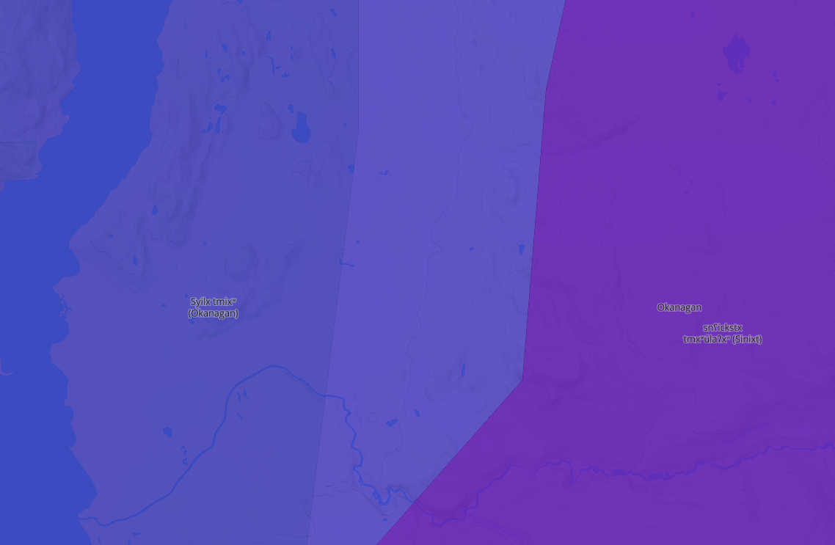**Task 2: Accessing and compiling First Nations demographic profiles**

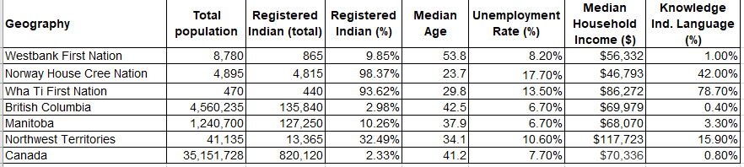**Task 2: Visual comparison of Indigenous population geographies**

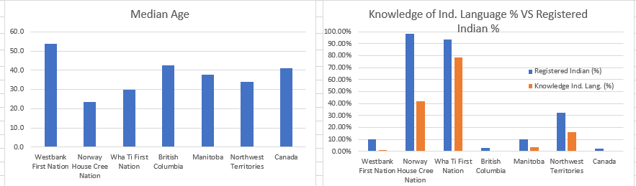**Task 4: Written explanation and comparison**

Describe the data in the table and charts from Task 2 and 3.

The locations described by the above data are the First Nations: Westbank, Norway House Cree, and Wha Ti located respectively in the following provinces: British Columbia, Manitoba, and the Northwest Territories in addition to the whole of Canada. The more precise locations contrast the larger provincial locations and the country of Canada. The data in the table illustrates some key attributes for comparing populations of Indigenous First Nations with provincial populations. Additionally, the data provides insight to how many people within a First Nation Territory are registered Indians, and how many have knowledge of Indigenous languages. The data further describes the median age, unemployment rate, and household income by location.

The data presents some interesting insights into the correlation of the specified attributes of population, percentage of registered Indians, median ages, unemployment rates, median household income, and percent of knowledge of an Indigenous language or languages. Something that I find immediately striking from the above data is how high the median age is for Westbank First Nation. Compared to all of Canada, it is still the highest by about two years, and this is just the median age. It certainly begs the question as to why the median age is so low for both Wha Ti and Norway House Cree First Nations in comparison.

Based on the above data it appears that compared to the First Nations of Wha Ti and Norway House Cree, the Westbank First Nation’s percentage of registered Indians and knowledge of Indigenous language is miniscule. This suggests that the Westbank First Nation is composed of less Indigenous peoples than Wha Ti and Norway House Cree First Nations. It also suggests that of the population that considers themselves to be Indigenous peoples, that they do not have as much knowledge of Indigenous languages as the other First Nations. When compared to the provincial stats, it is clear that by population, there are far more registered Indians who have Indigenous language knowledge in the Northwest Territories. It is interesting to note that the Norway House Cree Frist Nation has the highest percentage of registered Indians (98.37%), but is lacking in percentage of knowledge of Indigenous language (42%). Whereas the Wha Ti First Nation’s population is composed of a relatively high percentage of registered Indians (93.62%) and a relatively high percentage of Indigenous language knowledge (78.7%). Perhaps this is insightful to how Indigenous language is taught in these First Nations. The data certainly suggests that methods for improving Westbank and Norway House Cree First Nation’s knowledge of Indigenous languages may be found by examining how Indigenous language is taught in Wha Ti First Nation.

On a provincial level, the data illustrates that the Northwest Territory’s population is composed of the highest percentage of registered Indians. Out of the three provinces, its population is also the lowest. It would be interesting to survey other low population provinces to see if there is a correlation between provincial total population and population of registered Indians. The instance of the Northwest Territories suggests that the lower the overall population, the higher the population of registered Indians. Another interesting aspect about the Northwest Territory data is how high the median income is compared to the rest of the provinces. What makes it so high? Answering this question would necessitate a survey of the job market in the Northwest territories.