final-studyguide

Chapter 3

**Genes, Epigenetics, and the Environment**

* Are abilities such as intelligence and memory inherited through our genes?
  + Partially yes, but not entirely, environmental influences also play a role
* what do epigenetic studies suggest about how early life experiences may influence whether genes are expressed?
  + environmental factors in early life can affect how genes are expressed and are realized later in life

**Investigating the Brain**

* Identify the three main ways that researchers study the human brain
  + studying people with brain damage
  + studying the brain’s electrical activity
  + using brain imaging to study brain structure and watch the brain in action
* compare and contrast advantages and disadvantages of techniques used to study the brain in action
* How have brain disorders been central to the study of specific areas of the brain?
* What role does the **corpus callosum** play in behavior?
  + the corpus callosum transmits information between both hemispheres of the brain and thus allows the two hemispheres to function cooperatively
* How does the EEG record electrical activity in the brain?
  + it amplifies the electrical signals from synapses and action potentials through electrodes attached to the head
* Compare what can be learned from structural brain imaging with results from functional brain imaging
  + Structural: provides information about the basic structure of the brain and allows clinicians or researchers to see abnormalities in brain structure
  + Functional: provides information about the activity of the brain while people perform various kinds of cognitive motor tasks
* what does an fMRI track in an active brain?
  + it detects the difference between oxygenated hemoglobin and de-oxygenated hemoglobin
* Why should we avoid jumping to conclusions based on fMRI results?

Chapter 4

**Sensation and Perception are Distinct Activities**

* Distinguish between sensation and perception
  + *Sensation:* simple stimulation of a sense organ.
  + *Perception*: the organization, identification, and interpretation of a sensation in order to form a mental representation
* Explain what transduction is
  + *Transduction*: occurs when sense receptors convert physical signals from the environment into neural signals that are sent to the central nervous system
* Give examples of how sensation and perception are measured
* Differentiate between sensation and perception using, as an example, a person with healthy eyes, yet who, after brain damage, can no longer make sense of what she reads
* What are the benefits of sensory adaptation?
  + changes in stimulation often signals a need for action. By responding to changes in stimulation, the sensory system prepares us to take action when our environments change
* By what process do sensory inputs, such as light and sound waves, become messages sent to the brain?
  + transduction
* Why isn’t it enough for a psychophysicist to measure only the physical energy of a stimulus?
  + because psychophysics is concerned with the relationship between a physical stimulus and an observer’s perception of that stimulus
* What is an absolute threshold?
  + *Absolute Threshold*: the minimal intensity needed to just barely detect a stimulus in 50% of the trials
  + *Just Noticeable Difference (JND):* minimal change in a stimulus that can just barely be detected; not a fixed quantity; useful for acuity
* What is the importance of a ratio to the measurement of a just noticeable difference?
  + the change in a stimulus that is just noticeable is a constant ratio of the standard stimulus
* signal detection theory allows us to distinguish what two factors that work together to determine perception?
  + strength of the sensory environment for that stimulus
  + decision criterion: amount of evidence needed for perceptual system to decide if the stimulus is present

**Visual Pathways: Connections Between the Eye and the Brain**

* Discuss how the physical properties of light relate to the psychological dimensions of brightness, color, and saturation
* Describe how the eye converts light waves into neural impulses
* Discuss how we perceive color
* Describe what happens once the neural impulses reach the brain
* Describe the functions of the dorsal and ventral visual streams
* What are the physical and psychological properties of light waves?
* What is the importance of the process of accommodation in the eye?
* What is the function of the photoreceptor cells?
* What is the function of retinal ganglion cells? What is the relationship between the right and left eyes and between the right and left visual fields?
* How does color perception depend on relative activity, generated by light of different wavelengths, in the three cone “channels”?
* What happens when the cones in your eye become fatigued?
* What happens in the brain when an object’s shape is perceived?
* What are the main jobs of the ventral and dorsal streams?
  + *Dorsal (upper) stream*: travels up from the occipital lobe to the parietal lobes and includes brain areas that identify where an object is and how it is moving; “what” pathway
  + *Ventral (lower) stream:* travels across the occipital lobe into the lower levels of the temporal lobes and includes brain areas that represent an object’s shape and identity; “where/perception for action” pathway
* *Accommodation:* the process by which the eye maintains a clear image on the retina
* *Myopia (nearsightedness):* images are focused in front of retina
* *Hyperopia (farsightedness):* images are focused behind retina
* *Color-opponent system*: pairs of cone types work in opposition: L-cone goes against M-cone and S-cone goes against M-cone
* *Visual receptive field*: *region of the visual field to which each neuron responds*

**Parts of the Retina:**

Photoreceptor cells (rods + cones)

* *Photoreceptor cells:* transduce light into electrical signals
* *Cones*: color; operate under normal daylight conditions; focus on fine detail
* *Rods*: active under low-light conditions for night vision

Fovea:

* area of the retina where vision is the clearest; contains no rods

Bipolar cells:

* collect electrical signals from rods/cones and transmit the signal to the outermost layer of retina

Retinal ganglion cells (RGCs):

* organize signals and send them to the brain; form the optic nerve

Hole in the retina

* *Blind spot*: location in the visual field that produces no sensation on the retina

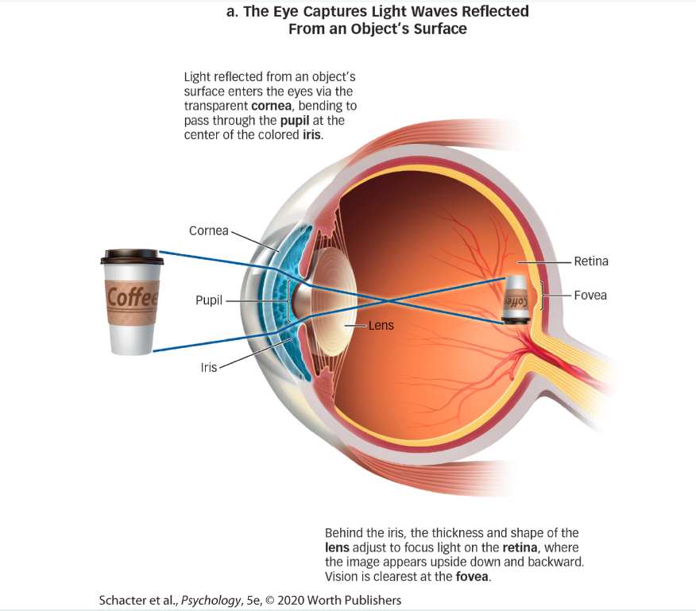

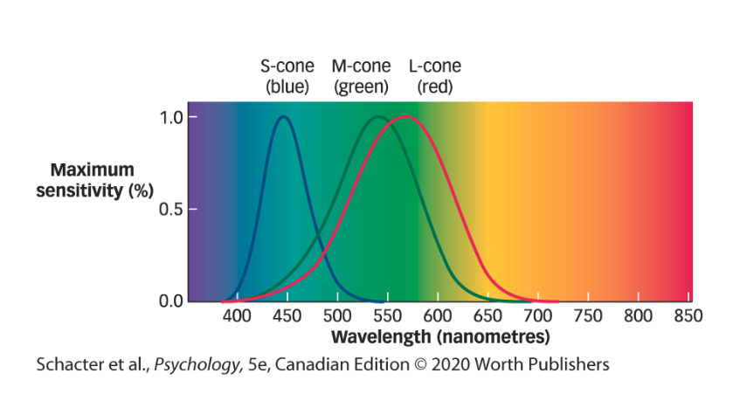

**Visual Perception: Recognizing What We See**

* List the factors that allow us to recognize objects by sight
* Describe the visual cues essential for depth perception
* Discuss how we perceive motion and change
* How does the study of illusory conjunctions help us understand the role of attention in feature binding?
* How doe we recognize our friends, even when they’re hidden behind sunglasses?
* What are the Gestalt rules of perceptual organization?
  + *Perceptual organization*: process of grouping and segregating features to create whole objects organized in meaningful ways
  + *Gestalt perceptual grouping rules*: Simplicity, Closure, Continuity, Similarity, Proximity, Common fate
    - *Simplicity* refers to selecting the simplest and most likely interpretation of an object’s shape
    - *Proximity* means that objects close together tend to be grouped together
    - *Similarity* is the idea that regions of similar color, lightness, shape, or texture are perceived as belonging to the same object.
    - *Continuity* is grouping together edges/contours with the same orientation.
    - *Common fate*: elements of a visual image that move together are perceived as parts of a single moving object (flashing lights on road sign)
* What does the face-vase illusion tell us about perceptual organization?
* What are perceptual constancy and perceptual contrast?
  + Perceptual constancy: as aspects of sensory signals change, perception remain constant (e.g., your friend is still your friend with or without glasses on)
  + Perceptual contrast: although the sensory information from two things may be similar, we perceive the objects as different (e.g., the dress debate)
* How can flashing lights on a casino sign give the impression of movement?
* How can a failure of focused attention explain change blindness?
  + *Change blindness*: occurs when individuals fail to detect changes to the visual details of a scene. Likely to occur when people fail to focus attention on the changed object. E.g., Switcheroo study. Inattentional blindness: failure to perceive objects that are not the focus of attention.
* *Retinal disparity/ binocular disparity*: image your right eye sees is different than your left because they are a small distance apart. The image you "see" is the two images merged, and this is a binocular depth cue
* *Relative size*: smaller objects appear to be further away; Linear perspective: parallel lines seem to converge with distance; Interposition: blocking objects are closer than blocked objects.

Chapter 6

**Storage: Maintaining Memories Over Time**

* distinguish sensory memory from short-term memory
* describe the elements of the model of working memory
* explain the interrelationship between memory and the hippocampus
* summarize the role of the neural synapse in long-term memory storage
* what evidence from the iconic memory test suggests that all the letters presented to participants were stored in memory before quickly fading?
* define iconic memory and echoic memory
* why is it helpful to repeat a telephone number you’re trying to remember?
* how does working memory expand on the idea of short-term memory?
* what did researchers learn about the role of the hippocampus and memory from HM?
* define anterograde and retrograde amnesia
* how does the process of recalling a memory affect its stability?
* how does building a memory produce a physical change in the nervous system?

Chapter 7

**Classical Conditioning: One Thing Leads to Another**

* describe the process of classical conditioning
* explain how cognitive, neural, and evolutionary aspects influence our understanding of classical conditioning
* why do some doges seem to know when it’s dinnertime?
* if both an unconditioned and conditioned stimulus can produce the same effect, what is the difference?
* what is second-order conditioning?
* how does a conditioned behavior change when the unconditioned stimulus is removed?
* why are generalization and discrimination “two sides of the same coin”?
* why did little Albert fear the rat?
* how does the role of expectation in conditioning challenge behaviorist ideas?
* what is the role of the amygdala in fear conditioning?
* how has cancer patients’ discomfort been eased by our understanding of food aversions?
* *Sensitization* is when the presentation of a stimulus leads to an increased response to a later stimulus.
* *Classical conditioning* was what Pavlov used in his experiments with dogs.
  + In classical conditioning, *learning* occurs when a neutral stimulus produces a response after being paired with a stimulus that naturally produces a response.
  + The *conditioned response* is a reaction that resembles an unconditioned response but is produced by the conditioned stimulus rather than the unconditioned stimulus
  + the *unconditioned stimulus* (the dog food) was replaced with the *conditioned stimulus* (the sound of the bell) to produce the *conditioned response* (salivating)
  + *Extinction* is the gradual elimination of a learned response that occurs when the conditioned stimulus is repeatedly presented without the unconditioned stimulus.
  + *Second-order conditioning*: a type of learning whereby a conditioned stimulus is paired with a stimulus that became associated with the unconditioned stimulus in an earlier procedure
* *Habituation* involves repeated or prolonged exposure to a stimulus resulting in a gradual reduction in response to that stimulus.

**Operant Conditioning: Reinforcements from the Environment**

* describe the process of operant conditioning
  + *Operant behavior* is a behavior that an organism performs that impacts the environment.
* explain how behavioral, cognitive, neural and evolutionary aspects influence our understanding of operant conditioning
* what is the law of effect?
  + *Law of effect* is the fact that behaviors followed by a satisfying situation tend to be repeated; those behaviors that produce an unpleasant situation are less likely to be repeated
* what do “positive” and “negative” mean in operant conditioning?
  + positive means added
  + negative means taken away
* why is reinforcement more constructive than punishment in learning a desired behavior?
  + punishment signals that an unacceptable behavior has occurred but it doesn’t specify what should be done instead
* what are primary and secondary reinforcers?
  + A *primary reinforcer* is a stimulus that leads to an involuntary response because that stimulus is biologically important to the organism (ie., food, sleep, water, etc.)
  + A *secondary reinforcer*, also known as a conditioned reinforcer, is a stimulus or situation that has acquired its function as a reinforcer after pairing with a stimulus that functions as a reinforcer (ie., because he collects the gold stars and can use them to get food this is an example of a secondary reinforcer)
* how does the concept of delayed reinforcement relate to difficulties with quitting smoking?
* what does it mean to say that learning takes place in contexts?
* how is the concept of extinction different in operant conditioning than in classical conditioning?
* how does a radio station use scheduled reinforcements to keep you listening?
* how do ratio schedules work to keep you spending your money?
  + In fixed ratio reinforcement, reinforcement is delivered after a specific number of responses has been made (i.e., every 10th response).
* how can operant conditioning produce complex behaviors?
* what are cognitive maps? why are they a challenge to behaviorism?
* how do specific brain structures contribute to the process of reinforcement?
* what explains a rat’s behavior in a T maze?

Memory

* *Iconic* memory is a fast-decaying store of visual information (decays in 1 second or less)
* *Echoic* memory is a fast-decaying store of auditory information (decays in about 5 seconds)
* Our *short-term memory* holds non-sensory information for more than a few seconds but less than a minute. As a side note, rehearsal refers to the process of keeping information in short-term memory by mentally repeating it.
  + can usually hold 7 meaningful items at once
  + *Chunking* involves grouping long strings of information into smaller chunks.
* *episodic buffer:*
  + It automatically combines separate items into an integrated whole
  + It integrates various kinds of sensory information
  + It plays a role in learning to recognize words
* The 3 key functions of memory are encoding, storage, and retrieval.
* *Shaping* is the process of reinforcing successively closer and closer approximations to a desired terminal behavior. There are 5 main steps in the shaping process:
  + Reinforce any response that in some way resembles the terminal behavior.
  + Reinforce the response that closely approximates the terminal behavior (no longer reinforcing the previous reinforced response).
  + Reinforce the response that resembles the terminal behavior even more closely.
  + Continue reinforcing closer and closer approximations to the terminal behavior
  + Reinforce only the terminal behavior

