Name: V Vyas
SRN: PES2UG24CS569
Section: 5J

SE Lab 6

Code Coverage
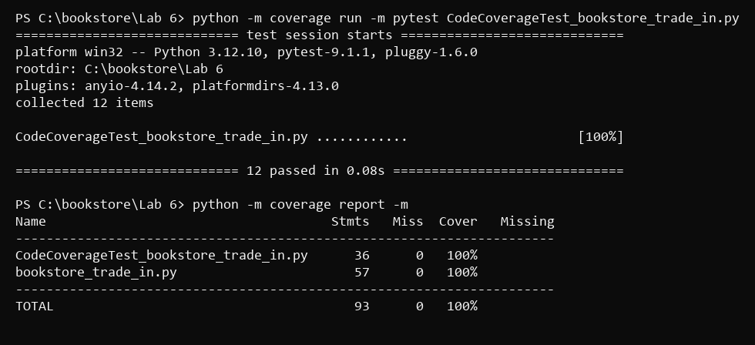

Branch Coverage


