AIM:
Create a web form that Write JavaScript to validate the Registration page.

CODE:
REGISTER.html

<html>
<head>
<title>Registration Form</title>
<style>
.error-message {
color: red;
font-size: 14px;
margin-top: 5px;
}
input{
padding: 5px;
border-radius: 6px;
display: block;
}
</style>
</head>
<body style="display:flex; flex-direction: column; justify-content: center; align-items: center;">
<h1>REGISTRATION FORM</h1>
<form name="RegForm" onsubmit="return validateForm()">
<p>
<label for="firstname">First Name:</label>
<input type="text" id="firstname" name="firstname" placeholder="Enter First Name" required/>
<span id="firstname-error" class="error-message"></span>
</p>
<p>
<label for="password">Password:</label>
<input type="password" id="password" name="password" placeholder="Enter Password" required/>
<span id="password-error" class="error-message"></span>
</p>
<p>
<label for="email">Email:</label>
<input type="text" id="email" name="email" placeholder="Enter Email" required/>
<span id="email-error" class="error-message"></span>
</p>
<p>
<label for="phone">Phone Number:</label>
<input type="tel" id="phone" name="phone" placeholder="Enter Phone Number" required/>
<span id="phone-error" class="error-message"></span>
</p>
<p>
<label for="lastname">Last Name:</label>
<input type="text" id="lastname" name="lastname" placeholder="Enter Last Name" required/>
<span id="lastname-error" class="error-message"></span>
</p>
<p>
<label for="address">Address:</label>
<textarea id="address" name="address" placeholder="Enter Address" required></textarea>
<span id="address-error" class="error-message"></span>
</p>
<p>
<input type="submit" value="Submit" name="Submit" />
</p>
</form>
<script>
function validateForm() {
let firstname = document.getElementById("firstname").value;
let password = document.getElementById("password").value;
let email = document.getElementById("email").value;
let phone = document.getElementById("phone").value;
let lastname = document.getElementById("lastname").value;
let address = document.getElementById("address").value;

const firstnameError = document.getElementById("firstname-error");
const passwordError = document.getElementById("password-error");
const emailError = document.getElementById("email-error");
const phoneError = document.getElementById("phone-error");
const lastnameError = document.getElementById("lastname-error");
const addressError = document.getElementById("address-error");

firstnameError.textContent = "";
passwordError.textContent = "";
emailError.textContent = "";
phoneError.textContent = "";
lastnameError.textContent = "";
addressError.textContent = "";
let isvalid = true;

if(/[^a-zA-Z]/.test(firstname))
{
firstnameError.textContent="First Name only contains alphabet";
isvalid = false;
}
else if(firstname.length <= 6){
firstnameError.textContent="First Name length not less than 6 characters";
isvalid = false;
}

if (password.length !=8) {
passwordError.textContent = "Password must be between 8 and 30 characters.";
isvalid = false;
}

const emailPattern = /^[a-zA-Z0-9._-]+@[a-zA-Z0-9.-]+\.[a-zA-Z]{2,}$/;
if (!emailPattern.test(email)) {
emailError.textContent = "Please enter a valid email address.";
isvalid = false;
}
if(phone.length!=10){
phoneError.textContent = "Phone number length must be 10";
isvalid = false;
}

if(isvalid){
alert("Register successfully");
return true;
}
else{
return false;
}
}
</script>
</body>
</html>

OUTPUT:

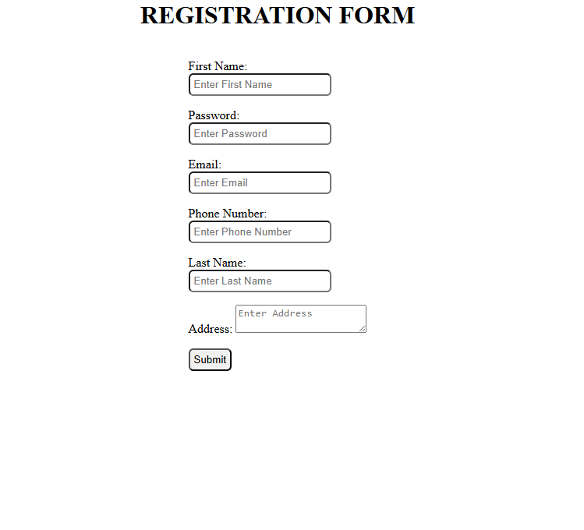

RESULT:
Validating Registration page is done successfully and displayed in the browser.

