KHULNA UNIVERSITY
Computer Science and Engineering Discipline
Course: Web Programming and Mobile Applications

Software Requirements Specification (SRS)
for
CampusNest
A MERN Stack Web Platform for Mess/Basa Rental,
Student Job & Tuition Marketplace

Submitted By:
Hasibur Rahaman (Student ID: 220227)
Nazmul Labib (Student ID: 220236)
Supervised By:
Kazi Masudul Alam
Professor, Computer Science and Engineering Discipline
Khulna University

Table of Contents
1. Introduction 3
2. Overall Description 5
3. System Models 7
3.1 Use Case Diagram 7
3.2 Entity-Relationship (ER) Diagram 7
3.3 System Architecture 8
4. Functional Requirements 9
5. Non-Functional Requirements 11
6. Business Model 12
7. External Interface Requirements 13
8. Future Enhancements 14
9. Conclusion 15

1. Introduction

1.1 Purpose
The purpose of this document is to provide a detailed Software Requirements Specification (SRS) for “CampusNest”, a full-stack web platform built using the MERN stack (MongoDB, Express.js, React.js, Node.js). This document describes the functional and non-functional requirements, system models, and the business/subscription model of the platform. It is intended to serve as a reference for the development team and the course supervisor throughout the design and implementation phases.

1.2 Scope
CampusNest is a multi-sided marketplace platform primarily targeted at university students, home/mess owners, guardians, and part-time teachers. The platform allows:
- Home owners to post mess/basa (room/seat) rental listings for students.
- Students to post available part-time jobs or tuitions they know of, and to apply for jobs, tuitions, or basa seats posted by others.
- Guardians to post their tuition requirements (subject, class, location, preferred gender, salary) so that suitable teachers can apply.
- Teachers/job seekers to browse and apply for tuition and job posts that match their skills.
- The platform administrator to manage users, content, and a subscription-based revenue model.
The system will be delivered as a responsive web application, with the possibility of extending to a mobile application in a future phase.

1.3 Intended Audience
- Project supervisor and course evaluators.
- Development team members (project group).
- Future maintainers/developers of the system.

1.4 Definitions, Acronyms and Abbreviations
Term | Description
SRS | Software Requirements Specification
MERN | MongoDB, Express.js, React.js, Node.js
Basa / Mess | Rented accommodation/seat for students
JWT | JSON Web Token, used for authentication
ODM | Object Document Mapper (Mongoose)
API | Application Programming Interface
Admin | Platform administrator/owner of the business

1.5 Document Overview
Section 2 gives an overall description of the product and its users. Section 3 presents the system models (use case, ER, and architecture diagrams). Section 4 lists the functional requirements module by module. Section 5 covers non-functional requirements. Section 6 explains the business/subscription model. Section 7 covers external interface requirements, Section 8 lists possible future enhancements, and Section 9 concludes the document.

2. Overall Description

2.1 Product Perspective
CampusNest is a new, independent web-based platform. It is not a replacement of any existing in-house system but competes with informal channels (Facebook groups, word-of-mouth, printed notices) currently used by students to find mess/basa, tuitions, and part-time jobs. The system follows a client-server architecture built entirely on the MERN stack, described in Section 3.3.

2.2 Product Features (Summary)
- Basa/mess listing posting, browsing, and filtering.
- Student job and tuition posting and application.
- Guardian tuition-requirement posting and teacher application.
- In-app messaging between interested parties.
- Subscription-based premium features for owners, students, guardians, and teachers.
- Admin dashboard for user, content, and revenue management.

2.3 User Classes and Characteristics
User Class | Description | Key Activities
Home Owner | Owns or manages mess/basa accommodation near the campus. | Post basa listings, manage applicants, subscribe for featured listing.
Student | University student looking for accommodation, and may also post jobs/tuitions they are aware of. | Search/apply for basa, post job/tuition leads, apply for jobs/tuitions.
Guardian | Parent/guardian looking for a home tutor for their child. | Post tuition requirement, review teacher applicants, hire a teacher.
Teacher / Job Seeker | Individual (often a student) offering tutoring or seeking part-time work. | Browse tuition/job posts, apply, build a profile, subscribe for boosted visibility.
Admin | Owner/operator of the CampusNest platform. | Manage users and content, monitor subscriptions and revenue, resolve disputes.

2.4 Operating Environment
- Client: Any modern web browser (Chrome, Firefox, Edge) on desktop or mobile, responsive UI built with React.js.
- Server: Node.js runtime with Express.js, hosted on a cloud platform (e.g., Render/Vercel/AWS).
- Database: MongoDB Atlas (cloud-hosted NoSQL database).
- Third-party services: Payment gateway (bKash/SSLCommerz) for subscription payments, cloud storage (Cloudinary/AWS S3) for images.

2.5 Design and Implementation Constraints
- The system must be developed using the MERN stack as required by the course.
- The system must support role-based access control for five user roles.
- Payment integration must comply with the chosen local payment gateway's API constraints.
- Development timeline is constrained by the academic semester schedule.

2.6 Assumptions and Dependencies
- Users have access to a smartphone/computer with internet connectivity.
- The payment gateway sandbox/test environment will be used during development.
- Users provide accurate information while posting listings and requirements.

3. System Models
This section presents the key analysis and design models used to plan CampusNest: the use case model (functional scope per actor), the entity-relationship model (data design), and the high-level system architecture.

3.1 Use Case Diagram
The diagram below shows the five actors of the system and the primary use cases each actor can perform.
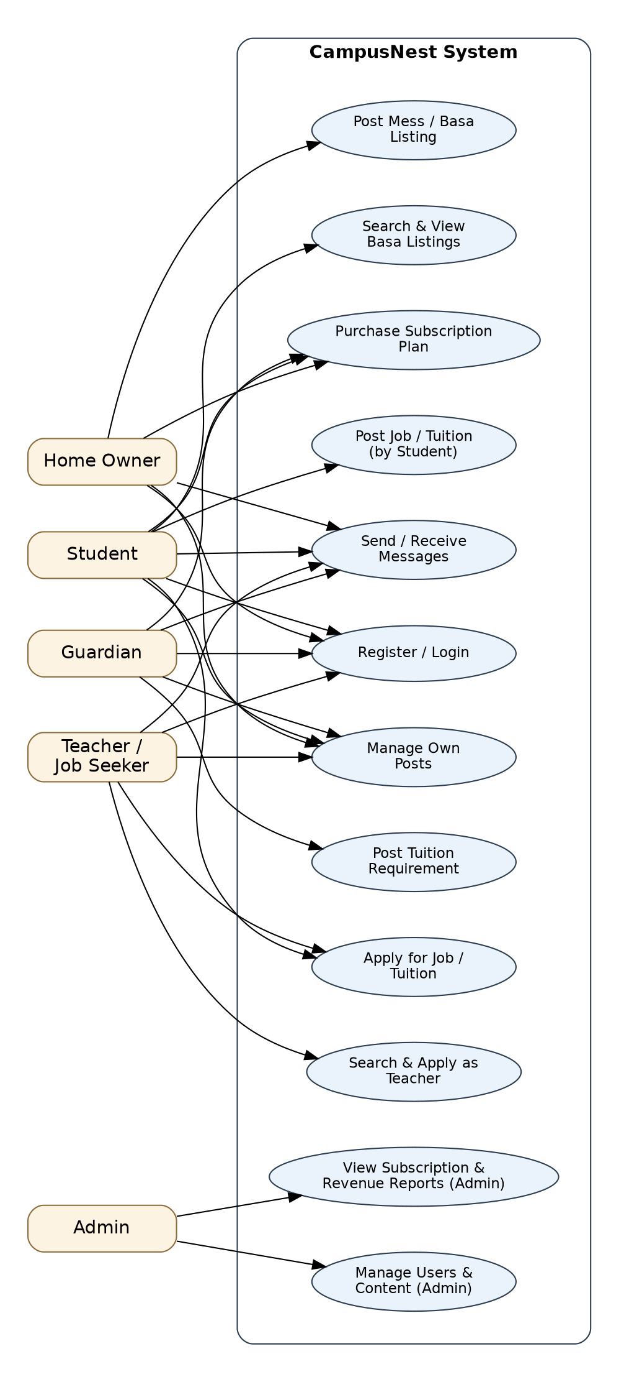
Figure 3.1: Use Case Diagram of CampusNest

3.2 Entity-Relationship (ER) Diagram
The ER diagram below models the core data entities of the system and their relationships, as planned for the MongoDB collections (implemented via Mongoose schemas).
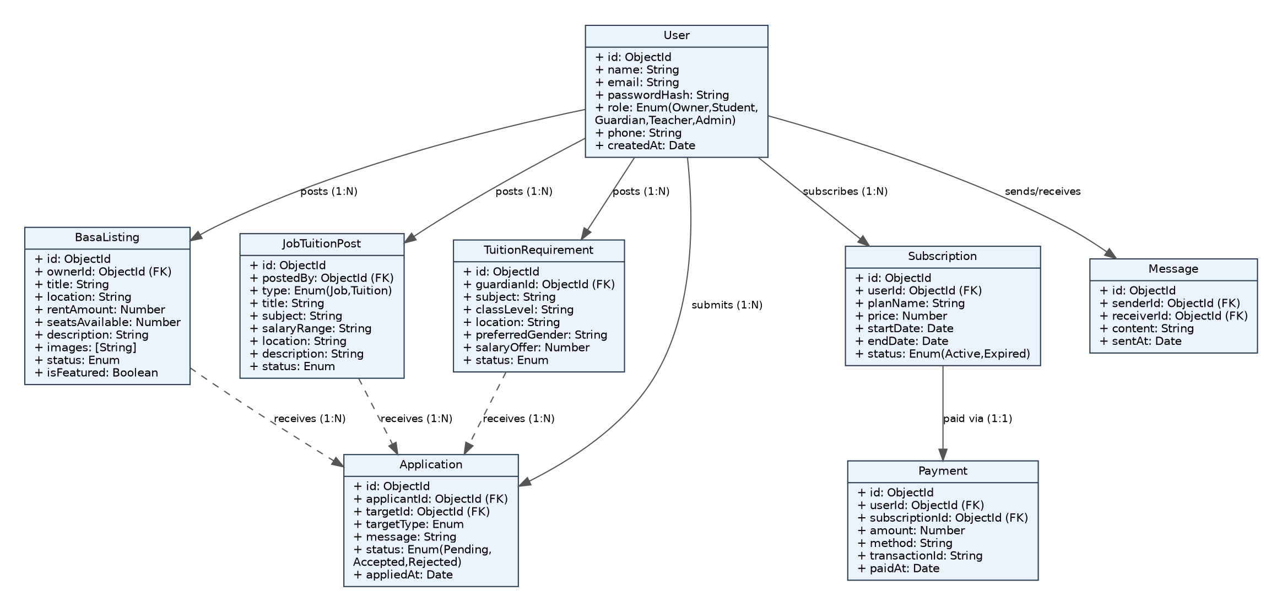
Figure 3.2: Entity-Relationship Diagram of CampusNest

3.3 System Architecture
CampusNest follows a standard MERN stack, three-tier architecture: a React.js single-page application on the client, an Express.js/Node.js REST API on the server, and MongoDB as the persistent data store, with external payment and cloud-storage services integrated at the service layer.
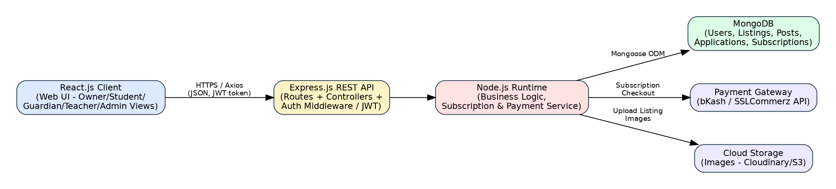
Figure 3.3: High-Level System Architecture of CampusNest

4. Functional Requirements

4.1 User Management Module
ID | Requirement
FR-1.1 | The system shall allow a user to register by selecting a role: Home Owner, Student, Guardian, or Teacher.
FR-1.2 | The system shall allow a registered user to log in using email and password (JWT-based authentication).
FR-1.3 | The system shall allow a user to create and edit a profile (name, phone, photo, address, bio).
FR-1.4 | The system shall allow an Admin to view, suspend, or delete any user account.

4.2 Basa / Mess Listing Module
ID | Requirement
FR-2.1 | The system shall allow a Home Owner to post a basa/mess listing with title, location, rent, seats available, description, and images.
FR-2.2 | The system shall allow a Student to search and filter listings by location, rent range, and seat availability.
FR-2.3 | The system shall allow a Student to apply/contact the owner for a listing.
FR-2.4 | The system shall allow a Home Owner to mark a listing as “rented out”/inactive.
FR-2.5 | The system shall allow a Home Owner to purchase a subscription to feature/boost their listing.

4.3 Job / Tuition Posting Module (by Students)
ID | Requirement
FR-3.1 | The system shall allow a Student to post a job or tuition opening they are aware of, with subject/role, salary range, and location.
FR-3.2 | The system shall allow any Teacher/Student to view and apply for a posted job/tuition.
FR-3.3 | The system shall notify the poster when a new application is received.

4.4 Guardian Tuition Requirement Module
ID | Requirement
FR-4.1 | The system shall allow a Guardian to post a tuition requirement specifying subject, class level, location, preferred gender, and salary offer.
FR-4.2 | The system shall allow a Teacher to browse and apply to tuition requirements matching their expertise.
FR-4.3 | The system shall allow a Guardian to view applicant profiles and accept/reject an applicant.
FR-4.4 | The system shall allow a Guardian/Teacher to purchase a subscription for priority listing/visibility.

4.5 Messaging Module
ID | Requirement
FR-5.1 | The system shall allow two users to exchange in-app messages once an application/interest has been initiated.
FR-5.2 | The system shall display a notification for unread messages.

4.6 Subscription & Payment Module
ID | Requirement
FR-6.1 | The system shall display available subscription plans to eligible users (Owner, Student, Guardian, Teacher).
FR-6.2 | The system shall integrate with a payment gateway to process subscription payments securely.
FR-6.3 | The system shall activate premium features immediately upon successful payment.
FR-6.4 | The system shall automatically expire a subscription at the end of its billing period.

4.7 Admin Module
ID | Requirement
FR-7.1 | The system shall provide an Admin dashboard showing total users, listings, posts, and active subscriptions.
FR-7.2 | The system shall allow the Admin to approve, flag, or remove any listing/post that violates platform policy.
FR-7.3 | The system shall allow the Admin to view subscription revenue reports over a selected time period.

5. Non-Functional Requirements
Category | Requirement
Performance | The system shall load listing/search pages within 2 seconds under normal network conditions.
Security | Passwords shall be hashed (bcrypt); all sensitive routes shall be protected using JWT-based authentication and role-based authorization.
Scalability | The system architecture shall support horizontal scaling of the Node.js API layer as user load grows.
Usability | The UI shall be responsive and usable on both desktop and mobile browsers, with a simple, student-friendly design.
Availability | The system shall target 99% uptime, hosted on a reliable cloud platform.
Maintainability | Code shall follow a modular MVC-like structure to ease future feature additions.
Data Privacy | User personal data (phone, email) shall only be visible to relevant matched parties, not publicly listed.

6. Business Model

6.1 Value Proposition
CampusNest brings together four fragmented, informal markets around student life — mess/basa rental, part-time jobs, and private tuition — into one trusted, searchable platform. Students save time and effort compared to scattered Facebook groups and notice boards; home owners, guardians, and teachers get faster, more relevant matches.

6.2 Revenue Streams
The core browsing and posting features will remain free to encourage adoption. The business generates income through a freemium subscription model, applied at specific high-value touch-points:
- Featured/boosted basa listings for Home Owners (higher visibility in search results).
- Priority placement for Guardian tuition requirements, so they attract applicants faster.
- Premium teacher/student profiles with a verified badge and higher ranking in search results.
- (Future) A small commission on successful paid placements facilitated through the platform.

6.3 Subscription Plans (Indicative)
Plan | Target User | Price (Monthly) | Key Benefits
Free | All users | Tk 0 | Basic posting, browsing, and applying with limited monthly posts.
Basic Boost | Owner / Guardian | Tk 150 | 1 featured listing/requirement, priority in search results for 7 days.
Pro | Owner / Guardian / Teacher | Tk 350 | Unlimited featured posts, verified badge, advanced applicant filtering.
Business | Owner (multiple mess) / Coaching centers | Tk 1000 | Multiple listings, dashboard analytics, dedicated support.

6.4 Admin Revenue Dashboard
The Admin panel will track active subscriptions, monthly recurring revenue (MRR), plan-wise distribution of subscribers, and churn (expired/cancelled subscriptions), enabling data-driven decisions about pricing and plan design as the platform grows.

7. External Interface Requirements

7.1 User Interfaces
- Public pages: Landing page, Browse Basa, Browse Jobs/Tuitions, Login/Register.
- Role-based dashboards for Owner, Student, Guardian, Teacher, and Admin.
- Responsive design supporting mobile, tablet, and desktop breakpoints.

7.2 Hardware Interfaces
No special hardware is required; the system runs on standard client devices with a browser and internet access.

7.3 Software Interfaces
- MongoDB Atlas — cloud database service.
- Payment Gateway API (bKash / SSLCommerz) — for subscription payments.
- Cloudinary / AWS S3 API — for image upload and storage.

7.4 Communication Interfaces
All client-server communication occurs over HTTPS using RESTful JSON APIs exposed by the Express.js backend.

8. Future Enhancements
- Native mobile application (React Native) for Android and iOS.
- AI-based matching between guardians and teachers based on ratings and past performance.
- Verified reviews and ratings for home owners and teachers.
- In-app video call for teacher-guardian interviews.
- Commission-based revenue on successful long-term placements.

9. Conclusion
CampusNest aims to simplify three everyday struggles of student life — finding accommodation, finding part-time work or tuition, and finding a reliable tutor — within a single, easy-to-use MERN stack platform. Its freemium subscription model provides a realistic path to sustainable revenue while keeping core features accessible to all students. This SRS document will guide the design, implementation, and evaluation of the system throughout the course project.

