

Bangladesh University of Engineering and Technology

A Report on

**FREQUENCY MODULATION & DEMODULATION USING PLL**

Submitted to:

Yeasir Arafat Dr. Samia Subrina Assistant Professor Associate Professor Dept. of EEE, BUET. Dept. of EEE, BUET.

Course No : EEE 210

Course Name : Electronic Circuit Simulation Laboratory

Submitted by:

Sultan Mohammad Manjur 1406040

Uday Kamal 1406041

Muntasir Islam Koushik 1406042

Shamim Aktaruzzaman 1406043

Nabila Fairuz 1406044

Md. Hasibul Amin 1406045

Department: EEE

Level : 2 Term : 1

Section : A2

Date of Submission : 08/06/16

FORWARDING LETTER

April 30, 2016.

Yeasir Arafat

Dr. Samia Subrina

Department of Electrical and Electronic Engineering,

Bangladesh University of Engineering and technology.

Subject: Submission of the report on "Frequency Modulation and Demodulation using PLL”

Dear madam and sir,

It is our authentic pleasure to submit the report entitled “**Frequency Modulation and Demodulation using PLL**” to your supremacy. We are, indeed, highly enthusiastic as well as meticulous, under your lenient and liberal instructions, in dealing with the process of fm transmission and reception which has significant application in the field of communication. In this report we modeled a frequency modulator and demodulator using phase-locked loop circuit in Pspice simulation software and investigated PLL operation.

We truly believe that in this very report we left no stone unturned to carry out the most accurate result and bring necessary changes to improve our circuit model and simulation results. We convey our wholehearted thanks to our fellow classmates and senior students, the authors of the books and articles and reports without which we could not enter deep into a out-of syllabus topic.

Nevertheless, we confess our limitations and imperfections over which we have no control and express our humble apology for the inconsistency, if any. We are waiting eagerly for your sympathetic perusal as well as favorable consideration and judgment.

Sincerely yours,

Sultan Mohammad Manjur

Uday Kamal

Muntasir Islam Koushik

Shamim Aktaruzzaman

Nabila Fairuz

Md. Hasibul Amin

Table of Contents

Contents Page No.

Forwarding letter .................................................................................. i

List of illustrations ................................................................................. iii

Summary ................................................................................................ iv

1. Introduction .............................................................................................. 01
2. Introduction to Frequency Modulation and Demodulation.............. 01
3. Theory of Frequency Modulation.......................................................... 02
4. Theory of Frequency Demodulation...................................................... 05
5. Introduction to Phase Locked Loop, PLL.............................................. 06
6. Operation principles of a phase-locked loop........................................ 07
7. PLL IC HC4046A/B, Building Block of the Demodulator.................. 09
   1. Phase Detector................................................................................. 11
   2. Loop Filter........................................................................................ 12
   3. Voltage Controlled Oscillator........................................................ 13
8. PLL Operation in the IC........................................................................... 14
9. Circuit Implementation of Frequency Modulator................................ 15
10. Circuit Implementation of Frequency Demodulator........................... 18
11. Advantages and Limitations of FM........................................................ 26
12. Applications of the Frequency modulator and demodulator............. 27
13. Conclusion.................................................................................................. 28
14. Recommendations..................................................................................... 28
15. Referrence................................................................................................... 29

List of Illustrations

Figures :

Fig 3.1: Frequency modulation for FM radio. ..................................................... 03

Fig 6.1: Block diagram of Basic Phase Locked Loop PLL.................................. 07

Fig 7.1: The functional diagram of 4046............................................................... 09

Fig 7.2: Pinouts of IC4046...................................................................................... 10

Fig 7.1.1: Operation of the phase detector with XOR gate. .............................. 11

Fig 7.2.1: Characteristic of Phase Detector............................................................ 09

Fig 9.1: Block Diagram of Modulator................................................................... 15

Fig 9.2: Circuit Diagram for Frequency Modulator........................................... 17

Fig 9.3: Input voltage waveform and the modulated output........................... 17

Fig 10.1: Basic Block Diagram of PLL FM Demodulator................................... 18

Fig 10.2 : The complete circuit diagram for FM Demodulation....................... 20

Fig 10.3: The modulating signal wave, the modulated output from the modulator and the input for demodulator and the demodulated output......................... 21

Fig 10.4: The complete circuit diagram for FM Demodulation with ripple filter........................................................................................................................... 22

Fig 10.5: The complete circuit diagram for FM Demodulation with ripple filter and a clamper.................................................................................................................. 23

Fig 10.6: The complete circuit diagram for FM Demodulation with ripple filter and a clamper along with a non inverting multiplier............................................... 25

Summary

Frequency modulation, FM is widely used for a variety of radio communications applications. FM broadcasts on the VHF bands still provide exceptionally high quality audio, and FM is also used for a variety of forms of two way radio communications. Phase locked loop, PLL FM demodulator or detector is a form of FM demodulator that has gained widespread acceptance in recent years. PLL FM detectors can easily be made from the variety of phase locked loop integrated circuits that are available, and as a result, PLL FM demodulators are found in many types of radio equipment ranging from broadcast receivers to high performance communications equipment. In this regard we developed a PLL FM modulator and demodulator circuit in Pspice simulation softwareOrCAD Pspice is a SPICE circuit simulator application for simulation and verification of analog and mixed-signal circuits.[[](https://en.wikipedia.org/wiki/OrCAD#cite_note-ee-16). In FM transmission, an audio signal is encoded in a high frequency carrier wave by the modulator .The wave, after transmitting through air, is received at the demodulator where the varying frequency of the carrier wave is turned into voltage output signal. In both modulator and demodulator, PLL is used, which can at the same time turn voltage variation into frequency variation and do the opposite in a loop. A compact PLL IC, CD4046 is available in pspice 9.2 version. After a detailed study of background theory, the circuit diagram of the modulator and demodulator was drawn in Pspice schematics and simulated to get the output modulated wave whose variations of frequency represents the input signal. The values of the IC had been set using related equations presented earlier and necessary changes were made to get a perfect observable output. The modulated wave was input to the demodulator circuit where we get the output which was similar to the input signal. After filtering, DC offsetting and amplifying , output was made identical to the input. An overview of the advantages and applications of this PLL modulation and demodulation and possibilities of further improvement is presented.

1.Introduction:

Frequency modulation, FM is widely used for a variety of radio communications applications. FM broadcasts on the very high frequency [VHF] bands still provide exceptionally high quality audio, and FM is also used for a variety of forms of two way radio communications, and it is especially useful for mobile radio communications. In view of its widespread use, frequency modulation, FM, is an important form of modulation, despite many forms of digital transmission being used these days. Since its first introduction the use of frequency modulation, FM has grown enormously. Now wideband FM is still regarded as a very high quality transmission medium for high quality broadcasting. It is also widely used for communications where it is resilient to variations in signal strength.

**2.Introduction to Frequency Modulation and Demodulation:**

FM has been in use for many years. However its advantages were not immediately apparent. In the early days of wireless, it was thought that a narrower bandwidth was required to reduce noise and interference. As FM did not perform well under these conditions, AM predominated and FM was not used. However, **Edwin Armstrong**, an American engineer looked at the use of wideband FM for broadcasting and introduced the idea against the trend of the thinking of the time.

FM Modulation: In telecommunications and signal processing, frequency modulation (FM) is the encoding of information in a carrier wave by varying the instantaneous frequency of the wave. Mobile phones and other wireless devices send information across free space using electromagnetic waves. To send these electromagnetic waves across long distances in free space, the frequency of the transmitted signal must be changed. If this input signal is added to the pure carrier wave, it will thereby change the frequency of the carrier wave. In that way, users can use changes of frequency to carry speech information. This is called **frequency modulation or FM.**

FM Demodulation: Demodulation is extracting the original information-bearing signal from a modulated carrier wave. A demodulator is an electronic circuit (or computer program in a software-defined radio) that is used to recover the information content from the modulated carrier wave.[1] There are many types of modulation so there are many types of demodulators. The signal output from a demodulator may represent sound (an analog audio signal), images (an analog video signal) or binary data (a digital signal).

3.Theory of Frequency Modulation:

With frequency modulation, the frequency of the carrier wave is shifted proportionally to the amplitude of the modulating signal. Therefore the frequency of the modulated wave is shifted continuously, and since a different spectrum from the modulating signal occurs centered on the carrier frequency, modulation is nonlinear.

If the information to be transmitted (i.e., the baseband signal) is {\displaystyle x_{m}(t)}  and the sinusoidal carrier is{\displaystyle x_{c}(t)=A_{c}\cos(2\pi f_{c}t)\,}, where *fc* is the carrier's base frequency, and *Ac* is the carrier's amplitude, the modulator combines the carrier with the baseband data signal to get the transmitted signal:

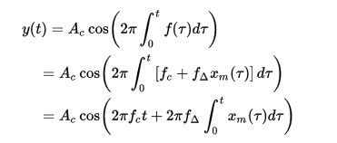

{\displaystyle y(t)=A_{c}\cos \left(2\pi \int _{0}^{t}f(\tau )d\tau \right)}

{\displaystyle =A_{c}\cos \left(2\pi f_{c}t+2\pi f_{\Delta }\int _{0}^{t}x_{m}(\tau )d\tau \right)}In this equation, {\displaystyle f(\tau )\,} is the instantaneous frequency of the oscillator and {\displaystyle f_{\Delta }\,}  is the frequency *deviation*, which represents the maximum shift away from *fc* in one direction, assuming  *xm*(*t*) is limited to the range ±1.

Mathematically, a baseband modulated signal may be approximated by a sinusoidal continuous wave signal with a frequency *fm*. This method is also named as Single-tone Modulation. The integral of such a signal is:



In this case, the expression for y (t) above simplifies to:



Where the amplitude {\displaystyle A_{m}\,} of the modulating sinusoid is represented by the peak deviation {\displaystyle f_{\Delta }\,}.

As in other modulation systems, the modulation index indicates by how much the modulated variable varies around its unmodulated level. It relates to variations in the carrier frequency:



where {\displaystyle f_{m}\,} is the highest frequency component present in the modulating signal *xm*(*t*), and {\displaystyle \Delta {}f\,} is the peak frequency-deviation i.e. the maximum deviation of the instantaneous frequency from the carrier frequency. For a sine wave modulation, the modulation index is seen to be the ratio of the peak frequency deviation of the carrier wave to the frequency of the modulating sine wave.

When the frequency modulation index m is less than 1, it’s known as narrowband FM, and if it’s greater than 1, it’s known as wideband FM. Wideband FM has good signal to noise ratio when it’s demodulated at the receiver, so it’s used widely in FM radios and so on. The higher the modulation index, the wider the bandwidth must be for transmission. Higher deviation during demodulation improves signal to noise, but this increases the bandwidth required for transmission. The priority given here depends on the system requirements. Improving the signal to noise by increasing the deviation is called FM gain.

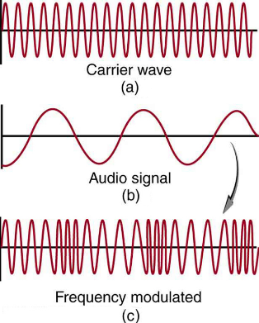

Figure 3.1: Frequency modulation for FM radio. (a) A carrier wave at the station's basic frequency. (b) An audio signal at much lower audible frequencies. (c) The frequency of the carrier is modulated by the audio signal without changing its amplitude.

FM Modulated Spectrum Wave:

The spectrum of the frequency modulation modulated wave occurs above and below the carrier wave Fc, and the frequency is the integeral multiple of the modulating signal Fm.

In the spectrum, the modulation signal frequency Fm, deviation Δf, and frequency modulation index m are related as follows. (When the modulating signal is a single sine wave)  
The spectrum interval is the modulation signal frequency Fm, and it spreads in an infinite frequency band. Deviation Δf is the difference in the center frequency Fc of the carrier wave and the frequency of the modulation index number from Fc.

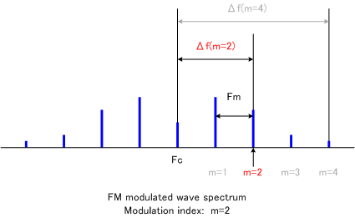

The required bandwidth for frequency modulated waves:  
The envelope amplitude of frequency modulated waves is said to be constant, but this is only when all spectrum components are collected, and actually, amplitude fluctuation appears due to frequency band restrictions.

The bandwidth B required so that amplitude fluctuation doesn’t become a problem for demodulation is as follows. Δf is the maximum frequency shift, m is the modulation index, and Fm is the modulation signal frequency.  
  
   
  
When the maximum frequency of the modulating signal is fixed, a wide transmission band is required if the modulation index m is high. When the maximum frequency shift Δf is fixed, the spectral interval becomes narrow if the modulation index m is high.  
For example, the occupied band width of FM radio is 200 kHz and the maximum frequency shift Δf is 75 kHz, so the maximum frequency Fm and modulation index m of the modulated wave are as follows.

Fm = B/2-Δf = 200/2-75 = 25 kHz  
 m = Δf/Fm = 75/25 = 3

4.Theory of Frequency Demodulation:

### FM demodulation or detection involves changing the frequency variations in a signal into amplitude variations at baseband, e.g. audio. In order to be able to receive FM a receiver must be sensitive to the frequency variations of the incoming signals.

There are a number of circuits that can be used to demodulate FM. Each type has its own advantages and disadvantages, some being used when receivers used discrete components, and others now that ICs are widely used.

Below is a list of some of the main types of FM demodulator or FM detector. In view of the widespread use of FM, even with the competition from digital modes that are widely used today, FM demodulators are needed in many new designs of electronics equipment.

* Slope FM detector:   This form of detector uses the slope of a tuned circuit to convert the frequency variations into amplitude variations. As the frequency of the FM signal varies, it changes its position on the slope of the tuned circuit, so the amplitude will vary. This signal can then be converted into a baseband signal by using an AM diode detector circuit. Read more about the Slope Detector
* Ratio detector:   This FM demodulator circuit was widely used with discrete components, providing a good level of performance. It was characterized by the transformer with three windings that was required. Read more about the Ratio Detector
* Foster-Seeley FM detector:   Like the Ratio detector the Foster Seeley detector or discriminator was used with discrete components, providing excellent performance for the day in many FM radios. Read more about the Foster-Seeley Detector
* PLL, Phase locked loop FM demodulator:   FM demodulators using phase locked loops, PLLs can provide high levels of performance. They do not require a costly transformer and can easily be incorporated within FM radio ICs. Read more about the PLL FM Detector
* Quadrature FM demodulator:   This form of FM demodulator is very convenient for use within integrated circuits. It provides high levels of linearity, while not requiring many external components. Read more about the Quadrature FM Detector
* Coincidence FM demodulator:   This form of demodulator has many similarities to the quadrature detector. It uses digital technology and replaces a mixer with a logic NAND gate.

Among these methods, we used the PLL to serve our demodulation purpose for its high quality performance and accuracy.

5.Introduction to Phase Locked Loop, PLL:

Phase locked loop, PLL FM demodulator or detector is a form of FM demodulator that has gained widespread acceptance in recent years. It forms the basis of many RF systems. They use the concept of minimizing the difference in phase between reference and a local oscillator to replace the reference signal frequency. Using this concept it is possible to use these loops for many application from FM demodulation to frequency synthesizers. PLL FM detectors can easily be made from the variety of phase locked loop integrated circuits that are available, and as a result, PLL FM demodulators are found in many types of radio equipment ranging from broadcast receivers to high performance communications equipment.

A basic phase locked loop, PLL, consists of three basic elements:

* VCO: A voltage-controlled oscillator or VCO is an [electronic oscillator](https://en.wikipedia.org/wiki/Electronic_oscillator) whose oscillation frequency is controlled by a voltage input. Consequently, modulating signals applied to control input cause frequency modulation (FM). In a Linear type VCO, a harmonic oscillator generate a sinusoidal waveform. It consists of a resonator (LC-tank oscillator). The voltage input controls the resonant frequency. There is a varactor (voltage-controlled capacitor). The varactor diode's capacitance is controlled by the voltage across the diode. It makes the LC oscillator vary its frequency in response to a control voltage (modulating signals).
* PHASE DETECTOR: A phase detector or phase comparator is a frequency mixer, analog multiplier or logic circuit that compares the phase of the VCO’s signal with the phase of the input periodic signal and adjusts the oscillator to keep the phases matched. It produces an error voltage between the reference signal and VCO to keep the VCO on the required frequency. It generates a voltage signal which represents the difference in phase between two signal inputs.
* LOW-PASS FILTER: A low-pass filter is a filter that passes signals with a frequency lower than a certain cutoff frequency and attenuates signals with frequencies higher than the cutoff frequency. it suppresses the noise and unwanted PD outputs. It determines the dynamics of phase-locked loop.

6.Operation principles of a phase-locked loop:

Phase-locked loop is a feedback loop where a voltage-controlled oscillator can be automatically synchronized (\locked") to a periodic input signal.

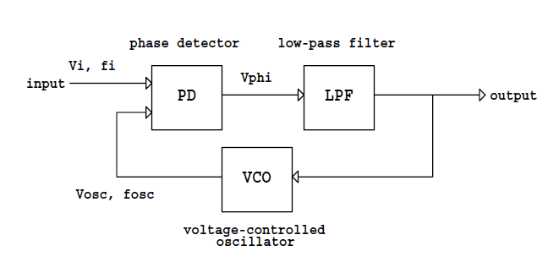

Figure 6.1: Block diagram of Basic Phase Locked Loop PLL

The VCO is an oscillator whose frequency fosc is proportional to input voltage vo. The voltage at the input of the VCO determines the frequency fosc of the periodic signal vosc at the output of the VCO. The output of the VCO, vosc, and a periodic incoming signal vi are inputs to the phase detector. As one familiar circuit example, an analog multiplier or mixer can be used as a phase detector. Recall that the mixer takes the product of two inputs.

Vd(t)=A(t)B(t)

If, A(t) = Acos (ωₒt+ ɸA)

B(t) = Bcos (ωₒt+ ɸB)

Then A(t)B(t) = (AB/2) cos (2ωₒt + ɸA + ɸB) + cos (ɸA - ɸB)

Since the two input is at the same frequency when the loop is locked, we have one output at twice the input frequency and an output proportional to the cosine of the phase difference. The double frequency component must be removed by the low pass loop filter. Any phase difference then shows up as the control voltage to the VCO, a DC or slowly varying AC signal after filtering.

Since ɸA - ɸB is very small, we can assume that the output signal of PD, after filtering is proportional to the phase difference of two signals. This voltage signal is the input signal of VCO, whose output frequency changes according to the signal. Thus the phase of VCO output is equaled to the input signal of PD. A basic property of the PLL is that it attempts to maintain the frequency lock (fosc = fi) between vosc and vi even if the frequency fi of the incoming signal varies in time.

Suppose that the PLL is in the locked condition, and that the frequency fi of the incoming signal increases slightly. The phase difference between the VCO signal and the incoming signal will begin to increase in time. As a result, the filter output voltage vo increases, and the VCO output frequency fosc increases until it matches fi, thus keeping the PLL in the locked condition. The range of frequencies from fi = fmin to fi = fmax where the locked PLL remains in the locked condition is called the lock range of the PLL. If the PLL is initially locked, and fi becomes smaller than fmin, or if fi exceeds fmax, the PLL fails to keep fosc equal to fi, and the PLL becomes unlocked, fosc = fi. When the PLL is unlocked, the VCO oscillates at the frequency fo called the center frequency, or the free-running frequency of the VCO. The lock can be established again if the incoming signal frequency fi gets close enough to fo. The range of frequencies fi = fo - fc to fi = fo + fc such that the initially unlocked PLL becomes locked is called the capture range of the PLL.

The lock range is wider than the capture range. So, if the VCO output frequency fosc is plotted against the incoming frequency fi, we obtain the PLL steady-state characteristic shown in Fig. . The characteristic simply shows that fosc = fi in the locked condition, and that fosc = fo = const: when the PLL is unlocked. A hysteresis can be observed in the fosc(fi) characteristic because the capture range is smaller than the lock range.

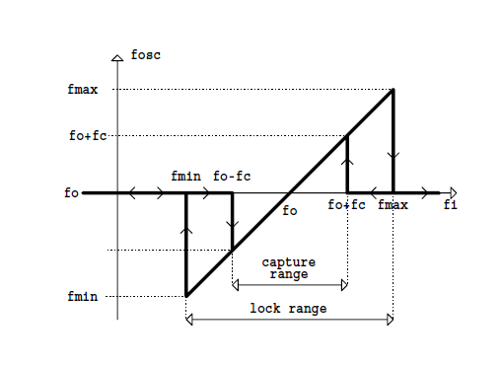

Figure 6.2: Steady-state fosc(fi) characteristic of the basic PLL.

7.PLL IC HC4046A/B, Building Block of the Demodulator:

The HCT4046A PLL with VCO is a high-speed CMOS IC designed for use in general purpose PLL applications, including frequency modulation, demodulation, Discrimination, synthesis, and multiplication. The functional diagram and the pinouts of the ic is given:

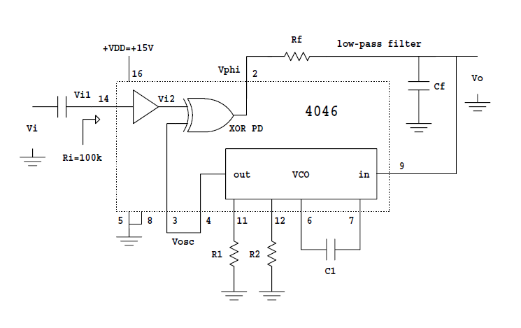

Figure 7.1: The functional diagram of 4046

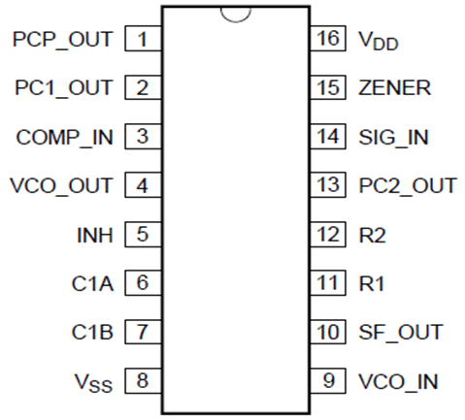

Figure 7.2: Pinouts of IC4046

Pin description:

|  |  |  |
| --- | --- | --- |
| PCP_OUT | 1 | Phase comparator pulse output |
| PC1_OUT | 2 | Phase comparator 1 output |
| COMP_IN | 3 | Comparator input |
| VCO_OUT | 4 | VCO output |
| INH | 5 | Inhibit input |
| C1A | 6 | Capacitor C1 connection A |
| C1B | 7 | Capacitor C1 connection B |
| VSS | 8 | Ground supply voltage |
| VCO_IN | 9 | VCO input |
| SF_OUT | 10 | Source-follower output |
| R1 | 11 | Resistor R1 connection |
| R2 | 12 | Resistor R2 connection |
| PC2_OUT | 13 | Phase comparator 2 output |
| SIG_IN | 14 | Signal input |
| ZENER | 15 | Zener diode input for regulated supply |
| VDD | 16 | Supply voltage |

The 74HC/HCT4046A are phase-locked-loop circuits that comprise a linear voltage-controlled oscillator (VCO) and three different phase comparators (PC1, PC2 and PC3) with a common signal input amplifier and a common comparator input. A single positive supply voltage is needed for the chip. The positive supply voltage VDD is connected to pin 16 and the ground is connected to pin 8. The incoming signal vi goes to the input of an internal amplifier at the pin 14 of the chip. The internal amplifier has the input biased at about +VDD/2. Therefore, the incoming signal can be capacitively coupled to the input, as shown in Fig. 3. The incoming ac signal vi of about one volt peak-to-peak is sufficient for proper operation. The capacitor Ci together with the input resistance at the pin 14 form a high-pass filter.

7.1 Phase Detector:

The phase detector on the 4046 is simply an XOR logic gate, with logic low output ( $v_{∅}$ = 0V) when the two inputs are both high or both low, and the logic high output ( $v_{∅}$ = VDD) otherwise. Fig. Illustrates the operation of the XOR phase detector when the PLL is in the locked condition.

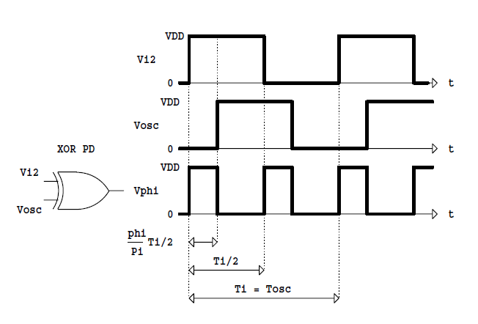

Figure 7.1.1: Operation of the phase detector with XOR gate.

Figure 4: Operation of the phase detector with XOR gate

$v_{1}$ ( the amplified $v_{i}$) and $v_{osc}$ (the VCO output) are two phase-shifted periodic square-wave signals at the same frequency $f_{osc}$ = $f_{i}$ = 1/ $T_{i}$, and with 50% duty ratios. The output of the phase detector is a periodic square-wave signal $v_{∅}\left(t\right)$ at the frequency 2fi, and with the duty ratio $D_{∅}$ that depends on the phase difference $∅$ between $v_{i}$ and $v_{osc}$

${ D}_{∅}= \frac{∅}{π}$

The periodic signal $v_{∅}\left(t\right)$ at the output of the XOR phase detector can be written as the Fourier series:

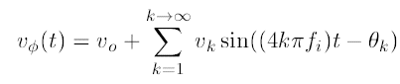

where $v_{0}$ is the dc component of $v_{0}\left(t\right)$ and $v_{k}$ is the amplitude of the kth harmonic at the frequency ${2kf}_{i}$. The dc component of the phase detector output can be found easily as the average of $v_{0}\left(t\right)$.

over a period Ti/2,

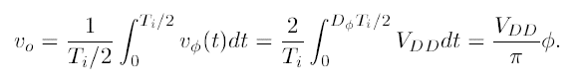

7.2 Loop Filter:

The output $v_{∅}$ of the phase detector is ltered by an external low-pass filter. In Fig. 3, the loop filter is a simple passive RC filter. The purpose of the low-pass filter is to pass the dc and low-frequency portions of $v_{∅}$ (t) and to attenuate high-frequency ac components at frequencies 2kfi. The simple RC filter has the transfer function:

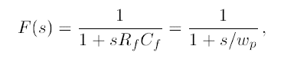

Where

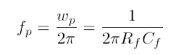

is the cut-o frequency of the filter. If $f_{p}$ << 2 $f_{i}$, i.e., if the cut-o frequency of the filter is much smaller than twice the frequency $f_{i}$ of the incoming signal, the output of the filter is approximately equal to the dc component $v_{0}$ of the phase detector output. In practice, the high-frequency components are not completely eliminated and can be observed as high-frequency ac ripple around the dc or slowly varying $v_{0}$ .

Eq. 4 shows that $v_{0}$ is proportional to the phase difference between the incoming signal $v_{0}\left(t\right)$ and the signal $v_{osc}\left(t\right)$ from the VCO. The constant of proportionality,

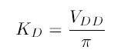

is called the gain or the sensitivity of the phase detector. This expression is valid for $0≤∅≤π$. In general, the filter output $v_{0}$ as a function of the phase difference is shown in Fig. .

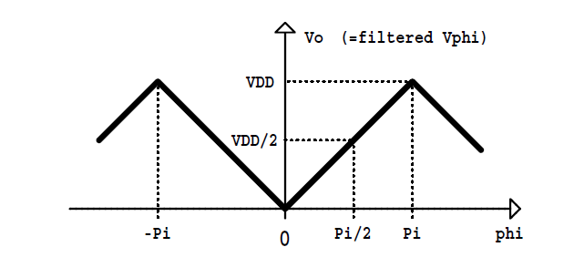

Figure 7.2.1: Characteristic of Phase Detector

Note that $v_{0}$ = 0 if $v_{i}$ and $v_{osc}$ are in phase ( $∅$ = 0), and that it reaches the maximum value $v_{0}$ = VDD when the two signals are exactly out of phase ( $∅$ = $π$). From Fig. 4 it is easy to see that for $∅$ < 0, $v_{0}$  increases, and for $∅$ > $π$, $v_{0}$  decreases. Of course, the characteristic is periodic in with period 2 $π$. The range $0≤∅≤π$ is the range where the PLL can operate in the locked condition.

7.3 Voltage Controlled Oscillator:

As shown in Fig. 3, the filter output $v_{0}$  controls the VCO, i.e., determines the frequency $f_{osc}$  of the VCO output $v_{osc}$. The voltage $v_{0}$ controls the charging and discharging currents through an external capacitor C1, and therefore determines the time needed to charge (discharge) the capacitor to a pre-determined threshold level. As a result, the frequency $f_{osc}$  of the VCO output is determined by $v_{o}$ . The VCO output $v_{osc}$  is a square wave with 50% duty ratio and frequency $f_{osc}$.

As shown in Fig. 3, the VCO characteristics are user-adjustable by three external components: R1, R2 and C1. When $v_{0}$ is at zero, the VCO operates at the minimum frequency $f_{min}$ given approximately by:

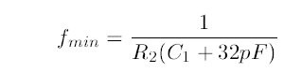

When $v_{0}$ = VDD, the VCO operates at the maximum frequency $f_{max}$ given approximately by

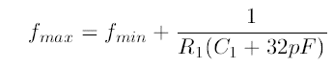

For proper operation of the VCO, the components R1, R2 and C1 should satisfy:



or $f_{osc}$ between the minimum $f_{min}$ and the maximum $f_{max}$, the VCO output frequency $f_{osc}$ is ideally a linear function of the control voltage $v_{0}$. The slope $K_{0}$ = $∆f_{osc}/∆v_{0}$ of the $f_{osc}\left(v_{0} \right)$ characteristic is called the gain or the frequency sensitivity of the VCO, in Hz/V.

8.PLL Operation in the IC:

Operation of the 4046 PLL can now be summarized as follows. Let us suppose that initially there is no incoming signal at all $v_{i}$ = 0. The VCO output $v_{osc}$ is a square-wave signal with 50% duty ratio. Since $v_{i}$ = 0 by assumption, the output of the XOR phase detector is exactly the same as the VCO output, $v_{∅}$ = $v_{osc}$. The low-pass filter attenuates ac components of $v_{osc}$ so that the filter output is approximately equal to the dc component of $v_{∅}$. In this case, the dc component $v_{o}$ is equal to VDD/2 because $v_{∅}$ is VDD for one half of the period and 0 for the other half of the period. The filter output voltage $v_{o}$ is the input of the VCO. Therefore, we conclude that the VCO operates at the frequency that corresponds to the voltage $v_{o}$ = +VDD/2 at the VCO input. This frequency is called the center, or the free-running frequency $f_{0}=f_{osc}$ of the PLL.

Let us suppose now that the incoming signal $v_{i}$ at frequency $f_{i}$ is brought to the input of the PLL, i.e., to one of the two inputs of the XOR phase detector. If the frequency fi is sufficiently close to the free-running frequency $f_{o}$, the PLL will “capture” the incoming signal. During the capture process, the phase difference between $v_{i}$ and $v_{osc}$ changes in time, and therefore $v_{o}$ changes in time until reaches the value required to lock the VCO frequency $f_{osc}$ to the frequency $f_{i}$ of the incoming signal. In the locked condition $f_{osc}=f_{i}$, and $v_{i}$ and $v_{osc}$ are phase shifted by $∅$. The phase difference $∅$ between $v_{i}$ and $v_{osc}$ depends on the value of the incoming signal frequency $f_{i}$.

If $f_{i}$ = $f_{o}$, the phase difference must be exactly $∅=π/2$ so that, from Eq. 4, $v_{o}$ = VDD/2 and the VCO indeed operates at $f_{0}$. If, for example, $f_{i}$ = ${ f}_{max}$, the phase difference $∅$ must be equal to $π$ in order to obtain $v_{o}$ = VDD that results in the VCO output frequency equal to $f_{max}$. It is important to note here that in order to keep $f_{osc}$ = $f_{i}$ in the locked condition, the filter output voltage $v_{o}$ must vary together with the frequency $f_{i}$ of the incoming signal. Therefore, a change in $f_{i}$ causes a proportional change in $v_{o}$, as long as the PLL stays in the locked condition with $f_{osc}$ = $f_{i}$. As a result, if the incoming signal is frequency modulated, with $f_{i}\left(t\right)$ varying in time, the PLL behaves as an FM demodulator with $v_{o}$ as the demodulated output.

9.Circuit Implementation of Frequency Modulator:

The modulator uses only VCO, as shown in the block diagram illustrated in figure . Values of R1 and C1 determine the frequency range of the VCO and center frequency of operation depends upon VCO input, which is a digital input signal level for a modulator. Hence high (bit1) and low (bit 0) voltage levels of digital input determines actual output frequencies and separation between them.

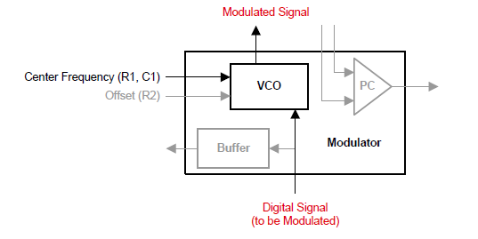

Figure 9.1: Block diagram of Modulator

Here we used Supply voltage *VCC* = 5*V* at pin-16 of the pll ic. Use a voltage divider network of two resistors with *R* = 10 *k*Ω for clamping the control voltage input (pin-9) at *Vcc*/2 = 2*.*5*V* Now for determining the free running frequency of the VCO i.e the frequency of the carrier wave, we selected the value of R1, R2 and C1 appropriately so that the carrier frequency becomes 25kz. For this prpose we used the following equation:

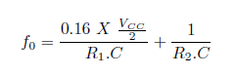

We selected *R*1 = 10 *k*Ω (pin-11), *R*2 = 100 *k*Ω (pin-12) and *C* = 0*:*002*uF* (between pin-6 and pin-7) so that free running frequency as per above equation is given by,



The pspice circuit diagram for producing the carrier is given below:

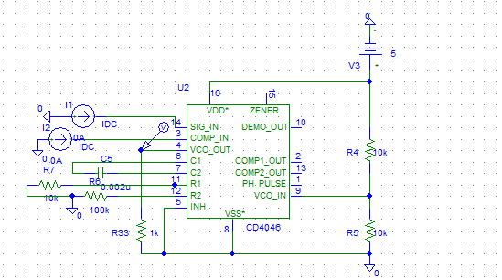

And the simulation output i.e the carrier wave is given below:

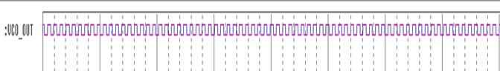



Now we gave a input message signal of frequency 1kHz and amplitude 1*Vpp* at control voltage input (pin-9) through a capacitor of *C*1 = 1*uF* as the modulating wave and The FM output was obtained from *VCOout* (pin-4) of PLL IC.

The complete Circuit diagram and the simulation output input is given below:

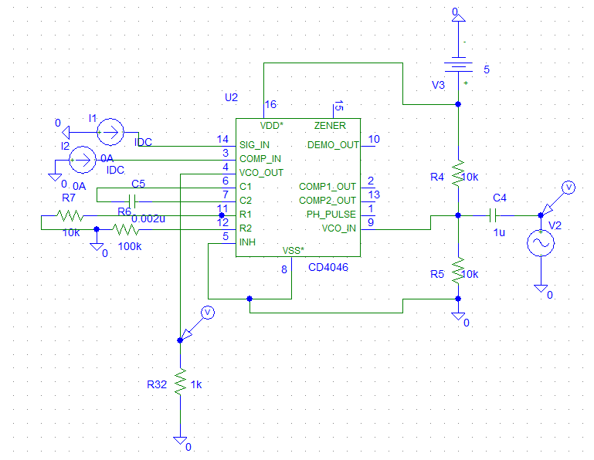

Figure 9.2: Circuit Diagram for Frequency Modulator

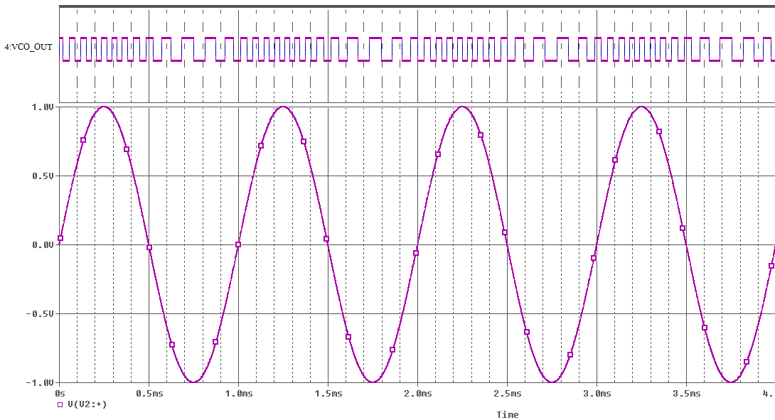

Figure 9.3: Input voltage waveform [below] and above is the modulated output.

10.Circuit Implementation of Frequency Demodulator:

The demodulator operates in closed-loop mode with the PC and an external LPF, as shown in the following figure:

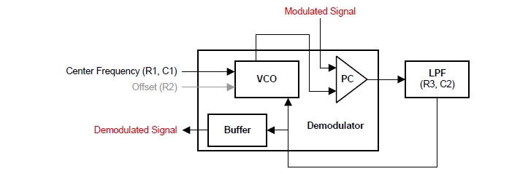

Figure 10.1: Basic Block Diagram of PLL FM Demodulator

Here we used another PLL ic for the demodulation purpose. Here we used the same *R*1, *R*2 and *C1* for the second PLL IC so that the free running frequency remains the same as that of the modulating IC. Feed the signal input pin of phase detector (pin-14) of the second IC with the FM signal. The other input of phase detector (pin-3) is fed with VCO output (pin-4). The output from phase detector (pin-2) is fed back to VCO input (pin-9) through

a low-pass filter with *R*3 = 10 *k*Ω and *C*1 = 0*:*01u*F*. We designed the loop filter so that it’s cutoff frequency remains at 1.5kHz using the following equation:



The circuit simulation for determining the filter parameter and it’s cut off frequency is given below:

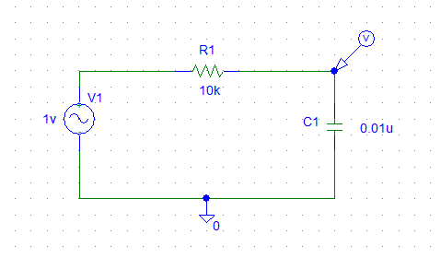

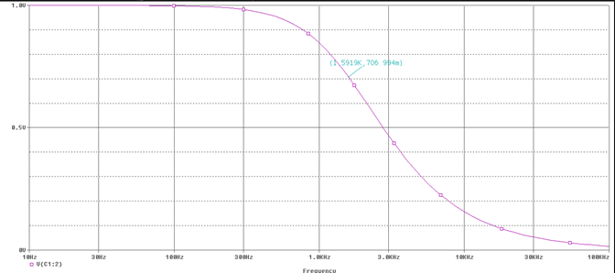

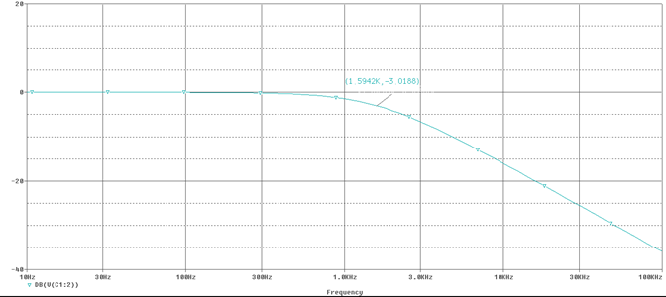

Here for the designed filter, from the above graph we can see that the DB function of output voltage cuts -3db at about 1.5kHz frequency so the desired cutoff frequency is 1.5kHz as it was required.

Now the complete circuit for the demodulation process along with its input from modulator is given below:

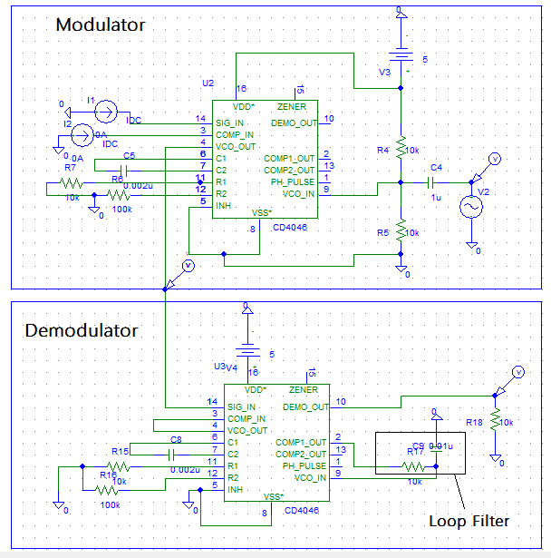

Figure10.2 : The complete circuit diagram for FM Demodulation.

And its input and output voltage waveform is shown below:

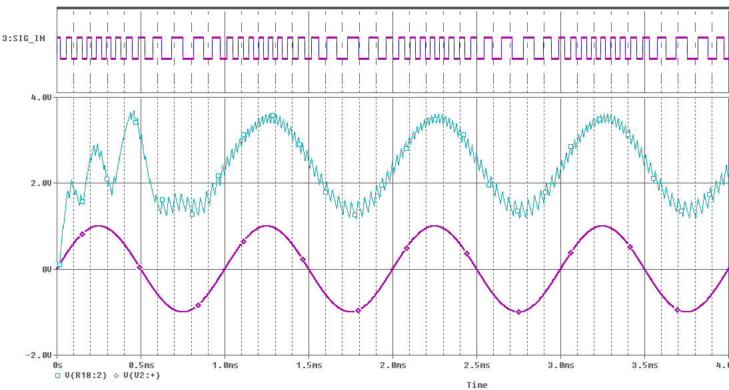

Figure 10.3: V[V2:+] as the modulating signal wave, SIG_IN as the modulated output from the modulator and the input for demodulator and V[R18:2] is the demodulated output.

Here we can see that there are two error that can be visible:

1. There are some ac ripple in the output.
2. There is a dc offset portion in the demodulated output.

So to remove the ripple, we introduced another low pass filter with cut off frequency 1.5kHz designed just as before at the DEMO_OUT terminal of the demodulator pll ic. The newly formed circuit diagram along with the output is shown below:

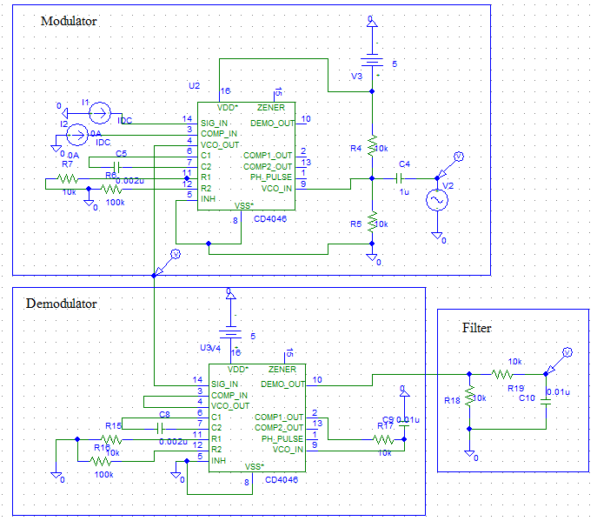

Figure 10.4: The complete circuit diagram for FM Demodulation with ripple filter.

And the output is shown below:

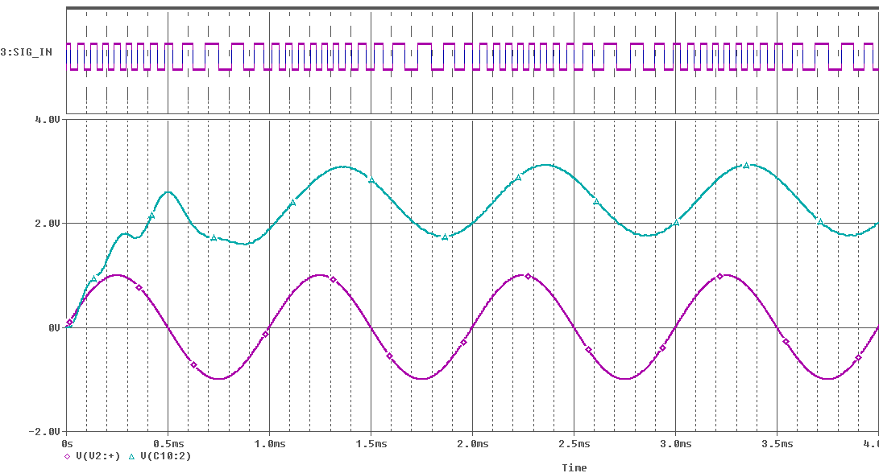

Figure: V [V2:+] as the modulating signal wave, SIG_IN as the modulated output from the modulator and the input for demodulator and V[C10:2] is the demodulated output.

Here from the output we can see that the previously output ripple has been reduced quite well by intruding the low pass filter.

But still there is a DC offset in the output so to reduce it, we used a clamper circuit at the end of the filter to remove the DC offset. We designed it using the value of C13=0.01uF and R25=20k then took the output across the R25. The complete circuit along with the output is shown below:

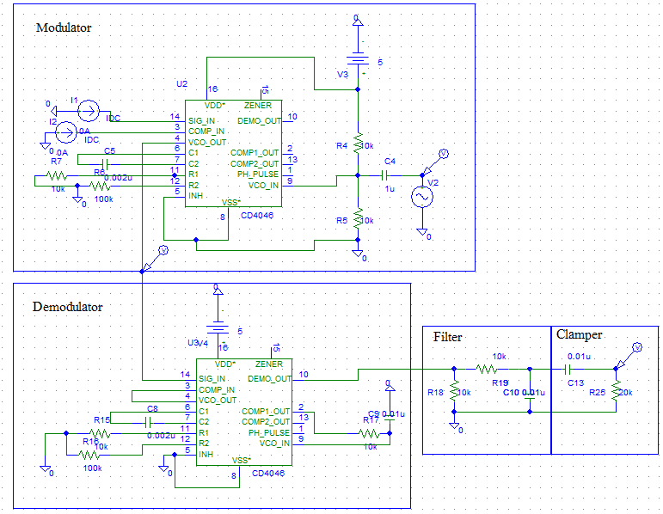

Figure 10.5: The complete circuit diagram for FM Demodulation with ripple filter and a clamper.

The output of the demodulated waveform is shown below:

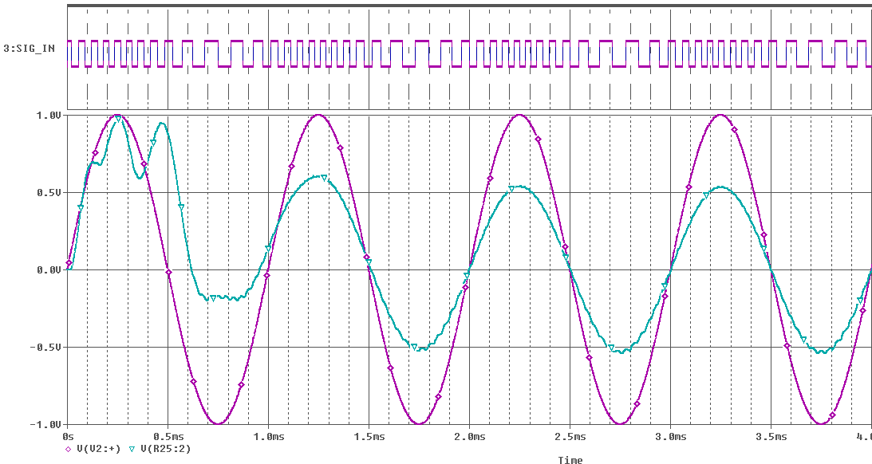

Figure: V [V2:+] as the modulating signal wave, SIG_IN as the modulated output from the modulator and the input for demodulator and V[R25:2] is the demodulated output.

So here we can see that both the problem has been solved to a satisfactory level.

Now we introduced a non inverting Voltage multiplier using the op amp uA741 model with a variable Resistor for the output resistance so that we can have a variable voltage gain. In this way we can vary the amplitude of the demodulated output wave i.e. we can control the volume of the demodulated incoming signal by varying the resistance.

Here we used Rin=1MegΩ and Rout=R_Var in pspice and voltage bias voltage we used +-15V dc at the 4 and 7 no terminal of the op amp.

Now if we want to get the output as say for example exactly the same as the input, then we will have to adjust the R_Var to a suitable value so that the gain makes both their amplitude same.

We calculated from the graph: Vamp[output]/Vamp[input]=1/0.538=1.85

So from the formula of the gain of the non inverting multiplier, we can write that:

Av=[1+Rf/Ri]

So if Ri=1MegΩ then from the formula, we can say that Rf=0.85MegΩ. So thus we implemented the multiplier and added this at the end of the clamper output. The final circuit along with its output is shown below:

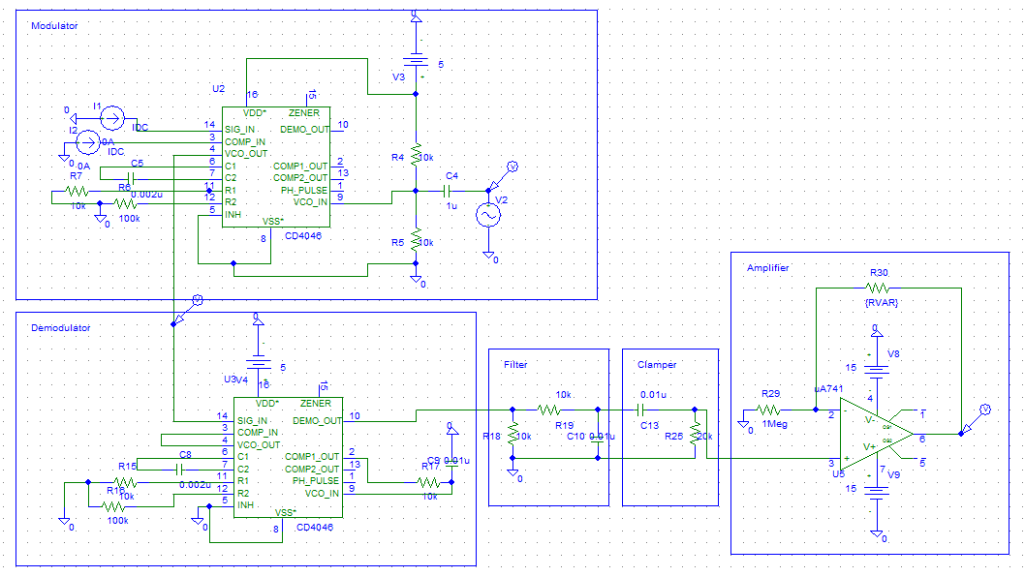

Figure 10.6: The complete circuit diagram for FM Demodulation with ripple filter and a clamper along with a non inverting multiplier with variable voltage gain.

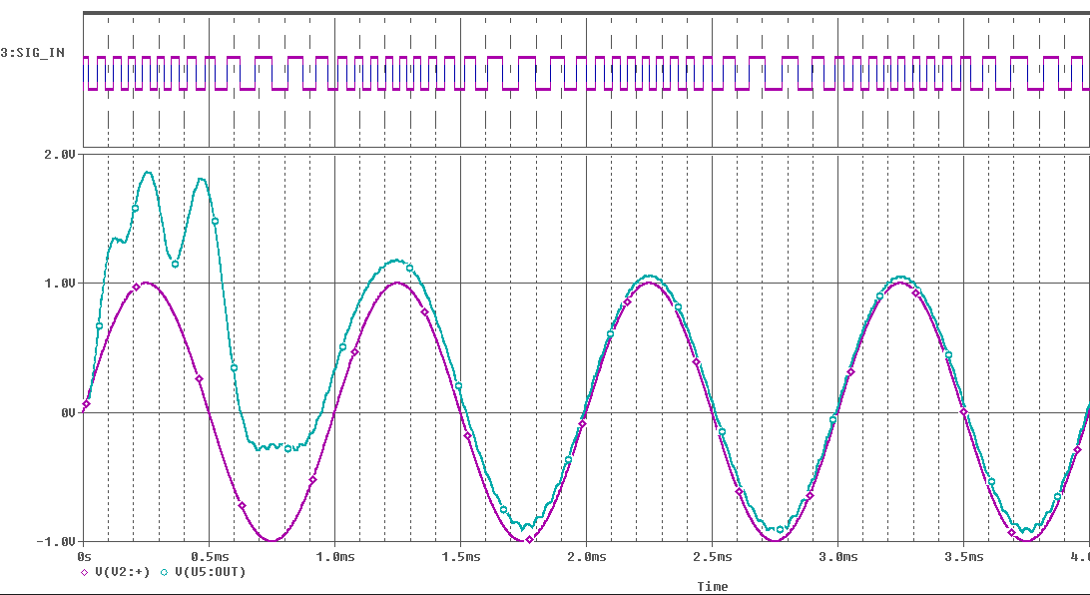

Figure: V [V2:+] as the modulating signal wave, SIG_IN as the modulated output from the modulator and the input for demodulator and V[U5:OUT] is the demodulated output.

11.Advantages and Limitations of FM:

FM is widely used because of the many advantages of frequency modulation. Although, in the early days of radio communications, these were not exploited because of a lack of understand of how to benefit from FM, once these were understood, its use grew.

There are many advantages of FM, but also some disadvantages, and as a result it is suitable for many applications, but other modes may be more suited to other applications

## ***Advantages of frequency modulation***

There are many advantages to the use of frequency modulation. These have meant that it has been widely used for many years, and will remain in use for many years.

* *Resilient to noise:*   One of the main advantages of frequency modulation that has been utilized by the broadcasting industry is the reduction in noise. As most noise is amplitude based, this can be removed by running the signal through a limiter so that only frequency variations appear. This is provided that the signal level is sufficiently high to allow the signal to be limited.
* *Resilient to signal strength variations:*   In the same way that amplitude noise can be removed, so too can any signal variations. This means that one of the advantages of frequency modulation is that it does not suffer audio amplitude variations as the signal level varies, and it makes FM ideal for use in mobile applications where signal levels constantly vary. This is provided that the signal level is sufficiently high to allow the signal to be limited.
* *Does not require linear amplifiers in the transmitter:*   As only frequency changes are required to be carried, any amplifiers in the transmitter do not need to be linear.
* *Enables greater efficiency than many other modes:*   The use of non-linear amplifiers, e.g. class C, etc means that transmitter efficiency levels will be higher - linear amplifiers are inherently inefficient

## *Limitations of frequency modulation*

There are a number of dis-advantages to the use of frequency modulation. Some are can be overcome quite easily, but others may mean that another modulation format is more suitable.

* *Requires more complicated demodulator:*   One of the minor dis-advantages of frequency modulation is that the demodulator is a little more complicated, and hence slightly more expensive than the very simple diode detectors used for AM. Also requiring a tuned circuit adds cost. However this is only an issue for the very low cost broadcast receiver market.
* *Some other modes have higher data spectral efficiency:*   Some phase modulation and quadrature amplitude modulation formats have a higher spectral efficiency for data transmission that frequency shift keying, a form of frequency modulation. As a result, most data transmission system use PSK and QAM.
* *Sidebands extend to infinity either side:*   The sidebands for an FM transmission theoretically extend out to infinity. To limit the bandwidth of the transmission, filters are used, and these introduce some distortion of the signal.

12.Applications of the Frequency modulator and demodulator:

FM is widely used because of the many advantages of frequency modulation. Although, in the early days of radio communications, these were not exploited because of a lack of understand of how to benefit from FM, once these were understood, its use grew. Some of its applications are described below:

***FM Radio Broadcasting:*** FM broadcasting is radio broadcasting using frequency modulation (FM) technology. Invented in 1933 by American engineer Edwin Armstrong, it is used worldwide to provide high-fidelity sound over broadcast radio.  In radio transmission, an advantage of frequency modulation is that it has a larger signal-to-noise ratio and therefore greatly rejects so it is used for most music broadcasts.

***Magnetic Tape Storage****:* FM is also used at intermediate frequencies by analog VCR systems to record the luminance (black and white) portions of the video signal. Commonly, the chrominance component is recorded as a conventional AM signal, using the higher-frequency FM signal as bias. FM is the only feasible method of recording the luminance ("black and white") component of video to (and retrieving video from) magnetic tape without distortion; video signals have a large range of frequency components – from a few hertz to several megahertz, too wide for equalizers to work with due to electronic noise below −60 dB. FM also keeps the tape at saturation level, acting as a form of noise reduction; a limiter can mask variations in playback output, and the FM capture effect removes print-through and pre-echo. A continuous pilot-tone, if added to the signal – as was done on V2000 and many Hi-band formats – can keep mechanical jitter under control and assist timebase correction.

***Sound synthesizer:*** FM is also used at audio frequencies to synthesize sound. This technique, known as FM synthesis, was popularized by early digital synthesizers and became a standard feature in several generations of personal computer sound cards.

***Miscellaneous Application:***  It is also used in telemetry, radar, seismic prospecting, and monitoring newborns for seizures via EEG, two-way radio systems [where  narrow band FM (NBFM) is used to conserve bandwidth for land mobile, marine mobile and other radio services.]

13.Conclusion:

Frequency modulation is widely used for radio transmissions for a wide variety of applications from broadcasting to general point to point communications.

Frequency modulation, FM offers many advantages, particularly in mobile radio applications where its resistance to fading and interference is a great advantage. It is also widely used for broadcasting on VHF frequencies where it is able to provide a medium for high quality audio transmissions.

In view of its widespread use receivers need to be able to demodulate these transmissions. There is a wide variety of different techniques and circuits that can be used. Among them The PLL FM demodulator is one of the more widely used forms of FM demodulator or detector these days. Its suitability for being combined into an integrated circuit, and the small number of external components makes PLL FM demodulation ICs an ideal candidate for many circuits these days.

However with more systems using digital formats, phase and quadrature amplitude modulation formats are on the increase. Nevertheless, the advantages of frequency modulation mean that it is an ideal format for many analogue applications.

14.Recommendations:

* To further improve the demodulated out i.e. to further reduce the ripple from the output, the filter can be more accurately designed and even a second order low pass filter can be used.
* At the demodulator pll ic, we can use a variable resistor so that we can manually tune the free running frequency of the VCO. As a result this will enable us to demodulate our desired signal sent from a specific modulator with a specific carrier frequency.
* For wireless radio communication, a properly designed antenna must be used at both modulator and demodulator terminal for radio transmission and receiving purpose respectively.

Reference:

[1] B. Razavi, *Design of Analog CMOS Integrated Circuits*, Chapter 15, McGrawHill, 2001.

[2] P. R. Gray and R. G. Meyer, *Analysis and Design of Analog Integrated Circuits*, Chapter 10, 3rd ed., Jonh Wiley & Sons, 1993 (or latest edition).

[3] Fairchild Semiconductor, CD4046BC Micropower Phase-Locked Loop, 2002.Downloadable <http://www.fairchildsemi.com/pf/CD/CD4046BC.html>

[4] J. Dunlop and D. G. Smith, *Telecommunications Engineering*, 3rd Ed., Chapman & Hall, pp68-70, 1994.

[5] N. S. Nise, *Control Systems Engineering*, 4th Ed., John Wiley & Sons, 2004.