

Sample Project Final Report

# Course Information

**Course:** CSE 479 Web Programming (Sections 1)

**Instructor:** Abdus Satter, Adjunct Faculty, CSE Dept.

# Project Name

|  |  |
| --- | --- |
| **Title of Project** | Online Prescription |
| **Student**  **(ID & Name)** | Hasib Ar Rafiul Fahim (2019-1-60-036) |

**Project Purpose** The purpose of the Online Prescription system is to simplify and automate the process of searching for patient, medicine and generate prescriptions with ease and maintain the records of blood patient’s and doctor’s details and prescriptions.

# Project Goals and Objectives

The goals and objectives of the Online Prescription System are as follows:

1. To allow the doctors to manage their records and manage the records of patients.
2. To allow doctors to maintain the records of medicines and their usage and dosage.
3. To provide an easier method to generate prescriptions and save them to database.
4. To provide and easier and efficient management system of medicine, patients and prescriptions

for doctors to store and lookup when ever needed.

**Project Description** The system which was developed is Online Prescriptions. This is a database application system that is to be used by the doctors to search for medicines to prescribe to a patient and manage their records. The system keeps the record of all the doctors, patients, medicines and prescriptions. This project intends to computerize the process of prescribing medicines to patient in a hospital or doctors chamber in order to improve the record management efficiency due to the grown size of records of data.

**Scope** As a whole the system is focused to work with medicine and prescription management system and on additional modification it can be also used as management systems for patients and doctors.

# System Users

* + **Doctors:** Has full privilege on the system's functions of adding, editing and deleting any records.

# Database

# 

# Processes

* **Login:** The system provides security features through username-password matching where only authorized user can access the system. 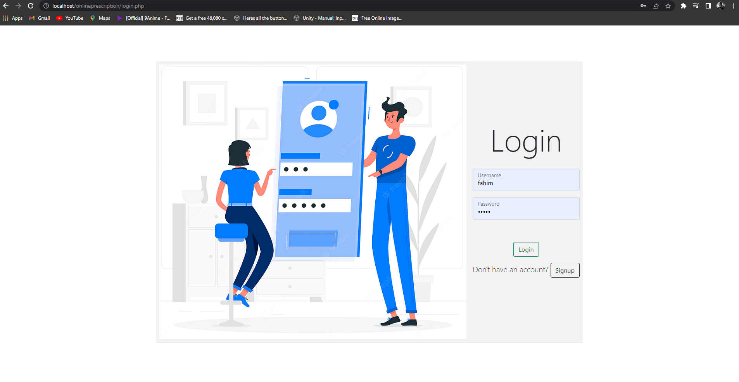
* **Signup:** A doctor can sign up for an account to start using this application.

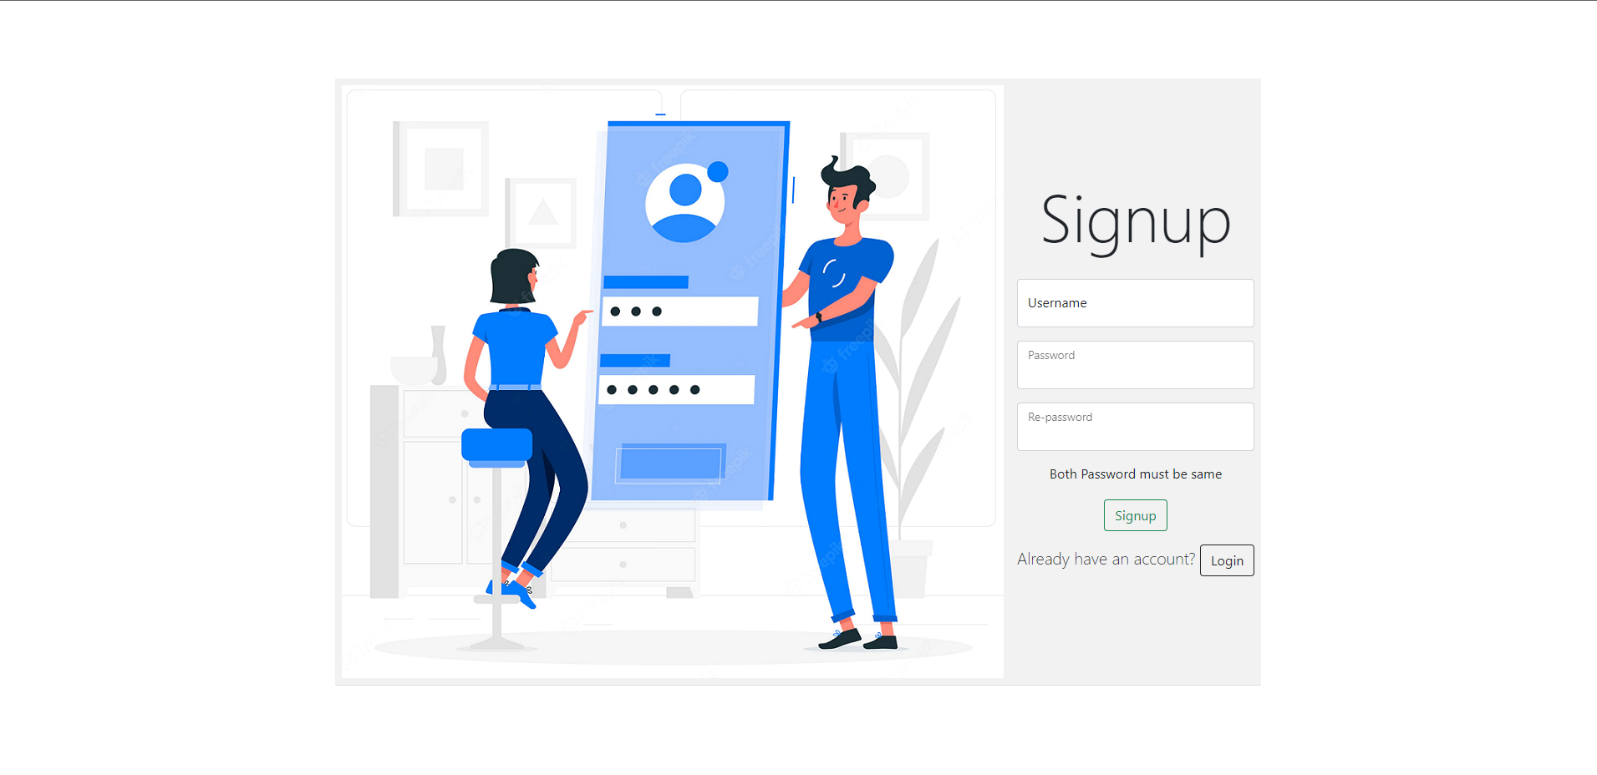

* **Home Page:** This allows to see all the records about medicines and patients and allows to

edit or delete them.

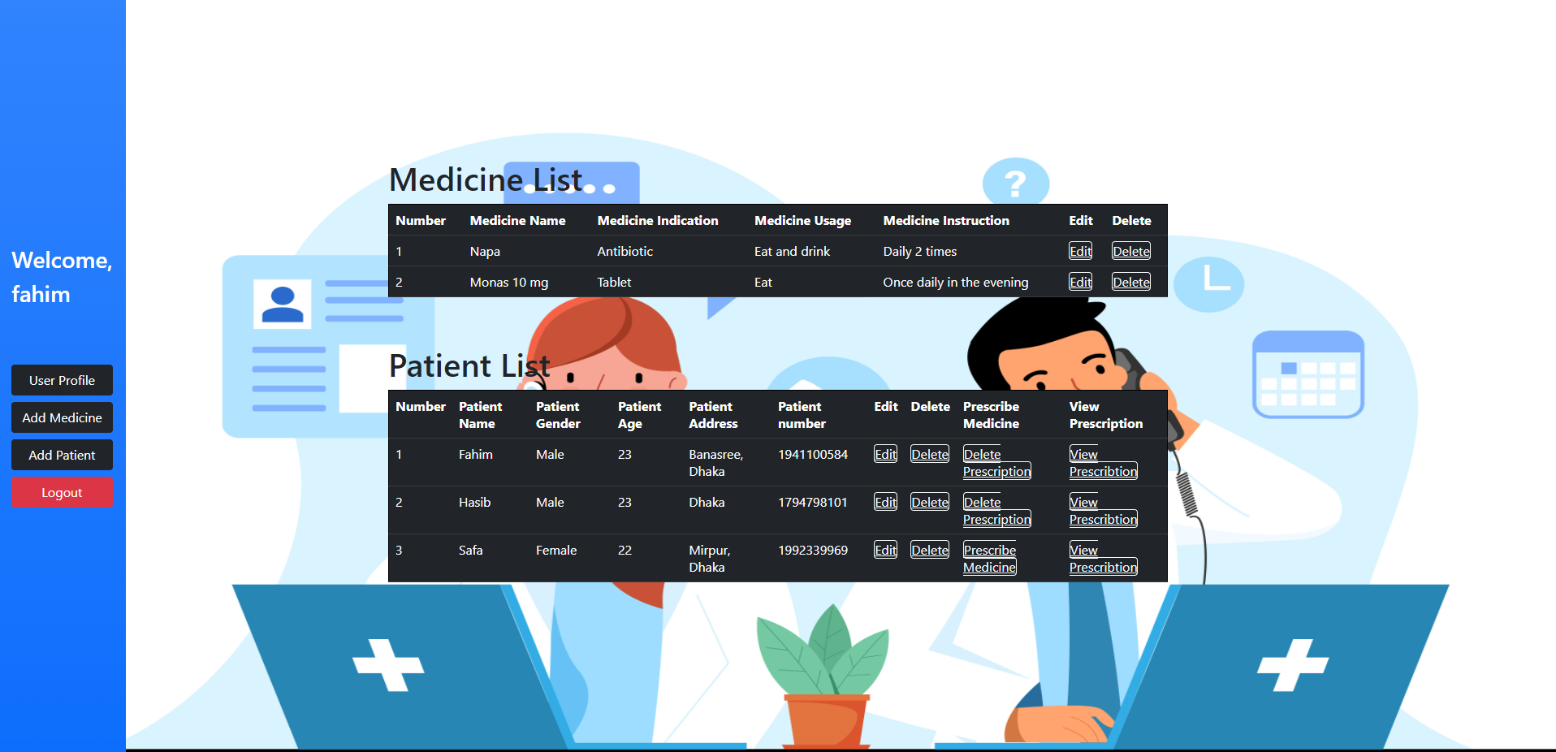

* **User Profile:** This allows to create, update profile for logged in doctors.



* **Add Medicine, Patient:** This allows logged in doctors to add new records of medicines and patients.

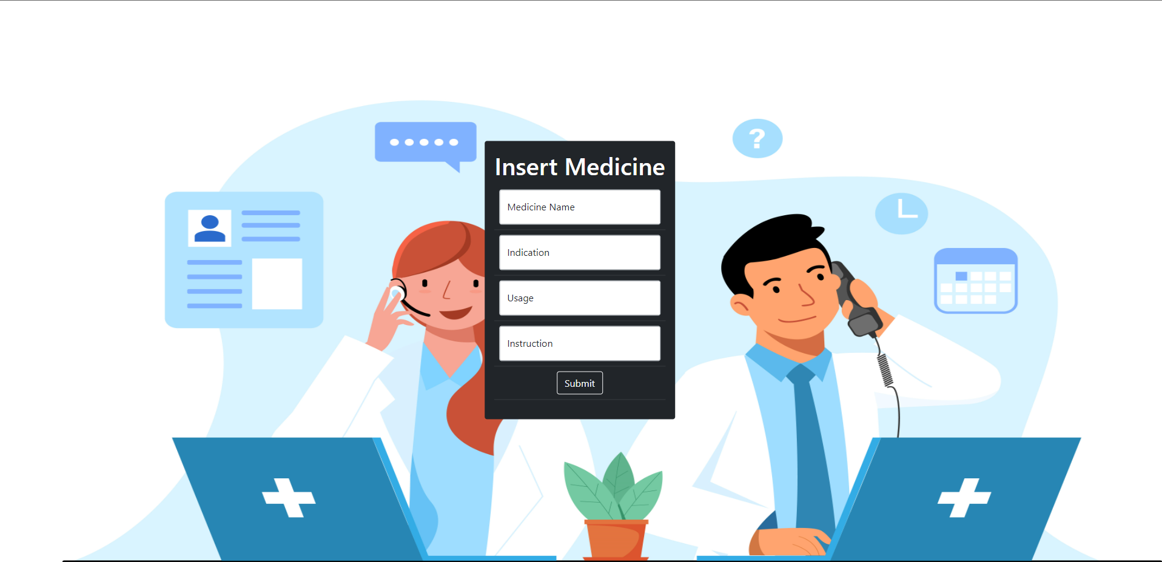

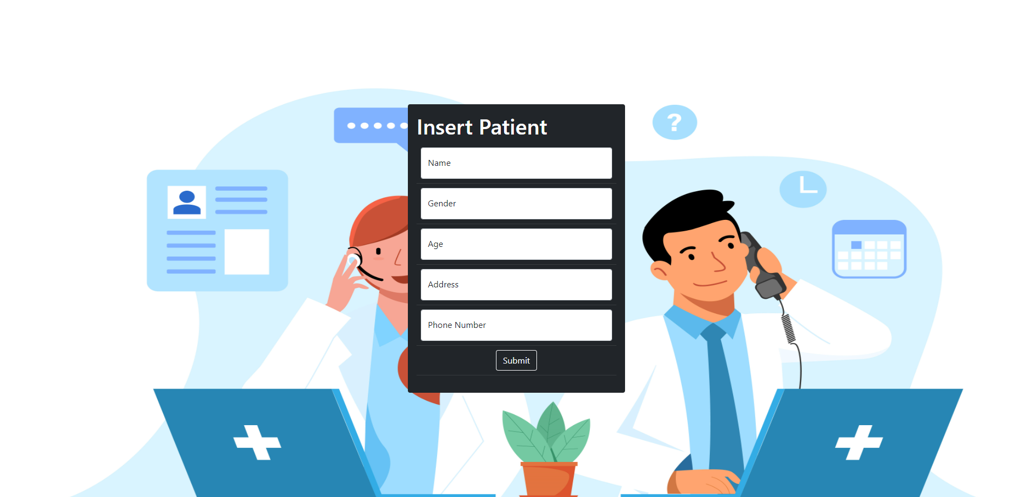

* **Prescribe/view prescriptions:** This allows doctors to prescribe medicines to patients and store them to database to view for later.

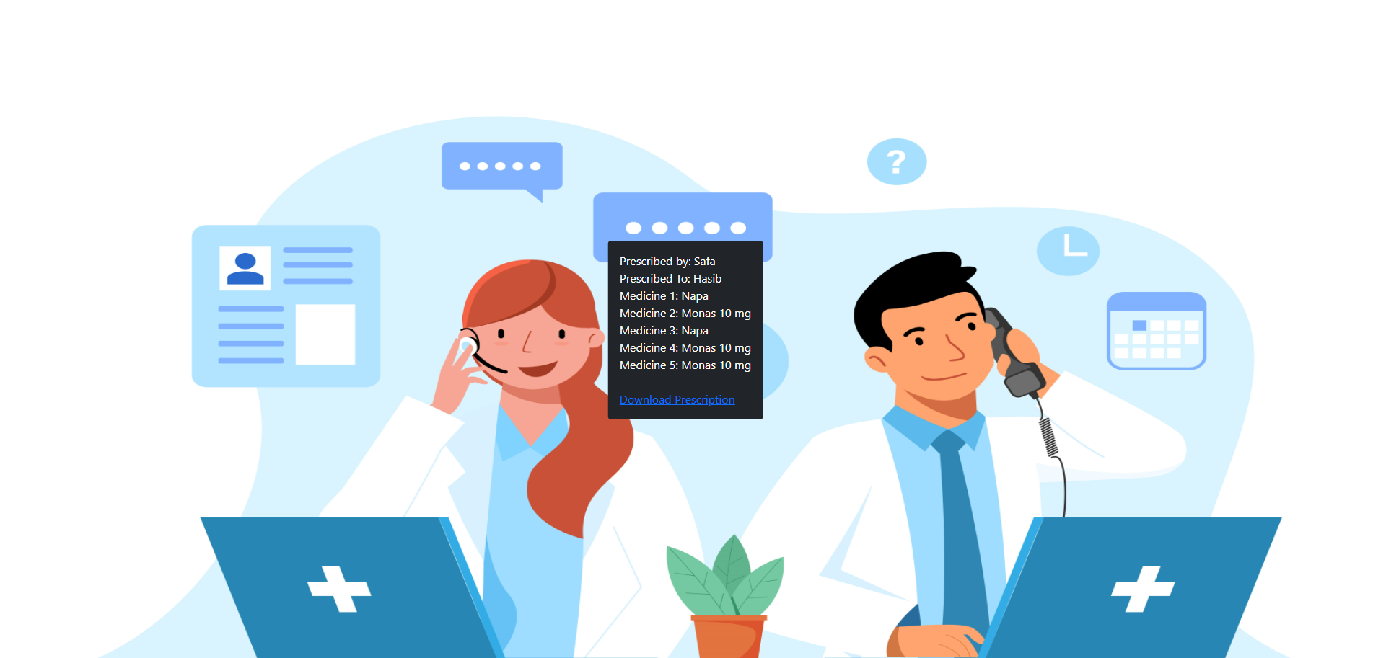

* **Download Prescriptions:** This allows doctor to generate a pdf for patients to print or save them locally.

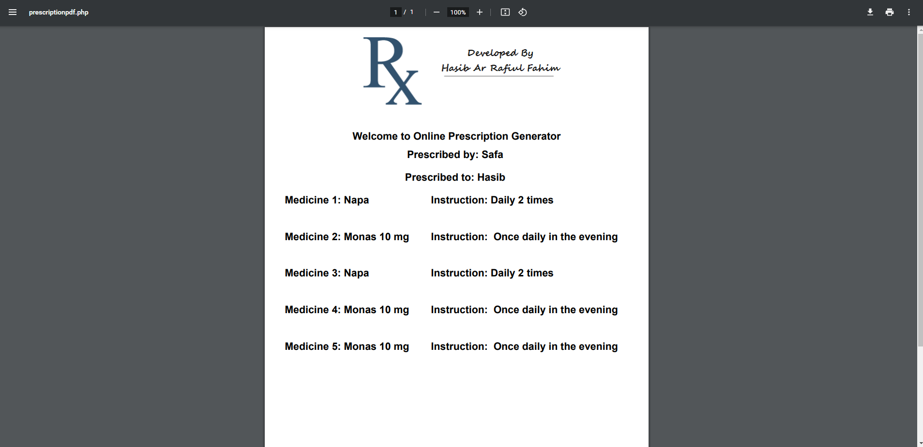

# Technology Frontend Language: PHP, Html, CSS, JavaScript, Bootstrap

**Backend Language: MySQL Database**