**1 Analyst**

**1.1 Assumption**

Assumption need to start the development process and complete the developing process easily. In this course work there need to be implement a broadcasting website which will be a clone site for a broadcasting website. In this website user can view news, scheduled program, weather, they can provide contact details and others functionality videos, lives and shows may include. For this coursework the developing website is ABC news. For this coursework user will involve viewing the site and admin to controlling the site. Admin can provide information about the site and provide contacting details, maintain the enquiries. To complete the coursework there need to have a Scrum Master for planning and maintain the work, Designer to design the site, Programmer to develop the site, and a tester for testing the site. While developing the site there may have some extra functionality which is differ from the main broadcasting site. And there may have some features which will be under development.

**1.2 User Stories**

**Viewer**

As Viewer, I want to access the system so that I can view the latest news

As Viewer, I want to access the system so that I can view schedule of program

As Viewer, I want to access the system so that I can see the weather update

As Viewer, I want to access the system so that I can contact when I need by providing my details

As Viewer, I want to access the system so that I can see live shows

As Viewer, I want to access the system to shat I can see more news videos

As Viewer I want to access the system so that I can get information about international, lifestyle, virtual reality, tips, technology

As Viewer I want to access the system so that I can entertain myself by its feature of entertainment

As Viewer I want to access the system so that I can get the information of upcoming election news

As viewer, I want to access the system so that I can see the upcoming event

**Admin**

As admin, I want to access the system so that I can publish the latest news

As admin, I want to access the system so that I can maintain the schedule of programs

As admin, I want to access the system so that I can maintain the enquiries which user has provide by contacting with the system

As admin I want to access the system so that I can maintain database of the system

As admin, I want to access the system so that I can manage live shows

As admin, I want to access the system so that I can maintain the information of lifestyle, virtual reality, tips, technology

As admin, I want to access the system so that I can maintain the sub features of the system

As admin I want to access the so that I can maintain the count down time for upcoming event

**1.3 Use case Diagram**

Use case Diagram is need for understand the process between User and the system. The use case for this course work are following

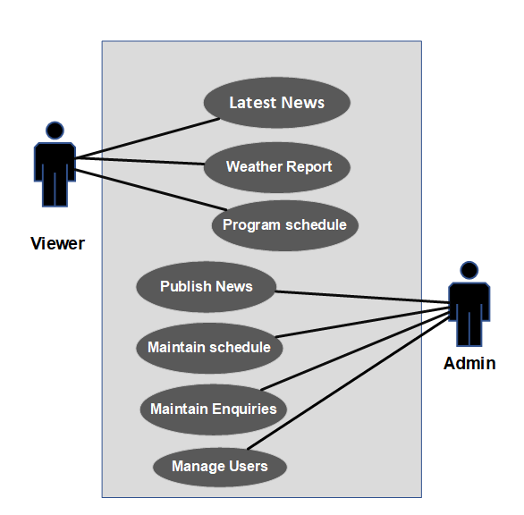

Figure 1: Use Case Diagram

**1.4 Workflow**

Workflow for the course work system are need to know about the function and its process. The workflow is given below.

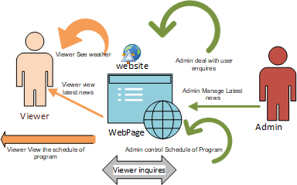

Figure 2: Workflow for the System

**1.5 Initial Class Diagram**

Initial class diagram for the system are following

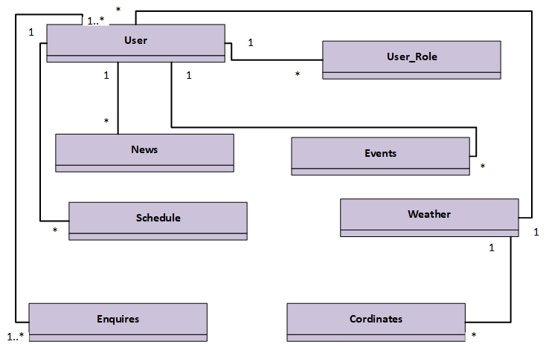

Figure 3: Initial Class Diagram

**1.6 ERD**

Entity Relationship Diagram are given below for the coursework are given below.

