# **Experiment : Temperature Sensing and showing output on LCD & serial monitor**

**1. Introduction** This lab project demonstrates the use of the LM35 temperature sensor to measure the ambient temperature and display the output on a 16x2 LCD screen using an Arduino Uno. The LM35 provides an analog voltage output proportional to the temperature, which is read by the Arduino, processed, and displayed in degrees Celsius.

2. Objective: The **objective** of this experiment is to measure the ambient temperature using the **LM35 temperature sensor**, process the analog data with an **Arduino Uno**, and display the temperature readings on a **16x2 LCD screen**. This experiment aims to demonstrate the interfacing of a temperature sensor with an Arduino and effectively visualizing real-time temperature data.

**3. Components Used**

* Arduino Uno
* LM35 Temperature Sensor
* 16x2 LCD Display
* Potentiometer (for adjusting LCD brightness)
* Connecting Wires

**4. Implementation & Circuit Diagram:** The LM35 temperature sensor has three pins:

* VCC: Connected to 5V of the Arduino
* GND: Connected to GND of the Arduino
* VOUT: Connected to Analog Pin A0 of the Arduino

The 16x2 LCD is connected to the Arduino using the following pin configuration:

* RS: Pin 12
* E: Pin 11
* D4, D5, D6, D7: Pins 5, 4, 3, 2
* VSS & RW: Connected to GND
* VDD: Connected to 5V
* V0: Connected to the middle pin of the potentiometer for contrast adjustment

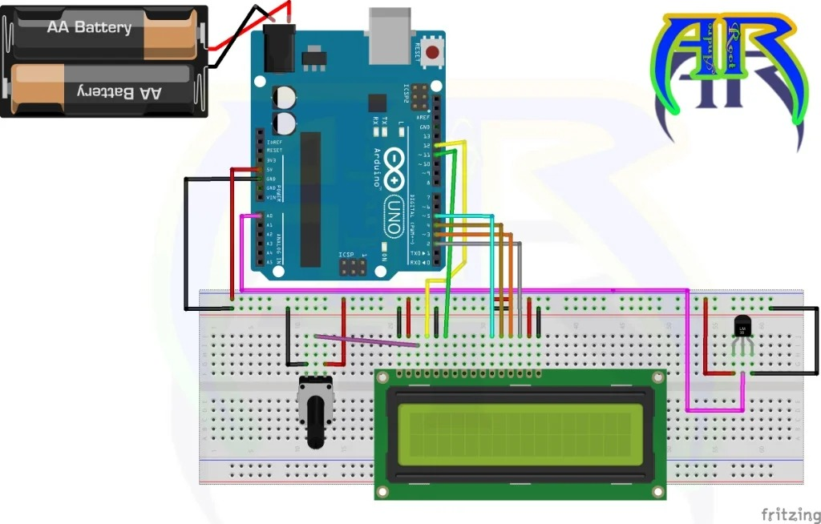

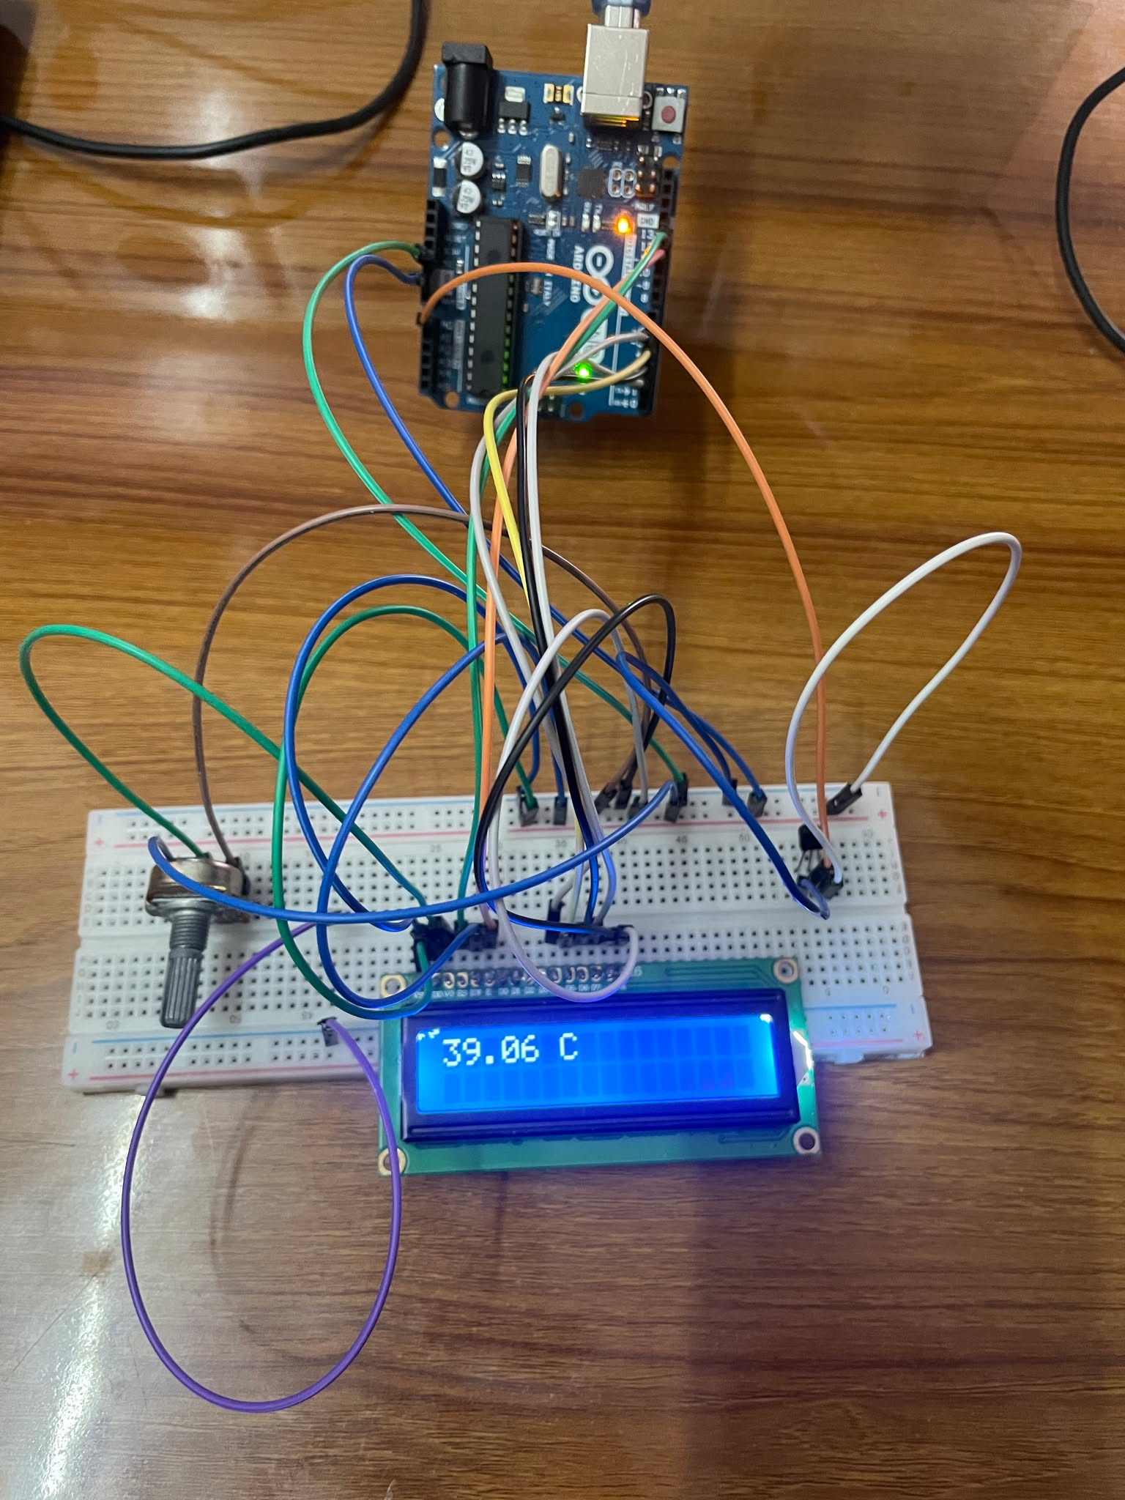

**5. Code Implementation** The following Arduino code reads the temperature from the LM35 sensor, converts the analog reading into a Celsius value, and displays it on the 16x2 LCD screen:

#include <LiquidCrystal.h>

LiquidCrystal lcd(12, 11, 5, 4, 3, 2);

const int inPin = A0;

void setup() {

  lcd.begin(16, 2);

  Serial.begin(9600);

}

void loop() {

  int value = analogRead(inPin);

  if (value < 10) {

    value = 0;

  }

  float celsius = value * (5.0 / 1024.0) * 100.0;

  Serial.print("Temperature: ");

  Serial.print(celsius);

  Serial.println(" C");

  lcd.clear();

  lcd.setCursor(0, 0);

  lcd.print(celsius);

  lcd.print(" C");

  delay(1000);

}

}

**6. Working Principle**

* The LM35 sensor outputs an analog voltage corresponding to the ambient temperature.
* The Arduino reads the sensor’s output using the analogRead() function.
* The analog value is converted into degrees Celsius using the formula:
* The converted temperature is printed on the serial monitor and displayed on the LCD screen.
* The temperature reading updates every second using a delay(1000) function

**7. Observations**

* The LCD correctly displays the temperature in Celsius.
* The serial monitor outputs real-time temperature values, helping in debugging and monitoring.
* The potentiometer effectively adjusts the LCD brightness for better readability.
* The sensor provides consistent temperature readings within its accuracy range.

**8. Conclusion** This project successfully demonstrates how to use the LM35 temperature sensor with an Arduino Uno and a 16x2 LCD display. The system efficiently reads, processes, and displays temperature data, making it useful for various applications such as weather monitoring, home automation, and environmental sensing.