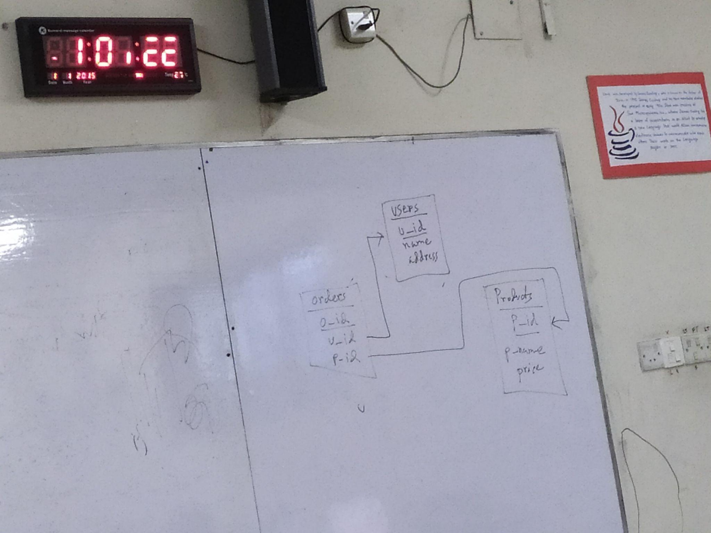

**Lab -01: (21 August, 2024)**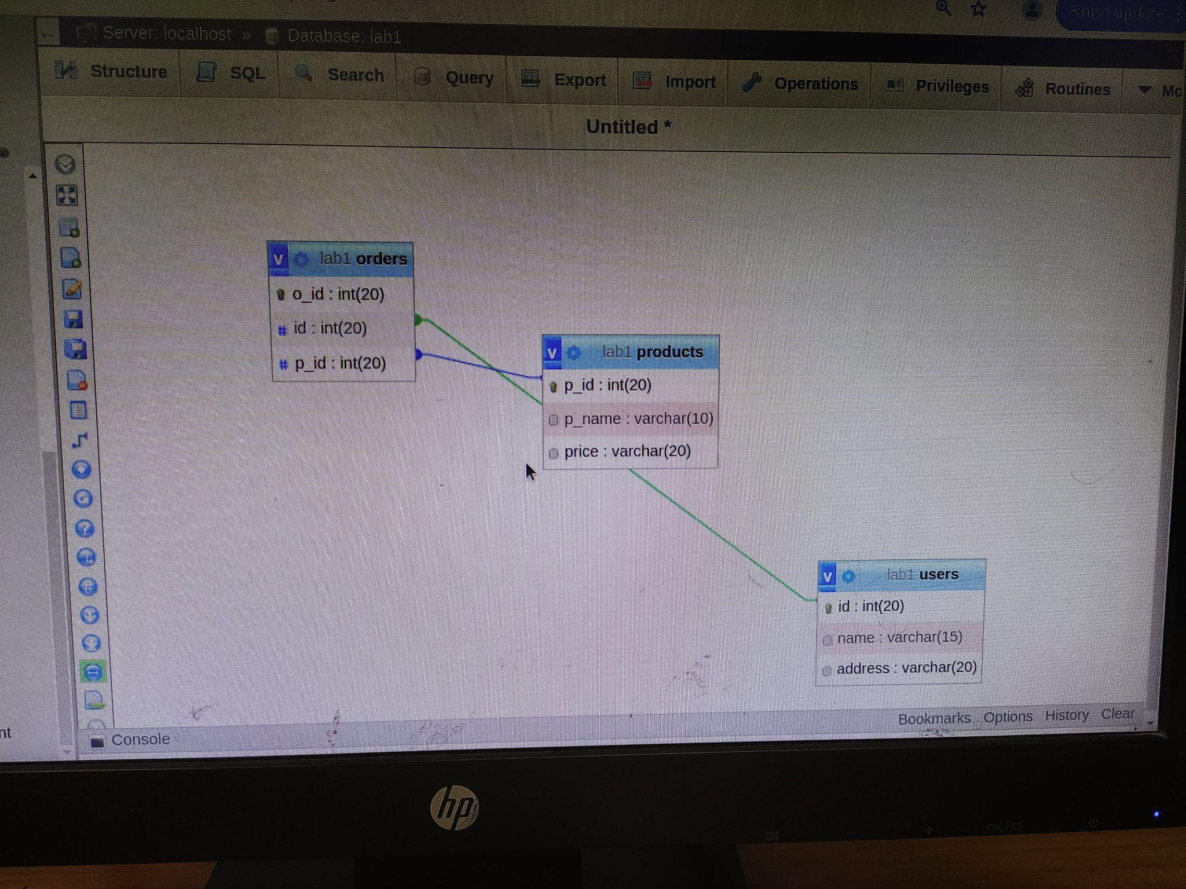

**Users Table :**

CREATE TABLE Users(

u_id varchar(15),

name varchar(15),

address varchar(15),

PRIMARY KEY(u_id));

**Products Table :**

CREATE TABLE Products(

p_id varchar(15),

p_name varchar(15),

price numeric(7,2),

PRIMARY KEY(p_id));

**Order Table:**

CREATE TABLE orders(

o_id varchar(15),

u_id varchar(15),

p_id varchar(15),

PRIMARY KEY(o_id),

FOREIGN KEY(u_id) REFERENCES users (u_id) ON DELETE CASCADE,

FOREIGN KEY(p_id) REFERENCES product (p_id) ON DELETE CASCADE);

**Add primary key after:**

ALTER TABLE users

ADD PRIMARY KEY(u_id);

**User value:**

INSERT into Users(u_id, name, address) VALUES

("u1", "Pranto", "Dhaka"),

("u2", "Mushfiq", "Barisal"),

("u3", "Rahat", "Munshiganj"),

("u4", "Insana", "Dhaka"),

("u5", "Nabila", "Chittagong"),

("u6", "Tamim", "Dinajpur"),

("u7", "Jannat", "Tangail"),

("u8", "Sajid", "Chuadanga"),

("u9", "Vanilla", "Faridpur"),

("u10", "Choco", "Sylhet");

**Product value:**

INSERT into Products(p_id, p_name, price) VALUES

("p1", "iphone", 1250.50),

("p2", "samsung", 1240.50),

("p3", "TV", 9000.00),

("p4", "Fridge", 8000.50),

("p5", "Fan", 2000.50),

("p6", "AC", 6700.50),

("p7", "Dustbin", 200.50),

("p8", "Laptop", 25000.50),

("p9", "Toaster", 1000.50),

("p10", "Watch", 2200.50);

**Order value:**

INSERT into orders(o_id, u_id, p_id) VALUES

("o1", "u10", "p1"),

("o2", "u9", "p2"),

("o3", "u8", "p3"),

("o4", "u7", "p4"),

("o5", "u6", "p5"),

("o6", "u5", "p6"),

("o7", "u4", "p7"),

("o8", "u3", "p8"),

("o9", "u2", "p9"),

("o10", "u1", "p10");

**Lab-02: (28 August, 2024)**

*Horizontal Fragmentation Of Product Table:*

CREATE TABLE Products1 AS

SELECT *

FROM Products

WHERE price<1500.00

CREATE TABLE Products2 AS

SELECT *

FROM Products

WHERE price>=1500.00

*Union Table of Products1 & Products2 (Union) :*

CREATE TABLE ProductsUnion SELECT * FROM Products1 UNION SELECT* FROM Products2