**Lab -03: (04 September, 2024)**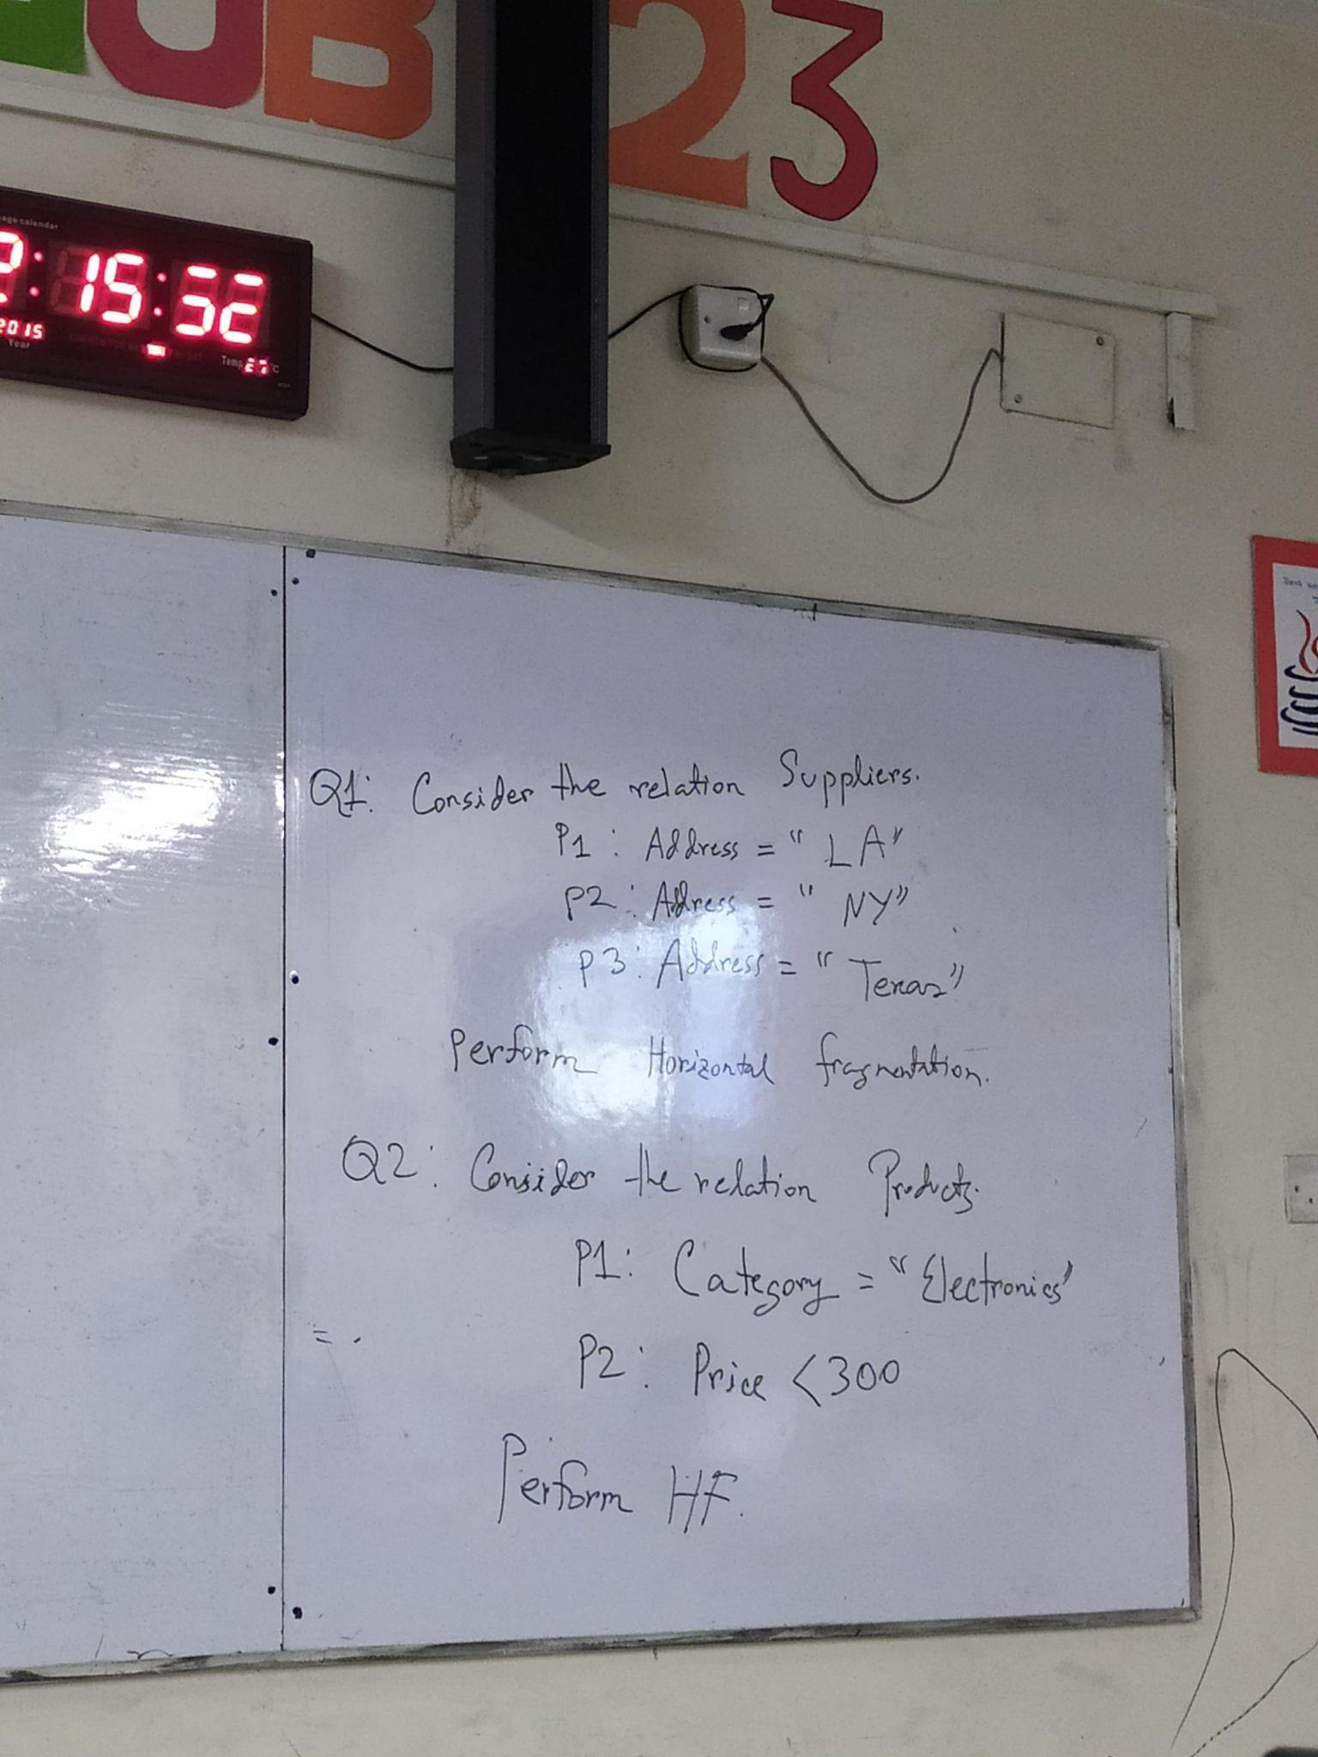

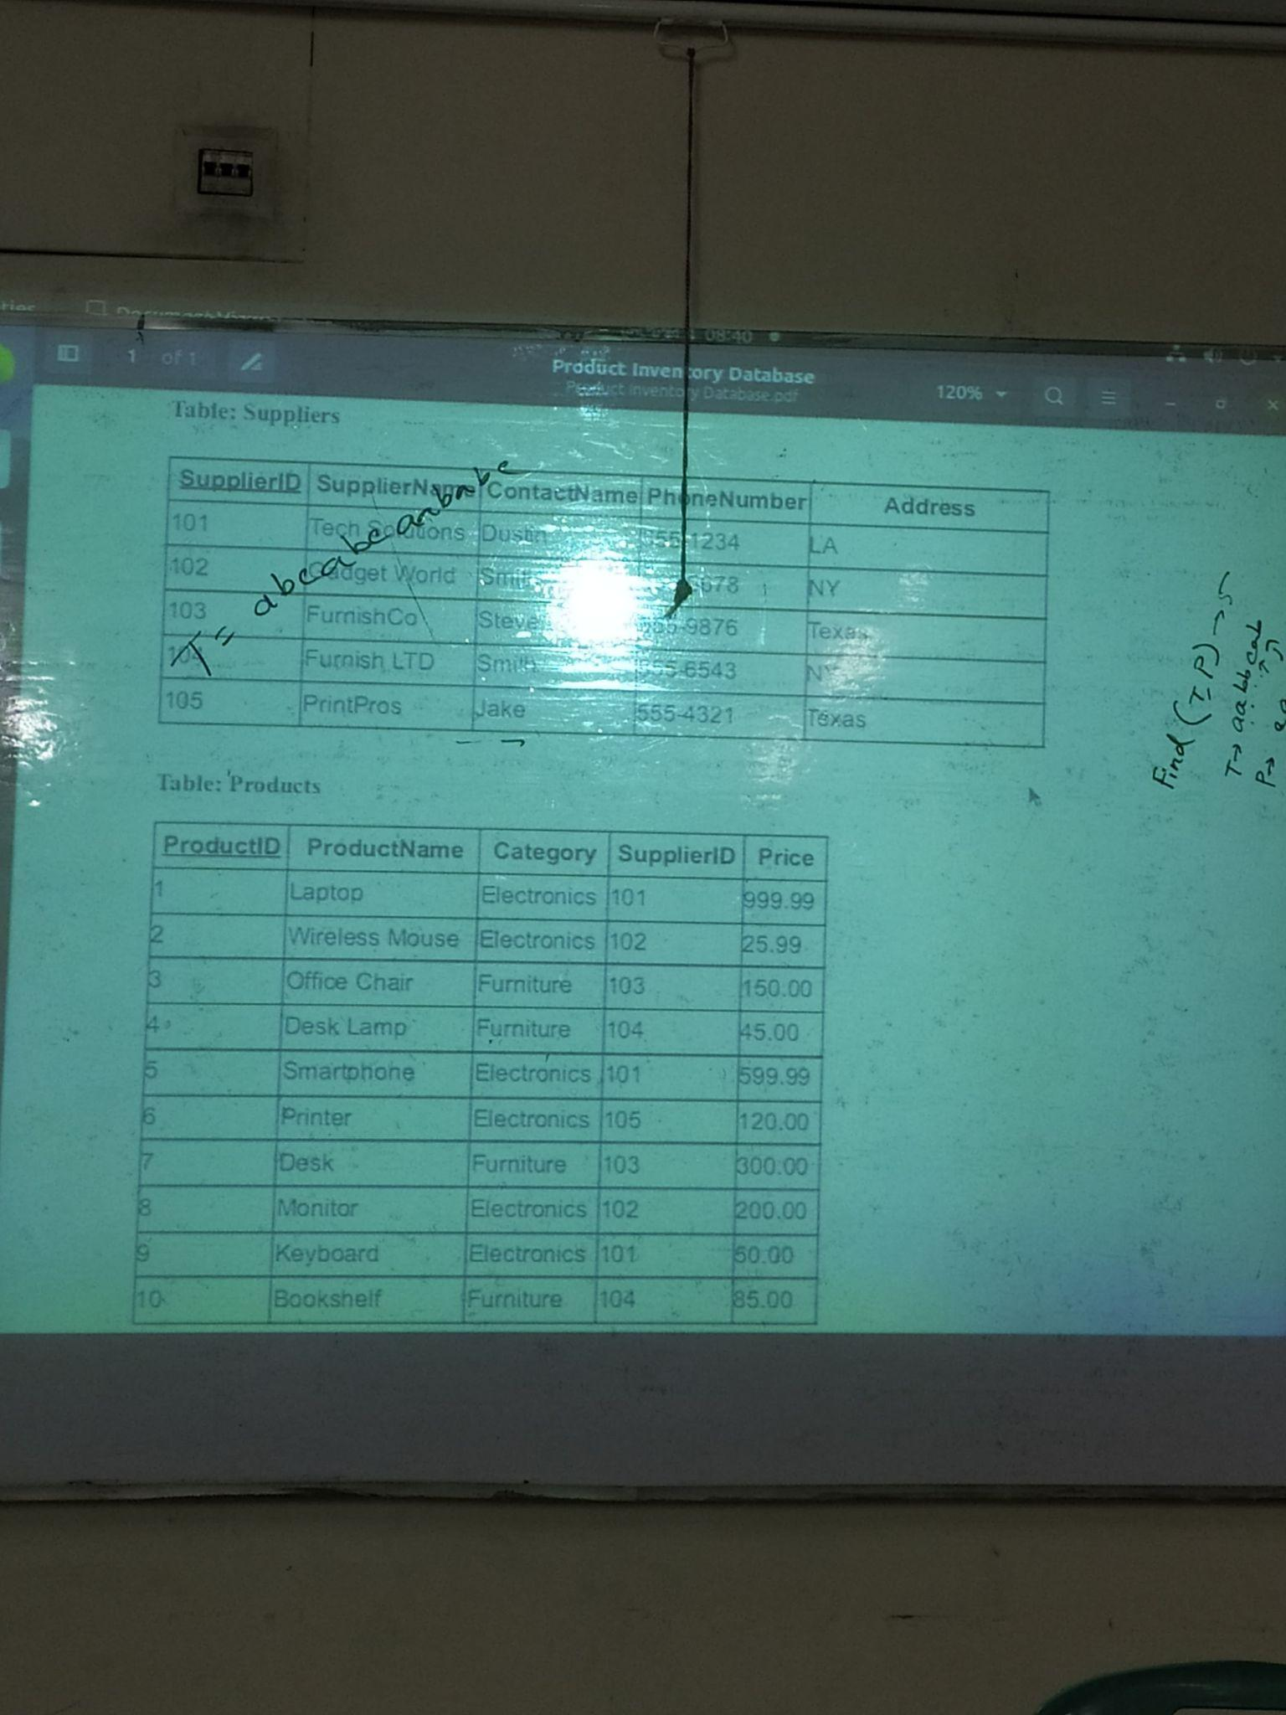

**1.Table Suppliers**

create TABLE suppliers(SupplierID varchar(20),

SupplierName varchar(20),

ContactName varchar(20),

PhoneNumber varchar(20),

Address varchar(20));

*add primary key after*

ALTER table suppliers ADD PRIMARY KEY(SupplierID);

**2.Table Products**

CREATE TABLE products(ProductID varchar(15),

ProductName varchar(15),

Category varchar(15),

SupplierID varchar(15),

Price varchar(15),

PRIMARY KEY(ProductID),

FOREIGN KEY(SupplierID) REFERENCES suppliers(SupplierID) ON DELETE CASCADE);

**3.Suppliers Value add**

INSERT INTO suppliers(SupplierID,SupplierName,ContactName,PhoneNumber,Address) VALUES

(101,"Tech Solution","Dustin","555-1234","LA"),

(102,"Gadget World","Smith","555-5678","NY"),

(103,"FurnishCo","Steve","555-9876","Texas"),

(104,"Furnish LTD","Smith","555-6543","NY"),

(105,"PrintPros","Jake","555-4321","Texas");

**4.Products value add**

INSERT INTO products(ProductID,ProductName,Category,SupplierID,Price) VALUES

(1,"Laptop","Electronics",101,"999.99"),

(2,"Wireless Mouse","Electronics",102,"25.99"),

(3,"Office Chair","Furniture",103,"150.00"),

(4,"Desk Lamp","Furniture",104,"45.00"),

(5,"Smartphone","Electronics",101,"599.99"),

(6,"Printer","Electronics",105,"120.00"),

(7,"Desk","Furniture",103,"300.00"),

(8,"Monitor","Electronics",102,"200.00"),

(9,"Keyboard","Electronics",101,"50.00"),

(10,"Boookshelf","Furniture",104,"85.00");

**5.Supplier table HF**

CREATE TABLE suppliers_LA AS SELECT*FROM suppliers WHERE Address="LA";

CREATE TABLE suppliers_NY AS SELECT*FROM suppliers WHERE Address="NY";

CREATE TABLE suppliers_Texas AS SELECT*FROM suppliers WHERE Address="Texas";

**6.Products table HF**

CREATE TABLE products_1 AS SELECT*FROM products WHERE Category="Electronics" AND Price<300;

CREATE TABLE products_2 AS SELECT*FROM products WHERE Category="Electronics" AND Price>=300;

CREATE TABLE products_3 AS SELECT*FROM products WHERE Category!="Electronics" AND Price>=300;

CREATE TABLE products_4 AS SELECT*FROM products WHERE Category!="Electronics" AND Price<300;

**7.Suppliers Table Union**

CREATE TABLE supppliersUnion SELECT* FROM suppliers_LA UNION SELECT*FROM suppliers_NY UNION SELECT*FROM suppliers_Texas;

**8.Products Table Union**

CREATE TABLE PRODUCTSUnion SELECT* FROM products_1 UNION SELECT*FROM products_2 UNION SELECT*FROM products_3 UNION SELECT* FROM products_4;