 EAST WEST UNIVERSITY

Dept. of Computer Science and Engineering

Fall 2019

Course Name: Course Name: Software Engineering & Information System Design

Requirement specification of

Job-Portal System

* **Introduction**
* **Diagrams(Class, Use case, Activity, Sequence)**
* **Database(ER)**
* **GUI Screenshot**
* **Project timeline**
* **Implementation Details**
* **References**

# Introduction:

With the advent of internet applying for jobs and getting a placement has become a hassle free task. The purpose of this project is to develop an online job Portal for the Placement Details for job seekers. This Job portal is an application which connects employers and job seekers where employers register themselves and post jobs using the system which will be visible to all the site users. The job seekers can find jobs and apply job and also views status of applied jobs. The employers can view the job seekers resume who have applied their posted job and accept or reject the application. The status of job application can be viewed by respective applicant/job seeker.

Motivation for making this website:

* Developing or building an online search Portal for job application for job seekers.
* The system project is an online web be accessed anywhere.
* The job recruitment or hiring employees process in the past years was based on advertisements in newspapers and have a panel on the appointed day to interview applicants. The whole process from advertisement to hiring a quality applicant takes a lot of time and its costly.Those question or problem can be solved by an online job portal system
* At a very low cost,The Internet will give employees and job searchers that opportunity

# Non-Functional Requirement:

* Secure access to confidential data (user details) should be provided
* Application should be accessible over Internet
* Better component design to get better performance  for example response Time, throughput, utilization
* Flexible service-based architecture will be highly desirable for future development

# Functional Requirement:

A person should be able to

* Register into the system
* Login to the system through the first page of the application
* Change the password after logging into the system
* Upload his/her CV.
* See/change his/her details.
* Apply for a job.
* View applied job status.

An employer should be able

* New employers can register into the system
* Create new post, view a post, modify or delete a post
* View applicants details
* Download the applicants resume
* Accept or reject and application

# Website Organization:

* Home page
* Log in
* Sign up
* Profile page
* Edit Profile
* Search Job
* Apply Job
* View Applied Job
* Post Job
* Edit Job Post
* Accept/reject Job Request
* Logout

**USECASE DIAGRAM:**

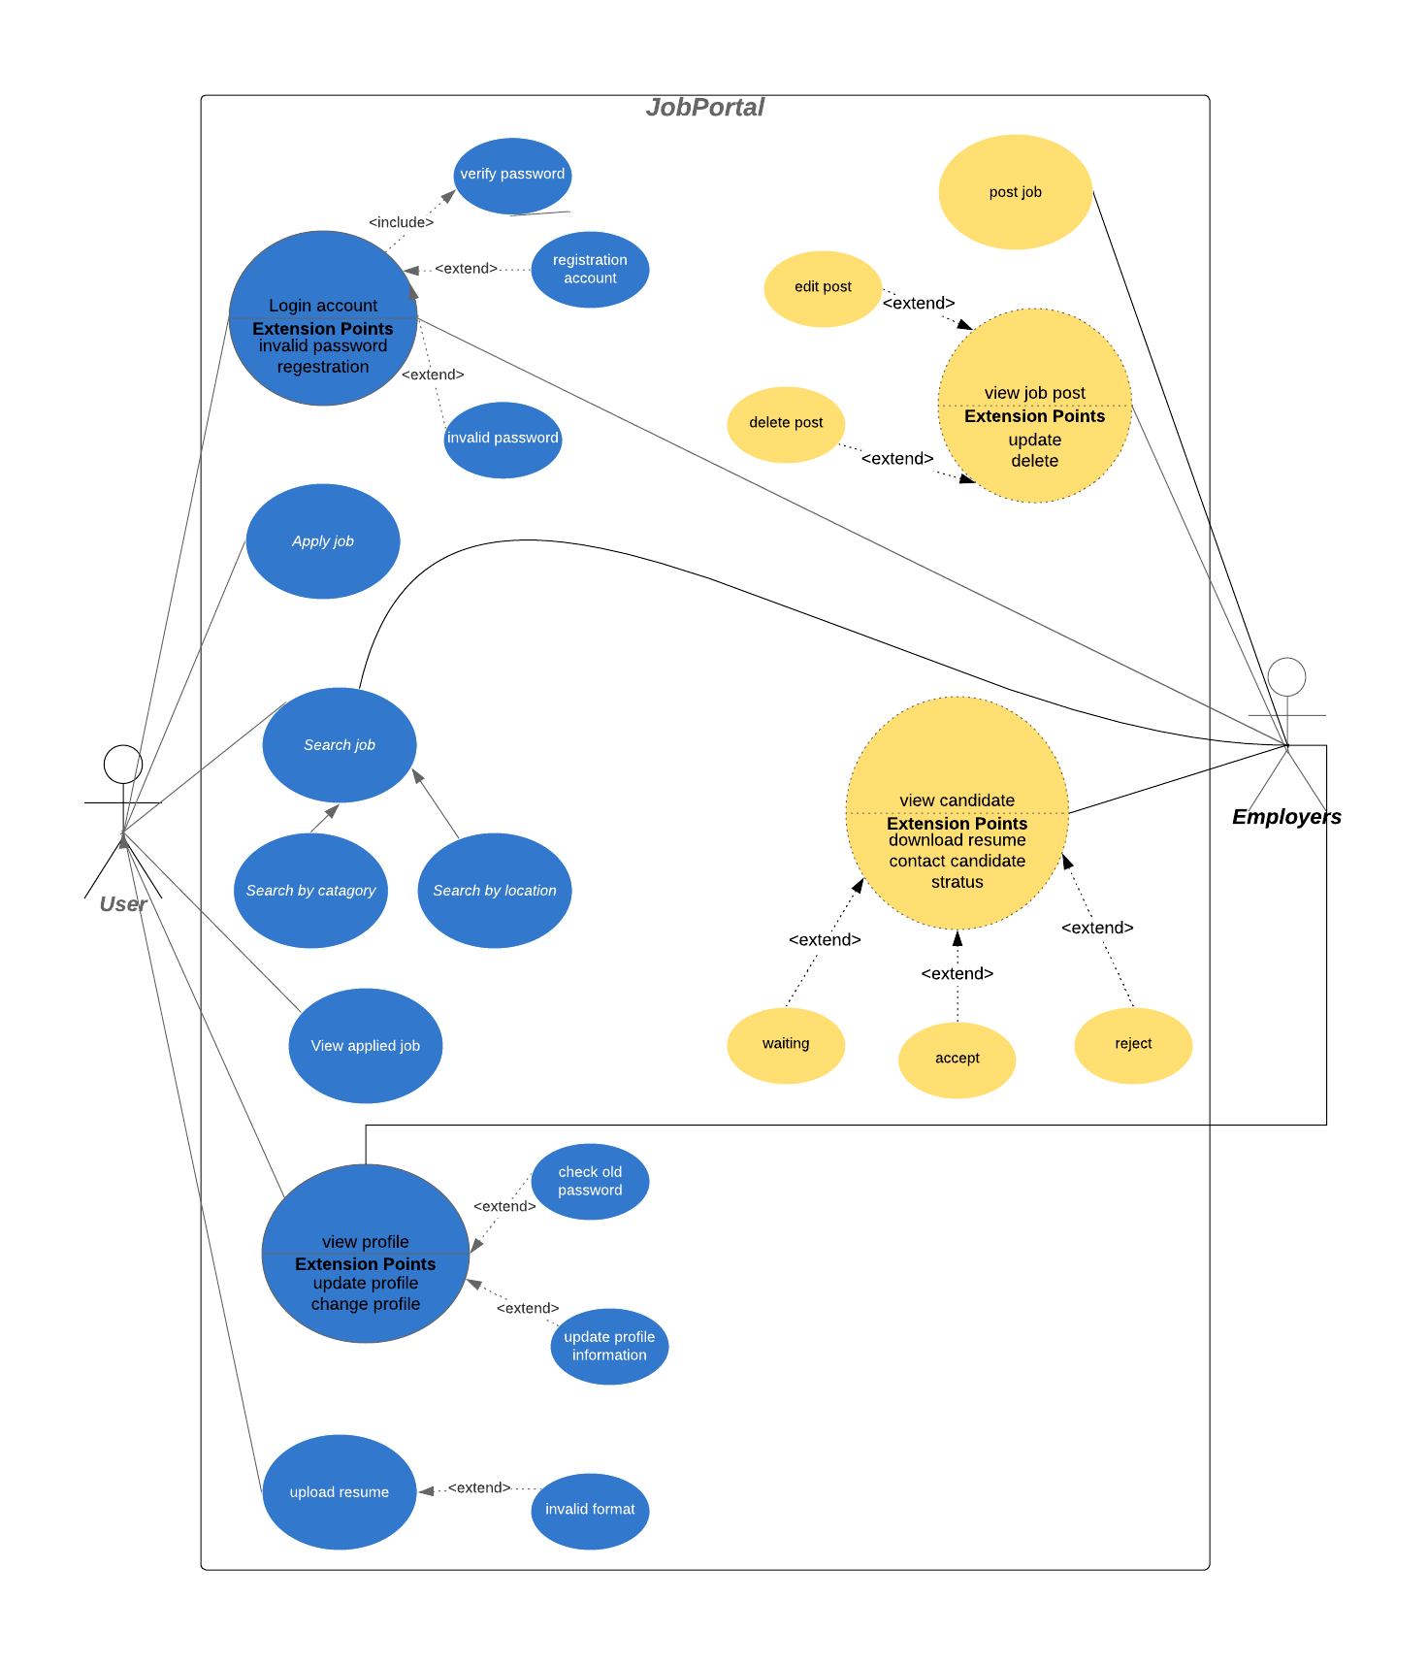

**CLASS DIAGRAM:**

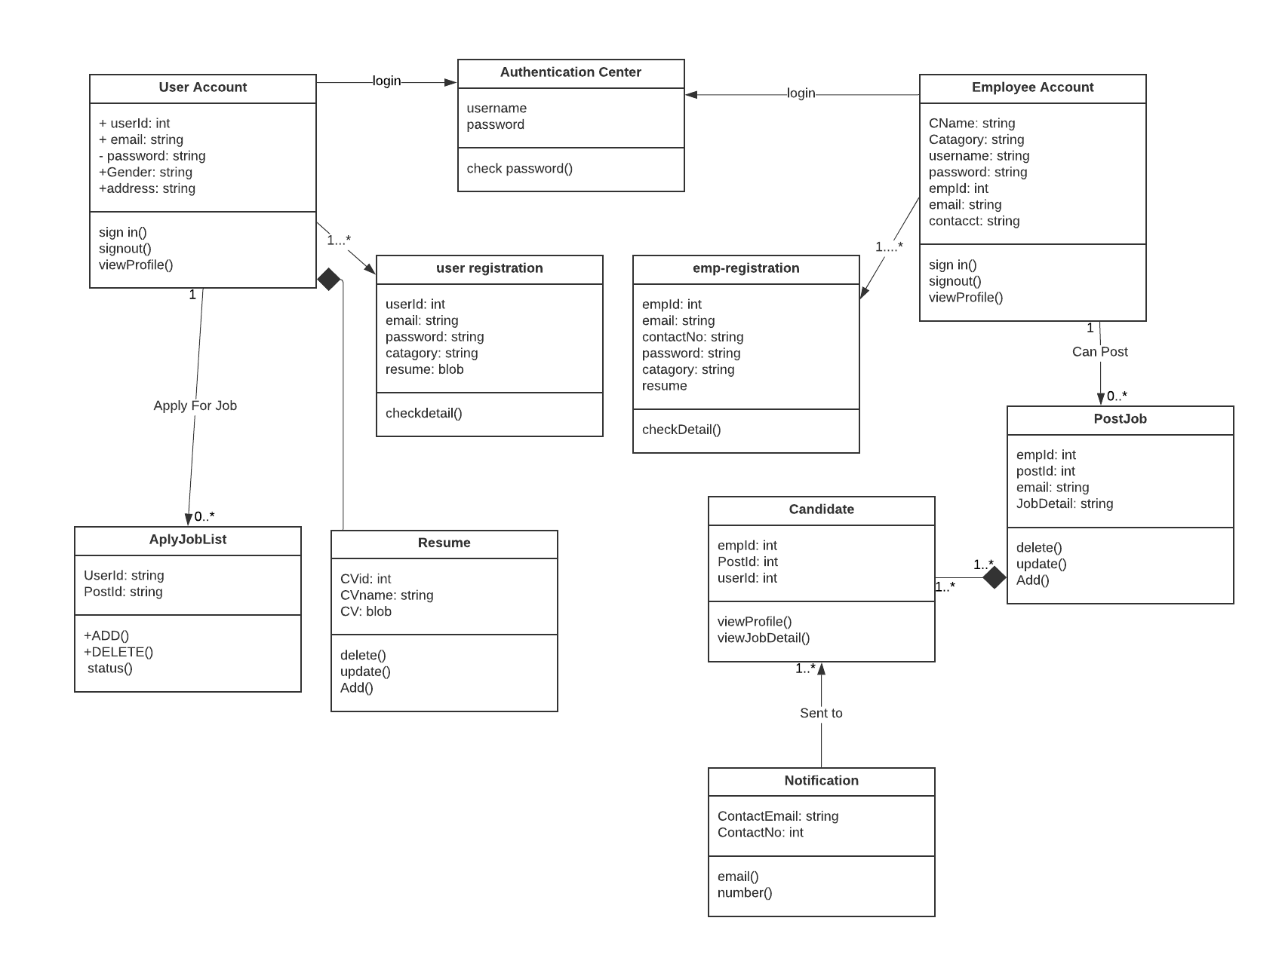

**ACTIVITY DIAGRAM:**

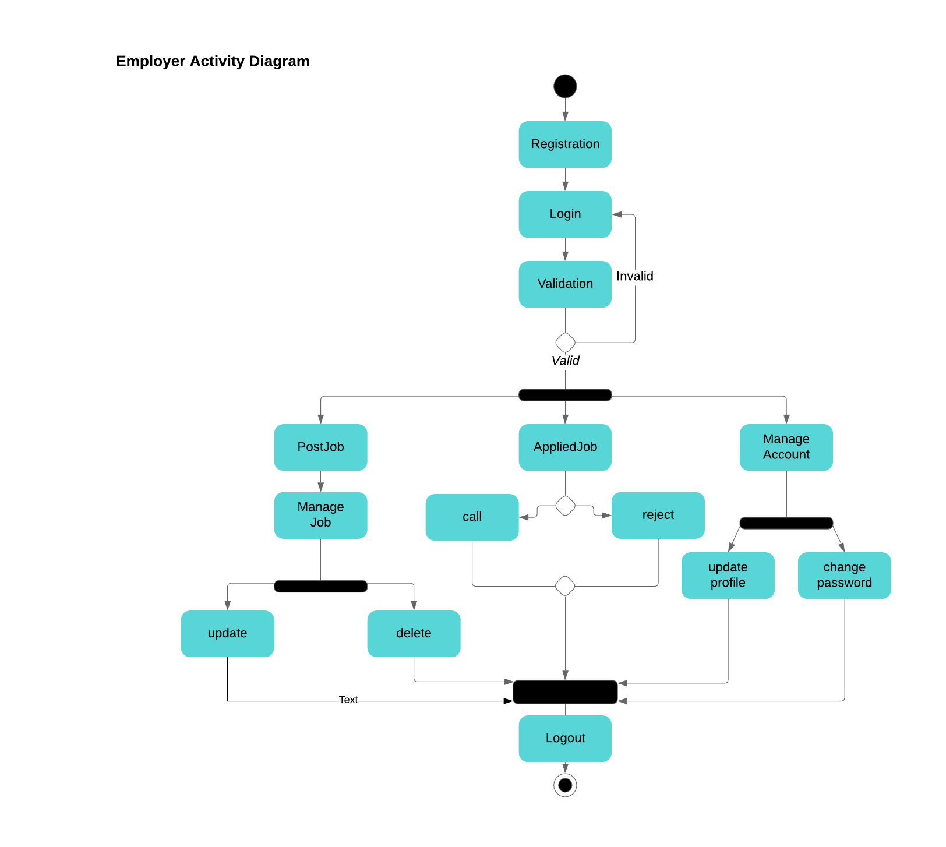

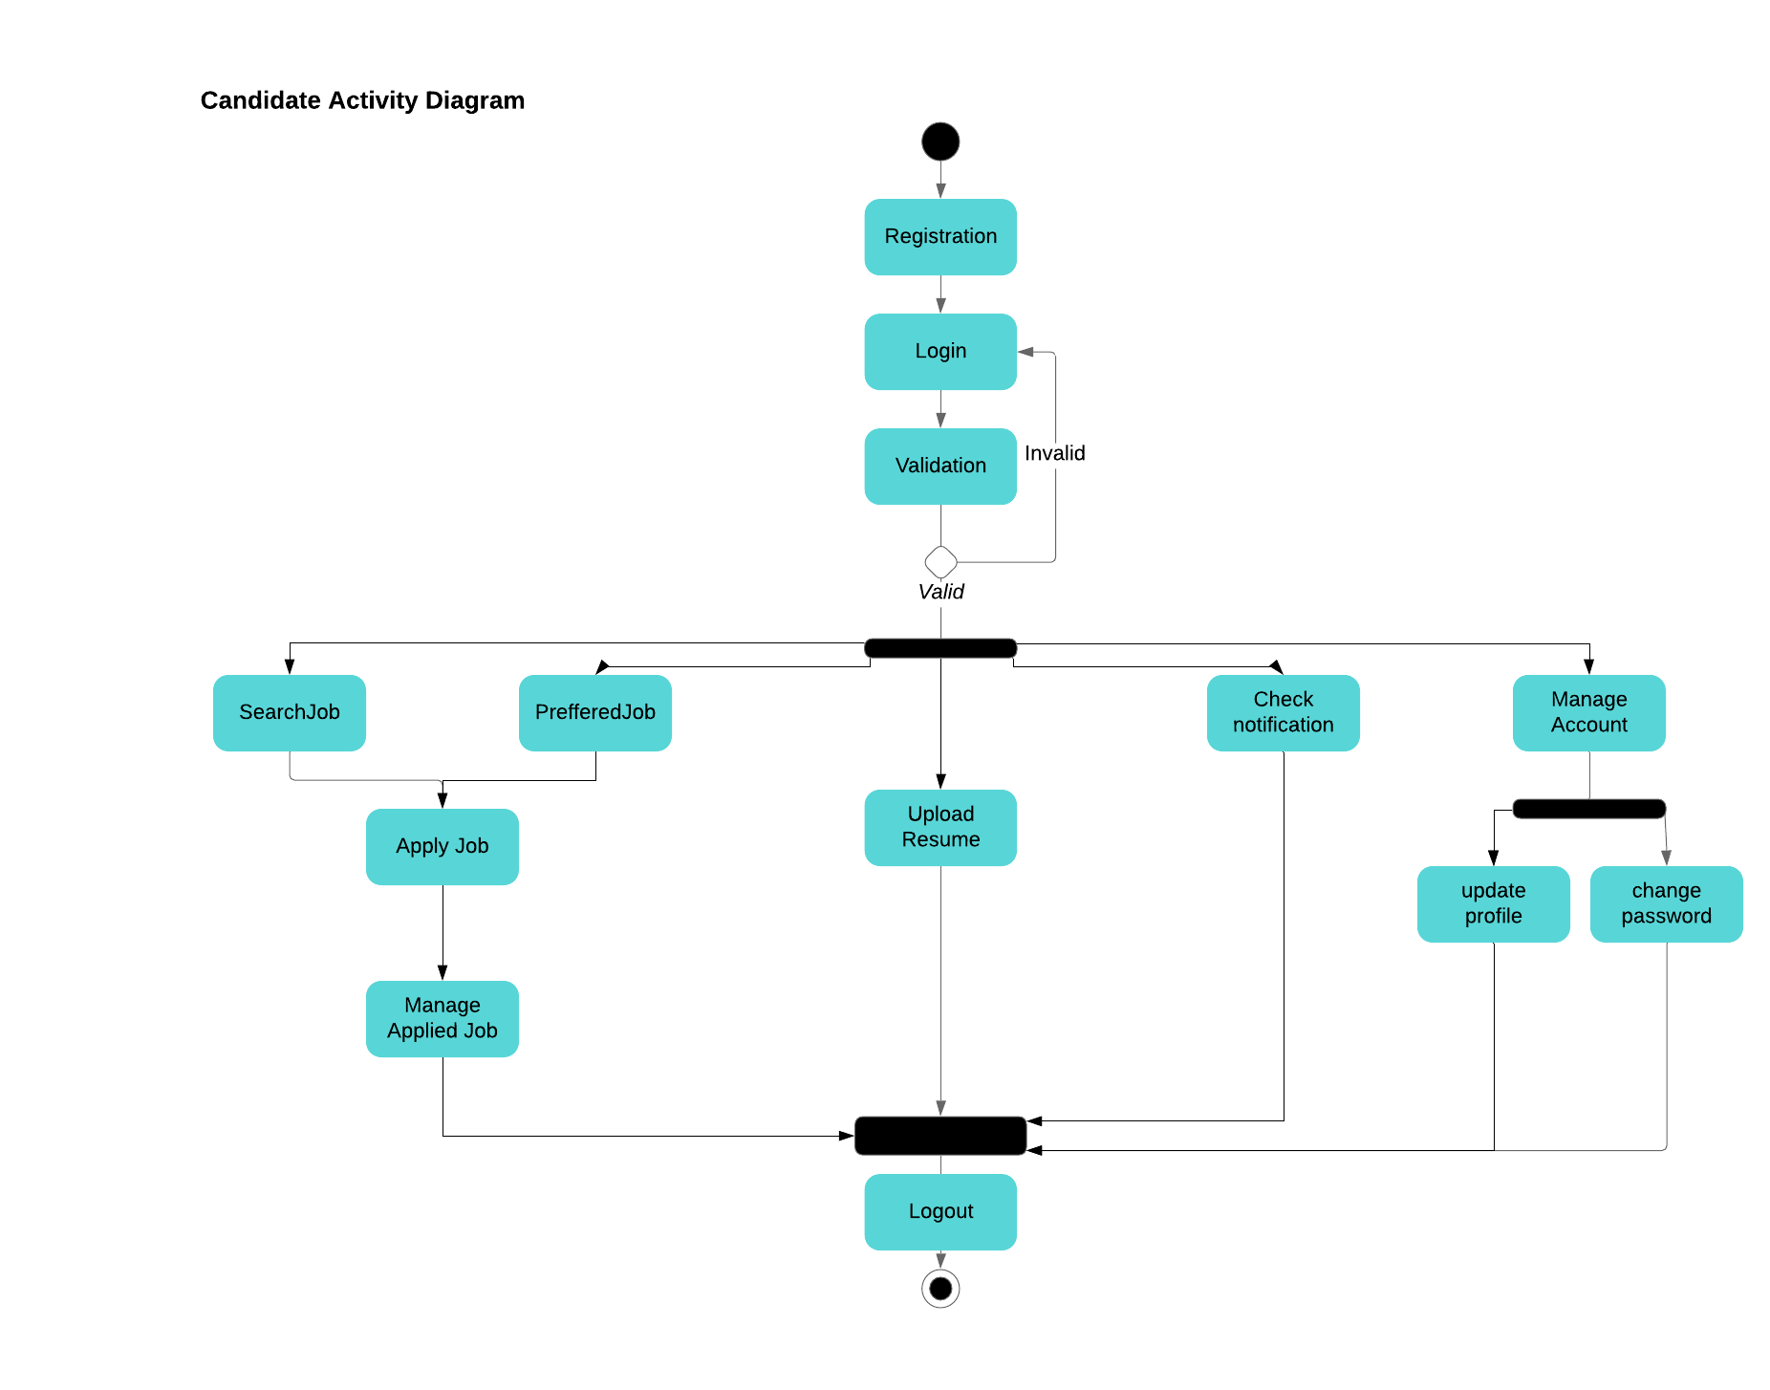

**SEQUENCE DIAGRAM:**

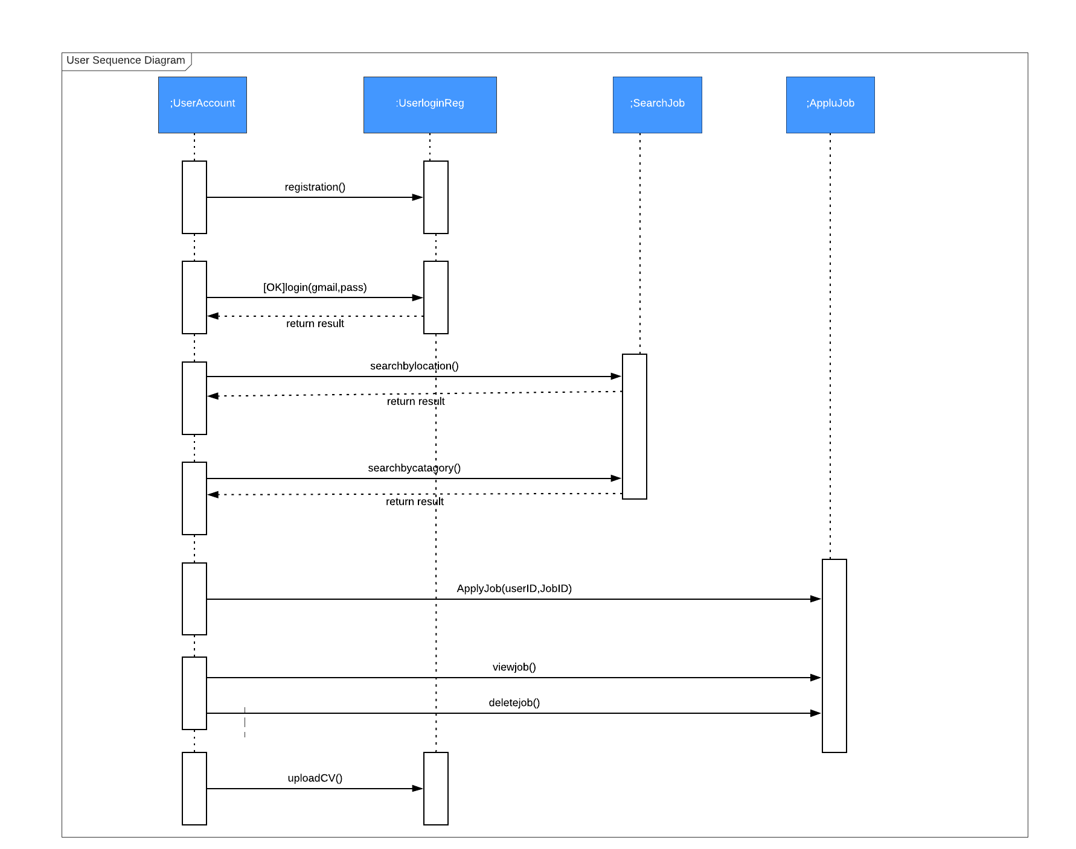

**ER Diagram:**

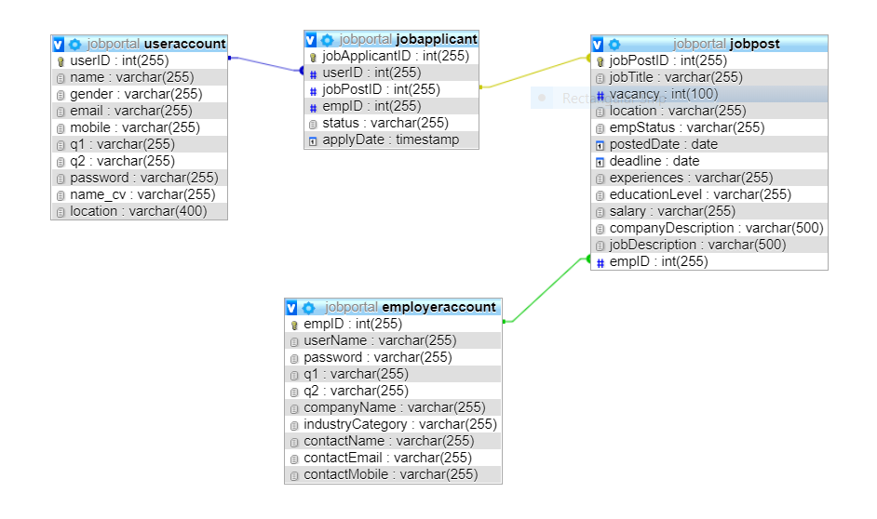

# GUI Screenshots:

**Create Account:**

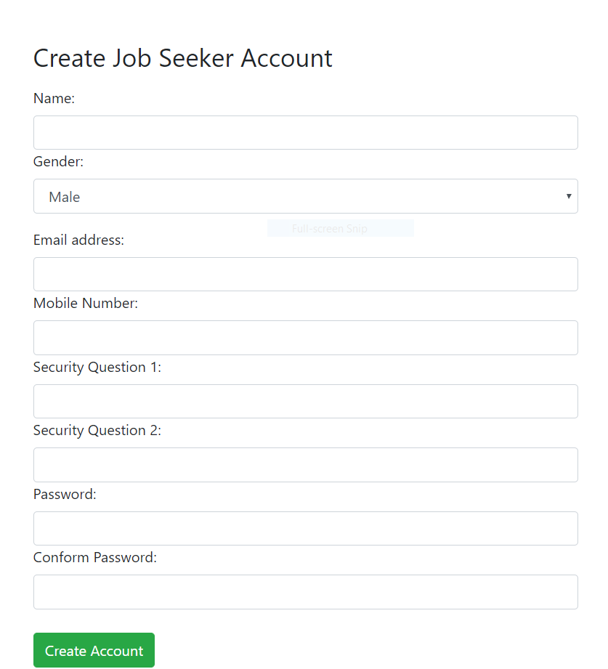

**Sign in:**

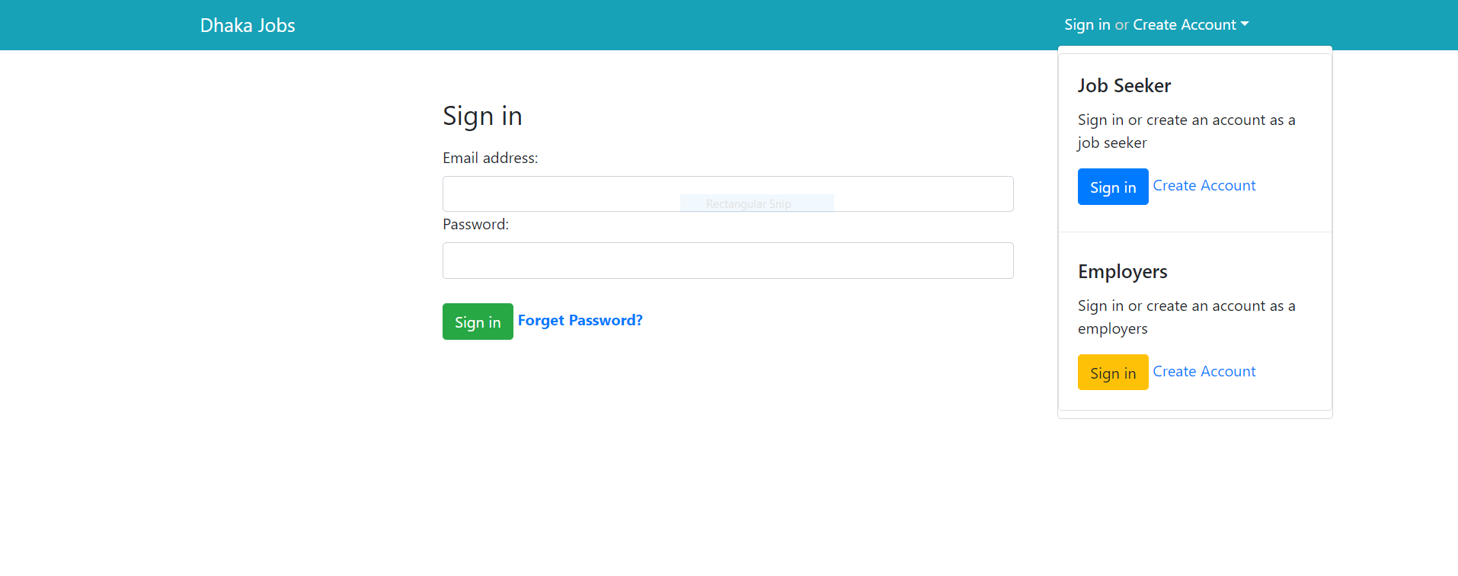

**Forget Password:**

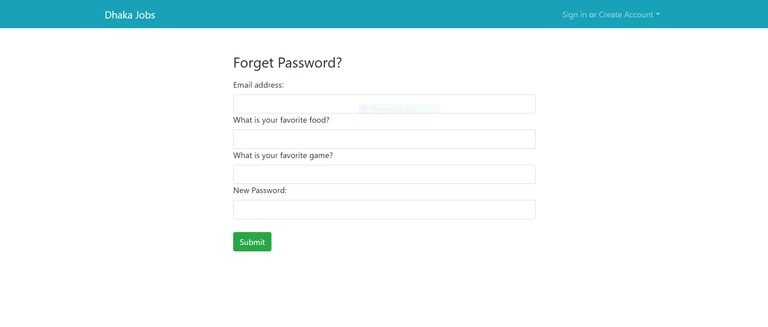

**Home:**

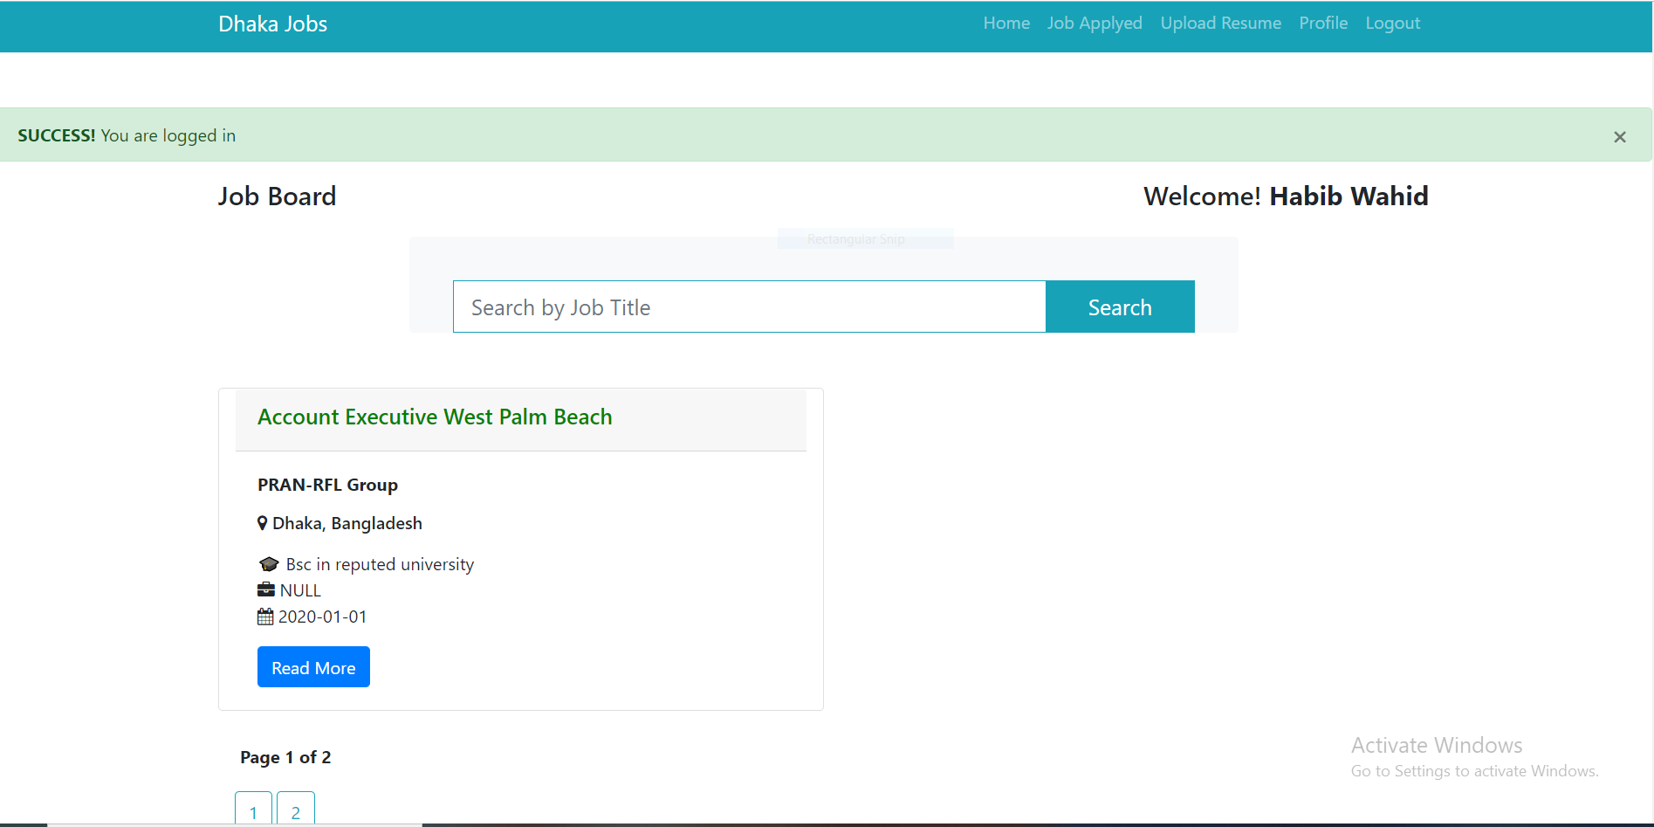

**User Profile:**

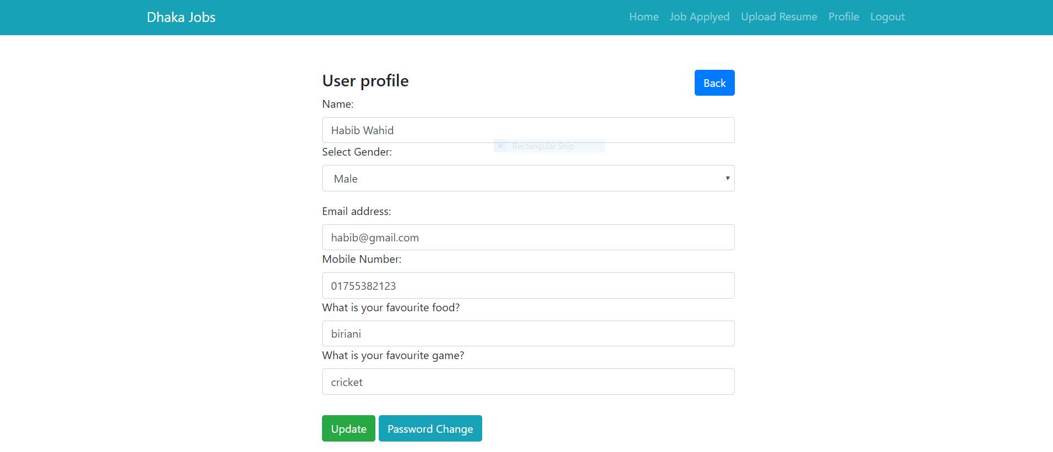

**JobDetail:**

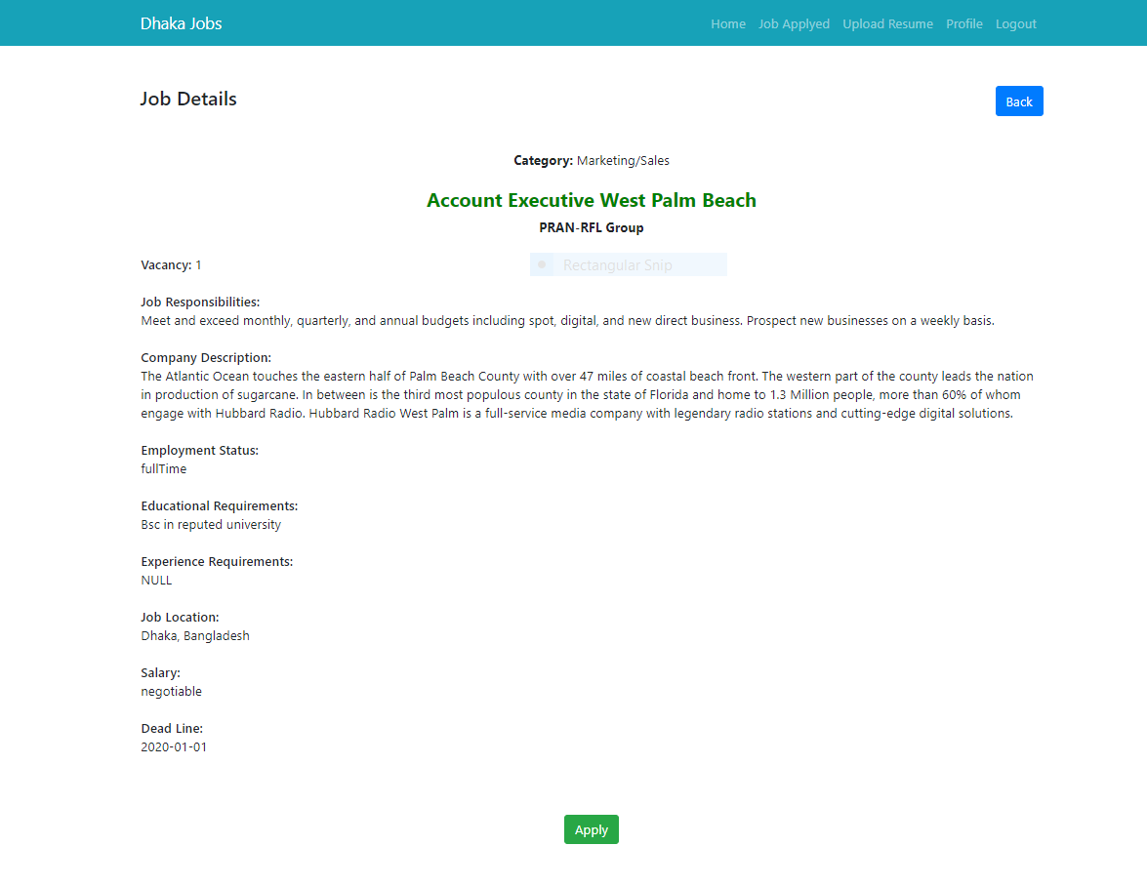

**Job Applied:**

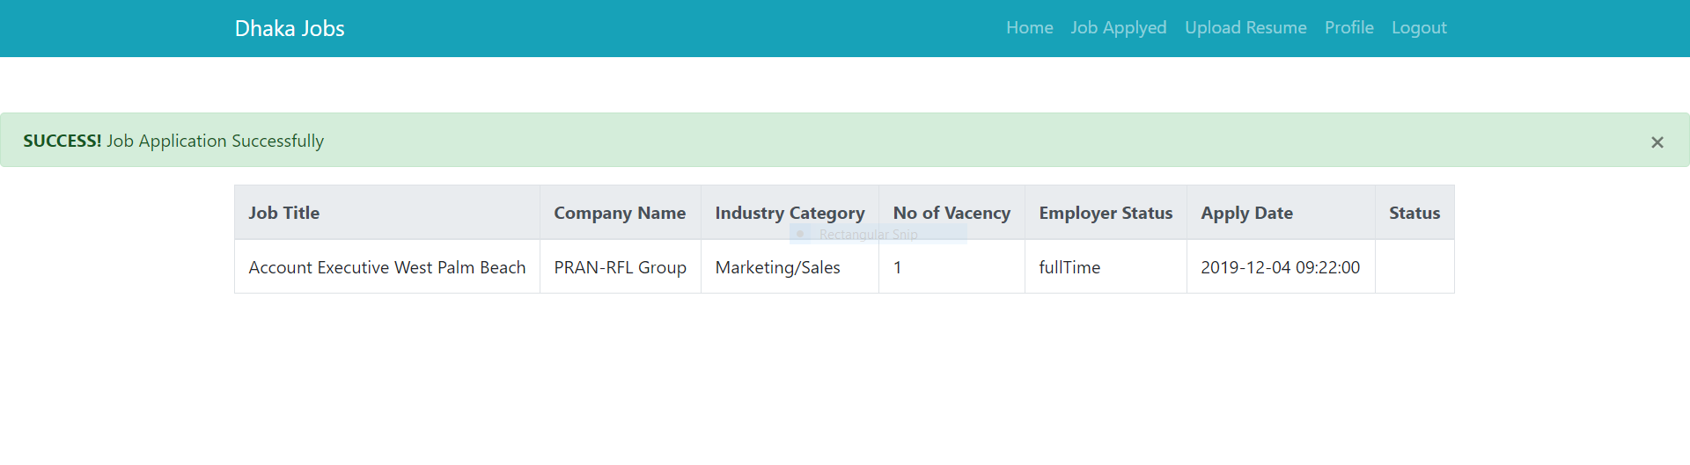

**Employer Profile:**

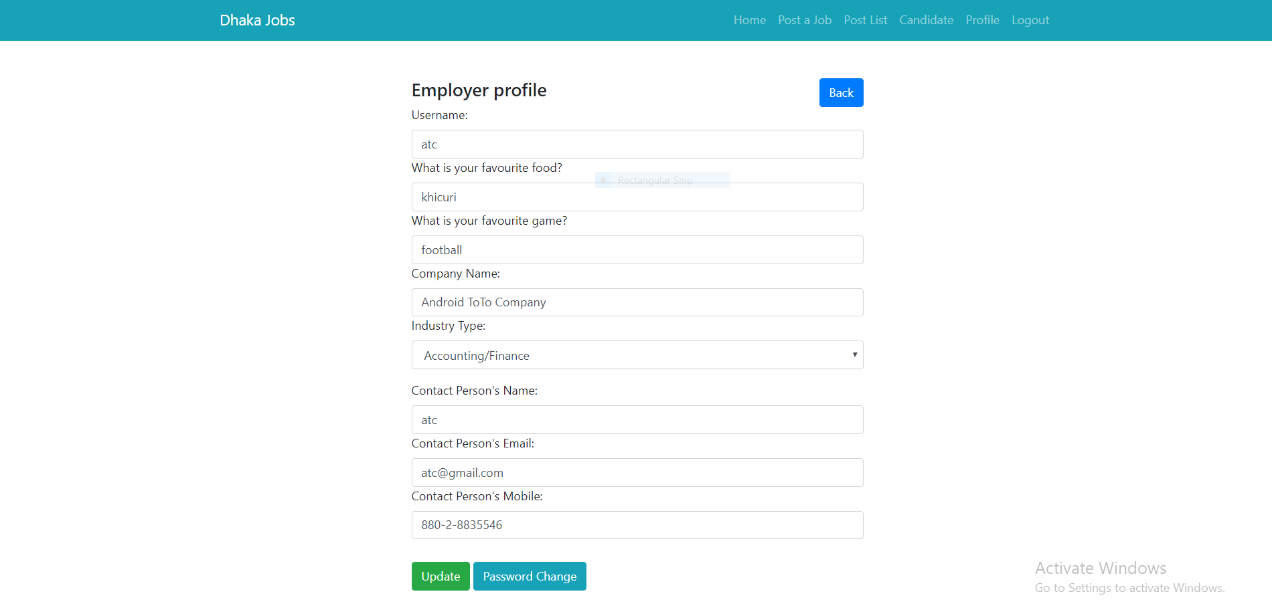

**Posting Job:**

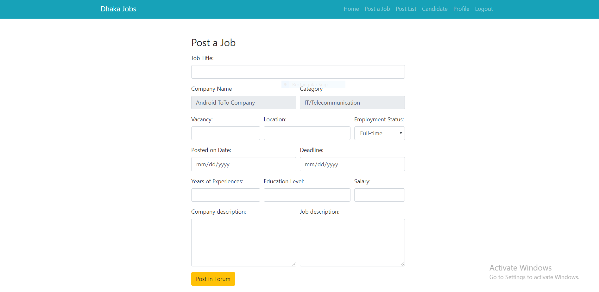

**Candidates Applied Job:**

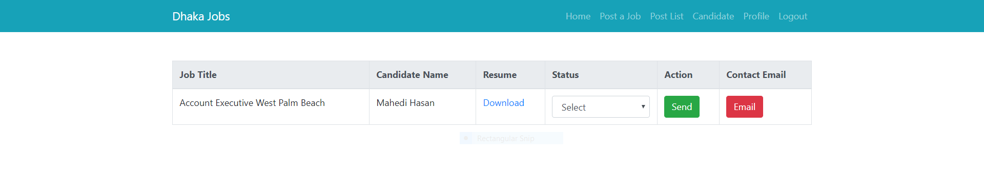

# Timeline:

|  |  |  |
| --- | --- | --- |
| Week | SDLC phase | Work |
| 0 | Analysis | System analysis and investigation |
| 1 | System Design | Database design |
| 2 | Bootstrap template design for header and footer |
| 3 | Home page design |
| 4 | login and logout page design |
| 5 | User Request and Visitor panel design |
| 6 | System Development | Connecting database with all the pages with PHP |
| 7 | Database implementation |
| 8 | Implementation | Fully functional prototype release |
| System testing as Employer |
| System testing as user |

**Table : Project planning for an JobPortal system.**

**Technologies Used:**

PHP, Mysql, Bootstrap, Javascript, Html, CSS.

# References:

1. <https://www.tutorialspoint.com/>
2. <https://www.w3schools.com/>