
DEPARTMENT OF CSE
PROJECT ABSTRACT SUBMISSION
COURSE: SOA PROGRAMMING AND MICROSERVICES– (24SDCS03) A.Y. 2026 – 2027

TITLE OF THE PROJECT | AquaMind AI: Agentic Smart Water Supply & Leakage Management System using SOA
S. No. | University ID | Name
1 | 2420030227 | P.HASIKA
2 | 2420030785 | K.VASAVI
Name of the Guide |  | THOTA.MAHESH

Abstract
Urban water management systems today face significant operational challenges that reduce reliability and increase wastage. Citizens are frequently unaware of exact water supply timings, and schedules often change without prior notice, leaving households unable to plan around them. Pipeline leakages go unnoticed for long periods, causing large volumes of water to be wasted, while complaints are still processed manually, which delays repairs. Citizens also struggle to locate alternative water sources during shortages, and municipal authorities lack the predictive insight needed to plan efficient distribution across the city.
To address these gaps, this project proposes AquaMind AI, an Agentic AI-powered Smart Water Supply and Leakage Management System built using Service-Oriented Architecture (SOA). Rather than functioning as a passive dashboard that waits for user input, AquaMind AI deploys multiple specialized AI agents that continuously monitor events, analyze citizen reports, predict issues, and proactively assist both citizens and municipal staff. Each service in the system operates independently and communicates through REST APIs, allowing the platform to scale and evolve without disrupting other components.
The system is powered by five specialized AI agents, each responsible for a distinct function. The Water Prediction Agent continuously analyzes supply patterns to forecast tomorrow's water arrival time, anticipate delays, and detect abnormalities. The Leakage Detection Agent uses computer vision to classify leakage severity from citizen-uploaded photos or videos and automatically raises a prioritized complaint. The Complaint Automation Agent converts a citizen's spoken description of an issue into a registered complaint with a tracked complaint ID, removing the need for lengthy forms. The Water Conservation Agent studies household consumption trends and generates personalized weekly reports with actionable suggestions and estimated water savings. Finally, the Emergency Water Agent responds to supply failures by locating nearby tankers and public water points and issuing timely alerts.
The platform is designed around eight independent microservices, covering user management, water supply, leakage handling, complaints, notifications, AI agent orchestration, analytics, and administration, each backed by its own MySQL database and exposed through a common API Gateway to a React frontend. Five AI capabilities underpin the agents: a large language model for understanding citizen queries, speech-to-text for voice-based complaint registration, computer vision for leakage severity analysis, predictive machine learning for supply and demand forecasting, and text-to-speech for accessible alerts, particularly for elderly citizens.
Three features distinguish AquaMind AI from conventional dashboard-based projects: proactive AI-driven prediction of water supply timing and delays rather than fixed schedules; smart leakage severity analysis that automatically assigns repair priority from a single uploaded photo; and a personalized water conservation coach that tracks usage trends and delivers concrete, quantified saving recommendations. Together, these agents help cities reduce water wastage, improve complaint response times, and deliver a more responsive public utility service.
Collectively, AquaMind AI aligns directly with UN Sustainable Development Goal 6 (Clean Water and Sanitation) and contributes to SDG 11 (Sustainable Cities and Communities) and SDG 9 (Industry, Innovation and Infrastructure). By combining agentic AI with a Service-Oriented Architecture, the project demonstrates a technically robust, scalable solution for the SOA Programming and Microservices course while presenting a clear, socially impactful hackathon narrative for citizens, municipal water boards, maintenance engineers, tanker operators, and government officials alike

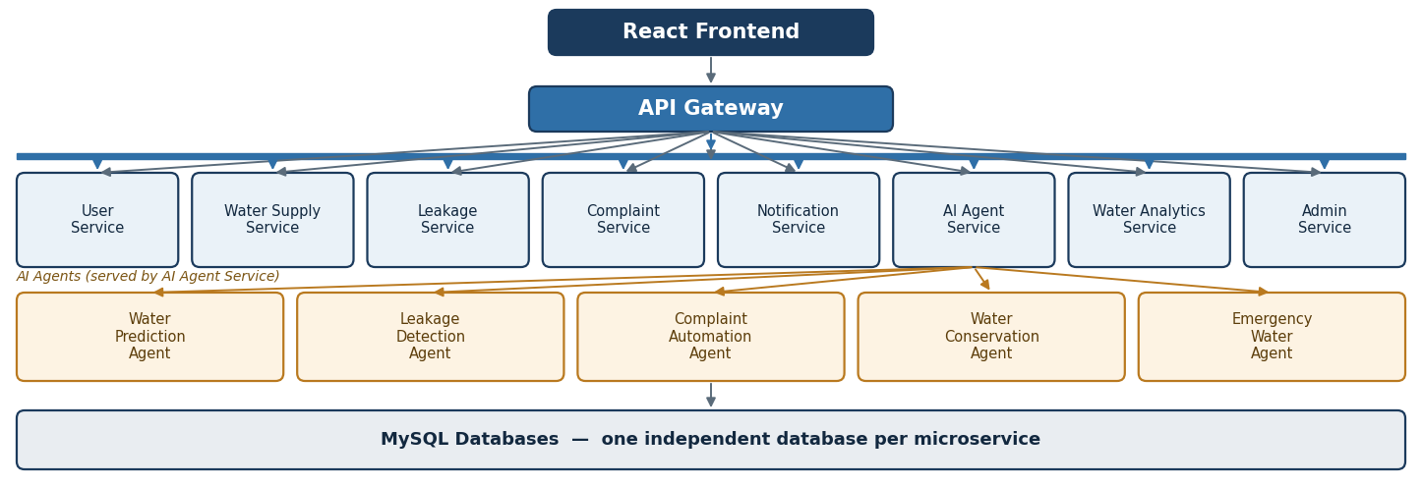
Project Architecture/Project Overview:

