HealthBoard Application is to view applications status in a dashboard. Application has the functionality to create a new application, update application and view application details.

While creating an application, system get the status of the application url and update the status in database.

Upon landing to application dashboard page, it open a websocket with stomp to the server internally. A scheduled job is running in back ground to update the status of the application health. Upon finishing updating status of all the application push the details to topic using stomp message broker. Application dashboard listen to the web socket gets notified about the updated status.

**Technology stack**:

Springboot, Angular JS, H2 (file based), Stomp Message Broker.

**How to run:**

With java below java command application can be run any machine.

Java –jar health-board-api.war <<folder of in memory data>>

Default refresh time is 3 mins. To configure app refresh time, place **conf.properties** in a folder**.**

Then run below command

Java –jar health-board-api.war --spring.config.additional-location= “path of conf.properties”

Application accept an additional argument directory path, where database file would get created.

If no path specified system will create a folder **health-board-data** in current directory. While restarting application will use the database created in data folder, if no database found will create a new one.

**Component Diagram**:

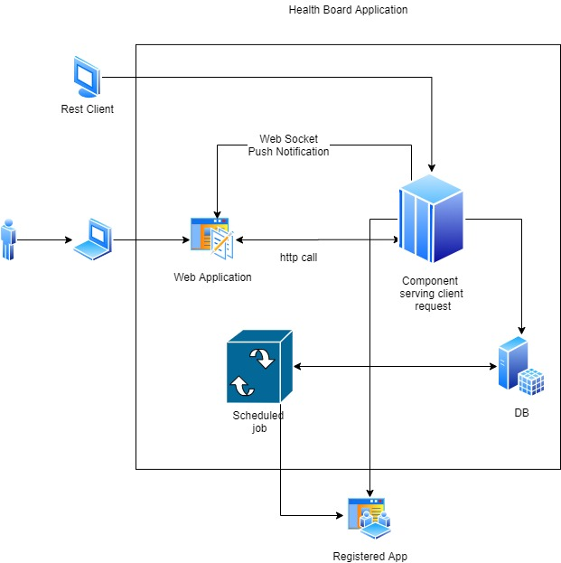

**Get Applications:**

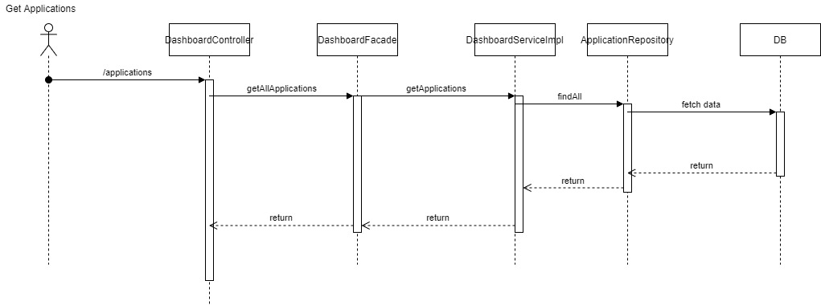

**Create Application:**

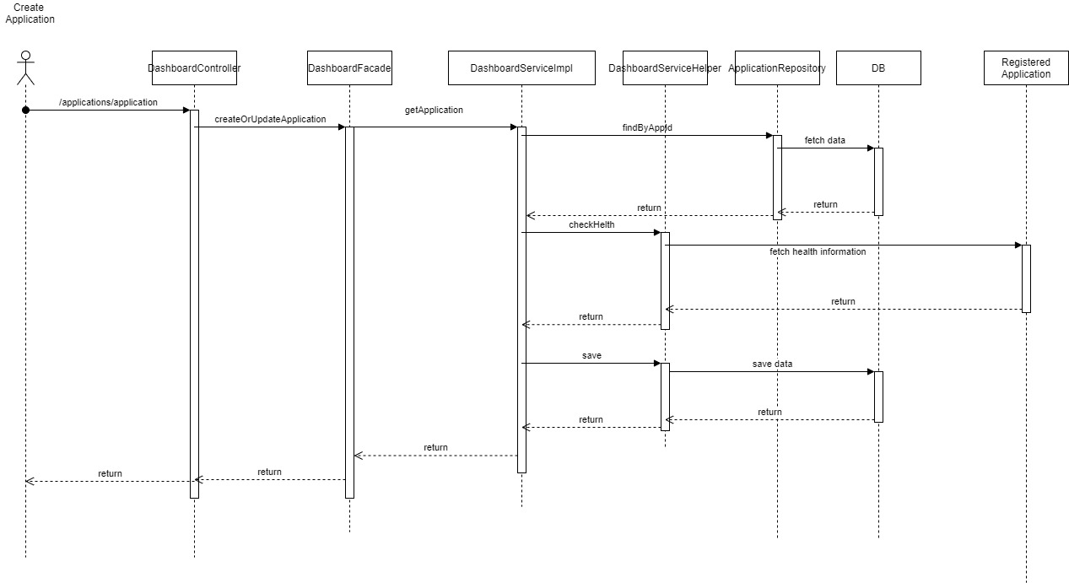

**Get Application:**

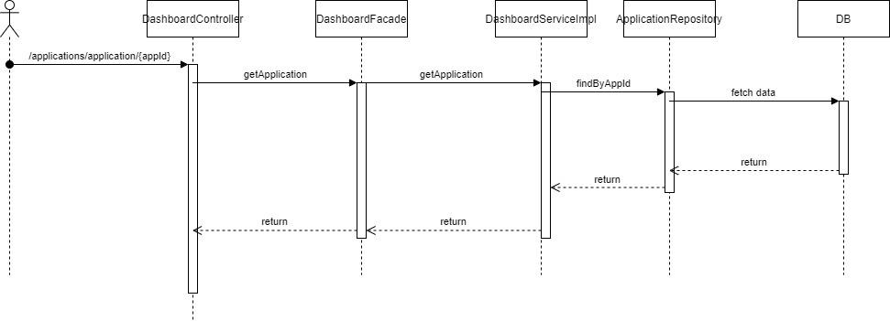

**Refresh Status:**

