

Department of Computer Science and Engineering
Islamic University of Technology (IUT)
A subsidiary organ of OIC

Laboratory Report

CSE 4412: Data Communication and Networking Lab

Name: Hasin Mahtab Alvee
Student ID: 210042174
Section: SWE-Even (B)
Semester: 4th (Summer)
Academic Year: 2023-24

Date of Submission: 1st March, 2024

Title: Configuring and Verifying of RIP and OSPF in a network topology.

Objective:
- Understanding Dynamic Routing
- Configure Routing Information Protocol (RIP)
- Understanding OSPF routing protocol
- Advantages of OSPF over RIP

Devices/ software Used:
      - Cisco Packet Tracer Software

Theory:

Routing Information Protocol (RIP)

Two of the most common dynamic routing protocols are – RIP following the distance-vector algorithm
and OSPF following the link state routing algorithm. RIP is somewhat an obsolete protocol due to its limitations and the advent of more modern and sophisticated protocols like OSPF, EIGRP etc.

Forwarding Table used in RIP

- Every RIP router keeps a routing table with a list of all known destinations (networks) and the hop count metric-based shortest path to each destination. A router modifies its routing table in response to information it gets from a neighbour.

Hop Count as cost

- The hop count measure is used by RIP to find the optimal path to a destination network. The hop count rises by one with each hop (router) on the way to a destination. Less hops on a path is preferred by RIP.

Timers in RIP

- Multiple timers are used by Routing Information Protocol (RIP) to control different parts of its functioning. These timings are essential for preserving the stability of the network and guaranteeing timely convergence and updates.

Diagram of the experiment:
(Provide screenshot of the final network topology. Make sure to label the network components.)
Task #01:

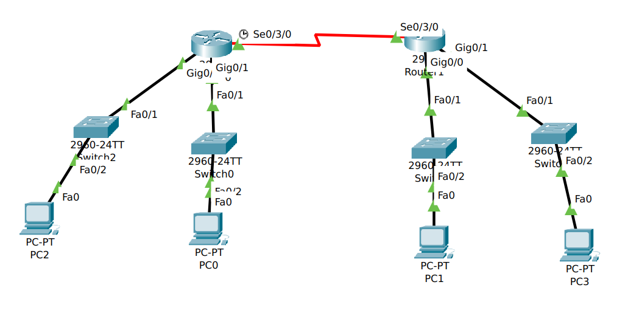

Task #02:

Working Procedure:
(Explain in brief how you completed the tasks. Provide necessary screenshots of used commands for each task.)
Task #01:

- First, we need to configure the interfaces for both the routers that are connected to the switches and with the serial port connection with the other router using the HWIC – 2T ports.
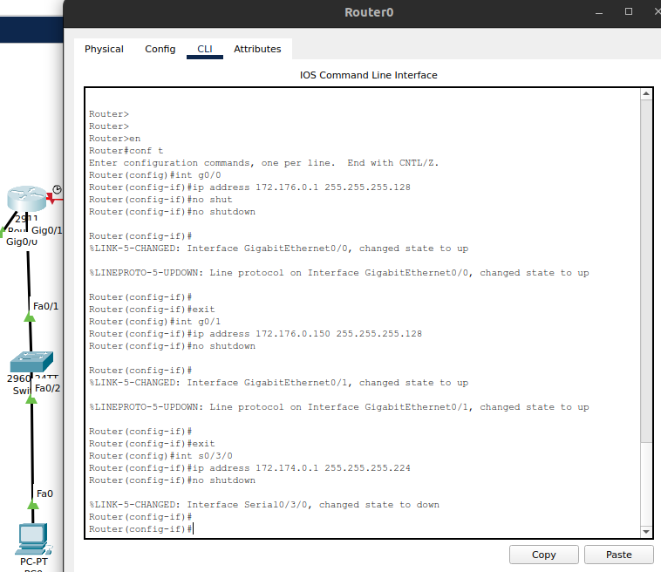

- Next we will configure the PCs according to the interface routes and IP addresses.

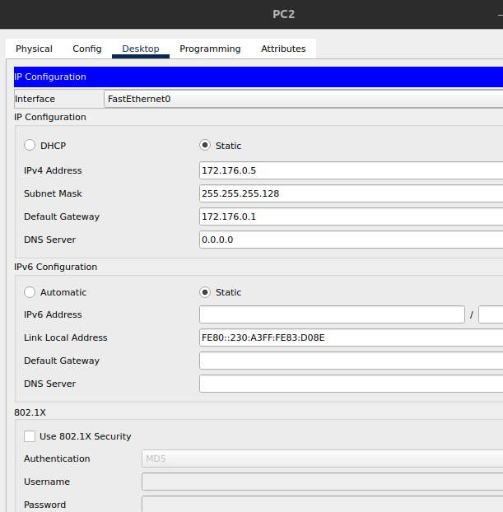

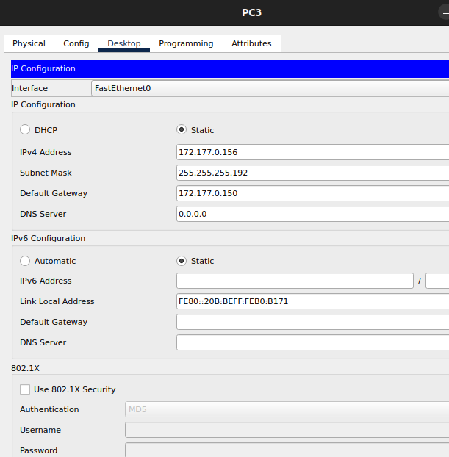

- Lastly, we need to set up the RIP networks for both the router interface, which will define the common network between the routers.

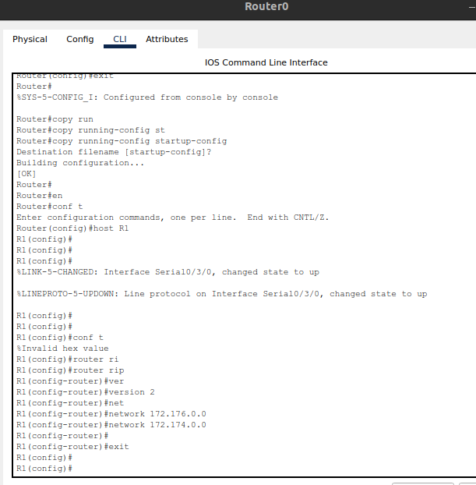

Task #02:

Q/A for the tasks:
(There were many q/a sections inside the task pdfs. Copy the questions and your answers here.)

Task #02:

Observation:

Challenges (if any):
- I could not implement the Task 2.

