# **Department of Computer Science and Engineering Islamic University of Technology (IUT)** A subsidiary organ of OIC

# **Lab Report 01**

# CSE 4512 : Computer Networks Lab

## 

## **Name:** Hasin Mahtab Alvee **Student ID:** 210042174 **Section:** SWE - B (Even) **Semester:** Summer (4th) **Academic Year:** 2023-24

**Date of Submission:** January 28, 2024

### **Title:** Configure router using static routing to connect multiple networks in Cisco Packet Tracer

### **Objectives**:

1. Understand how to operate Cisco Packet Tracer
2. Learn to create and connect multiple networks using static routing
3. Understand wiring of different network components like router, switch, PC etc.
4. Configure router and switch interfaces
5. Verify connectivity of the network
6. Understand the basics of IP Subnetting
7. Learn to subnet a network following given specifications

### **Diagram of the experiment:**

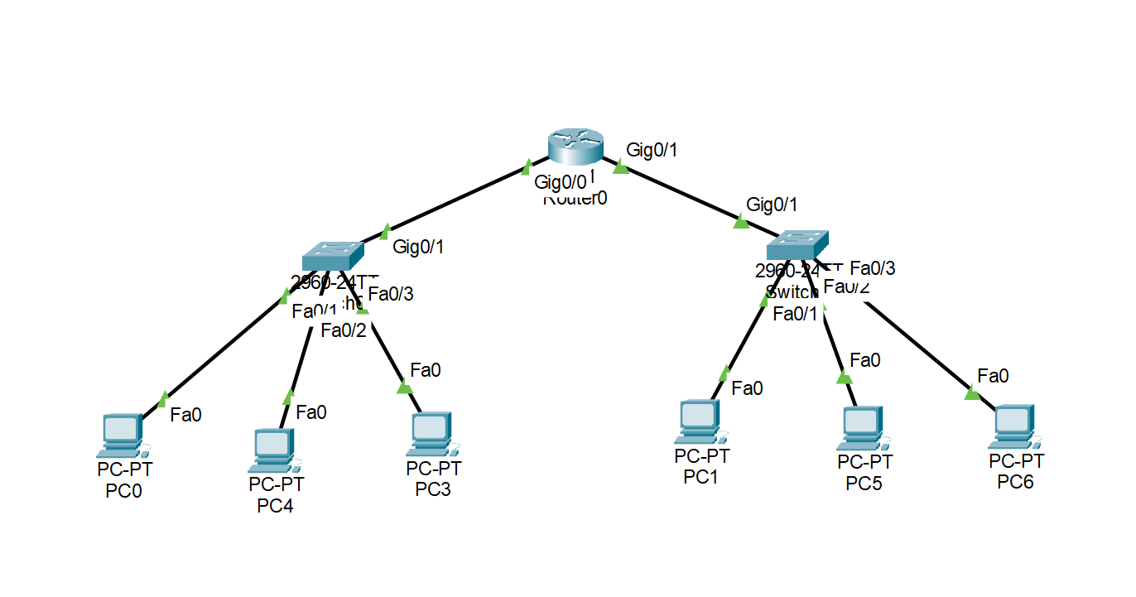

### 

### **Working Procedure:**

* Once the topology for the given task was completed, we needed to set up the IP and subnetmasks for the connected devices. We also needed to set up the default gateway.
* First, we needed to set up the router interfaces. As the router is connected to two different switches, we needed to configure the interfaces for both switches.
* From the router **config** panel, we set up the hostname according to the ID, 174.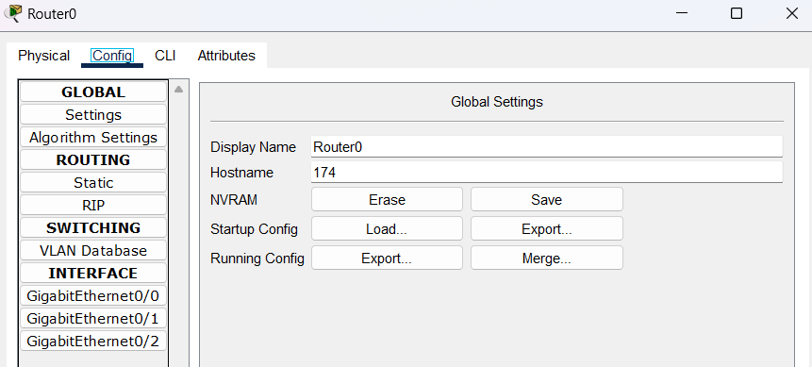
* Next, we need to enter the router's configuration mode in the **CLI;** the command is **enable** and **conf t.**

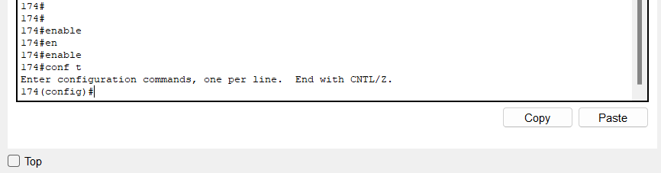

* We will set up the interfaces for both switches. We use the following commands in order

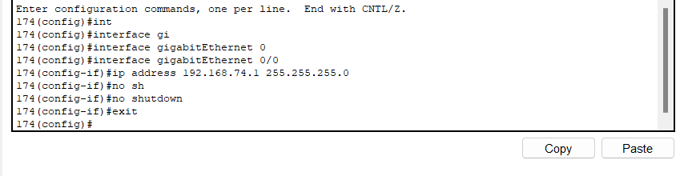

* Now again for the next interface -

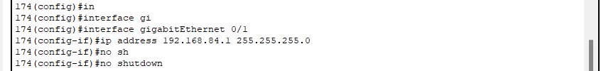

* After the interfaces, we just need to set up the IP address, subnetmask, and default gateway for the computers that we have connected to the switches. We need to provide IP of the corresponding switch as the default gateway for the computers.

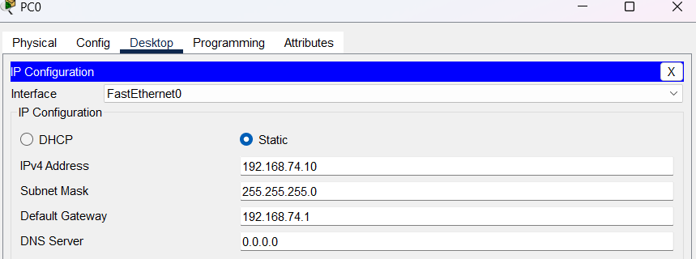

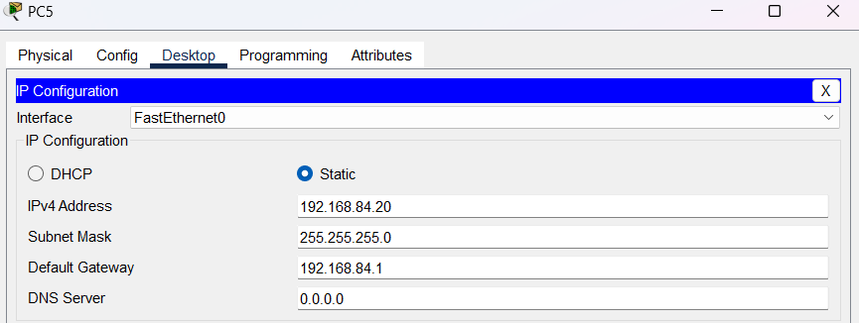

* Now we will be able to communicate and pass data from one network to another using the routers. Here is an example ping from the first interface to the second one. Where we can see the data, it is being pinged from the 192.168.74.20 computer to the 192.168.84.20 computer. This shows that the switches have established a connection over the router using the interfaces.

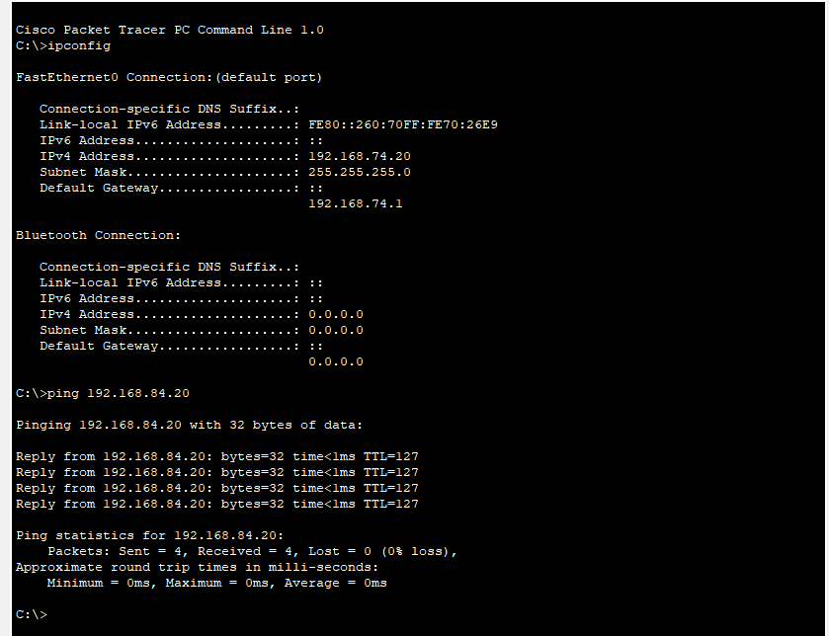

### **Questions (Answer to the point)**:

**Q1.** Write the command to check the status of all interfaces in a router.

Ans: **show interfaces**

**Q2.** Why do we use switches and not hubs?

Ans: Hubs usually broadcast packets/data to all connected devices, which in most cases is not the goal. Switches provide better packet management as the data is directed to only the destination device address. This is why we use switches and not hubs.

**Q3.** How do you make all the configuration changes on a Cisco device persistent? What would happen if you don’t do this?

Ans: To make all the configuration changes on a Cisco device persistent, we need to save the running configuration to the startup configuration. We can do that with the command -

**copy running-config startup-config**

If we don’t save the startup configuration, at the next start up of the.pkt file, the configuration changes will be discarded.

**Q4.** What are the interfaces of the router? Why are they necessary?

Ans: Router interfaces are generally connections via Ethernet, fiber optics, and other physical layers. Each network interface is used to enable data packets to be forwarded from one transmission system to another.

**Q5.** Why is the default gateway necessary?

Ans: A default gateway is a router that connects your host to remote network segments. It is the exit point for all the packets in your network that have destinations outside your network. Usually, the IP address of the router is set as the default gateway for the connected devices in that network.

### **Challenges (if any):**

* The main challenge that I faced was when I had to set up the default gateway for the connected computers.

### 