# **Department of Computer Science and Engineering Islamic University of Technology (IUT)** A subsidiary organ of OIC

# **Lab Report 03**

# CSE 4412: Data Communication and Networking Lab

## 

## **Name: Hasin Mahtab Alvee Student ID: 210042174 Section: Even (B) Semester: 4th (Summer) Academic Year: 2023-24**

**Date of Submission: 11th February, 2024**

### **Title:** Understanding the basics of Variable Length Subnet Mask (VLSM) and VLANs and Inter-VLAN communication

### **Objectives**:

1. Learn to subnet a network following the given specifications
2. Describe the advantages of VLAN
3. Define and describe the concept of VLAN
4. Design and implement Inter-VLAN routing
5. Understand and implement VLSM

### **Diagram of the experiment:**

(Provide screenshot of the final network topology. Make sure to label the network components.)

**TASK #01:**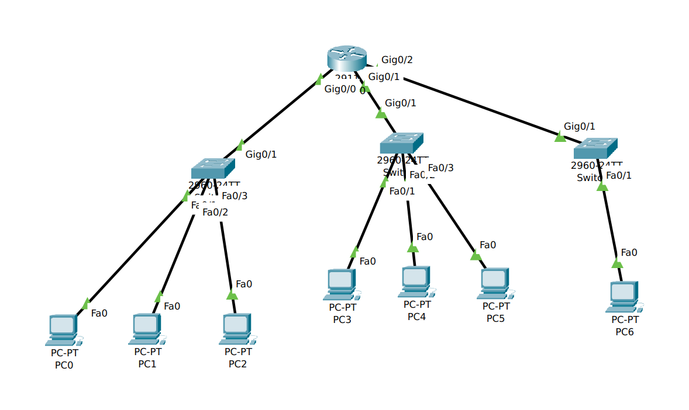

**TASK #02:**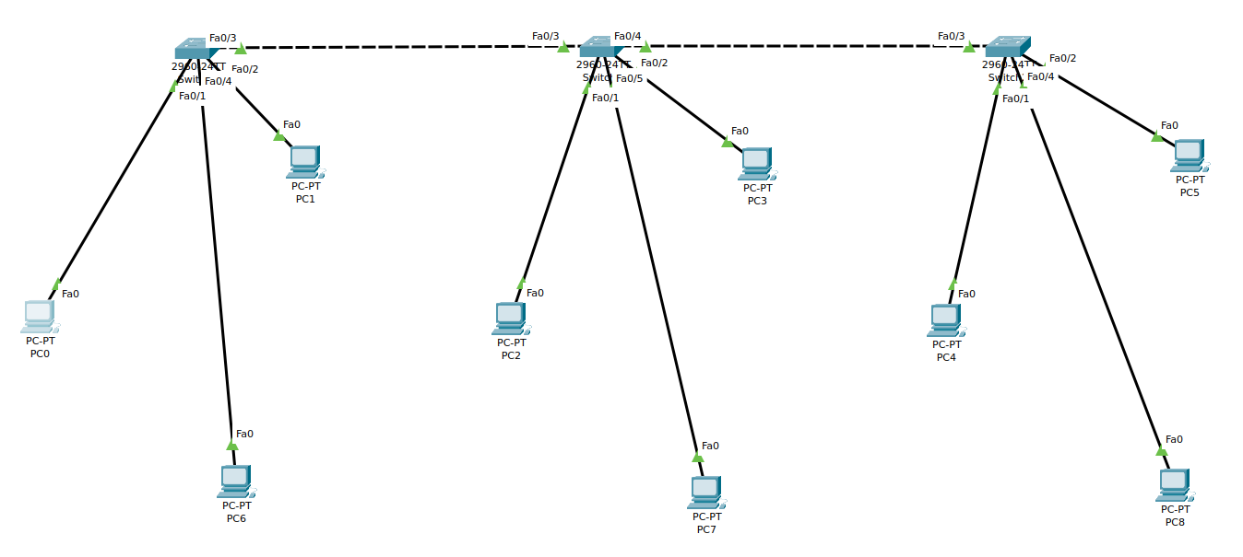

### 

### 

### 

### 

### **Working Procedure:**

**TASK #01:**

* For task 1, we need to divide the network among multiple devices so that the hosts can be connected with the most efficiency in the networks. For ID 74, we have a total of 74 host devices which need to be connected, and we also need to include another network with the capacity of the same number of host devices.
* We first find the number of bits we need to assign to the network if we want 74 devices as hosts. For that, we assign 128 devices as that is the 7th power of 2. Which will make the binary representation look something like 10000000, and we will only have 1 bit for the network, which makes the network 192.168.79.1/25 for the first interface.
* Now, we just need to assign the IP and the Subnet Mask to the router and then set up the IP and the default gateways for the devices in separate networks.

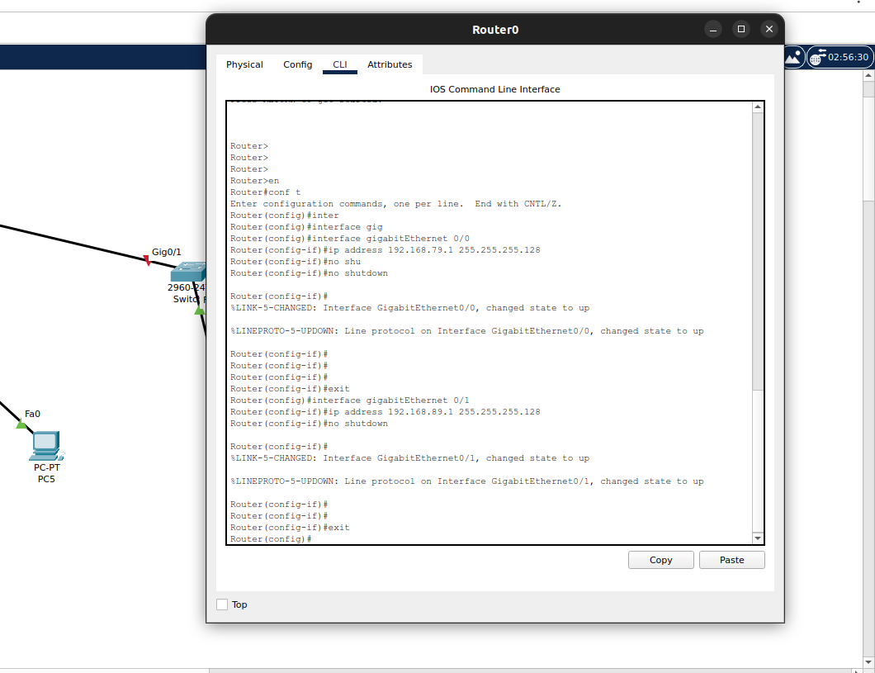

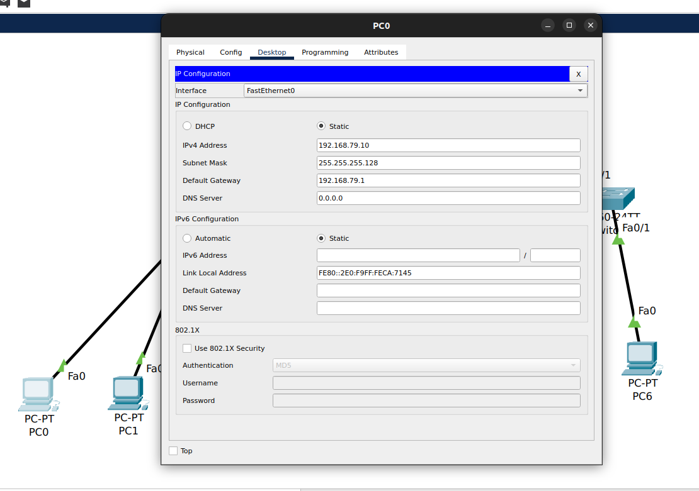

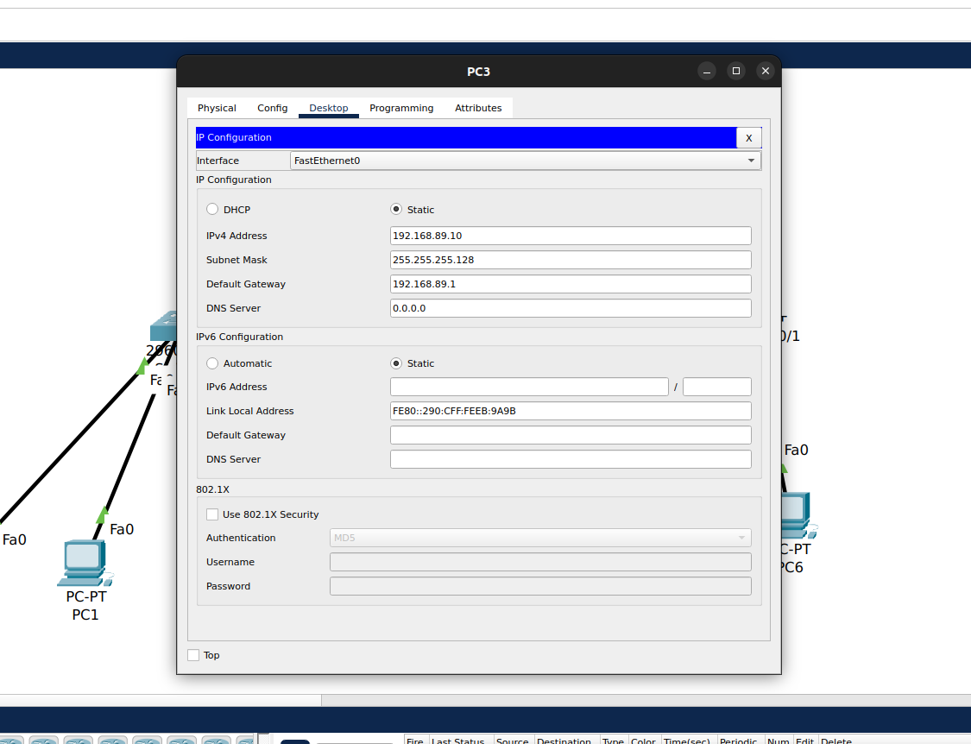

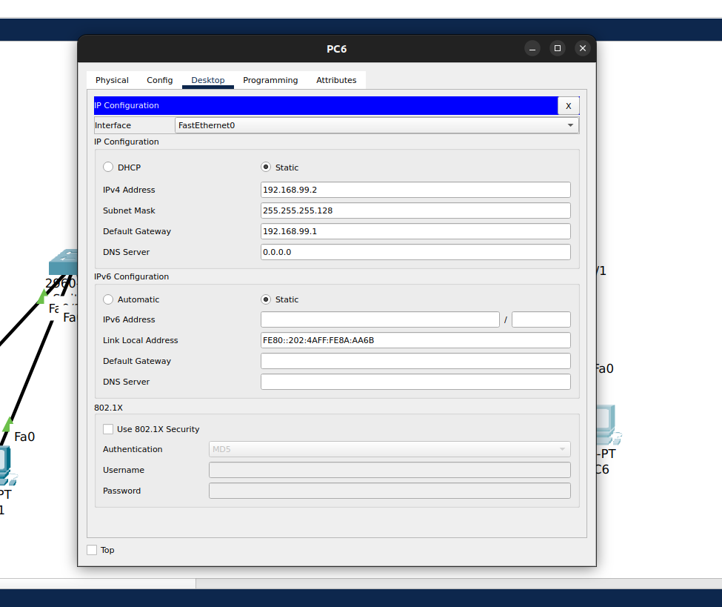

**TASK #02:**

* In task 2, we first need to create the VLANS with the specified VLAN ID, which is 10, 20, 30 for the Students, Teachers and Admin respectively. We create them with appropriate names.
* After that, we configure which interface belongs to which VLAN. We use the switch port access mode to access specific VLAN for the specific Switch.
* Once all the switches are done, we also need to set up the trunk ports for the switches to be able to communicate with each other. And we set the trunk for all the VLANs.
* Now we just need to set the IP address and subnet masks for the devices which will then communicate with only the specified VLAN device.

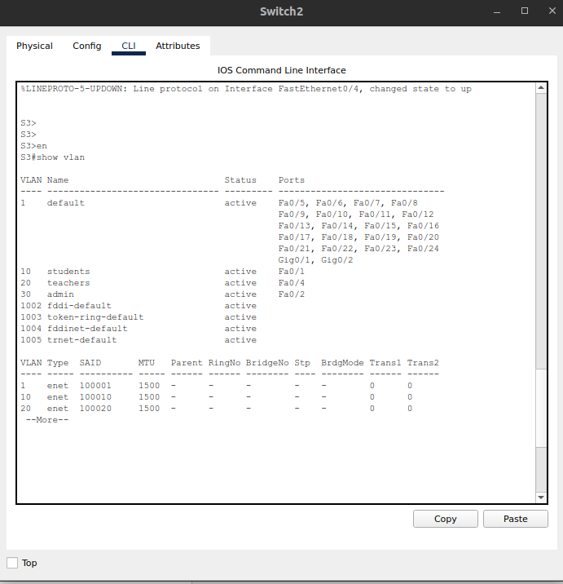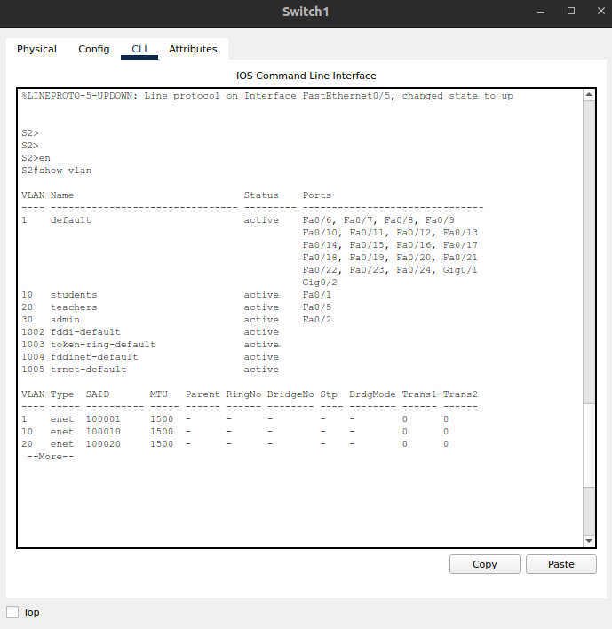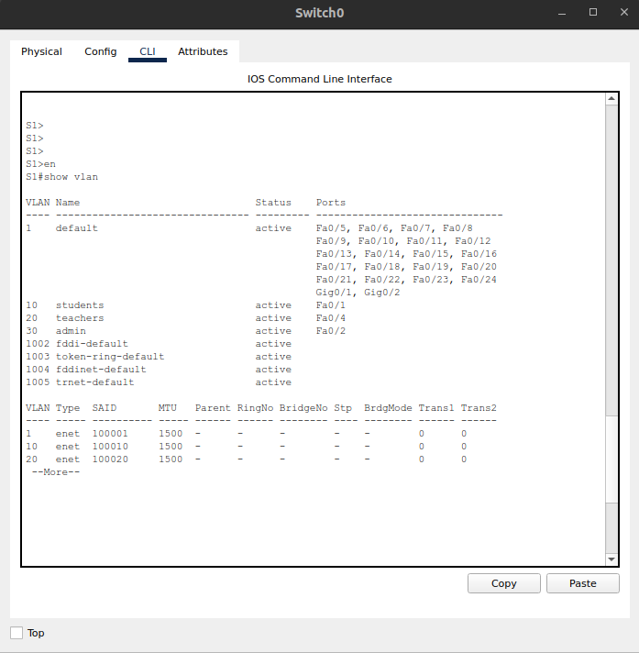

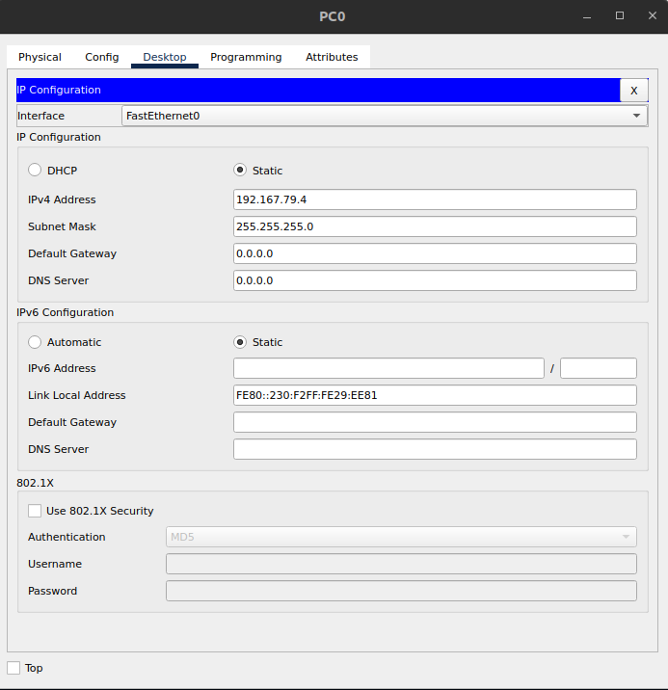

### **Questions (Answer to the point)**:

* + - 1. How many host bits are needed in the largest required subnet?

**Ans:** We need to evaluate the number of host devices and then according to the power of 2, we can determine the number of host bits needed for hosts. If we have a total of 74 hosts, we will need at least 2^7, which is 128 host devices. And we will have 7 host bits.

* + - 1. How many VLANs need to be configured to each of the switches?

**Ans:** For each switch, according to task 2, we need to set up at least 3 VLANs. We can figure this out by determining the group of devices we have in a scenario, here we have Students, Teachers and Admin.

* + - 1. Which interfaces need Access Link?

**Ans:** Access links are needed to connect end devices with the interfaces isolated within the VLANs. This ensures that the end devices with the same access link of VLANs can only communicate with each other.

* + - 1. Which interfaces need Trunk Link?

**Ans:** Interfaces that are connecting multiple switches need the Trunk Link, so that we can communicate with multiple VLANs across multiple networks. Here, the 3 switches are connected through the Trunk Links for the interfaces.

* + - 1. After configuring VLAN, what will happen if we broadcast?

**Ans:** Even if we broadcast some data, the data will only reach the devices with the same VLAN as the source device, and all other devices will ignore the data.

### **Challenges (if any):**

### **While setting up the VLANs, I could not figure out which interfaces needed the Trunk Links.**