# **Department of Computer Science and Engineering Islamic University of Technology (IUT)** A subsidiary organ of OIC

# **Lab Report 04**

# CSE 4412: Data Communication and Networking Lab

## **Name: Hasin Mahtab Alvee Student ID: 210042174 Section: SWE – B (Even) Semester: 4th (Summer) Academic Year: 2023-2024**

**Date of Submission: February 19th**

### **Title:** Understanding the basics of Inter-VLAN communication using Router, L3 Switch along with basics of Static Routing

### **Objectives**:

1. Understand and Implement Inter-VLAN using Router-on-a-stick
2. Understand and Implement Inter-VLAN using Multilayer Switches
3. Understand and Implement the Demo Static routing using ID

### **Diagram of the experiment:**

**TASK 1:**

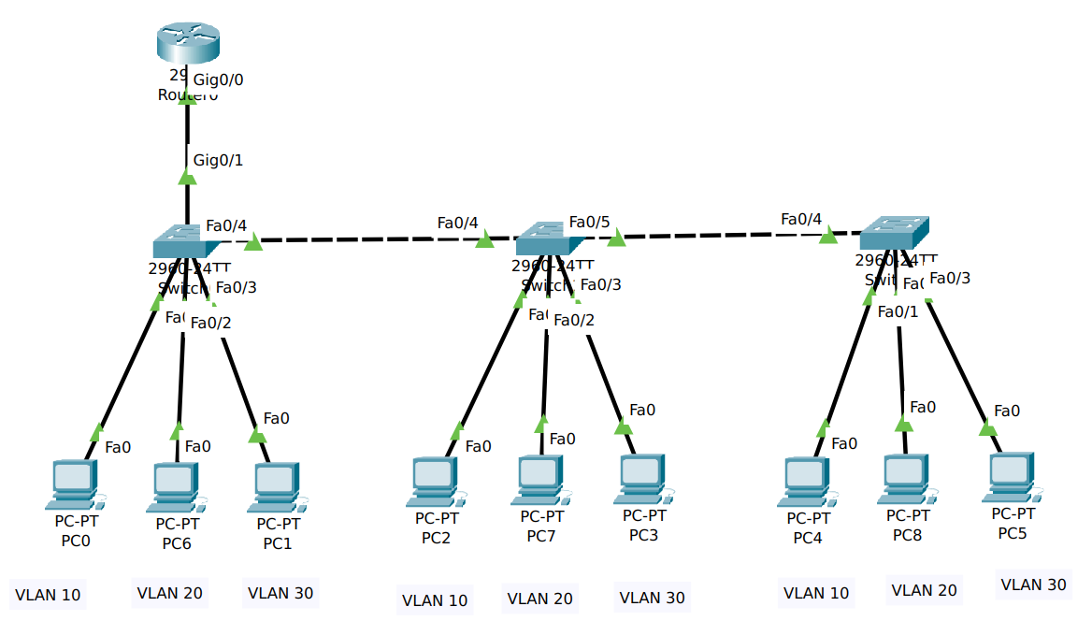

**TASK 2:**

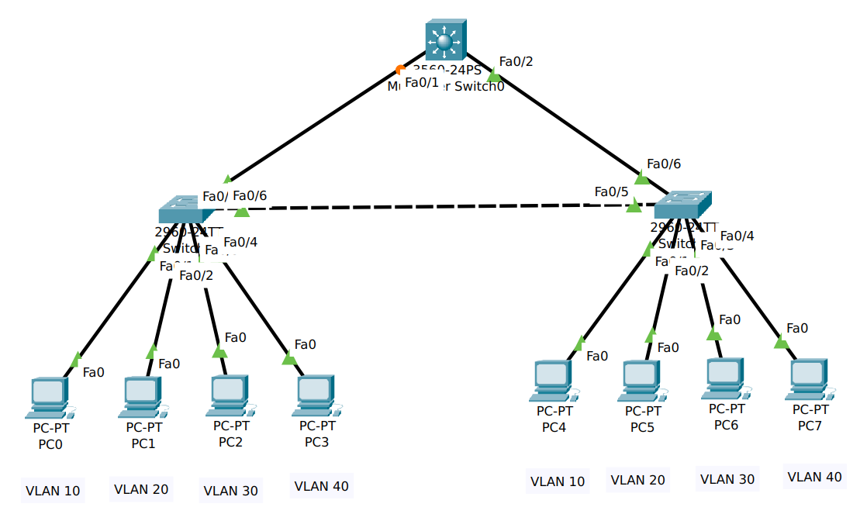

**TASK 3:**

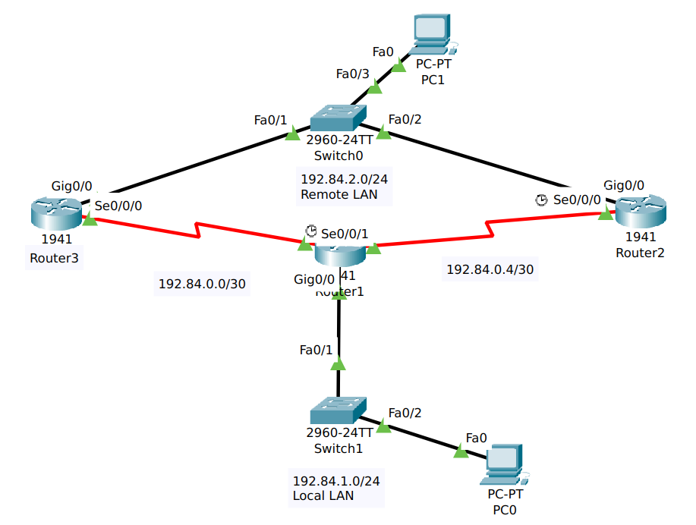

### **Working Procedure:**

**TASK 1:**

* After creating the topology accordingly, we need to create the VLANs – 10, 20, 30 and then configure them to each interfaces in access port mode.

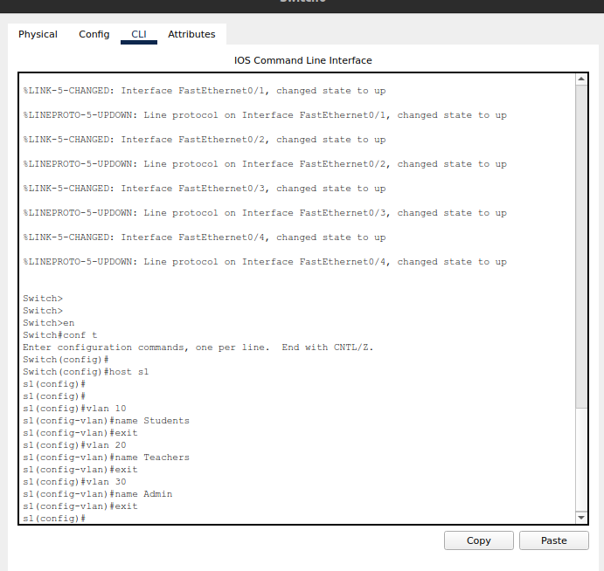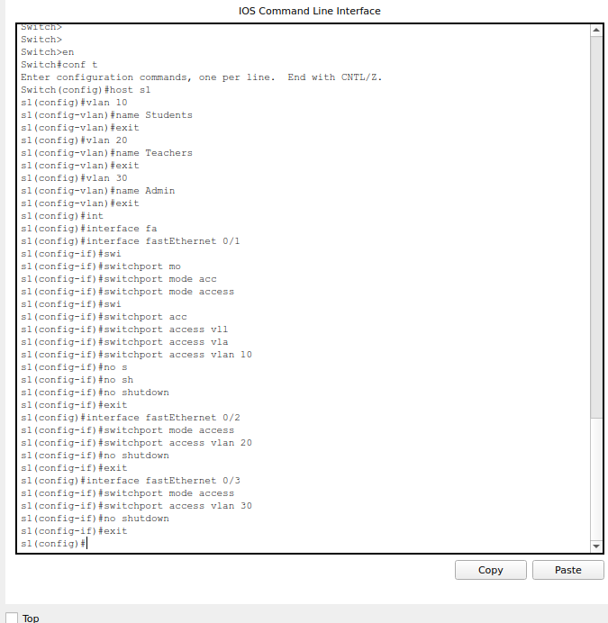

* Then we need to set the IP addresses, Masks and default gateways for the PCs according to the specific VLANs.
* Now we connect a Router-on-a-stick to the first switch and configure it.

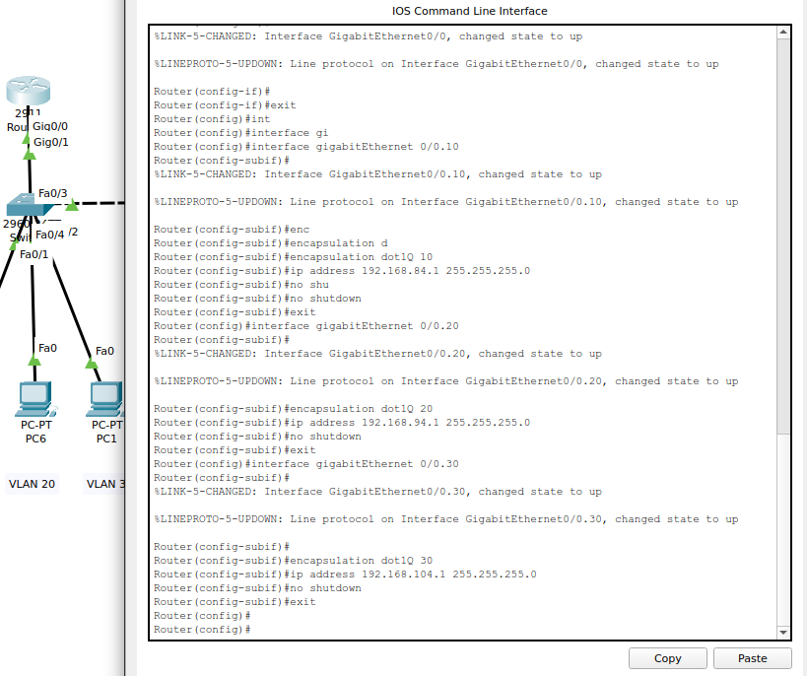

* Finally we need to set the Trunk for the switch and the router.

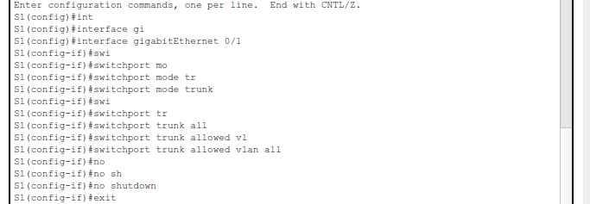

**TASK 2:**

* We create a topology using the Multilayer Switch, with 2 switches and 4 PCs.
* Then we configure the VLANs 10, 20, 30 and 40 accordingly.

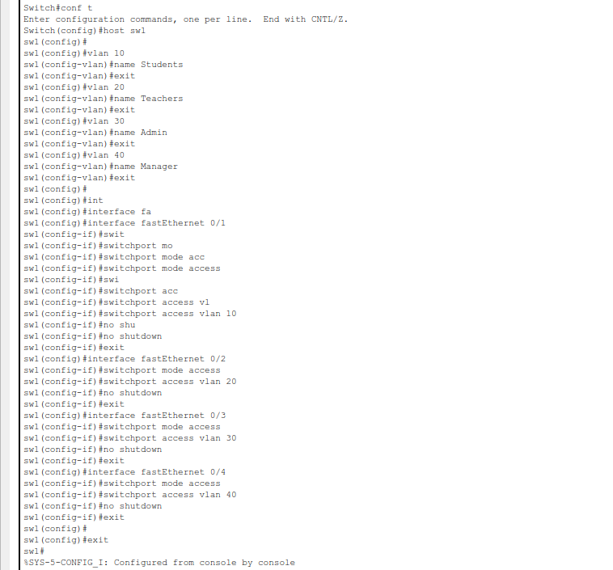

* We set the Trunk for both the switches.

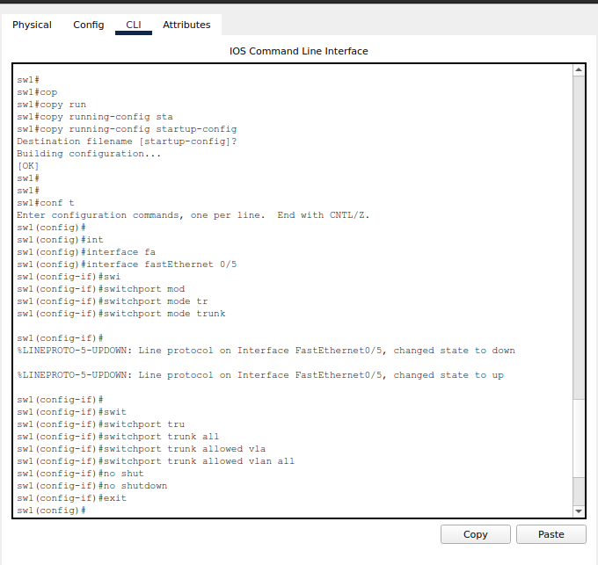

* Then we configure the IP addresses, Masks and default gateways for the devices according to my ID.
* Now we configure the trunk ports from the switches to the Multilayer switch.

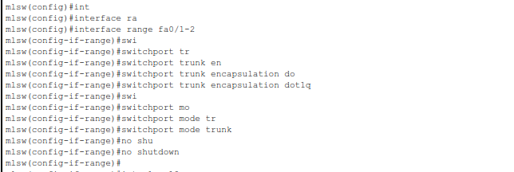

* We need to define and set the IP routing for the VLANs in the Multilayer switch and allocate IP addresses to them.

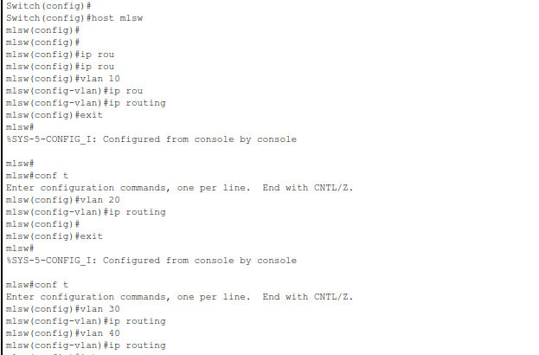

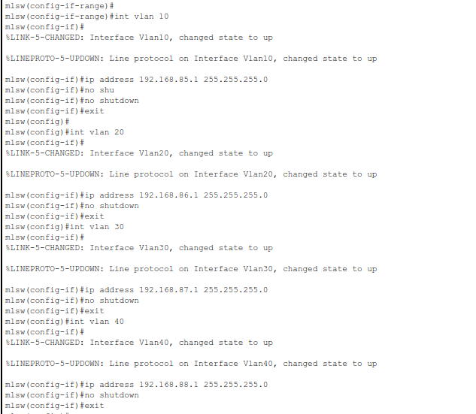

**TASK 3:**

* First we need to set up the topology, using routers and switches. We need to add a HWIC – 2T in the routers, for them to have access to serial ports, to connect DCE interfaces.

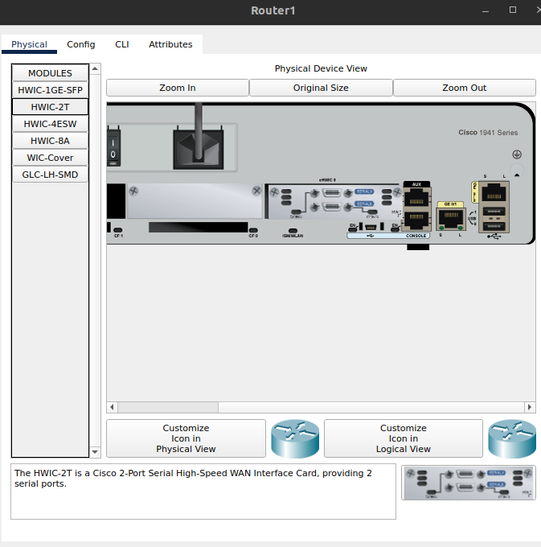

* Now we configure the first router with the serial port to connect to other 2 routers and the switch for the local LAN.

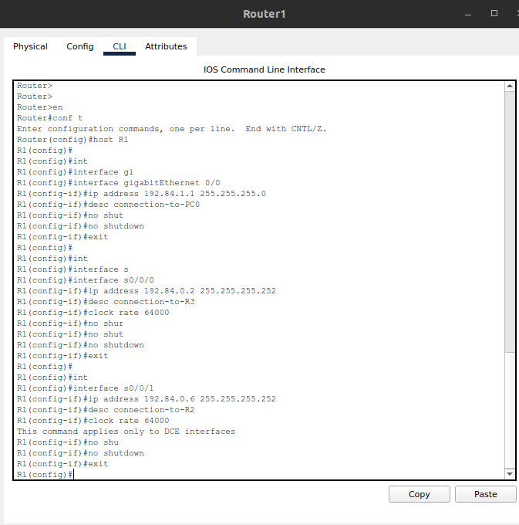

* Similarly, we can configure the other 2 routers with their serial ports to connect to the other routers and switches.

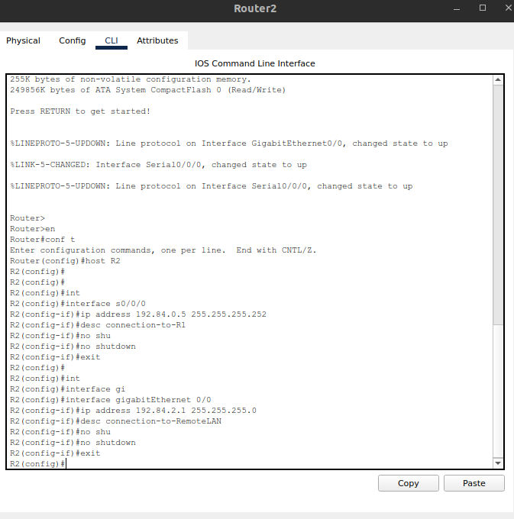

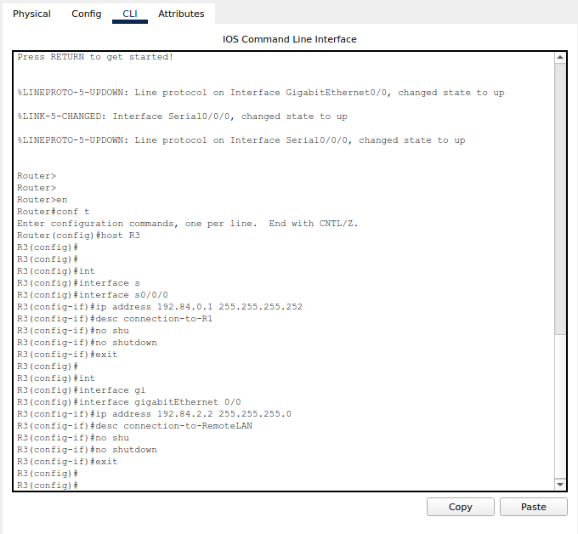

* Then we set up the PC0 and PC1 according to the IP and Mask.

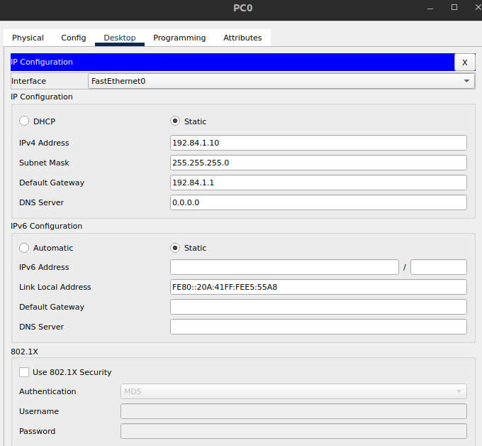

* Finally, we set up the IP, Masks and HOP routes for the 3 routers.

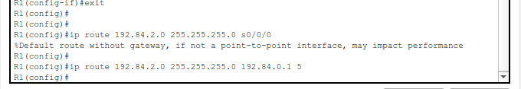

### **Questions (Answer to the point)**:

* + - 1. Why do we need L3 Switches?

**Ans:** A layer 3 switch can perform the functionality of both a switch and a routing, which makes it efficient to handle large amount of network traffic.

* + - 1. What is the use router in Inter-Vlan Routing?

**Ans:** The routers direct the network traffic from one VLAN to other VLANs.

* + - 1. What changes are needed while configuring VLANs using L3 switches instead of Router-on-a-stick approach?

**Ans:** For L3 switches we assign IP addresses directly to VLAN interfaces instead of using sub-interfaces.

* + - 1. What is next-hop floating address?

**Ans:** The next-hop floating address is a backup route that is used to get to the specified destination if the main route fails.

* + - 1. What is the disadvantage of static routing?

**Ans:** If any device is changed in a topology, we need to manually configure the network interfaces, which is not necessary in dynamic routing.

### **Challenges (if any):**

### **In the second task, I forgot to set up the Trunk connections between the switches.**

### **In the third task, I had trouble figuring out which serial port should route to which one.**