# 

# **Department of Computer Science and Engineering Islamic University of Technology (IUT)** A subsidiary organ of OIC

# **Laboratory Report**

# CSE 4512: Computer Networks Lab

## 

## **Name: Hasin Mahtab Alvee Student ID: 210042174 Section: SWE – Even (B) Semester: 4th Academic Year: 2023-24**

**Date of Submission: April 7th, 2024**

### **Title:** Configuring ACL and NAT in Cisco Devices

### **Objective**:

1. Configure and understand ACL
2. Configure and understand NAT

### 

### **Devices/ software Used**:

* + - 1. Cisco Packet Tracer

### **Diagram of the experiment(s):**

**TASK 01**

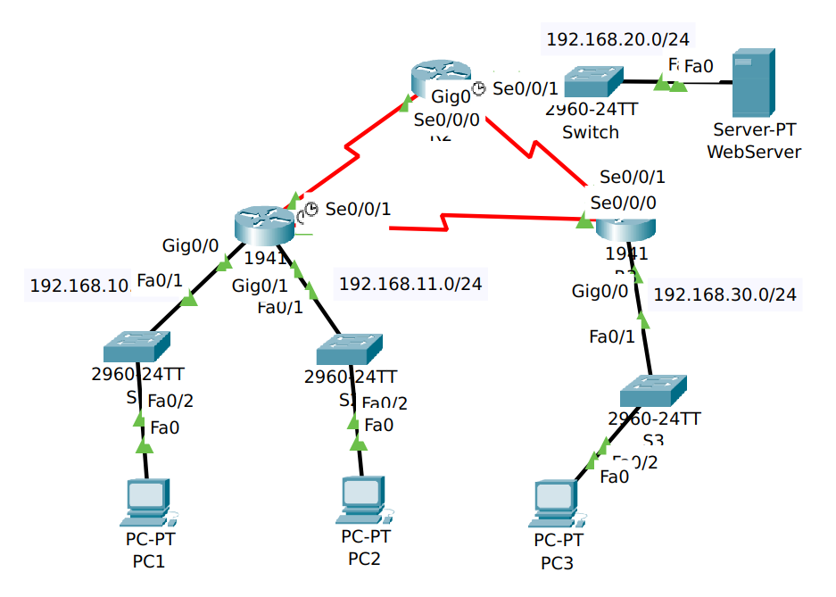

**TASK 02**

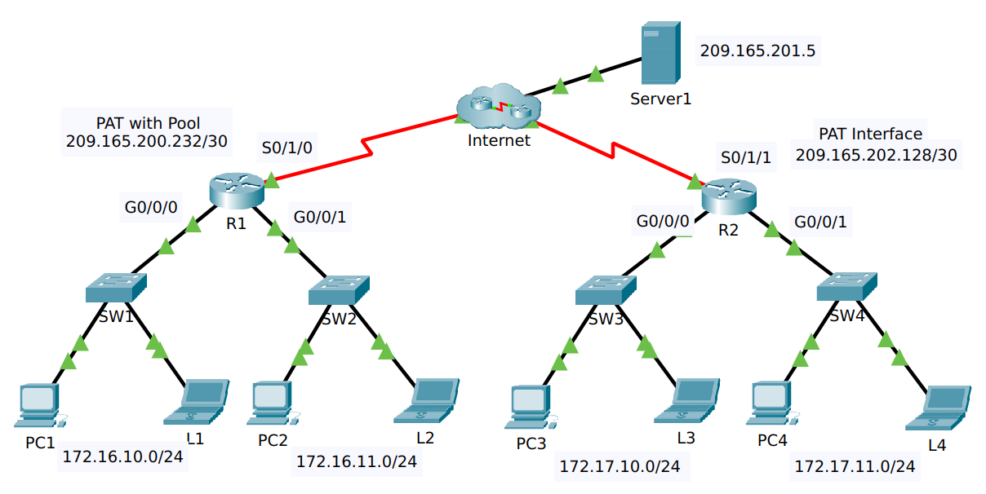

### **Working Procedure:**

**TASK 01**

* At first, I created a ACL for the access list 1 on Router 2, where I denied access permission to network 192.168.11.0. By default, if I deny permission to a network, ACL denies to all networks, so I need to permit all other networks using “permit any” on access list 1.
* Next, I need to set the access list to a specific interface, which I did the network of PC 1.
* I did the same for the next router, and configured ACL.

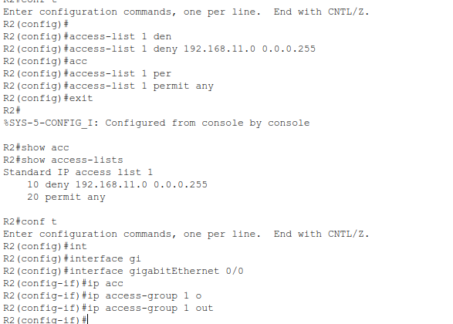

### 

* Later, I performed some tests to verify the connection and found the the number of packets that matched with each line of access list.

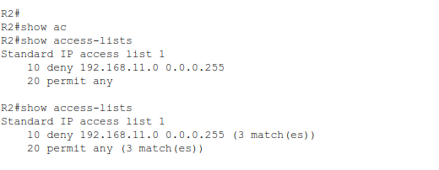

**TASK 02**

* On Router 1, we configured ACL on 172.16.0.0 to permit any connections.
* Then we used NAT pool to add two networks to the pool, which are 209.165.200.233 and 209.165.200.234, with the netmask of 255.255.255.252.
* Then I configured the NAT with the interfaces.

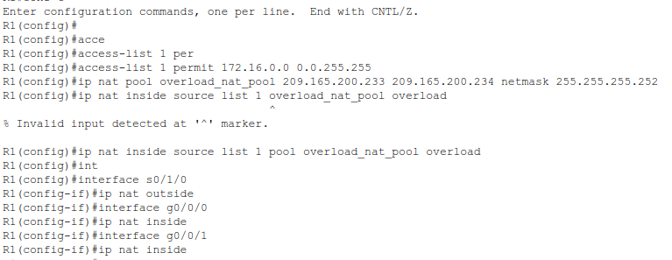

### Then I check the NAT translations on Router 1.

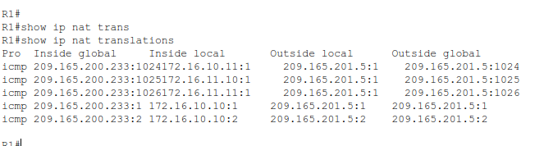

### For router 2, we need to configure a PAT connection. We use ACL on access list 2 for the PAT.

* Then I checked the PAT translations.

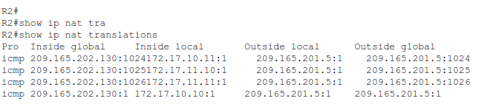

### **Questions**:

**Task # 01:**

The ping from 192.168.10.10 to 192.168.11.10 is successful or not? Explain.

**Ans:** It was successful as we did not deny ACL between these networks.

The ping from 192.168.10.10 to 192.168.20.254 is successful or not? Explain.

**Ans:** It was successful as we did not deny ACL between these networks.

The ping from 192.168.11.10 to 192.168.20.254 failed or not? Explain.

**Ans:** It was not successful. AS we denied ACL between these networks.

**Task # 02:**

1. From the web browser of each of the PCs that use R1 as their gateway (PC1, L1, PC2, and L2), access the web page for Server1.

**Question:**

Were all connections successful?

**Ans:** Yes all the connections were successful.

1. From the web browser of each of the PCs that use R2 as their gateway (PC3, L3, PC4, and L4), access the web page for Server1.

**Question:**

Were all connections successful?

**Ans:** Yes all the connections were successful.

1. Compare the NAT statistics on the two devices.

**Question:**

Why doesn’t R2 list any dynamic mappings?

**Ans:** In R1, there are multiple NAT translations; in R2, there is just one. Because PAT only generates one-to-many translations utilising a single public IP address and various source port numbers, R2 doesn't display any dynamic mappings when using PAT.

### **Observation**:

* The task defines how we can use ACL to allow and deny connections over the internet. We can also implement NAT and PAT to have control over our internal and external connections with hosts and servers.

### **Challenges (if any):**

* I could not add the extra PC in the task 1 according to my Student ID.