🌸 Color Report — Pink Cottagecore Theme

1. Research Questions

1.1 What are “warm” and “cool” colors? What feelings do they evoke?
Warm colors, reds, oranges, yellows, tend to feel energetic, cozy, and inviting. Cool colors, blues, greens, purples, tend to feel calm, peaceful, and soothing. Cottagecore palettes often blend warm neutrals with soft pastels to create comfort and nostalgia, which aligns with the emotional effects described in cottagecore color guides.

1.2 How does a color’s effect change depending on nearby colors? (Simultaneous Contrast)
Color appearance shifts depending on surrounding hues. A color can look brighter, softer, warmer, or cooler depending on what it sits next to. Cottagecore palettes often use this intentionally—pairing soft pinks with warm neutrals or greens to enhance the gentle, sun-washed feeling. This aligns with how cottagecore palettes borrow from natural materials like linen, herbs, and aged paper, which naturally create contrast.

1.3 What are some cultural differences in color meaning?
Color meanings vary across cultures:
- Pink is often associated with softness and romance in Western contexts, but cottagecore uses it as a symbol of nostalgia and handmade warmth.
- Pastel tones in cottagecore are described as “whispering” colors that evoke calmness and romantic retreat, showing how cultural aesthetics shape meaning.

2. Research Sources
- Modern Cottagecore Tones: 20 Palettes + Hex Codes — Media.io
- Essential Cottagecore Color Schemes for a Cozy Home — ABI Interiors Blog
- The Ultimate Guide to Cottagecore Colors — Melanie Jade Design
- Cottagecore Color Palettes: The Ultimate Guide — Guildford Glen

🌷 3. Image Examples + Mood + Color Palettes
Below are three pink cottagecore images that match your website’s personality: soft, cozy, feminine, and aesthetic.

🌸 Image 1 — “Blush Cottage Tea Table”
- 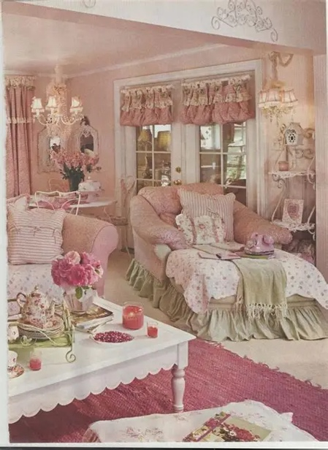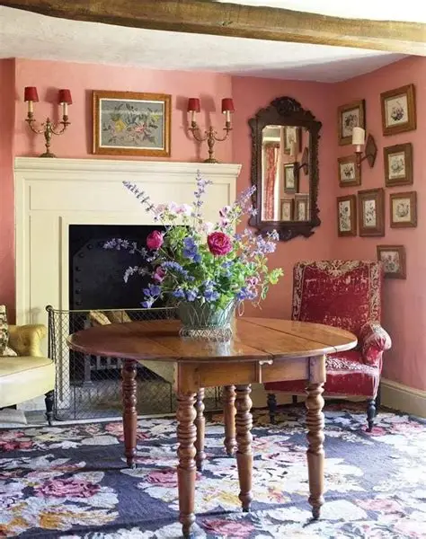

- 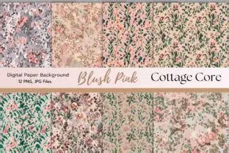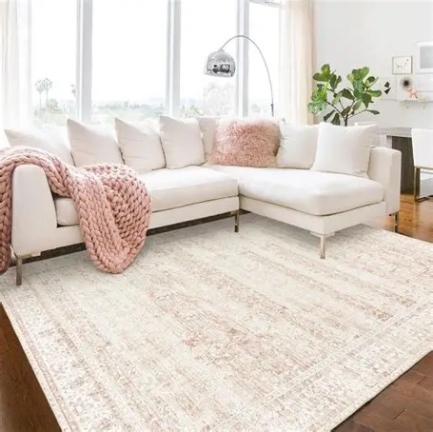

Mood / Personality: Warm, gentle, cozy. Feels like a quiet morning in a pink cottage, tea, lace, flowers, and soft sunlight.
Color Palette (Hex Values):
- #FCE8EF — pale blush
- #F7C7D9 — soft rose
- #E8A6BE — warm pink
- #C97A96 — muted mauve
- #A45F73 — vintage berry

🌿 Image 2 — “Cottage Window Light”
- 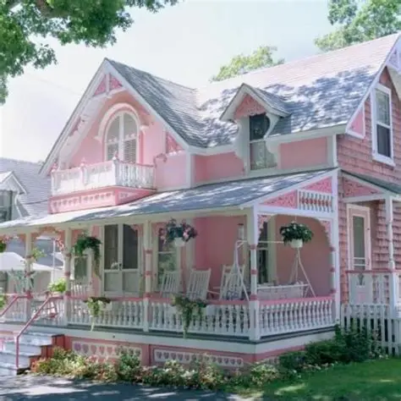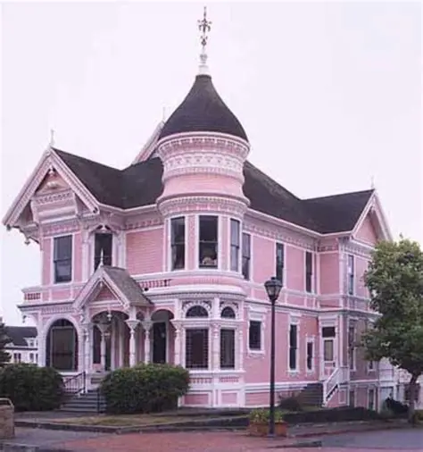
- 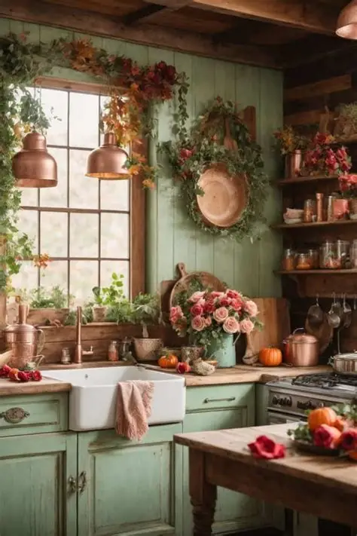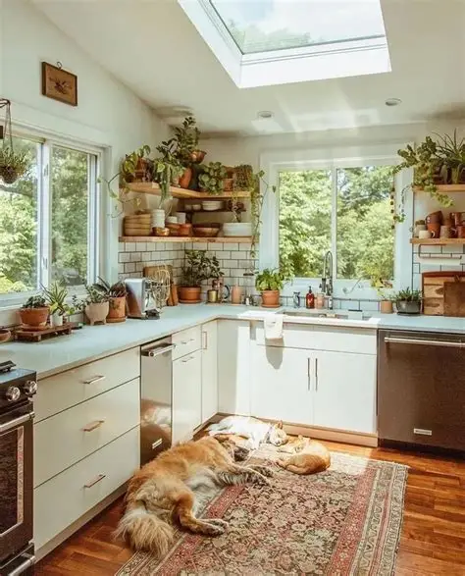

Mood / Personality: Airy, peaceful, dreamy. Soft pink light mixed with natural textures creates a romantic, calm cottage atmosphere.
Color Palette (Hex Values):
- #FFF1F6 — airy pink
- #FFD6E5 — pastel rose
- #F4AFC6 — bright cottage pink
- #D98AA7 — warm mauve
- #A96C82 — soft plum

🍓 Image 3 — “Floral Cottage Picnic”
- 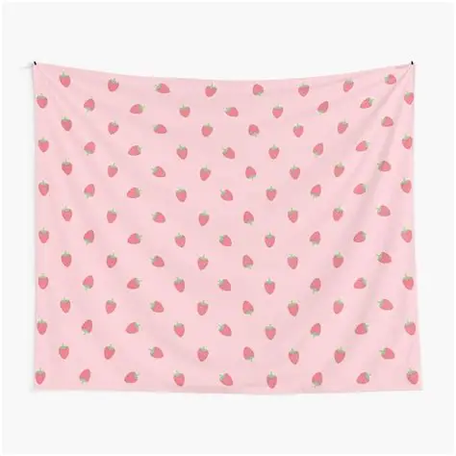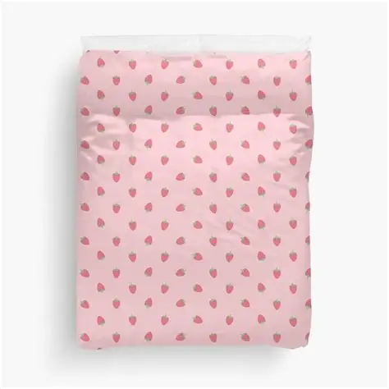

- 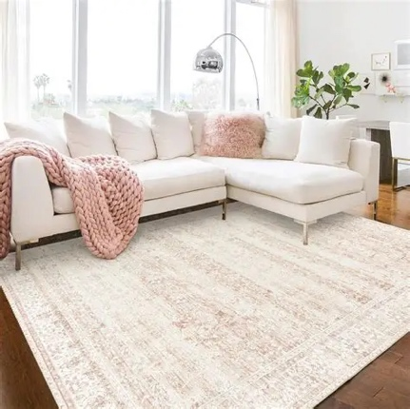

Mood / Personality: Cute, feminine, playful. Feels like a sweet picnic with flowers, berries, and soft fabrics, perfect for a friendly, aesthetic portfolio.
Color Palette (Hex Values):
- #FFE9F2 — cotton-candy blush
- #FFC4DA — sweet pink
- #F49EBE — rosy mid-tone
- #D67A9A — warm berry
- #A85C78 — vintage rosewood

🌼 4. Summary
This report explains how color temperature, contrast, and cultural meaning shape emotional tone in design. The selected images and palettes reflect a pink cottagecore aesthetic, soft, cozy, feminine, and welcoming, perfect for your personal website.

