Getting Started with Core Java

Objectives

Java Architecture
Core Execution flow
Platform Independence & JVM
1.Learn
Java Architecture is a multi-tiered framework designed around the philosophy of "Write Once, Run Anywhere" (WORA). It achieves this by integrating a two-step process of compilation and interpretation, ensuring that Java code runs seamlessly on any hardware platform without modification.
Core Execution Flow
The Java execution lifecycle converts human-readable code into machine-executable instructions:
- Source Code: A developer writes code saved as a .java file.
- Compilation: The Java Compiler (javac) translates the source code into intermediate, platform-independent Bytecode saved as a .class file.
- Interpretation & Execution: The Java Virtual Machine (JVM) interprets and converts this bytecode into native machine code for the specific underlying host operating system.

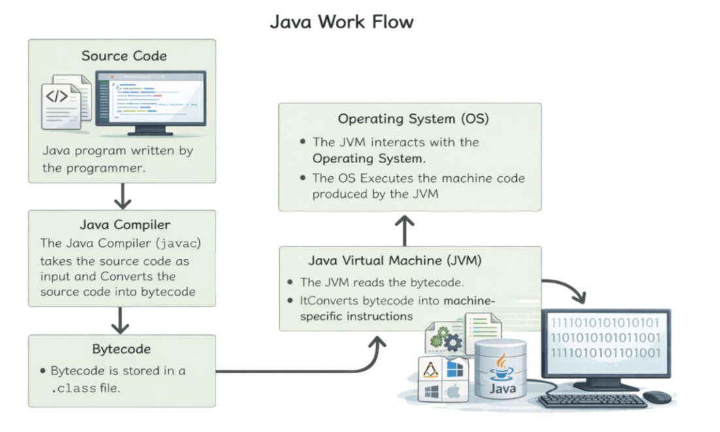
The Three Main Structural Components
Java's ecosystem is divided into three nested layers:
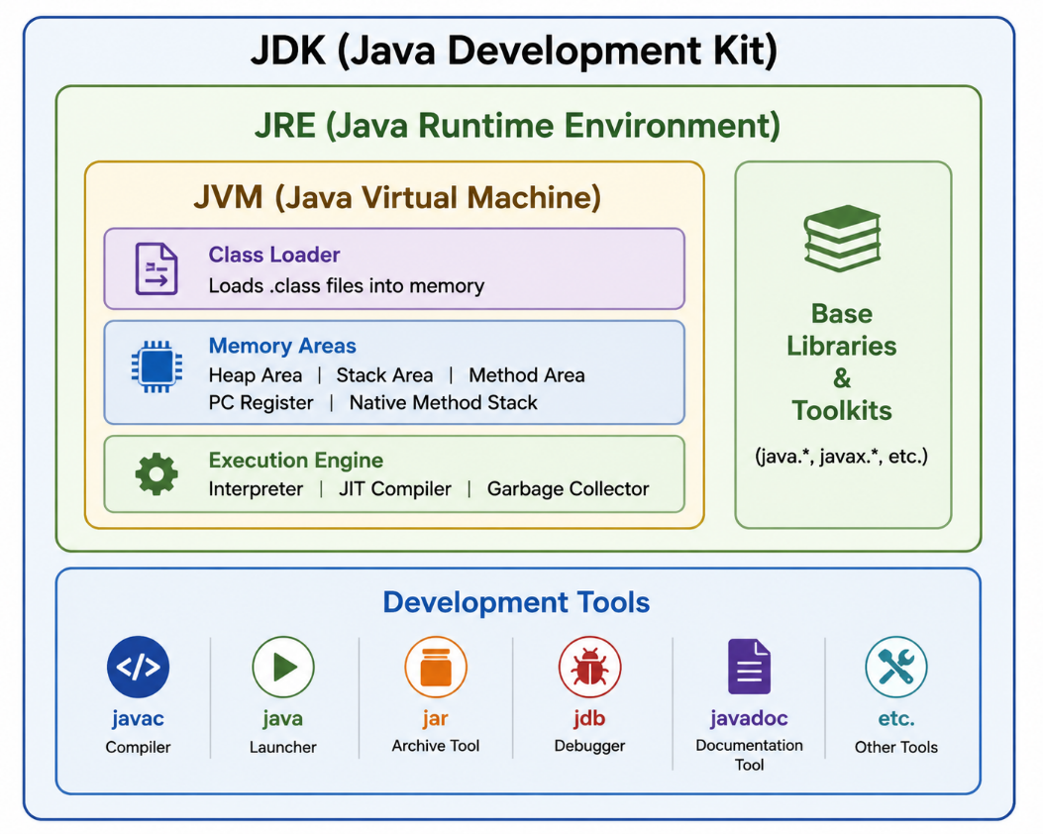
JVM (Java Virtual Machine): The core engine that loads, verifies, and executes bytecode. It serves as the abstract computer layer sitting directly on the operating system.
- JRE (Java Runtime Environment): The physical installation package that provides the environmental infrastructure required to run a Java application. It wraps the JVM along with core platform libraries (e.g., math, utilities, collections) and user interface toolkits.
- JDK (Java Development Kit): The full-featured software development environment. It encompasses the entire JRE plus development-specific utilities like the compiler (javac), debugger (jdb), and documentation generator (javadoc).

Internal JVM Architecture
The outline three primary subsystems responsible for running a compiled application:

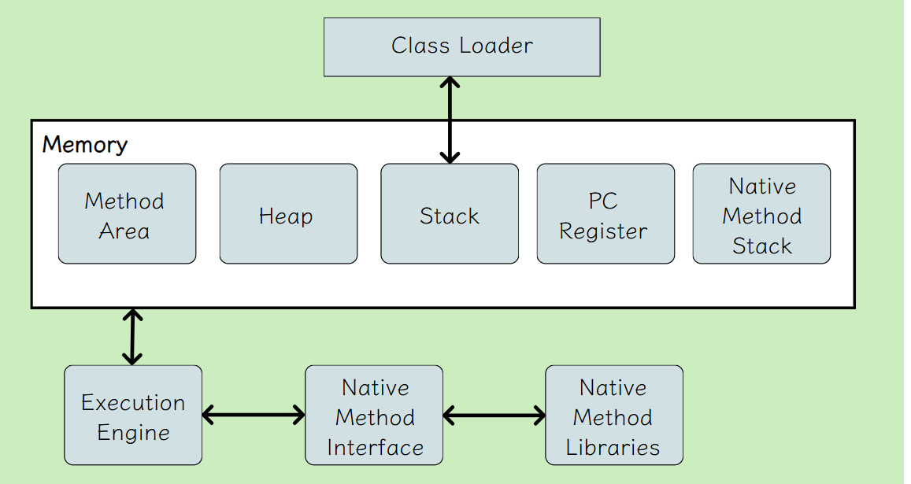
1. Class Loader Subsystem
This subsystem handles dynamic class loading, linking, and initialization.
- Loading: Locates the .class files and imports the binary data into the memory area.
- Linking: Verifies bytecode structure safety, allocates memory for static fields, and resolves symbolic references into direct memory targets.
- Initialization: Executes static initializers and assigns final initial values to static variables.
2. Runtime Data Areas (JVM Memory)
The allocated system memory is broken down into five distinct regions:
- Method Area: A shared pool storing class-level structures, metadata, field data, and method bytecodes.
- Heap Area: A shared memory space where all actual objects and instances are dynamically allocated and stored.
- Stack Area: A thread-private memory zone that allocates a "frame" for every active method call to handle local variables and intermediate results.
- PC Registers: Separate thread counters tracking the direct address of the current instruction being executed.
- Native Method Stack: Dedicated blocks holding instructions for underlying platform-native code (such as C/C++ utilities).
3. Execution Engine
The layer that processes bytecode instructions line-by-line using three primary routines:
- Interpreter: Reads bytecode and translates it into machine code directly.
- JIT (Just-In-Time) Compiler: Identifies frequently executed "hot" segments of code and compiles them into optimization-heavy native machine instructions to drastically boost runtime speed.
- Garbage Collector: Automatically tracks memory footprints and reclaims the allocation pools of unreferenced or dead objects to prevent leaks.

Practice Questions

Practice Question 1: Java Execution Flow

Scenario
A developer writes a Java program named Employee.java.

Questions
- What command is used to compile the Java source file?
- What file is generated after compilation?
- Which component executes the generated bytecode?
- Explain the complete execution flow from source code to output.
- Draw the execution flow diagram.

Practice Question 2: JVM, JRE, and JDK

Scenario
A company wants to install Java on two systems:
- System A: Used only for running Java applications.
- System B: Used for developing and running Java applications.

Questions
- Which Java package should be installed on System A?
- Which Java package should be installed on System B?
- Differentiate between JVM, JRE, and JDK.
- List any four tools available in JDK.
- Explain the relationship among JVM, JRE, and JDK using a diagram.

Practice Question 3: Internal JVM Architecture

Scenario
A Java application creates thousands of objects and executes several methods simultaneously.

Questions
- In which memory area are objects stored?
- Which memory area stores local variables and method calls?
- What is the role of the Class Loader Subsystem?
- How does the JIT Compiler improve performance?
- What is the function of the Garbage Collector?

Frequently Asked Questions (FAQs)

1. What is Java Architecture?
Java Architecture is a framework that enables Java programs to run on multiple platforms using Bytecode, JVM, JRE, and JDK.

2. What is meant by "Write Once, Run Anywhere" (WORA)?
WORA means a Java program can be written once and executed on any operating system that has a compatible JVM.

3. What is Bytecode?
Bytecode is the platform-independent code generated by the Java compiler (javac) and stored in a .class file.

4. What is the difference between Source Code and Bytecode?
Source Code | Bytecode
Written by programmer | Generated by compiler
Stored in .java file | Stored in .class file
Human-readable | Machine-independent

5. What is JVM?
JVM (Java Virtual Machine) is the virtual environment responsible for loading, verifying, and executing Java bytecode.

6. What is JRE?
JRE (Java Runtime Environment) provides the libraries and JVM required to run Java applications.
Formula:
JRE = JVM + Java Libraries

7. What is JDK?
JDK (Java Development Kit) is a complete development package that contains JRE and development tools such as javac, jdb, and javadoc.
Formula:
JDK = JRE + Development Tools

8. What is Platform Independence in Java?
Platform Independence means Java programs can run on different operating systems without modifying the source code because JVMs are available for different platforms.

9. What is the role of the Class Loader?
The Class Loader is responsible for:
- Loading .class files into memory
- Linking classes
- Initializing static variables and blocks

10. What are the Runtime Data Areas in JVM?
The JVM memory is divided into:
- Method Area
- Heap Area
- Stack Area
- PC Register
- Native Method Stack

11. What is JIT Compiler?
JIT (Just-In-Time) Compiler is a component of the Execution Engine that converts frequently executed bytecode into optimized machine code to improve performance.

12. What is Garbage Collection?
Garbage Collection is the automatic process of identifying and removing unused objects from Heap Memory to free up system resources.

