
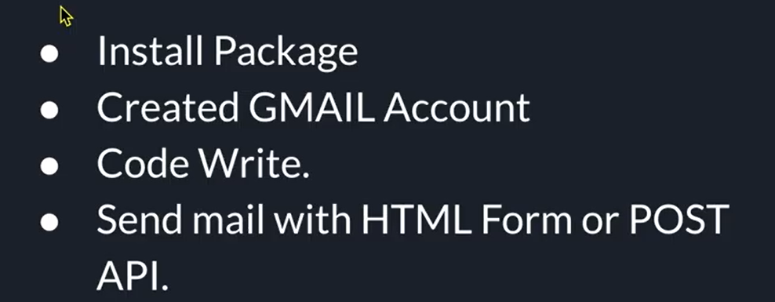
- Create a new Folder Email Sending
- Create sub folder backend
- In Backend folder run npm init -y
- Install nodemailer ,express,cors and body-parser
  - Npm I nodemailer,express,cors,body-parser
- Open Gmail Account
- Open MyAccount.google.com ---Open Secuirty tab
- Make sure 2 step verification is done
- After that on url type app.pass
- 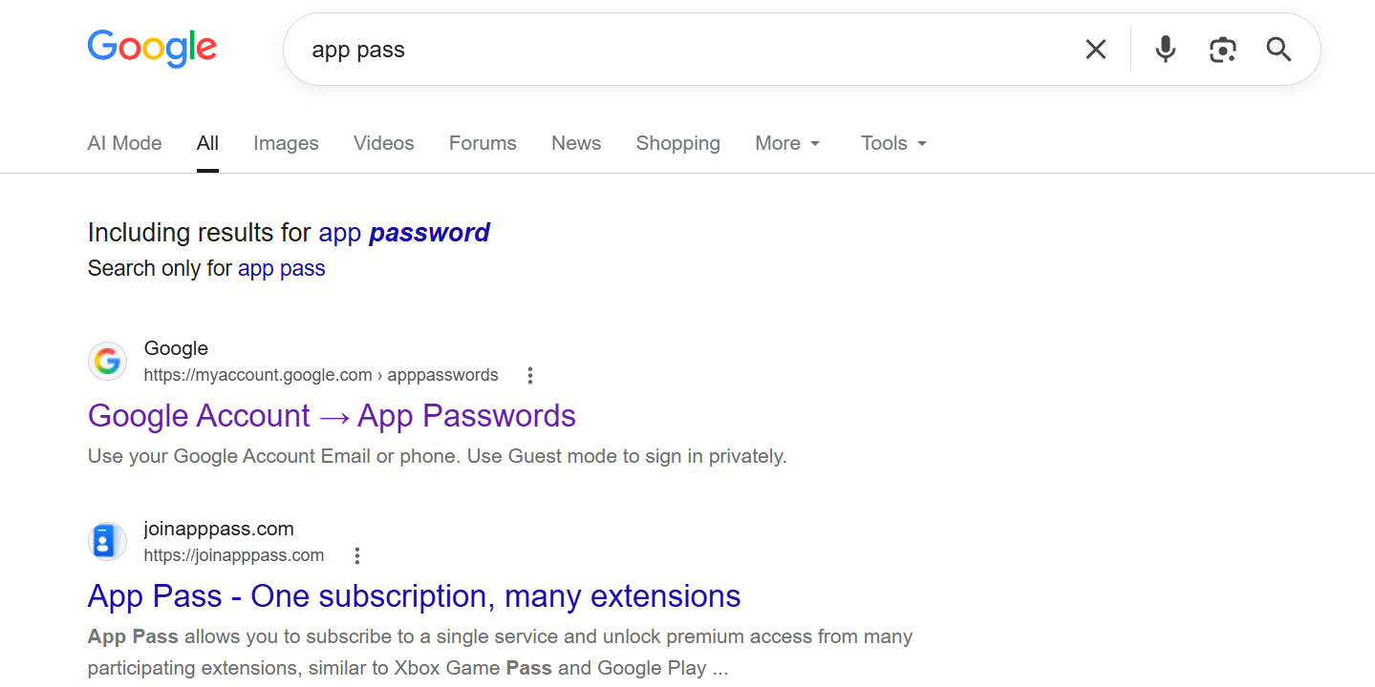
- Select Google Account App Password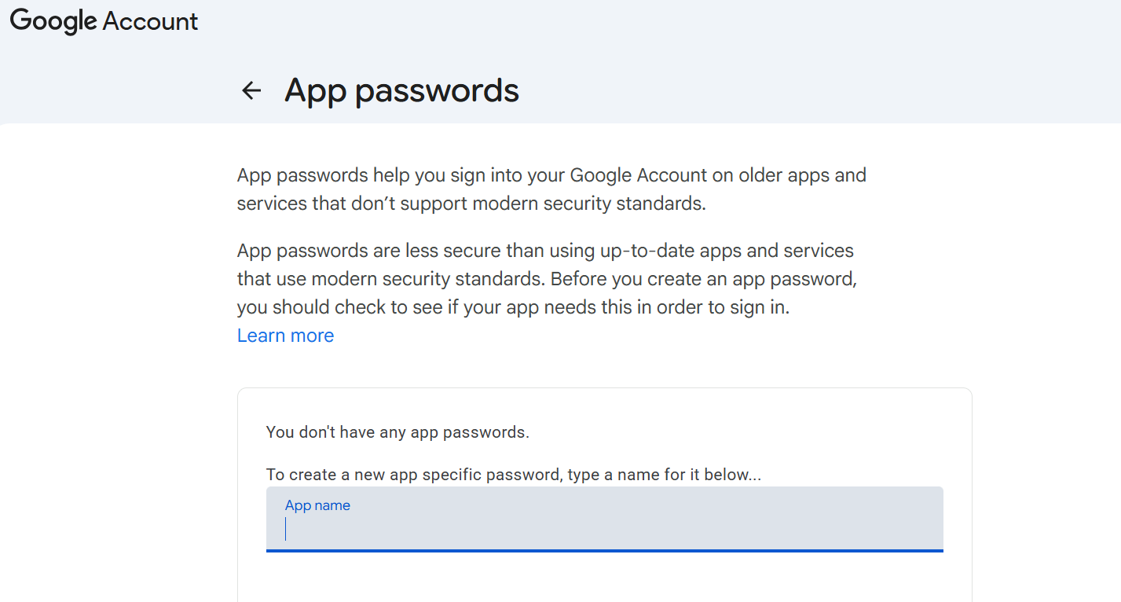Type App name to create app password suppose MailApp786
- 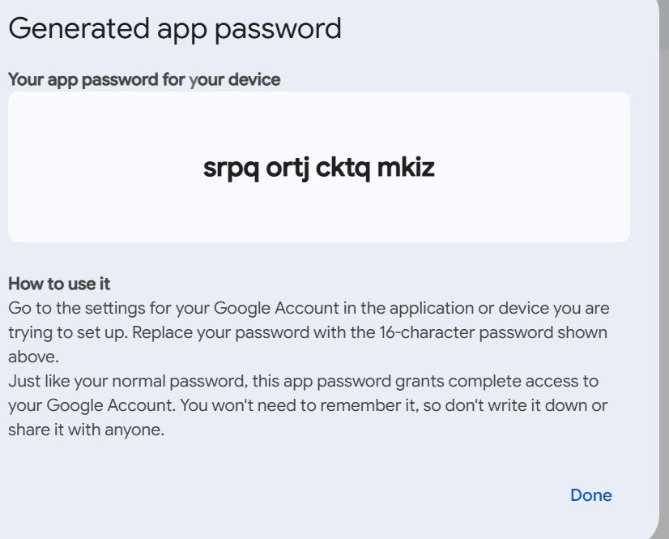
- You will 16 character app password for your device
- Create one text file and store this as app password
- srpq ortj cktq mkiz
- Use This Password for creating app
- 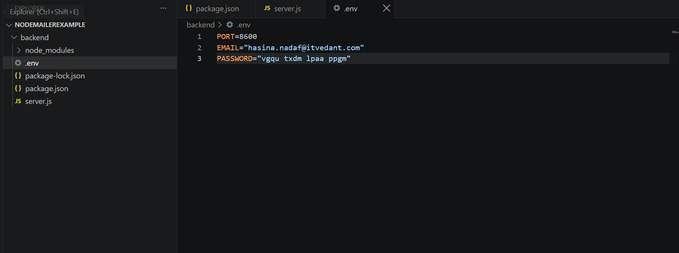
- Create .env file by taking 16 digit password created
- Then Create server.js File with Following Code
- require("dotenv").config();

- const express = require("express");
- const nodemailer = require("nodemailer");
- const cors = require("cors");

- const myserver = express();

- myserver.use(cors());
- myserver.use(express.json());
- myserver.use(express.urlencoded({ extended: true }));

- // Email Sending Route
- myserver.post("/send-email", async (req, res) => {

- const { name, email, message } = req.body;

- try {

- const transporter = nodemailer.createTransport({
- service: "gmail",
- host: "smtp.gmail.com",
- port: 587,
- secure: false,

- auth: {
- user: process.env.EMAIL,
- pass: process.env.PASSWORD
- },

- tls: {
- rejectUnauthorized: false
- }
- });

- // Email Options
- const mailOptions = {
- from: process.env.EMAIL,

- to: "hasina.nadaf2011@gmail.com",

- subject: `New Message from ${name}`,

- html: `
- <h3>New Message from Hasina Portfolio</h3>

- <p>
- <strong>Name:</strong> ${name}
- </p>

- <p>
- <strong>Email:</strong> ${email}
- </p>

- <p>
- <strong>Message:</strong> ${message}
- </p>
- `
- };

- // Send Email
- await transporter.sendMail(mailOptions);

- console.log("Email sent successfully");

- res.status(200).send({
- status: true,
- message: "Email Sent Successfully"
- });

- } catch (err) {

- console.log("Error Sending Email:", err);

- res.status(500).send({
- status: false,
- message: "Failed to send Email",
- error: err.message
- });
- }
- });

- const port = process.env.PORT || 8600;

- myserver.listen(port, () => {
- console.log("Server Started at port " + port);
- });

- myserver.get("/", (req, res) => {
- res.send("Hello World ...!");
- });

Install Nodemon and in start in package.json
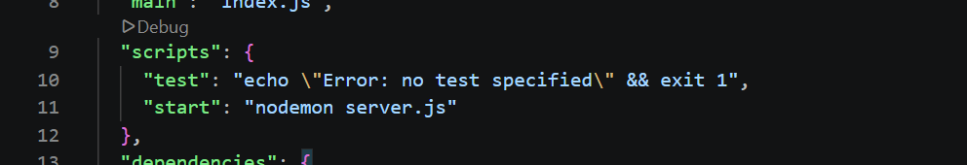

Test Woring on thunder Client as shown in image
