SE4050 – Deep Learning Lab Sheet 4
YOLO Object Detection – Analysis Report

7. Analysis of boxes.eval().shape
The shape of boxes.eval() is (1783, 4) because the YOLOv2 model initially produces 19 × 19 × 5 = 1805 candidate bounding boxes. There are 19 × 19 grid cells and 5 anchor boxes are predicted at each grid cell.
Each candidate box has four coordinates, which explains the second dimension of 4. The 80 class probabilities do not create additional bounding boxes; they provide class scores for each candidate box.
In the original experiment, 22 of the 1805 candidate boxes were removed by the score threshold. Therefore, 1805 − 22 = 1783 boxes remained.
The maximum possible number of boxes after this filtering step is 1805, while the minimum possible number is 0. These values are before the later non-maximum suppression and max_boxes limitation.

Parameter Experiment Results
Experiment | Parameter | Shape
Original | threshold = 0.5 | (1783, 4)
Lower threshold | threshold = 0.3 | (1790, 4)
Higher threshold | threshold = 0.7 | (1772, 4)
All boxes retained | constant scores | (1805, 4)
No boxes retained | constant scores | (0, 4)

8. Anchor Boxes
Anchor boxes are predefined bounding-box shapes that provide useful initial size and aspect-ratio estimates for objects. They allow YOLO to detect objects with different sizes and shapes more effectively.
The advantage of anchor boxes is that the network does not have to learn every bounding box completely from scratch. Instead, it predicts adjustments or offsets relative to predefined anchor shapes. This reduces the search space and makes bounding-box regression more stable and efficient.
The five anchor boxes in the supplied yolo_anchors.txt file are approximately: (0.57273, 0.67739), (1.8745, 2.0625), (3.3384, 5.4743), (7.8828, 3.5278), and (9.7705, 9.1683).
The anchor sizes were determined from the distribution of bounding-box widths and heights in the training dataset. A clustering method such as k-means clustering is commonly used to identify representative width-height groups. The resulting cluster centers are then used as anchor-box dimensions.

10. Analysis of Autonomous Driving Dataset

Image 0100.jpg
The original image contains several visible vehicles. With the original confidence threshold of 0.25, YOLO detected only one car. The detected bounding box corresponds to a real vehicle, but several other visible cars were not detected. Therefore, the image contains correctly detected objects as well as undetected objects (false negatives). No obvious incorrect car detections were observed.
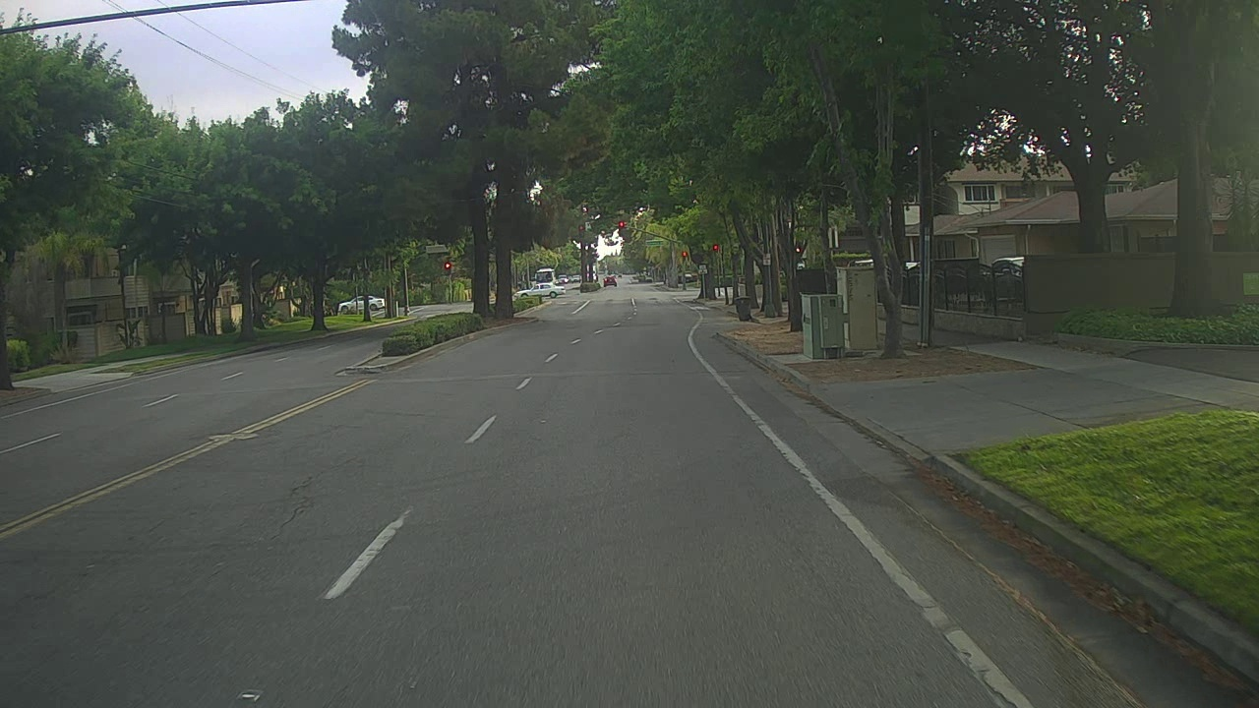

Figure: Original 0100.jpg and YOLO detection output.

Image 0105.jpg
The original image contains two visible cars. YOLO correctly detected both cars using the original parameters. The two bounding boxes were positioned around the cars reasonably well. No obvious incorrectly detected objects or undetected cars were observed.
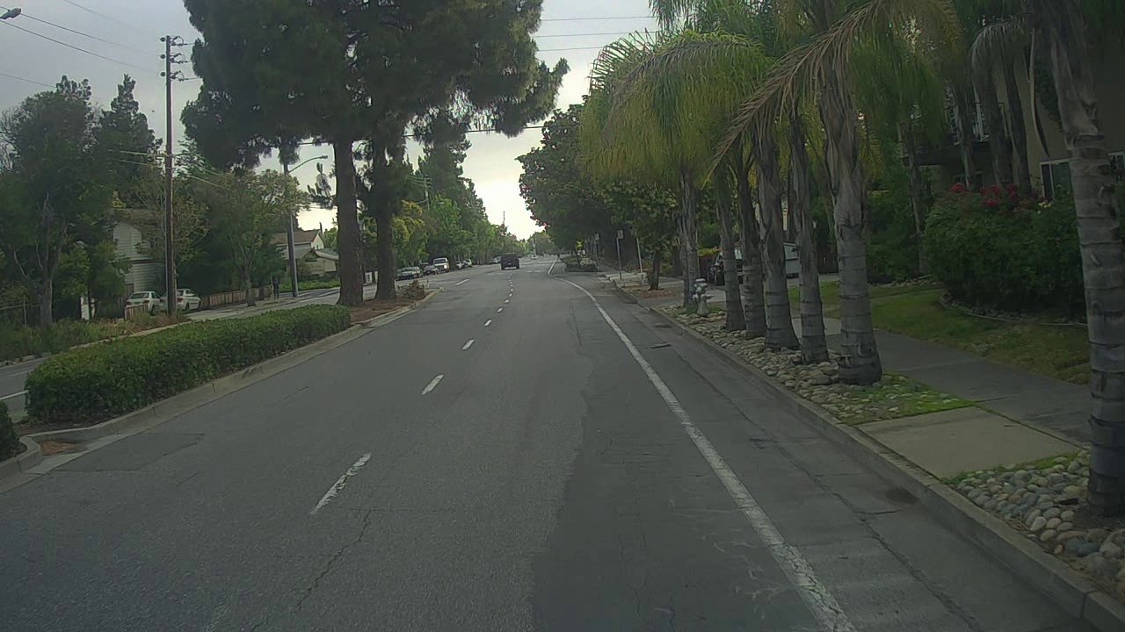

Figure: Original 0105.jpg and YOLO detection output.

11. Effect of YOLO Parameters

11.1 Maximum Number of Boxes
The maximum number of boxes was changed to 2 while keeping the other parameters unchanged. For 0100.jpg, the result remained at one detected car. For 0105.jpg, the result remained at two detected cars. Therefore, changing max_boxes to 2 did not improve either image because the original number of detections was already within the limit.

11.2 Score Threshold
The score threshold was reduced from 0.25 to 0.10. For 0100.jpg, the number of detected cars increased from 1 to 5. For 0105.jpg, the number increased from 2 to 7. Visual inspection showed that the additional detections corresponded to actual cars in the images. Therefore, the lower score threshold improved detection by recovering vehicles that were previously missed.
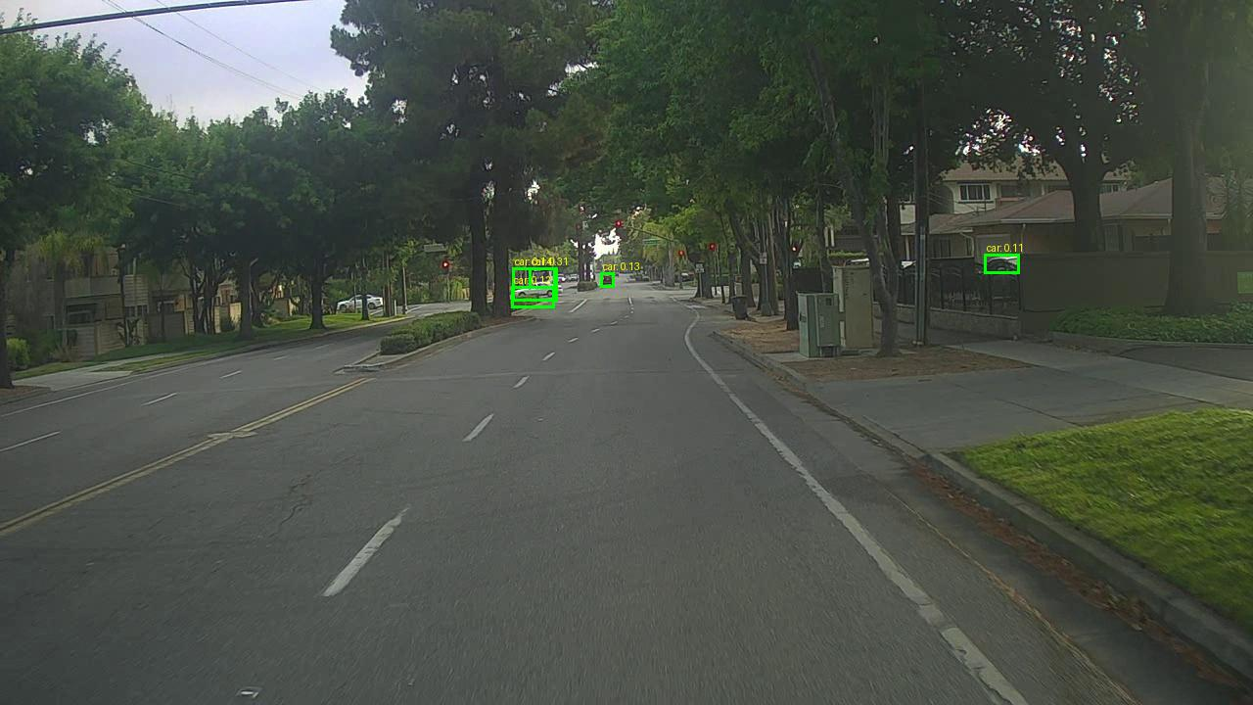
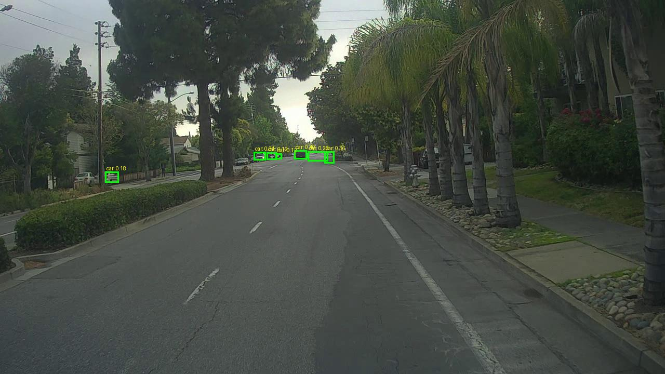
Figure: Results after reducing score_threshold to 0.10.

11.3 IoU Threshold
The IoU threshold was increased from 0.45 to 0.75. For 0100.jpg, the number of detected cars remained at 1 and the bounding box remained correct. For 0105.jpg, the number of detected cars increased from 2 to 4. All four detected boxes corresponded to actual cars. Therefore, the higher IoU threshold improved the result for 0105.jpg.
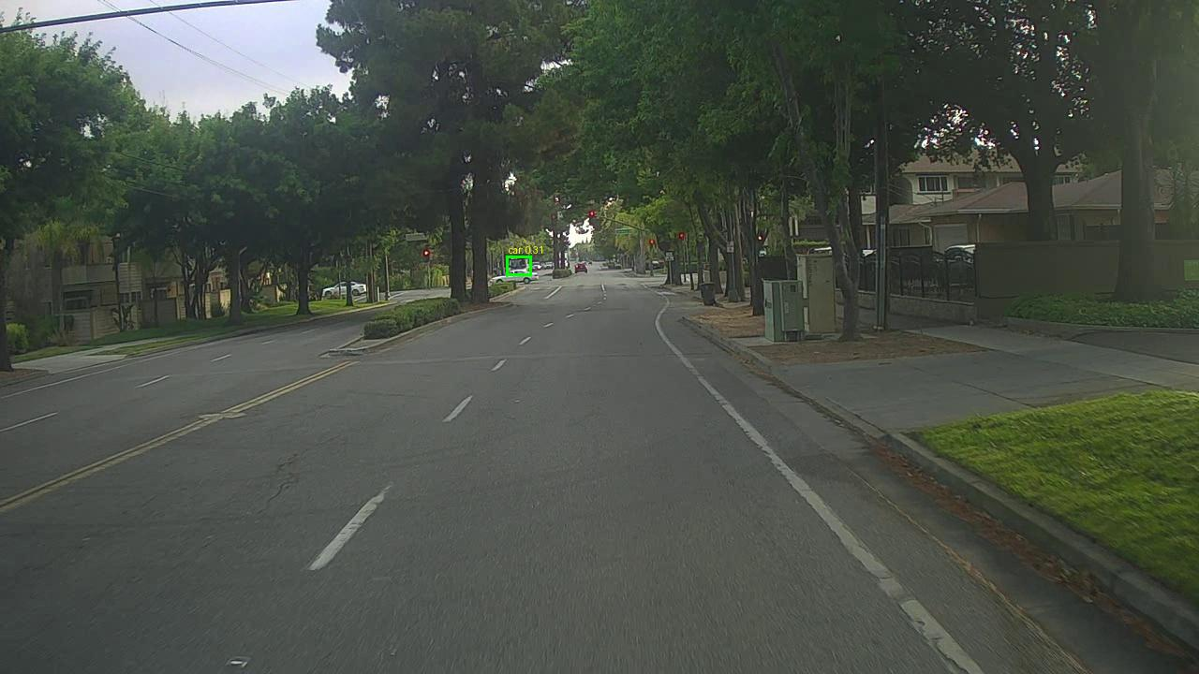
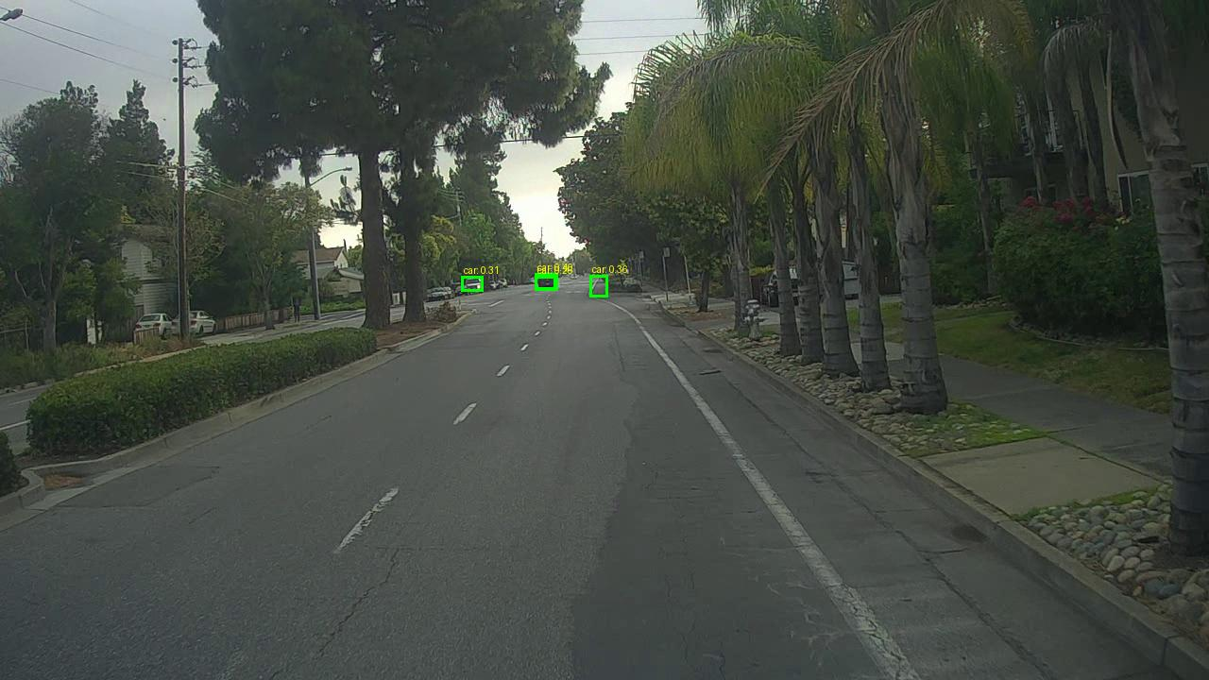
Figure: Results after increasing iou_threshold to 0.75.

Conclusion
The experiments demonstrated that YOLO detection performance depends strongly on the selected parameters. Lowering the confidence threshold allowed more cars to be detected in the selected images, while increasing the IoU threshold also improved detection for 0105.jpg. The max_boxes change did not produce an improvement in the selected images. These experiments demonstrate the trade-off between detecting additional objects and controlling unwanted or duplicate detections.

