About This Website
Mind Well is a web-based platform designed to support mental wellness by helping users track and understand their emotional health. In today’s fast-paced digital lifestyle, people often experience stress, anxiety, and emotional imbalance but lack simple tools to monitor their mental state.
Mind Well provides a safe, user-friendly environment where users can:
- Record their daily mood
- Track emotional patterns over time
- Receive basic mental wellness suggestions
The platform focuses on awareness, simplicity, and accessibility, making mental health support easy for everyone.

✨ 🚀 Features
- 🔐 User Authentication – Secure login system
- 😊 Mood Tracking – Daily emotional input
- 📊 Dashboard – Visual representation of mood trends
- 💡 Suggestions – Basic mental wellness tips
- 📁 Data Storage – Stores user history securely
- 🧭 Simple Navigation – Easy-to-use interface

🖼️ 📸 Screenshots
- 🔐 Login Page
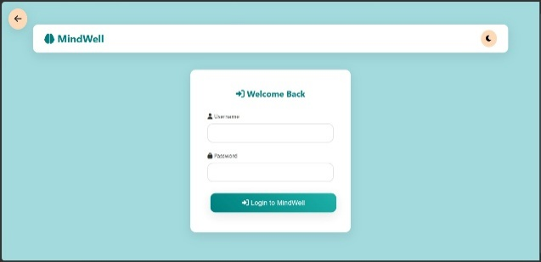

😊 Home page
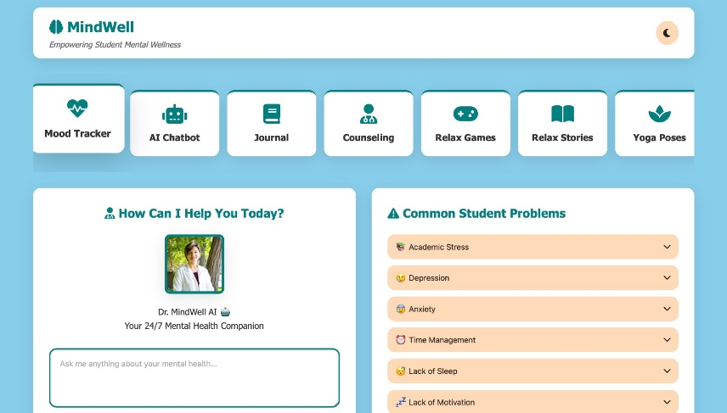
📊 mood Tracker
Background colours can change according to mood
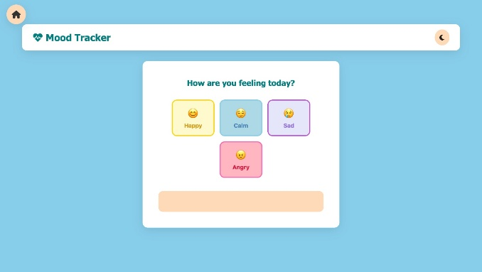 calm
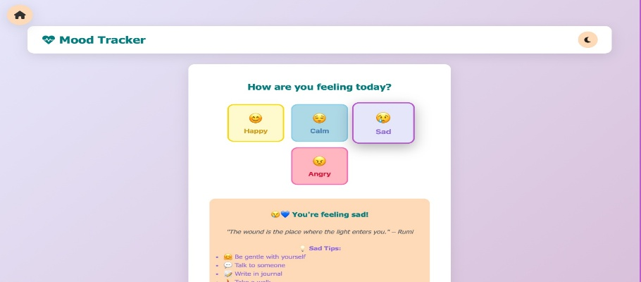 sad
Chat bot
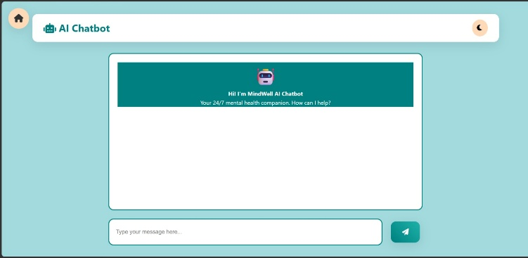

Resources page
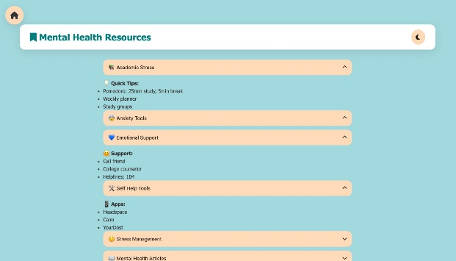

🛠️ 💻 Technologies Used
Layer | Technology
🎨 Frontend | HTML, CSS, JavaScript
⚙️ Backend | Node.js / Python
🗄️ Database | MySQL / Firebase
🎯 Design | Figma / Framer

🏗️ 📂 Project Structure
MindWell/
│
├── frontend/
│ ├── index.html
│ ├── styles.css
│ ├── script.js
│
├── backend/
│ ├── server.js / app.py
│
├── database/
│ ├── schema.sql
│
├── assets/
│ ├── images/
│
└── README.md

▶️ ⚙️ How to Run
1.clone the repository:
git clone https://github.com/snigdhanistala2024-ui
2.open the folder:
Student mental health platform UI-DTI
3. Run the project:
.open index.html in your browser

👩‍💻 👥 Team Members & Roles
Name | Role | Responsibility
N. Snigdha | Frontend Developer | UI design, frontend pages, integration
A.Hasini | Backend Developer | Server logic, system functionality
G. Vyshnavi | Database Manager | Database design, data storage
D. Harini | UI/UX Designer | Designed UI layout and theme

🚀 🔮 Future Improvements
- 🤖 AI-based mood prediction
- 💬 Chatbot for mental health support
- 📱 Mobile application development
- ⌚ Integration with wearable devices
- 📊 Advanced analytics dashboard

📝 📌 Note
This project is developed as a prototype for learning and demonstration purposes.
It focuses on providing a basic understanding of mental wellness tracking systems.

📜 ⚖️ License
This project is developed for academic purposes (DTI Lab).
It is intended only for educational use and not for commercial deployment.

🤝 💬 Support
If you like this project,give it a star on Github!

🏁 🎯 Final Line
👉 “MindWell aims to make mental health awareness simple, accessible, and stigma-free.”

