Customer Churn Prediction and Analytics Using Machine Learning

G. Saranya
Department of Computer Science and Engineering
Koneru Lakshmaiah Education Foundation
Hyderabad, India
2420030071@klh.edu.in

Dr N SUNANDA
Department of Computer Science and Engineering
Koneru Lakshmaiah Education Foundation
Hyderabad, India
drnsunanda@klh.edu.in
B. Hasini
Department of Computer Science and Engineering
Koneru Lakshmaiah Education Foundation
Hyderabad, India
2420030324@klh.edu.in
T. Nandini
Department of Computer Science and Engineering
Koneru Lakshmaiah Education Foundation
Hyderabad, India
2420030325@klh.edu.in

Abstract—Customer churn, the loss of existing customers to competitors or to service discontinuation, is one of the most costly problems for subscription-based businesses, because acquiring a new customer usually costs far more than retaining an existing one. This paper presents a customer churn prediction and analytics framework that combines exploratory analysis of customer behavior with supervised machine learning. Using the public IBM Telco Customer Churn dataset of 7,043 customers and 21 attributes, the framework identifies the contractual, service, and billing factors associated with churn, engineers additional features, and handles the 26.5% minority class with the Synthetic Minority Over-sampling Technique (SMOTE) applied inside the training folds. Seven classifiers, namely Logistic Regression, Decision Tree, K-Nearest Neighbors, Support Vector Machine, Random Forest, Gradient Boosting, and XGBoost, are compared using stratified 5-fold cross-validation and a held-out test set. XGBoost achieved the best test AUC of 0.843 and an accuracy of 78.2%, and a decision threshold selected on out-of-fold predictions raised its churn recall to 73.8%. Feature-importance analysis identifies month-to-month contracts, short tenure, fiber-optic service, missing security and support services, and electronic-check payment as the strongest churn indicators. The paper also describes a proposed system architecture and converts predicted probabilities into risk segments that support targeted retention campaigns.
Keywords—customer churn prediction, machine learning, customer analytics, XGBoost, random forest, SMOTE, class imbalance, customer retention

Introduction
Telecommunication operators, banks, insurers, and streaming and software-as-a-service providers operate in markets where customers can switch providers with little effort. Customer churn refers to customers who stop using a company's products or services within a given period. Because retaining a customer is considerably cheaper than acquiring a new one, and because small improvements in retention can produce large increases in profit [1], churn management is a central concern of customer relationship management (CRM).
Traditional retention practice is reactive: a company often learns that a customer is dissatisfied only when the cancellation request arrives. Predictive churn modeling changes this by estimating, in advance, the probability that each active customer will leave, so that retention offers can be directed at the customers who are both at risk and valuable [2]. Many techniques have been applied to the problem, from logistic regression and decision trees [3] to ensemble methods [4], and the choice of features and of the evaluation metric has been shown to matter as much as the choice of algorithm [3], [5].
Building a useful churn model in practice raises several difficulties. Churn data are imbalanced because churners are a minority [6]; the raw attributes mix categorical and numerical types; and a model that is accurate but opaque gives managers little guidance on why customers leave. This project therefore treats churn as both a prediction problem and an analytics problem: the goal is to rank customers by risk and to explain the factors behind that risk.
The contributions of this work are: (i) an exploratory churn analytics study that quantifies how contract, tenure, service, and billing attributes relate to attrition; (ii) a leakage-free machine learning pipeline that combines preprocessing, feature engineering, and SMOTE-based class balancing; (iii) a comparison of seven classifiers with cross-validation and a held-out test set, including decision-threshold optimization; and (iv) a proposed system architecture with risk segmentation that turns predictions into retention actions.
The remainder of this paper is organized as follows. Section II states the problem and objectives. Section III reviews related work. Section IV describes the methodology, and Section V presents the proposed system architecture. Section VI details the machine learning algorithms, Section VII describes the implementation, and Section VIII presents the results and evaluation. Section IX discusses challenges and limitations, and Section X concludes the paper.

Problem Statement and Objectives
The problem addressed is the difficulty of identifying, before they leave, which customers are likely to churn and why. A company typically holds demographic, account, service, and billing data for every customer, but without a predictive model this data does not translate into timely, targeted retention action. The model must cope with an imbalanced target, must be evaluated in a way that reflects the business cost of missing a churner, and must produce results that managers can interpret.
The scope of the work is a churn prediction and analytics prototype built on a public telecom dataset. The system predicts churn probability for each customer and summarizes the drivers of churn; it does not execute retention campaigns itself. The objectives are to:
- prepare and clean the customer data consistently;
- analyze churn patterns across demographic, contractual, service, and billing attributes;
- engineer features that capture customer engagement and spending behavior;
- handle class imbalance without leaking information into the evaluation;
- train and compare multiple classifiers using appropriate metrics such as recall, F1-score, and ROC-AUC; and
- interpret the best model and convert its predictions into risk segments for retention planning.
Whether each objective is met is established through the experiments reported in Section VIII, rather than assumed from the design.

Related Work
Churn prediction has been studied for more than two decades, particularly in telecommunications, where data are plentiful and switching is common. This section reviews the literature that most directly informs this project.
Neslin et al. analyzed the results of a churn modeling tournament in which many teams applied different methods to the same data, and found that the modeling approach and the effort invested had a measurable, economically significant effect on predictive accuracy [2]. Huang et al. evaluated a wide range of features and classifiers, including logistic regression, decision trees, and neural networks, on a large telecom dataset and showed that feature selection strongly affects performance [3]. Coussement and Van den Poel applied support vector machines to subscription churn and showed that careful parameter selection is needed for SVMs to outperform simpler baselines [7]. Verbeke et al. argued that comprehensible models are important for managerial acceptance and proposed rule-induction techniques for churn [8].
Lemmens and Croux showed that bagging and boosting classification trees substantially improve churn prediction compared with a single tree or logistic regression [4]. Breiman introduced Random Forests, which aggregate many decorrelated trees grown on bootstrap samples with random feature selection [9]. Friedman formulated gradient boosting as stagewise additive modeling in function space [10], and Chen and Guestrin proposed XGBoost, a regularized and scalable implementation that has become one of the most accurate methods for tabular data [11]. Ahmad et al. built a churn model on a big-data platform for a telecom operator and reported that XGBoost gave the best AUC among the algorithms tested [12].
He and Garcia surveyed learning from imbalanced data and described sampling, cost-sensitive, and algorithmic remedies [13]. Burez and Van den Poel studied these remedies specifically for churn and found that re-balancing the training data improves the detection of churners [6]. Chawla et al. proposed SMOTE, which creates synthetic minority samples by interpolating between neighboring minority instances instead of duplicating them [14]. A recurring caution in this literature is that re-sampling must be applied only to training data, otherwise evaluation results become optimistic.
Verbeke et al. proposed a profit-driven evaluation framework, arguing that churn models should be judged by the profit of the retention campaigns they enable and not only by statistical accuracy [5]. Lundberg and Lee introduced SHAP values, a unified approach for explaining individual predictions of complex models [15]. Together, these works motivate pairing accurate models with clear explanations of churn drivers.
Fawcett described ROC analysis and the AUC, which summarize classifier performance across all decision thresholds and are well suited to imbalanced problems [16]. Kohavi compared cross-validation and bootstrap methods for accuracy estimation and recommended stratified 10-fold or similar cross-validation for model selection [17]. For churn, the IBM Telco Customer Churn dataset is a widely used public benchmark [18].
- Summary of Reviewed Approaches
Approach | Representative work | Strength / limitation
Tournament study | Neslin et al. [2] | Shows method matters; no single winner
Feature study | Huang et al. [3] | Rich features; telecom-specific
SVM | Coussement [7] | Strong margins; tuning sensitive
Rule induction | Verbeke et al. [8] | Comprehensible; lower accuracy
Bagging / boosting | Lemmens [4] | Accurate; less interpretable
Gradient boosting | Chen [11] | State of the art; many parameters
Class imbalance | Burez [6] | Finds churners; risk of leakage
Profit-driven | Verbeke et al. [5] | Business-aligned; needs cost data

As Table I shows, each line of work addresses a different need: traditional models are interpretable but less accurate, ensembles are accurate but opaque, imbalance techniques improve churner detection but can bias evaluation if misapplied, and profit-driven work aligns models with business goals. Many applied studies report only accuracy, apply re-sampling before splitting the data, or stop at the prediction without translating it into retention actions. This project does not propose a new learning algorithm. Its intended contribution is the integration of descriptive churn analytics, a leakage-free balanced pipeline, a broad and fair model comparison, threshold optimization, and risk segmentation in a single, reproducible framework.

Methodology
The methodology follows a pipeline from data preparation through exploratory analytics, feature engineering, class balancing, and model training. Each stage is described below.

Data Collection and Preparation
The experiments use the IBM Telco Customer Churn dataset [18], which describes 7,043 customers of a fictional telecommunications company through 21 attributes. These cover demographic information (gender, senior-citizen status, partner, dependents); account information (tenure, contract type, paperless billing, payment method); subscribed services (phone, multiple lines, internet type, online security, online backup, device protection, technical support, streaming TV and movies); and charges (monthly and total). The target, Churn, indicates whether the customer left within the last month. A total of 1,869 customers (26.5%) churned, giving an imbalance ratio of about 1:2.8.
The customerID column was removed because it carries no predictive information. TotalCharges was stored as text and contained 11 blank values, all for customers with zero tenure who had not yet been billed; it was converted to a numeric type and these values were set to zero. The target was encoded as 1 for churn and 0 otherwise.

Exploratory Churn Analytics
Descriptive analytics were performed before modeling to understand which characteristics are associated with churn. Table II summarizes churn rates for the most informative attributes, and Fig. 1 shows the effect of contract type and tenure.
- Churn Rate by Key Customer Attributes
Attribute | Category | Churn rate (%)
Contract | Month-to-month | 42.7
 | One year | 11.3
 | Two year | 2.8
Internet service | Fiber optic | 41.9
 | DSL | 19.0
 | No internet | 7.4
Payment method | Electronic check | 45.3
 | Mailed check | 19.1
 | Automatic (bank / card) | 16.0
Tech support | No | 41.6
 | Yes | 15.2
Senior citizen | Yes | 41.7
 | No | 23.6
All customers |  | 26.5

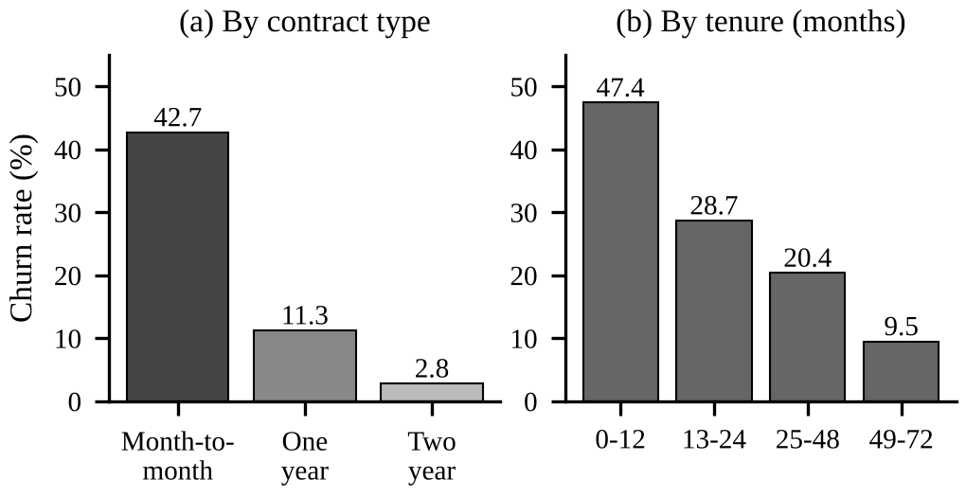
- Churn rate (%) by (a) contract type and (b) customer tenure group.
Contract type is the strongest single indicator: 42.7% of month-to-month customers churned, compared with 11.3% on one-year and 2.8% on two-year contracts. Churn is highest in the first year of service (47.4%) and falls to 9.5% for customers who have stayed more than four years. Churners had an average tenure of 18.0 months against 37.6 months for retained customers and paid higher monthly charges (USD 74.44 vs. USD 61.27). Fiber-optic subscribers churned at more than twice the DSL rate, customers without technical support churned at 41.6% versus 15.2% with support, and electronic-check payers (45.3%) and paperless-billing users (33.6%) were also more likely to leave. These findings guided the feature engineering and provide an interpretable baseline against which model results can be checked.

Feature Engineering
Three features were derived from the raw attributes. NumServices counts the value-added services (online security, online backup, device protection, technical support, streaming TV, and streaming movies) to which a customer subscribes, as a proxy for engagement. AvgMonthlySpend divides total charges by tenure to capture the historical spending rate, which reveals recent price changes when compared with MonthlyCharges. TenureGroup bins tenure into 0–12, 13–24, 25–48, and 49–72 months and is used for analytics and risk profiling. Numerical features were then standardized to zero mean and unit variance, and categorical features were one-hot encoded, with binary attributes reduced to a single indicator.

Class Balancing
Because churners form only about one quarter of the data, a classifier trained on the raw distribution tends to favor the majority class. SMOTE [14] was used to balance the training data. For a minority sample x_{i} and one of its k nearest minority neighbors x_{nn}, a synthetic sample is generated as
x_{new} = x_{i} + λ (x_{nn} − x_{i}) (1)
where λ is drawn uniformly from [0, 1]. SMOTE was placed inside the training pipeline, so synthetic samples are generated only from training folds and the validation folds and test set keep their original class distribution.

Model Training and Validation
The data were split into a stratified training set of 5,634 customers (80%) and a test set of 1,409 customers (20%), which was held out until final evaluation. Each model was assessed with stratified 5-fold cross-validation on the training set [17], then retrained on the full training set and scored once on the test set. ROC-AUC was used as the primary criterion for model selection [16].

Proposed System Architecture
The architecture is divided into five layers: data ingestion, preprocessing and feature engineering, model training, prediction and scoring, and analytics and reporting. The data ingestion layer loads customer records from a CSV export or, in production, from the company's CRM or billing database, and validates column types and missing values.
The preprocessing layer applies cleaning, feature engineering, scaling, and encoding through a single scikit-learn pipeline [19], so that exactly the same transformations are applied during training and prediction. The model training layer adds SMOTE from imbalanced-learn [20], fits and cross-validates the candidate classifiers, and stores the selected pipeline as a serialized model file.
The prediction layer loads the stored pipeline and returns a churn probability and risk segment for each customer. In the implemented prototype this runs as a batch Python script; a REST scoring service, for example using FastAPI, is proposed for production so that CRM tools can request scores on demand. The analytics and reporting layer presents churn rates by segment, feature importance, and lists of high-risk customers, and is proposed as a dashboard for marketing and customer-care teams.
Customer data contains personal and financial attributes, so the production design should restrict access to authorized staff, avoid storing identifiers in model files, and log scoring requests. These deployment details go beyond the current prototype and should be confirmed during implementation.
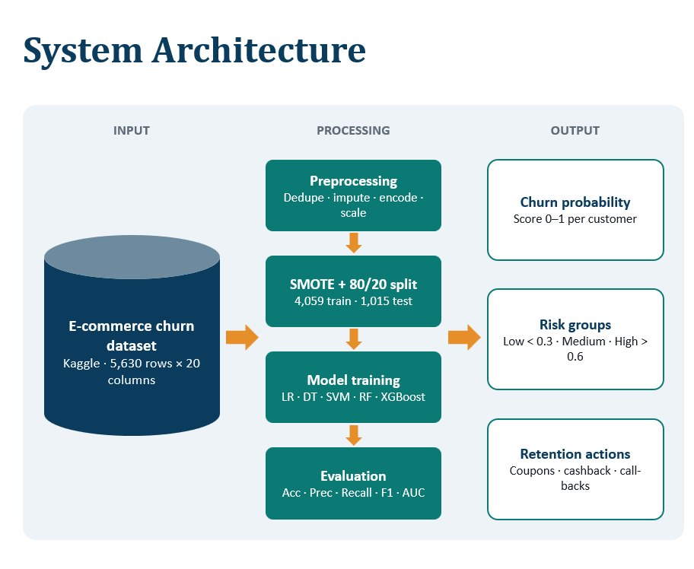

Machine Learning Algorithms
Seven supervised classifiers representing linear, distance-based, kernel, tree, and ensemble families were compared.

Logistic Regression
Logistic regression [21] models the churn probability of a customer with feature vector x as
P(y = 1 | x) = 1 / (1 + e^{−(wTx + b)}) (2)
where w and b are learned weights and bias. Its coefficients are directly interpretable, which makes it a strong baseline for churn [3].

Decision Tree
A decision tree recursively splits the data on the feature that most reduces node impurity. Using the CART criterion [22], the Gini impurity of a node with class proportions p_{c} is
G = 1 − Σ_{c} p_{c}² (3)
The tree was limited to a depth of 6 with at least 20 customers per leaf, which gives a readable set of if–then rules.
K-nearest neighbors [23] classifies a customer by majority vote of the k most similar customers in the scaled feature space; k = 25 was used. The support vector machine [24] finds a maximum-margin boundary, and a radial basis function kernel with C = 1 was used to capture non-linear relationships [7].
Random Forest [9] trains many decision trees on bootstrap samples, considering a random subset of features at each split, and averages their predictions. This reduces variance and provides impurity-based feature importance. The model used 400 trees with a maximum depth of 10.
Gradient boosting [10] builds trees sequentially, with each new tree fitted to the errors of the current ensemble. XGBoost [11] minimizes a regularized objective over K trees f_{k}:
L = Σ_{i} l(y_{i}, ŷ_{i}) + Σ_{k} Ω(f_{k}) (4)
Ω(f) = γT + ½ λ ||w||² (5)
where l is the log-loss, T is the number of leaves, w are the leaf weights, and γ and λ control model complexity. Gradient Boosting used 300 trees of depth 3 with a learning rate of 0.05; XGBoost used 400 trees of depth 4, a learning rate of 0.03, and row and column subsampling of 0.8.

Decision Threshold Selection
Each model outputs a probability, and a customer is labeled as a churner when it exceeds a threshold. Because missing a churner usually costs more than a retention offer, the threshold that maximizes the F1-score was selected using out-of-fold predictions on the training set, so the test set was not used for tuning.

Implementation
The system was implemented in Python using pandas for data handling, scikit-learn [19] for preprocessing, classical models, and evaluation, imbalanced-learn [20] for SMOTE, XGBoost [11] for gradient-boosted trees, and Matplotlib for visualization. Preprocessing, SMOTE, and the classifier are combined in one imbalanced-learn pipeline, which guarantees that re-sampling occurs only on training data within each fold.
All random processes, including the data split, cross-validation folds, SMOTE, and model initialization, use a fixed seed of 42 so that the results are reproducible. Table III lists the main hyperparameters. These were set to commonly used values rather than exhaustively tuned, so that the comparison reflects the algorithms rather than unequal tuning effort.
- Model Hyperparameters
Model | Main settings
Logistic Regression | L2 penalty, C = 1.0, max. iterations = 2000
Decision Tree | max. depth = 6, min. samples per leaf = 20
KNN | k = 25, Euclidean distance
SVM | RBF kernel, C = 1.0, probability outputs
Random Forest | 400 trees, max. depth = 10, min. leaf = 5
Gradient Boosting | 300 trees, depth = 3, learning rate = 0.05
XGBoost | 400 trees, depth = 4, learning rate = 0.03, subsample = 0.8

Results and Evaluation
With churn as the positive class, let TP, TN, FP, and FN denote true positives, true negatives, false positives, and false negatives. The following metrics were computed:
Accuracy = (TP + TN) / (TP + TN + FP + FN) (6)
Precision = TP / (TP + FP) (7)
Recall = TP / (TP + FN) (8)
F1 = 2 × Precision × Recall / (Precision + Recall) (9)
Recall is especially important because a missed churner is a lost customer, while a false alarm only costs a retention offer. Since accuracy is misleading for imbalanced data, ROC-AUC [16] was used as the primary criterion.

Model Comparison
Table IV reports test-set performance at the default threshold of 0.5 together with the mean 5-fold cross-validated AUC, and Fig. 2 shows the ROC curves. Accuracy, precision, recall, and F1 are given in percent.
- Performance Comparison of Classifiers
Model | Acc. | Prec. | Rec. | F1 | AUC | CV AUC
Logistic Regression | 74.0 | 50.6 | 79.7 | 61.9 | 0.840 | 0.845
Decision Tree | 76.4 | 54.7 | 65.5 | 59.6 | 0.810 | 0.818
KNN | 68.1 | 44.7 | 86.1 | 58.9 | 0.815 | 0.822
SVM | 75.6 | 52.8 | 74.6 | 61.9 | 0.819 | 0.827
Random Forest | 76.3 | 54.2 | 69.3 | 60.8 | 0.838 | 0.843
Gradient Boosting | 77.9 | 57.5 | 63.9 | 60.5 | 0.841 | 0.844
XGBoost | 78.2 | 58.4 | 62.3 | 60.3 | 0.843 | 0.843

XGBoost achieved the highest test AUC (0.843) and accuracy (78.2%), followed closely by Gradient Boosting (AUC 0.841) and Logistic Regression (AUC 0.840). The single Decision Tree had the lowest AUC (0.810), confirming the benefit of combining many trees. KNN obtained the highest recall (86.1%) but also the lowest precision (44.7%) and accuracy, meaning it raises many false alarms. Cross-validated AUC standard deviations were between 0.008 and 0.013, and the small gaps between cross-validated and test AUCs show that none of the models overfits significantly.
Logistic Regression performs almost as well as the boosted ensembles and has the best F1-score (61.9%) at the default threshold. This indicates that much of the churn signal in this dataset is carried by a few strong, largely monotonic relationships, such as contract type and tenure, which agrees with the analytics in Section IV.
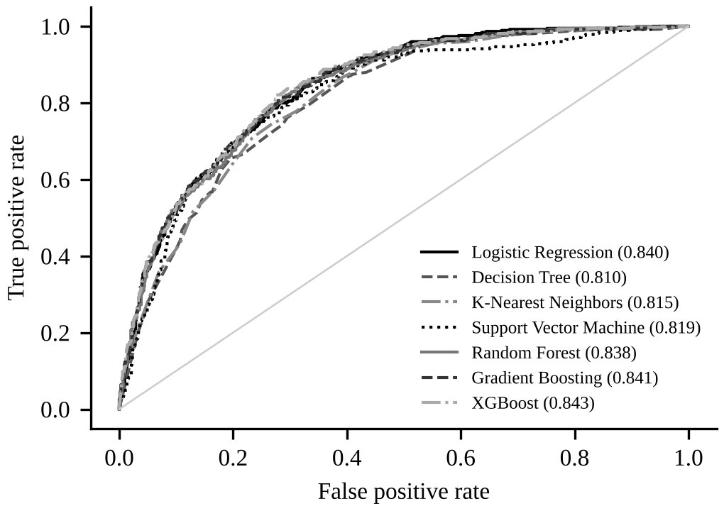
- ROC curves of the seven classifiers on the test set (AUC in parentheses).
At the default threshold, XGBoost identified 233 of the 374 churners in the test set and missed 141. The F1-optimal threshold selected on out-of-fold training predictions was 0.38. Table V compares the two operating points.
- XGBoost at Two Decision Thresholds
Threshold | TN / FP | FN / TP | Recall (%) | F1 (%)
0.50 (default) | 869 / 166 | 141 / 233 | 62.3 | 60.3
0.38 (tuned) | 798 / 237 | 98 / 276 | 73.8 | 62.2

With the tuned threshold, recall rose from 62.3% to 73.8% and the F1-score from 60.3% to 62.2%, so 43 additional churners were captured, while accuracy decreased moderately to 76.2%. The threshold can be adjusted further according to the actual cost of a retention offer and the value of a retained customer [5].
Fig. 3 shows the ten most important features of XGBoost by gain. A month-to-month contract is by far the most influential feature, followed by the absence of online security, fiber-optic service, the absence of technical support, and electronic-check payment, while a two-year contract reduces risk. The impurity-based ranking of Random Forest confirmed the same drivers and also ranked tenure and total charges among the top features. The agreement between the descriptive analytics, two different ensembles, and domain intuition suggests that these drivers are genuine rather than artifacts of one algorithm.
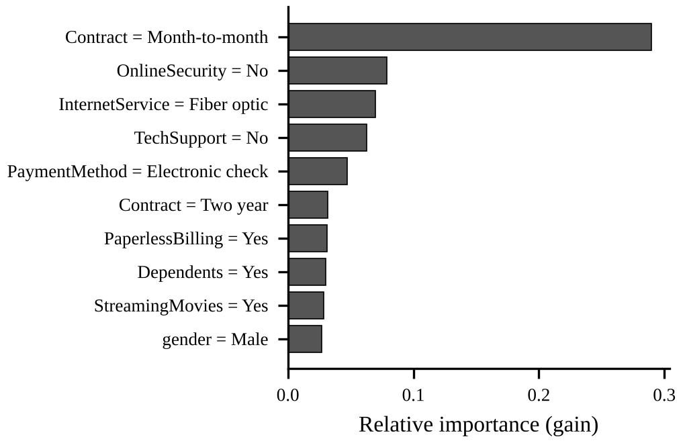
- Top ten features ranked by XGBoost gain importance.
Predicted probabilities were grouped into three risk segments. Table VI shows the size, actual churn rate, and average monthly charge of each segment in the test set.
- Risk Segmentation of Test Customers
Risk segment | Customers | Actual churn (%) | Avg. monthly (USD)
Low (p < 0.3) | 814 | 8.2 | 57.15
Medium (0.3–0.6) | 296 | 37.5 | 72.08
High (p > 0.6) | 299 | 65.5 | 75.07

Actual churn rises from 8.2% in the low-risk segment to 65.5% in the high-risk segment, which contains only about 21% of customers and pays the highest monthly charges. Based on the identified drivers, the following actions are recommended:
- offer incentives to move month-to-month customers, especially in their first year, to one- or two-year contracts;
- bundle online security and technical support with fiber-optic plans and review the price and quality of that service;
- encourage electronic-check users to switch to automatic bank or card payments; and
- prioritize personal outreach for the high-risk segment and lower-cost digital campaigns for the medium-risk segment.
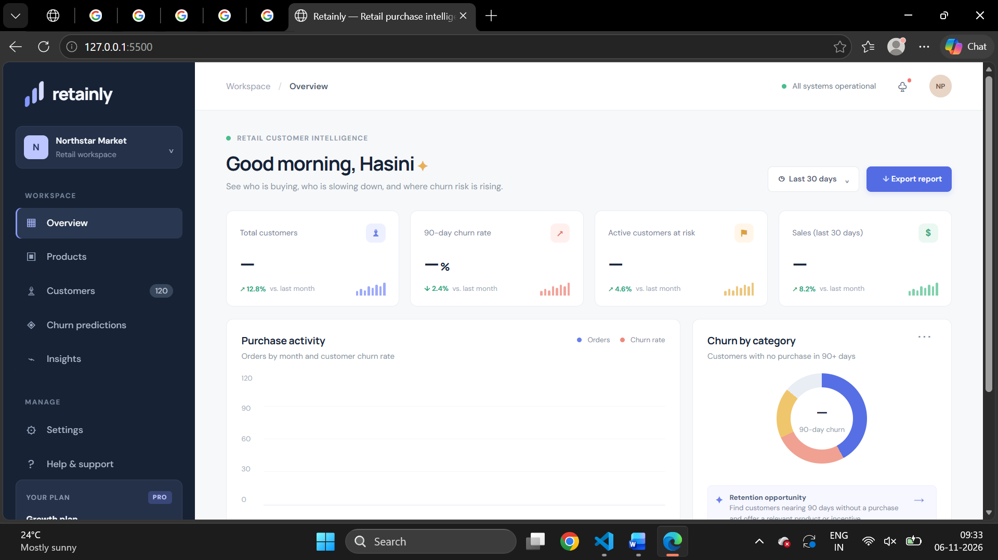
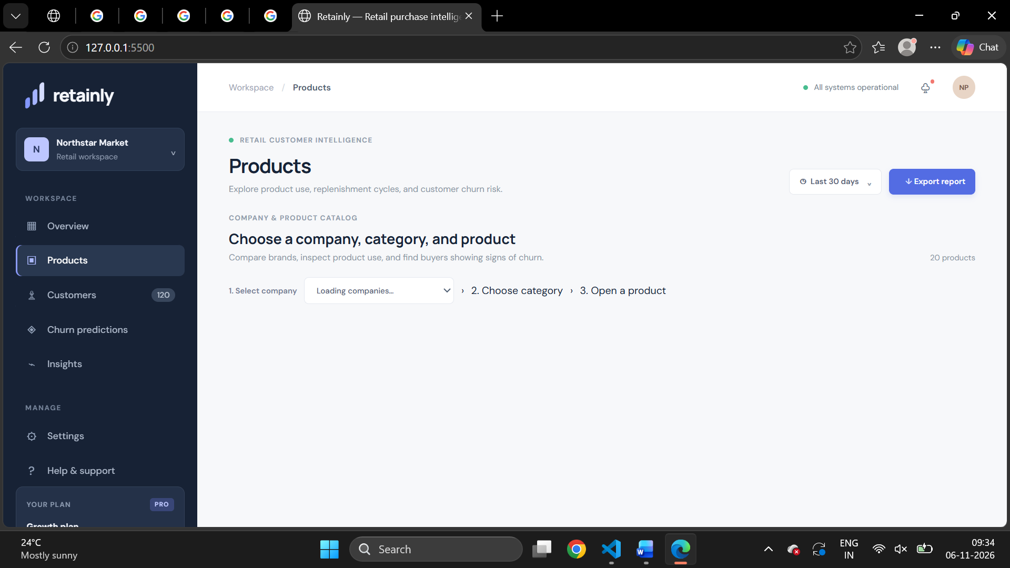

Challenges and Limitations
The main challenges encountered were the class imbalance of the target, the mixed categorical and numerical attributes, the blank TotalCharges values, and the trade-off between recall and precision when choosing a decision threshold. Handling imbalance without leaking synthetic samples into the evaluation required placing SMOTE inside the cross-validation pipeline.
Other limitations follow from the data and design. The study uses a single, static public dataset in which each customer is observed once, so temporal usage patterns, complaints, and customer-service interactions could not be modeled. The dataset describes a fictional company, so the numerical results may not transfer directly to a specific operator. Hyperparameters were set to reasonable values rather than exhaustively optimized, and gain-based importance indicates association rather than causation. Finally, the retention recommendations have not been tested in a live campaign.
Accordingly, this paper reports offline results on a benchmark dataset and a proposed deployment architecture, rather than claiming measured business improvements in production.

Conclusion and Future Work
This paper presented a customer churn prediction and analytics framework that combines exploratory analysis with supervised machine learning. Analytics on the IBM Telco dataset showed that contract type, tenure, internet service type, support services, and payment method are strongly associated with churn. A leakage-free pipeline with feature engineering and SMOTE was used to compare seven classifiers; XGBoost achieved the best test AUC of 0.843 and an accuracy of 78.2%, and a cross-validated threshold increased its recall to 73.8%. Feature importance and risk segmentation translated these predictions into specific retention actions.
Future work includes Bayesian hyperparameter optimization, explaining individual predictions with SHAP values [15], adding time-series usage and customer-support data, adopting profit-based evaluation [5], and deploying the model as a real-time scoring service connected to a CRM dashboard, followed by a controlled retention campaign to measure its business impact.

Acknowledgment
The authors thank their project guide, [Guide Name], Department of Computer Science and Engineering, KLH Bowrampet Campus, for guidance on this work.

References
- F. F. Reichheld and W. E. Sasser, Jr., “Zero defections: Quality comes to services,” Harvard Bus. Rev., vol. 68, no. 5, pp. 105–111, Sep./Oct. 1990.
- S. A. Neslin, S. Gupta, W. Kamakura, J. Lu, and C. H. Mason, “Defection detection: Measuring and understanding the predictive accuracy of customer churn models,” J. Marketing Res., vol. 43, no. 2, pp. 204–211, May 2006.
- B. Huang, M. T. Kechadi, and B. Buckley, “Customer churn prediction in telecommunications,” Expert Syst. Appl., vol. 39, no. 1, pp. 1414–1425, Jan. 2012.
- A. Lemmens and C. Croux, “Bagging and boosting classification trees to predict churn,” J. Marketing Res., vol. 43, no. 2, pp. 276–286, May 2006.
- W. Verbeke, K. Dejaeger, D. Martens, J. Hur, and B. Baesens, “New insights into churn prediction in the telecommunication sector: A profit driven data mining approach,” Eur. J. Oper. Res., vol. 218, no. 1, pp. 211–229, Apr. 2012.
- J. Burez and D. Van den Poel, “Handling class imbalance in customer churn prediction,” Expert Syst. Appl., vol. 36, no. 3, pp. 4626–4636, Apr. 2009.
- K. Coussement and D. Van den Poel, “Churn prediction in subscription services: An application of support vector machines while comparing two parameter-selection techniques,” Expert Syst. Appl., vol. 34, no. 1, pp. 313–327, Jan. 2008.
- W. Verbeke, D. Martens, C. Mues, and B. Baesens, “Building comprehensible customer churn prediction models with advanced rule induction techniques,” Expert Syst. Appl., vol. 38, no. 3, pp. 2354–2364, Mar. 2011.
- L. Breiman, “Random forests,” Mach. Learn., vol. 45, no. 1, pp. 5–32, Oct. 2001.
- J. H. Friedman, “Greedy function approximation: A gradient boosting machine,” Ann. Statist., vol. 29, no. 5, pp. 1189–1232, Oct. 2001.
- T. Chen and C. Guestrin, “XGBoost: A scalable tree boosting system,” in Proc. 22nd ACM SIGKDD Int. Conf. Knowl. Discovery Data Mining (KDD), 2016, pp. 785–794.
- A. K. Ahmad, A. Jafar, and K. Aljoumaa, “Customer churn prediction in telecom using machine learning in big data platform,” J. Big Data, vol. 6, Art. no. 28, 2019.
- H. He and E. A. Garcia, “Learning from imbalanced data,” IEEE Trans. Knowl. Data Eng., vol. 21, no. 9, pp. 1263–1284, Sep. 2009.
- N. V. Chawla, K. W. Bowyer, L. O. Hall, and W. P. Kegelmeyer, “SMOTE: Synthetic minority over-sampling technique,” J. Artif. Intell. Res., vol. 16, pp. 321–357, 2002.
- S. M. Lundberg and S.-I. Lee, “A unified approach to interpreting model predictions,” in Proc. 31st Conf. Neural Inf. Process. Syst. (NIPS), 2017, pp. 4765–4774.
- T. Fawcett, “An introduction to ROC analysis,” Pattern Recognit. Lett., vol. 27, no. 8, pp. 861–874, Jun. 2006.
- R. Kohavi, “A study of cross-validation and bootstrap for accuracy estimation and model selection,” in Proc. 14th Int. Joint Conf. Artif. Intell. (IJCAI), 1995, pp. 1137–1145.
- IBM, “Telco customer churn,” IBM sample data sets. [Online]. Available: https://github.com/IBM/telco-customer-churn-on-icp4d
- F. Pedregosa et al., “Scikit-learn: Machine learning in Python,” J. Mach. Learn. Res., vol. 12, pp. 2825–2830, 2011.
- G. Lemaître, F. Nogueira, and C. K. Aridas, “Imbalanced-learn: A Python toolbox to tackle the curse of imbalanced datasets in machine learning,” J. Mach. Learn. Res., vol. 18, no. 17, pp. 1–5, 2017.
- D. W. Hosmer, S. Lemeshow, and R. X. Sturdivant, Applied Logistic Regression, 3rd ed. Hoboken, NJ, USA: Wiley, 2013.
- L. Breiman, J. H. Friedman, R. A. Olshen, and C. J. Stone, Classification and Regression Trees. Belmont, CA, USA: Wadsworth, 1984.
- T. Cover and P. Hart, “Nearest neighbor pattern classification,” IEEE Trans. Inf. Theory, vol. 13, no. 1, pp. 21–27, Jan. 1967.
- C. Cortes and V. Vapnik, “Support-vector networks,” Mach. Learn., vol. 20, no. 3, pp. 273–297, Sep. 1995.

