

CTEC 22043 - Object Oriented Programming
S.D HASINI MAHEESHA
CT/2022/061
University of Kelaniya

INTRODUCTION
This lab is about using Java to solve simple numerical problems. It helps us practice basic calculations like temperature conversion, BMI, area, and interest.
Through this, we learn how to use variables and formulas in Java and how to take input and give output. It also improves our problem-solving skills using real-life examples.

1) Write Java expressions to compute each of the following.
a. The square root of B² + 4AC (A and C are distinct variables)
b. The square root of X + 4Y3
c. The cube root of the product of X and Y
d. The area of a circle
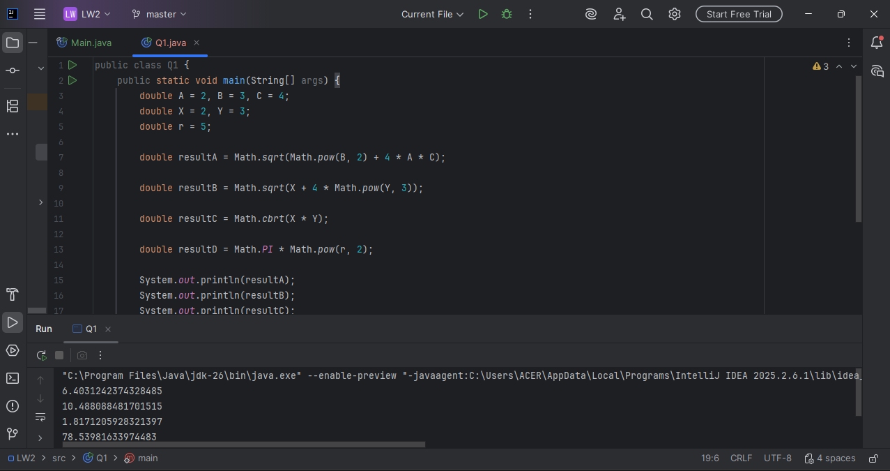
2) Write a program to convert centimeters (input) to feet and inches (output).
1 in 2.54 cm.
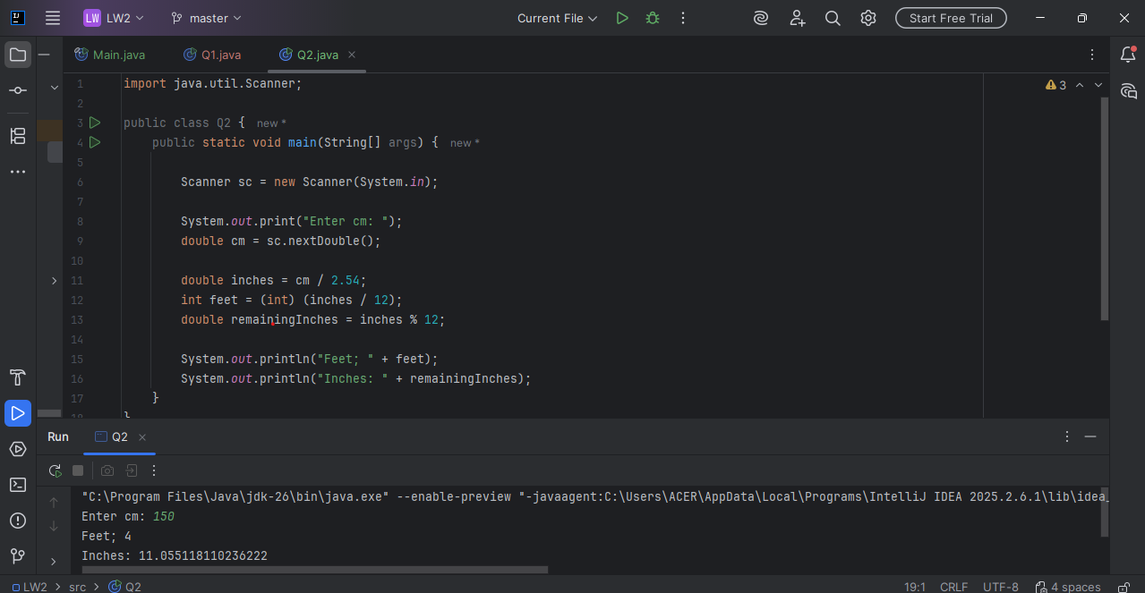

3) Write a program that inputs temperature in degrees Celsius and prints out the temperature in degrees Fahrenheit. The formula to convert degrees Celsius to equivalent degrees Fahrenheit is,
Fahrenheit = (1.8 x Celsius) + 32

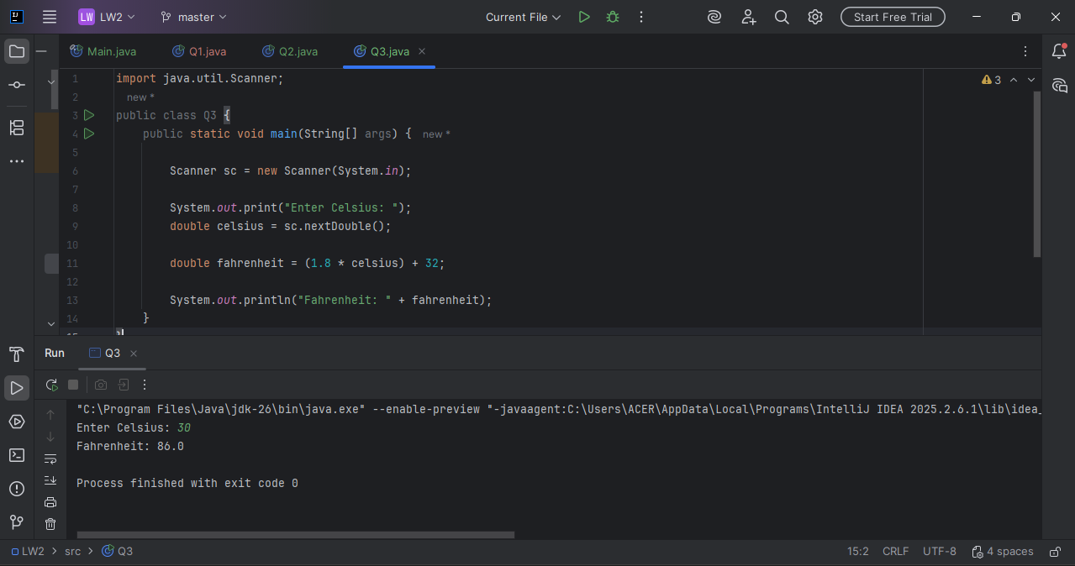
4) Write a program that accepts a person’s weight and displays the number of calories the person needs in one day. A person needs 19 calories per pound of body weight, so the formula is, calories = bodyweight x 19
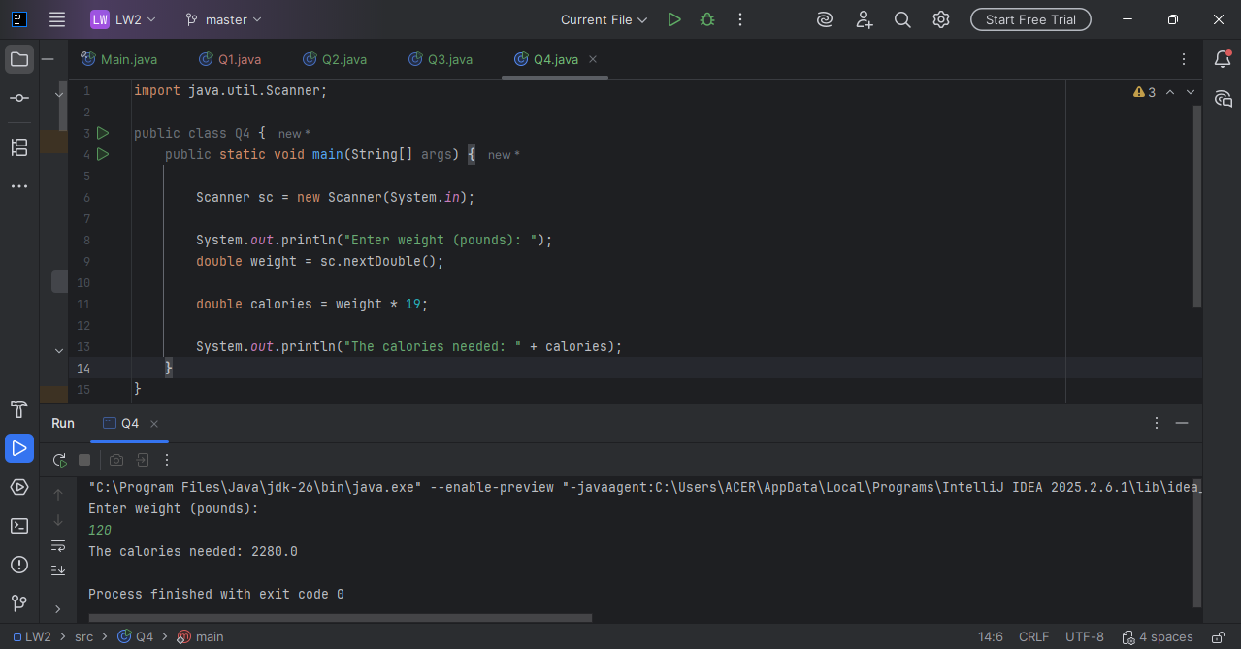
5) Write a program that inputs temperature in degrees Fahrenheit and prints out the temperature in degrees Celsius. The formula to convert degrees Fahrenheit to equivalent degrees Celsius is,
Celsius = (5 / 9) x (Fahrenheit - 32)

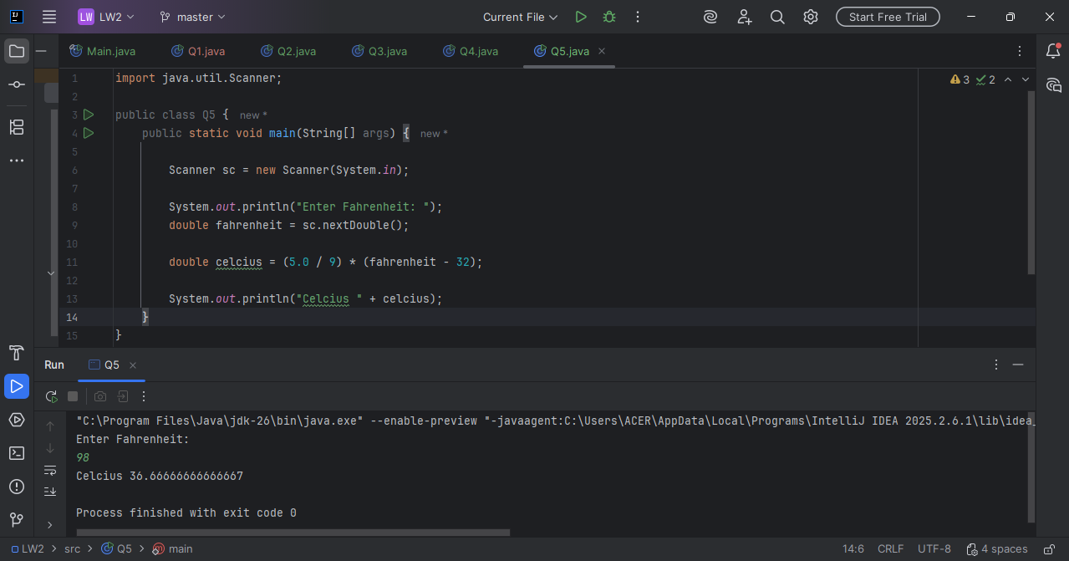
6) Write a program that inputs the year a person is born and outputs the age of the person in the following format:
You were born in 1990 and will be (are) 18 this year.

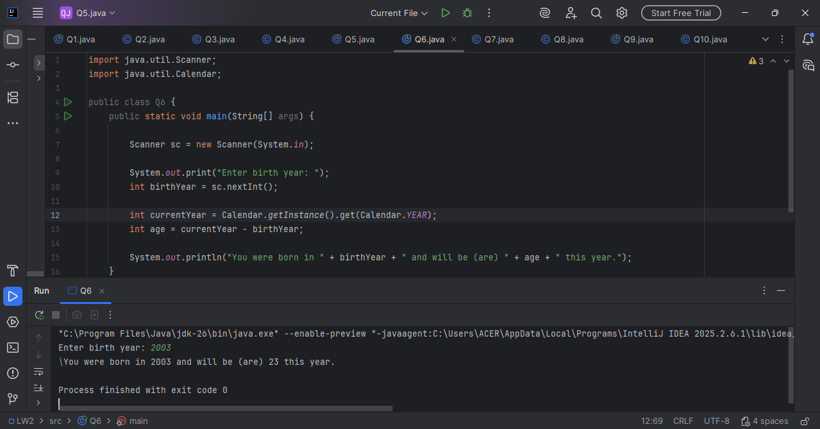
7) A quantity known as the body mass index (BMI) is used to calculate the risk of weight-related health problems. BMI is computed by the formula,
BMI = w / (h /100.0)2
where w is weight in kilograms and h is height in centimeters. A BMI of about 20to 25 is considered “normal.” Write an application that accepts weight and height
(both integers) and outputs the BMI.

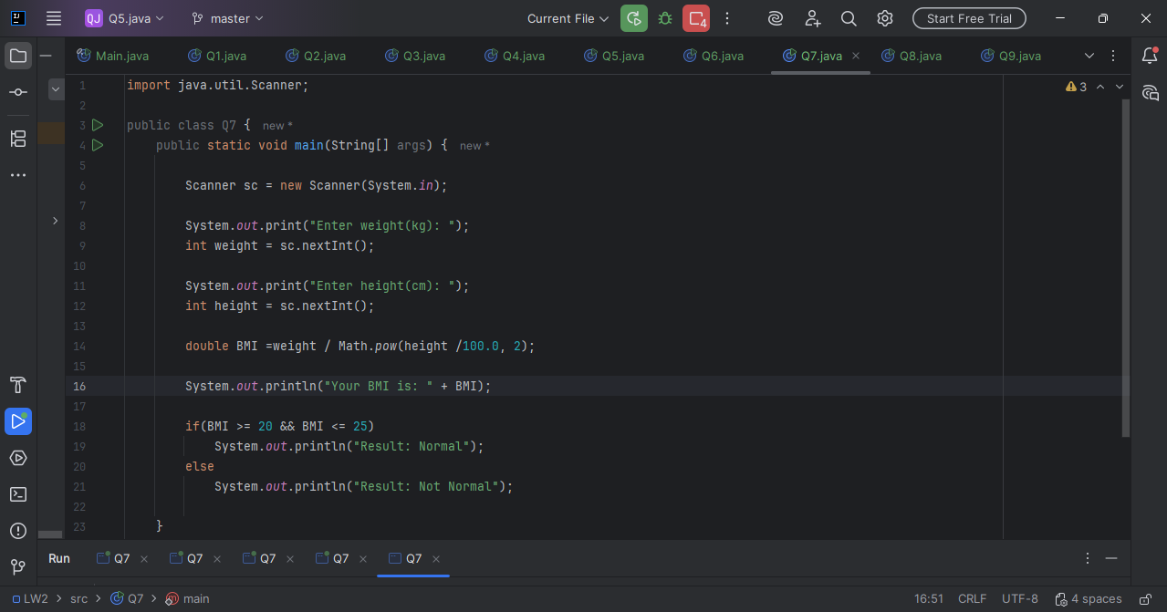
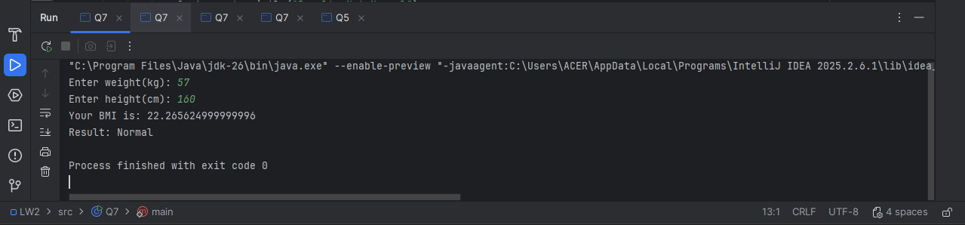

8) The volume of a sphere is computed by the equation,
V = (4 / 3) x (PI x r³)
where V is the volume, PI is the Pi value (3.14) and r is the radius of the sphere.
Write a program that computes the volume of a sphere with a given radius r

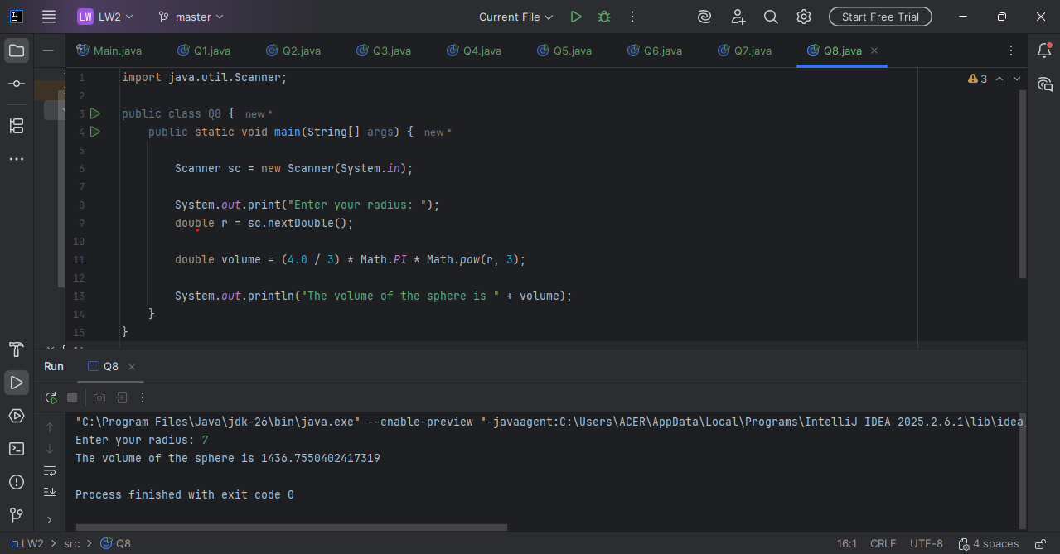

9) If you invest P dollars at R percent interest rate compounded annually, in N years, your
investment will grow to P(1 + (R / 100))N dollars. Write an application that accepts P, R,
and N and computes the amount of money earned after N years.

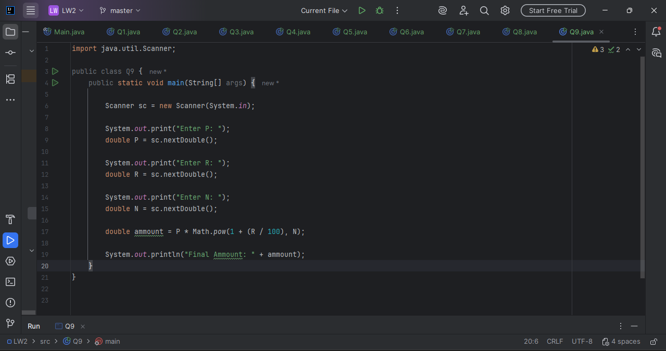
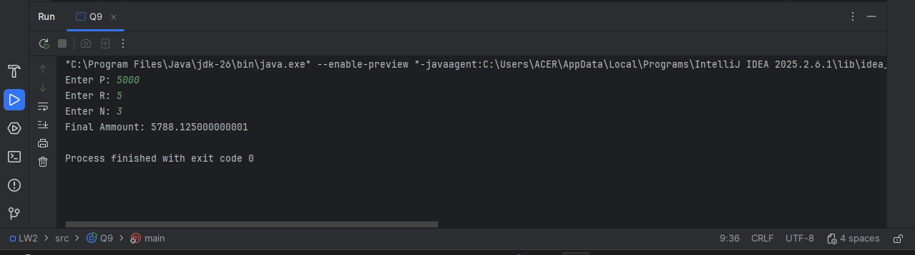
10) Write a loan calculator program that computes both monthly and total payments for the
given inputs loan amount, annual interest rate, and loan period.
1. monthlyInterestRate = annualInterestRate / 100.0 / MONTHS_IN_YEAR;
2. numberOfPayments = loanPeriod * MONTHS_IN_YEAR;
3. monthlyPayment = (loanAmount * monthlyInterestRate) / (1 - Math.pow( 1
/(1 + monthlyInterestRate), numberOfPayments) );s
4. totalPayment = monthlyPayment * numberOfPayments;
